Impact of Victoria’s Container Deposit Scheme on beverage prices and consumption 2025

Table of Contents

Executive summary 3

Context 3

Approach 3

Results 4

Pricing 4

Consumption 8

Limitations 10

Background and context 12

Introduction of the Victorian CDS 12

Purpose of report 12

Beverage types and eligible containers 13

Scheme funding and costs to First Suppliers 16

Anticipated impact on retail prices and consumption 17

Context of analysis 20

Approach and methodology 22

Scope of review 22

Data sources 23

Recycling Victoria data 23

Yetta pricing data 24

Nielsen consumption data 25

Econometric approach 26

Price and consumption analysis 28

Key variables 30

Limitations 32

Price changes attributable to CDS Vic 34

Price trend analysis 34

CDS Vic impact on beverage prices 35

Overall impact 35

Impact on eligible multipacks 37

Sensitivity analysis 38

Findings on price impact 39

Consumption changes attributable to CDS Vic 41

Consumption trend analysis 41

Impact on non-alcoholic consumption 42

Findings on consumption impact 44

Appendix A: Methodology 46

Appendix B: Treatment of data for analysis 49

Appendix C: Coverage of major supermarket chains 56

Publication information 58

# Executive summary

## Context

Victoria’s Container Deposit Scheme (CDS Vic) commenced on 1 November 2023. CDS Vic provides Victorians with the opportunity to return eligible beverage containers for a 10-cent refund at refund collection points across the state.

Under CDS Vic, suppliers of eligible beverages to the Victorian market pay a contribution fee to fund the scheme. For the period 1 November 2023 to 1 February 2025, the average fee was 12.3 cents per eligible container supplied including GST.[1] It was anticipated that suppliers in Victoria would pass on at least some of these costs to consumers through increased wholesale and therefore retail prices.

Recycling Victoria engaged Nous Group to analyse the impacts of the first year of operation of the CDS Vic on eligible beverage retail prices and consumption. This report provides the results of this analysis.

## Approach

This review undertook econometric analysis of retail beverage data to estimate any causal effect of CDS Vic on beverage prices and consumption. This approach was used to control for other factors that influence prices and consumption, such as inflation, seasonality, excise taxes, retail strategy or supply chain logistics. New South Wales (NSW) and Queensland (QLD) were used as comparison states to isolate the impact of the scheme in Victoria from other factors. This methodology is similar to the CDS price monitoring methodologies applied in NSW, QLD, Western Australia (WA) and the Australian Capital Territory (ACT).

The analysis draws on eligible alcoholic and non-alcoholic beverage price data from 1 November 2022 to 31 October 2024 and non-alcoholic beverage consumption data from 1 November 2021 to 3 November 2024. This allows a comparison of the first year of CDS Vic’s operation to the periods prior to the scheme[2].

Pricing data was sourced from Yetta and consumption data from Nielsen. Yetta data contains pricing information for around 18,500 beverage products and Nielsen data contains consumption information for around 4,500 beverage products (including both eligible and ineligible containers). Both data sets were used in other CDS price monitoring reviews.

## Results

### Pricing

The analysis found that in the first year of operation, the prices of eligible alcoholic beverages in Victoria increased by an average of 3.6 cents and the prices of eligible non-alcoholic beverages increased by an average of 9.1 cents due to CDS Vic.[3] These are relative to the increases experienced in the comparison states over the same period.

Furthermore, the overall average prices for eligible beverages increased by a greater amount, inclusive of other economic factors such as high inflation. The overall average price of eligible alcoholic beverages increased by 16.0 cents and eligible non-alcoholic beverages by 39.1 cents in Victoria.

At the beverage category level (type of beverage), CDS Vic e is estimated to have contributed to an average price increase of 4.6 cents for beer and cider, 5.1 cents for water and 9.4 cents for soft drink. The estimated price increase for ready-to-drink (RTD) spirits attributable to CDS Vic is statistically insignificant, however a statistically significant estimated average increase of 3.5 cents for RTD multipacks was observed[4]. Due to the minimal variation in juice prices over time in the available data[5] and compounded by a small sample of juice products, the estimated impact of CDS Vic on average juice prices was statistically insignificant and small. The analysis therefore cannot determine that CDS Vic had an impact on juice prices. These results are detailed in Table 1.

Table : Estimated impact of CDS Vic on eligible beverage prices in the first year of operation

| Beverage category | Estimated impact (cents) | Significance of impact | Average product price (dollars) | Sample size (no. of  products) |
| --- | --- | --- | --- | --- |
| Alcoholic (eligible) | 3.6 | *** | $5.88 | 3,529 |
| Beer and cider | 4.6 | *** | $4.55 | 2,244 |
| RTD spirits | 1.1 |  | $7.28 | 1,285 |
| Non-alcoholic (eligible) | 9.1 | *** | $7.95 | 732 |
| Juice | 0.5 |  | $16.42 | 20 |
| Water | 5.1 | ** | $2.75 | 17 |
| Soft drink | 9.4 | *** | $7.41 | 695 |

Significance indicates the probability that the observed price difference from CDS Vic is not due to a random chance. A lower significance level indicates a stronger confidence that the difference is real. The levels of significance are indicated by the asterisks (*), where * indicates 10% significance, ** indicates 5% significance and *** indicates 1% significance. No asterisk indicates that the estimate is not statistically significant.

**Source:** Nous Group analysis of Yetta price data for alcoholic and non-alcoholic beverages, from 1 November 2022 to 31 October 2024.

As the estimated price increases attributable to CDS Vic are less than the average supplier contribution amount of 12.3 cents per container, it indicates that suppliers, on average, have not passed on the full cost to consumers during the assessment period. This could suggest that some suppliers have passed on the costs in full, while others have passed on a portion of their contribution costs.

The estimated increase in prices in Victoria is lower than those reported in other Australian jurisdictions following the introduction of their schemes. This is detailed in Table 2.

There are various reasons why this could be the case, for instance, suppliers may be spreading some CDS Vic related costs across their national supply of containers, they may be absorbing some of the costs to maintain sales volumes in the current challenging high inflation environment and/or they may be intending to pass on the additional costs more gradually over time.

Table : Comparison of estimated price change in Victoria to other jurisdictions and scheme contribution cost in the first year of operation

| Jurisdiction | Estimated change in eligible beverage prices | Scheme contribution cost |
| --- | --- | --- |
| **VIC** | 9.1 cents (non-alcoholic)  3.6 cents (alcoholic) | 12.3 cents per container[6] |
| **NSW** | 10.1 cents (non-alcoholic)[7]  5.1 cents (alcoholic) | Contribution cost not reported, estimated direct cost to suppliers estimated to be 9.3 cents per container8 |
| **QLD** | 9.0 cents (non-alcoholic)[8]  9.9 cents (alcoholic) | Not reported |
| **WA** | 13.2 cents (non-alcoholic)[9]  3.9 cents (alcoholic) | 12.8 cents per container9 |
| **ACT** | 12.3 cents (wholesale price only)[10] | Contribution cost not reported, estimated direct cost to suppliers to be 7.5 cents per container10 |
| NT | 12.8 cents[11] | Not reported |

### Consumption

The review also analysed the impact of CDS Vic on the consumption of eligible non-alcoholic beverages. It estimated a decrease of 2.6% in average household consumption per non-alcoholic beverage. This result is weakly significant (at the 10% level of statistical significance).

Furthermore, there is no evidence that the introduction of CDS Vic affected the consumption of specific non-alcoholic beverage categories, as the estimates for eligible water, soft drink and juice are not statistically significant. This is outlined in Table 3.

These results could be due to a range of reasons including the relatively lower estimates in beverage price increase attributable to CDS Vic. It is also possible that household demand for the consumption of non-alcoholic beverages is inelastic, meaning that larger changes in price can correspond to a minimal change in consumption. This is combined with the fact that consumers could more than offset the average increase in beverage prices by redeeming eligible containers for a 10-cent refund.

It is not clear whether these findings would be the same for alcoholic beverages.

Table : Estimated impact of Victorian CDS on eligible non-alcoholic beverage consumption in the first year of operation

| Category | Estimated change in average household consumption per beverage | Sample size (no. products) |
| --- | --- | --- |
| **All eligible non-alcoholic** | **-2.6%\*** | **2,918** |
| Juice | -3.8% | 605 |
| Water | -2.5% | 325 |
| Soft drink | -2.2% | 1,988 |

*Significance indicates the probability that the observed price difference from CDS Vic is not due to a random chance. A lower significance level indicates a stronger confidence that the difference is real. The levels of significance are indicated by the asterisks (*), where * indicates 10% significance, ** indicates 5% significance and *** indicates 1% significance. No asterisk indicates that the estimate is not statistically significant.*

**Source:** Nous Group analysis of Nielsen price data for non-alcoholic beverages, from 1 November 2021 to 3 November 2024. Alcoholic consumption was not available to Nous Group / Recycling Victoria.

The estimated change in average consumption of non-alcoholic beverages per household per beverage was converted to an effect on average household consumption over a monthly period; a reduction of 411 millilitres (ml) per household. When compared to other jurisdictions, the estimated household beverage consumption impacts in Victoria are smaller (Table 4). This could be due to the relatively smaller estimated price increases in Victoria relating to CDS Vic’s operation therefore having a smaller influence on household beverage consumption.

Table : Comparison of estimated impact on eligible non-alcoholic beverage consumption, Victoria and other jurisdictions, first year of scheme operation

|  |  |
| --- | --- |
| Jurisdiction | Estimated change in consumption per month |
| **VIC** | Reduction of 411 ml per household (-2.6%) |
| **NSW** | Reduction of 950 ml per household (-6.7%)[12] |
| **QLD** | Reduction of 1.04 litres (L) per household (-6.5%)[13] |

## Limitations

While the econometric pricing and consumption analysis provided in this report is designed to be robust, there are limitations relating to the available data used:

* Price analysis cannot be weighted by sales volumes from consumption data (as they are different and non-aligned data). This means that price fluctuations are treated equally across all products within a category, regardless of how much each product contributes to overall sales. This could potentially skew the overall results if products with higher volumes experienced different price trends to those products with lower volumes.
* Eligible milk and wine products were excluded from the pricing analysis as the Yetta pricing data sample sizes for these products were too small.
* Consumption per beverage per household has been estimated differently than other jurisdictions, which may drive some differences in the results. Nielsen data acquired for this analysis includes consumption per beverage, which has been standardised to consumption per household per beverage using the Australian Bureau of Statistics (ABS) data. Other jurisdictional studies were able to acquire more disaggregated data on consumption per beverage by surveyed household, allowing for household characteristics to be included in estimation.

# Background and context

## Introduction of the Victorian CDS

In February 2020, the Victorian Government released its circular economy plan Recycling Victoria: A new economy, detailing the state’s commitment to reducing waste and improving recycling outcomes. This plan led to the establishment of Recycling Victoria on 1 July 2022 as a steward for the waste, recycling and resource recovery sector.

As a key commitment under the plan, CDS Vic commenced operation on 1 November 2023 under the supervision of Recycling Victoria. CDS Vic provides Victorians with the opportunity to return eligible beverage containers for a 10-cent refund at refund collection points across the state. CDS Vic is the first product stewardship program involving the beverage industry in Victoria, following schemes in South Australia (SA), Northern Territory (NT), NSW, QLD and WA.

Recycling Victoria is responsible for the oversight, regulation and administrative direction of the CDS Vic under Part 6 of the Circular Economy (Waste Reduction and Recycling) Act 2021 (the CE Act). A core responsibility under the CE Act is the determination of First Suppliers and the eligibility of drink containers for inclusion in the CDS Vic.

Under the CE Act, a **First Supplier** is the entity that supplies, or intends to supply, a beverage in an eligible container into Victoria and supplies it for the first time. The CE Act defines ‘supply’ as ‘supply in the course of business, whether by offer of sale or otherwise.’

## Purpose of report

Recycling Victoria engaged Nous Group to analyse the impact of the introduction of the CDS Vic on beverage retail prices and consumption.

The aim of this review was to assess the effects of the CDS Vic on:

* **beverage prices:** analysis of the impact on beverage pricing through econometric comparison of price data for Victoria and 2 comparison states (NSW and QLD).

**beverage consumption:** analysis of the impact on beverage consumption through econometric comparison of household consumption data for Victoria and 2 comparison states (NSW and QLD).

This will help to understand the extent to which First Suppliers have passed on the cost of scheme compliance to consumers through increased beverage prices.

The analysis for beverage pricing and consumption patterns covers the period from November 2022 to October 2024 for pricing and the period from November 2021 to November 2024 for consumption.

## Beverage types and eligible containers

The Circular Economy (Waste Reduction and Recycling) (CDS) Regulations 2022 detail the types of containers that are eligible for a 10-cent refund under the CDS Vic. Once eligible beverages are consumed, consumers can return them at a refund collection point to claim their 10-cent refund per container. Eligible and ineligible beverage containers are listed in Table 5.

Table : Eligible and ineligible containers as per the regulations

**Eligible**

| Beverage type | Container type and/or container size |
| --- | --- |
| Ale, beer or stout | Any container designed to hold 3 L or less |
| Flavoured milk | Any container designed to hold less than 1 L |
| Fermented milk product | Any container designed to hold 3 L or less |
| Pure fruit or pure vegetable juice (or a mixture of both) | At least 90% pure fruit or pure vegetable juice (any container designed to hold 1 L or less)  Less than 90% pure fruit or pure vegetable juice (any container designed to hold 3 L or less) |
| Other alcoholic beverages besides wine or a wine-based beverage | Any container not made of glass and designed to hold 3 L or less |
| Pure spiritous liquor[14] | Any container not made of glass and designed to hold 3 L or less |
| Pre-mixed alcoholic beverages (also known as ready-to-drink beverages (RTDs))[15] | Any container designed to hold 3 L or less |
| Water | A container other than an aseptic pack or a cask, 3 L or less  An aseptic pack or a cask designed to hold less than 1 L |
| Wine-based beverages | A container other than an aseptic pack or a cask made from any material other than plastic designed to hold 3 L or less  An aseptic pack or a cask designed to hold less than 1 L  A container, other than a sachet, that is made wholly of plastic and designed to hold less than 250 ml |
| Wine | A sachet or plastic designed to hold less than 250 ml an aseptic pack or a cask designed to hold less than 1 L  Made of aluminium and designed to hold 3 L or less  Container, other than a sachet, that is made wholly of plastic and designed to hold less than 250 ml |
| All beverage types | Any container designed to hold between 150 ml and 3 L |

**Ineligible**

| Beverage type | Container type and/or container size |
| --- | --- |
| Flavoured milk | Any container designed to hold one litre or more |
| Pure fruit or pure vegetable juice (or a mixture of both) | At least 90% pure fruit or pure vegetable juice (any container designed to hold 1 L or more) |
| Pure spiritous liquor | Glass bottle or glass container in all container sizes |
| Water | A container in an aseptic pack or cask designed to hold 1 L or more |
| Wine-based beverages | A container in an aseptic pack or cask designed to hold 1 L or more |
| Wine | A glass bottle or glass container of all container sizes  An aseptic pack or cask designed to hold 1 L or more  A sachet designed to hold 250 ml or more of wine |
| All beverage types | A container designed to hold less than 150 ml or more than 3 L  Any container with a ring-pull opening mechanism where the ring detaches when opened |

**Exempt**

| Beverage type | Container type and/or container size |
| --- | --- |
| Milk (other than flavoured milk and fermented milk products) | All container types in all sizes |
| Cordial | All container types in all sizes |
| Concentrated fruit or vegetable juice (or a mixture of both concentrated fruit and vegetable juices) intended to be diluted before consumption | All container types in all sizes |
| Registered health tonics | All container types in all sizes |

## Scheme funding and costs to First Suppliers

As in other jurisdictions, the costs of providing the refund and operating CDS Vic are covered by First Suppliers in the beverage industry. First Suppliers pay a contribution based on the material types and number of eligible containers they supply in Victoria. The current contribution amount per container supplied is 12.3 cents, based on a weighted average across different material types. The contributions are set at a level that CDS Vic estimates will generate enough revenue to fund the costs of the scheme.

A breakdown of the contribution amounts by material type for the period 1 November 2023 to 1 February 2025 are outlined in Table 6.

Table : Scheme pricing from 1 November 2023 – 1 February 2025

| Material type | Cost per container supplied |
| --- | --- |
| Aluminium | 12.2 cents |
| Glass | 12.5 cents |
| HDPE | 12.3 cents |
| PET | 12.3 cents |
| Liquid paper board | 12.7 cents |
| Steel | 12.2 cents |
| Other plastics | 12.2 cents |
| Other materials | 12.2 cents |
| **Weighted average cost** | **12.3 cents** |

**Source:** VicReturn

In addition to these direct costs to First Suppliers, there are indirect costs incurred through complying with scheme requirements. These include registering eligible containers, labelling containers as meeting scheme requirements and administrative activities such as reporting container volumes and paying contribution fees. It is likely that these indirect costs are small on a per container basis.

The Victorian Government’s Regulatory Impact Statement (RIS) estimated the introduction of CDS Vic would have expected compliance costs to industry of $9.1 million over 20 years. This is expected to increase the operating costs for beverage suppliers.

## Anticipated impact on retail prices and consumption

The 2022 RIS assumed that First Suppliers would be able to pass the entire cost of CDS Vic compliance onto consumers. The RIS also expected that any increase in eligible beverage prices would result in a decrease in the consumption of eligible beverages.

These expectations of price and consumption behaviour are evidenced by the findings noted in other jurisdictions container deposit scheme beverage price monitoring reviews of the first year of each scheme’s operation. All jurisdictions found that their schemes increased the price of eligible beverages and for some, by an amount that approached the scheme contribution cost. NSW and QLD found evidence of decreased consumption for specific beverages. The results are outlined in Table 7.

Table : Results from other jurisdictions for the first year of each scheme’s operation

| Jurisdiction | Estimated change in eligible beverage prices | Scheme contribution cost | Estimated change in consumption of eligible beverages per household |
| --- | --- | --- | --- |
| **NSW** | 10.1 cents (non-alcoholic)[16]  5.1 cents (alcoholic) | Not reported − estimated direct cost to suppliers is 9.3 cents per container18 | Reduction of 950 ml per household per month (-6.7%)18 |
| **QLD** | 9.0 cents (non-alcoholic)[17]  9.9 cents (alcoholic) | Not reported | Reduction of 1.04 L per household per month (-6.5%)19 |
| **WA** | 13.2 cents (non-alcoholic)[18]  3.9 cents (alcoholic) | 12.8 cents per container20 | Not reported |
| **ACT** | 12.3 cents (wholesale price only)[19] | Not reported − estimated direct cost to suppliers is 7.5 cents per container21 | Not reported |
| **NT** | 12.8 cents[20] | Not reported | Not reported |

The estimated reductions in consumption per household in QLD noted above was primarily driven by a decrease in multipack consumption.

Since the introduction of CDS Vic, Victorian consumers have noted that the prices of soft drinks and beer have increased. ‘Victorian beer consumers have reported excessive price increases for a slab of beer with concerns companies are trying to profit from the state’s container deposits scheme.’

As Victoria is one of the later jurisdictions to introduce a scheme, it is possible that the impacts of CDS Vic may not be as pronounced as in other states and territories. Victoria may have already experienced beverage price increases when other jurisdictions introduced their schemes, as it is possible that some suppliers harmonise prices across Australia and/or spread any cost increases across all their Australian markets.

## Context of analysis

The Victorian Government is monitoring prices to understand the impact that the introduction of CDS Vic has had on beverage prices and consumption and whether these are in line with supplier contribution costs per container. This is offset against the backdrop of high inflation across the Australian economy.

In the quarter ending December 2023, during CDS Vic’s commencement, the ABS reported a 4.1% annual increase in the consumer price index (CPI), following a peak of 7.8% in the quarter ending December 2022. As shown in Figure 1, in recent years, prices of non-alcoholic beverages fluctuated more than overall inflation, but still follow a similar pattern. On the other hand, alcoholic beverages, which typically exhibit more stable growth, experienced a slight slowdown in 2021. However, since then they have returned to a more consistent growth rate that mirrors the overall inflation trend.

Given the differences in typical price changes between alcoholic and non-alcoholic beverages and the broader macroeconomic factors influencing prices across the economy, this review seeks to isolate the impact of the introduction of CDS Vic from other factors.

Figure : CPI changes for alcoholic and non-alcoholic beverages from March 2014 to June 2024

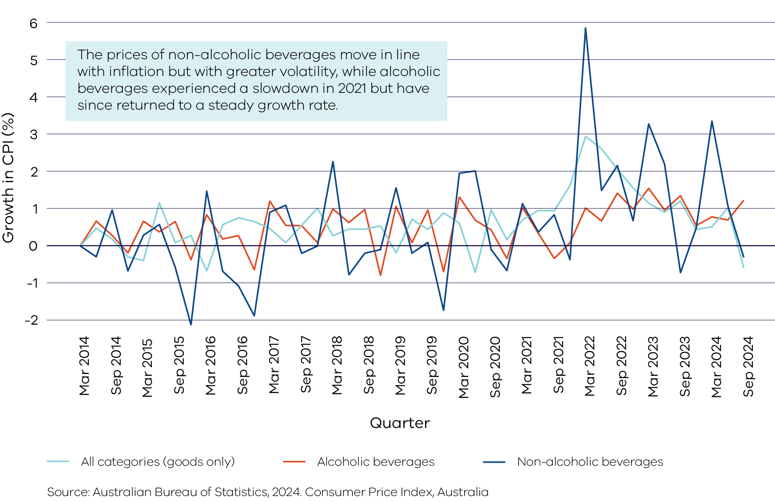

# Approach and methodology

This section details the scope of this review, the data sources used and detail on the econometric approach to understand the impact of CDS Vic on beverage prices and consumption.

## Scope of review

The approach to price monitoring combines the following:

* **Literature review:** Previous analysis of container deposit scheme impacts, the CDS Vic RIS and submissions to the then Department of Energy, Environment and Climate Action (the Department) about the impact of CDS Vic on prices have been reviewed to contextualise the analysis and inform the expected impact of CDS Vic.
* **Analysis and monitoring of pricing changes:** The impact of CDS Vic beverage pricing has been analysed by applying difference-in-difference statistical regressions of pricing data, provided by Yetta, by comparison to NSW and QLD. (see below for explanation of difference-in-difference)

**Analysis of market impacts on consumers:** The impact of the CDS Vic on consumption of beverages in Victoria has been analysed through a difference-in-difference statistical analysis of consumption volume data provided by Nielsen, by comparing to NSW and QLD.

The analysis has been conducted within the following boundaries:

* Price analysis for this final report is for the period of 1 November 2022 – 31 October 2024.
* Price analysis has been segmented into alcoholic and non-alcoholic beverages, with a further disaggregation into beverage categories.
* Consumption analysis is for the period 1 November 2021 – 3 November 2024.
* Consumption analysis is for non-alcoholic beverages only, segmented into beverage categories.[21]
* Price and consumption analysis has been conducted for Victoria, with comparison against NSW and QLD.

The approach, data and the econometric methodology described in this section have been informed by approaches undertaken in other Australian jurisdictions to monitor their container deposit scheme price and consumption impacts following scheme commencement.

## Data sources

This report draws on qualitative data from Recycling Victoria and large price and consumption datasets from providers (Yetta and Nielsen) were used to undertake the analysis. Further detail on how the data were managed is provided in Appendix B.

### Recycling Victoria data

Recycling Victoria material has contextualised the analysis and provided information on the establishment of CDS Vic. The following documents and information were used:

* the RIS for the introduction of CDS Vic
* the Victorian Scheme Payments and Contribution Methodology (SPCM)
* information about the introduction of CDS Vic.

### Yetta pricing data

Nous Group drew on a large pricing dataset provided by Yetta to conduct the price analysis in this report. Yetta provides a comprehensive dataset of alcoholic and non-alcoholic beverage prices across retailers in Australia. This data is collected online daily at the product level, which is the most detailed level available. This ensures the ability to distinguish price impacts for eligible containers. It also enables analysis that avoids capturing product and beverage category price trends that are unrelated to CDS Vic. The alcoholic and non-alcohol beverage container products in this dataset are described in Table 8. The analysis of Yetta data was conducted for the period 1 November 2022 to 31 October 2024.

Table : Categories included in the Yetta dataset

| Alcoholic beverages | Non-alcoholic beverages |
| --- | --- |
| Beer and cider | Soft drinks |
| RTD spirits | Juice |
| Wine | Water |
| Spirits and whisky | Milk |

The data contains the following fields:

* Brand name
* Product name
* Retailer name
* Category
* Sub-category
* Container type and size
* Pack size
* Price

Non-alcoholic beverage data provided by Yetta covers only Coles Supermarkets Australia Pty Ltd (Coles) and Woolworths Group Limited (Woolworths) as retailers. While this may pose a risk that the data may not cover all non-alcoholic products and competitive pricing efforts in Victoria, particularly in regional and remote areas, the size and scope of the 2 retailers covers a significant portion of the Victorian market. According to IBISWorld, Coles and Woolworths cover 67% of the supermarket and grocery market in Australia,[22] and both retailers offer delivery services for customers living in remote areas.[23] Coles, for example, delivers up to 100km from each store, with additional remote delivery options for those outside of this radius. This means the supermarkets cover between 96% (the total non-regional population) to 100% (the total non-remote population) of the Victorian population.[24] This coverage is illustrated in Appendix C.

The number of products covered by the Yetta data per category are outlined in Appendix B. Yetta data was also used in NSW and WA’s beverage price monitoring reports.

### Nielsen consumption data

Nielsen provided detailed data on the 4-weekly consumption of 10,000 households across Australia. Consumption results provided in this report are on a 4-weekly basis, however, to simplify the explanation of results, they are referred to on a ‘per month’ or ‘monthly’ basis.[25] The data provided by Nielsen is organised by beverage category, sub-category and brand.

Nielsen consumption data provided for this review was for the period 1 November 2021 to 3 November 2024.

The Nielsen dataset includes comprehensive information on the 4-weekly volume of beverages consumed, categorised by brand, product and markets. The market coverage includes the entirety of Australia, both offline and online sales, as well as data segmented by individual states. The categories in the Nielsen dataset and their alignment to categories used in this report is presented in Table 9.

Table : Categories from the Nielsen dataset

| Beverage categories | Categories from Nielsen dataset |
| --- | --- |
| Soft drinks | Energy drinks, sports drinks and ice-tea, soft drinks |
| Juice | Chilled juices |
| Water | Water (sparkling and still) |
| Milk | Chilled milk (plain and flavoured) |

The number of products covered by the Nielsen data per category are outlined in Appendix B. Nielsen data was also used in QLD, NSW and WA beverage price monitoring projects.

## Econometric approach

To isolate the impact of CDS Vic from other economic factors, econometric analysis of prices and consumption were undertaken. This is an analysis referred to as a ‘difference-in-difference’ analysis.

A difference-in-difference analysis involves comparing the changes in outcomes between a treatment group and a control group before and after a policy change. The key assumption of this method is that trends for each group would remain constant over time in the absence of treatment. The analysis therefore assumes that Victoria would experience a similar trend to NSW and QLD in the absence of the introduction of CDS Vic. This is known as the ‘parallel trends’ assumption.

Using a difference-in-difference analysis allows analysis to account for any industry or macroeconomic trends that affect states equally. This is particularly important given CDS Vic was introduced in a period of high inflation and national supply chain problems. This methodology is trusted for empirical economic estimation and public policy analysis and has been used by other Australian jurisdictions. Figure 2 provides an illustrative example of how the difference-in-difference approach was calculated.

Figure : Difference-in-difference analysis for Victoria versus NSW and QLD

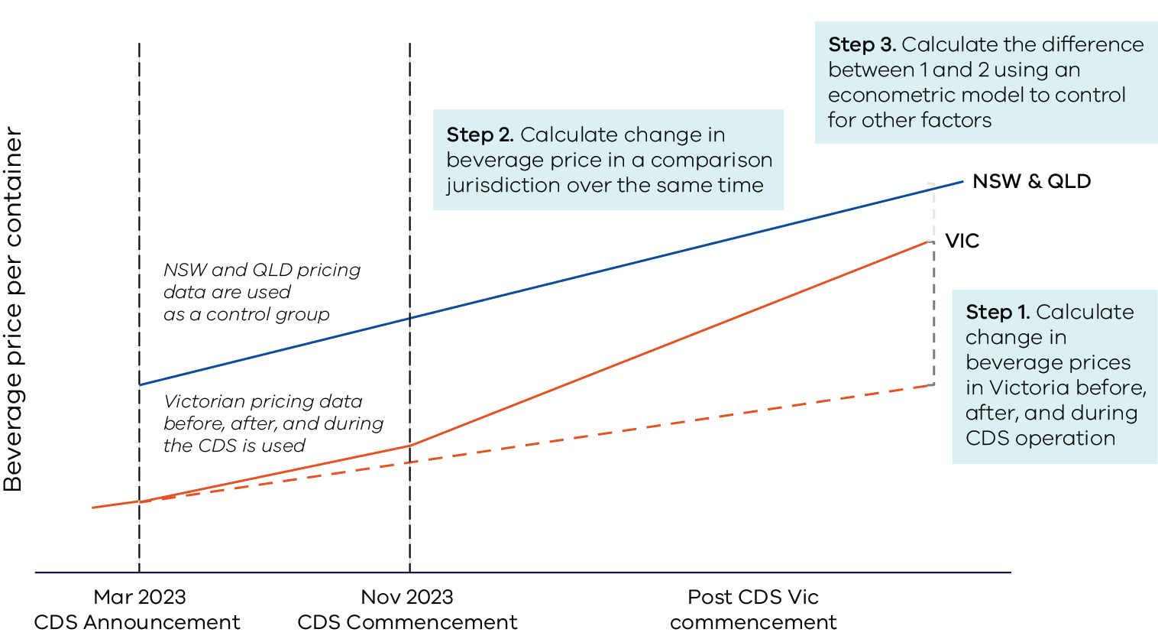

### Price and consumption analysis

A generalised linear model (GLM) was used to isolate the influence of the introduction of CDS Vic on beverage prices and consumption. This model builds on those used by other jurisdictions (particularly QLD and WA).

The model used for both price and consumption take the following regression equation format:

$Y_{itrs}= β_{0}+β_{1}SCHEME_{t}+β_{2}VIC_{st}+β_{3}SCHEME_{t}×VIC_{st}+β_{4}NSW_{st}+ α_{itrs}+ϵ_{itrs}$

Where:

* $Y_{itrs}$ is the outcome variable, price or consumption per household of beverage i at retailer r at time t in state s.
* $VIC*SCHEME_{t}$ is an interaction term between a dummy variable $VIC$ (that equals 1 if the beverage was sold in Victoria) and $SCHEME$, that equals 1 for all products sold in the period 1 November 2023 onward (commencement of CDS Vic).
* The coefficient of interest is $β_{3}$, which captures the impact of CDS Vic – that is, how much price or consumption changed due to the introduction of the scheme[26].
* accounts for state differences between the 2 control groups, NSW and QLD.
* $α_{itrs}$ are fixed effects or random effects that account for other influences on price. These include month, beverage size, multipack, container type, state characteristics, beverage subcategory, retailer and brands. An additional product type category (for example, apple juice, kombucha) is introduced in the consumption dataset. These effects allow us to isolate the impacts of other confounding variables on beverage price due to seasonality or retailer pricing strategies, or differences in beverages.
* $ϵ_{itrs}$ is a random error term which:
* for price, is assumed to have a Gamma distribution as prices will be positive[27]
* for consumption, is assumed to have a zero-adjusted Gamma distribution as consumption is either zero or positive[28].

**Fixed effects** are characteristics that have a consistent impact on beverage prices and are specific to each beverage type, such as brand or package size, which do not change over time.

**Random effects** are factors affecting price that vary but are constant over time, such as retailer pricing strategies or brand-specific pricing differences. These factors impact prices across multiple products in a consistent way over time but may differ between groups (retailers or brands).

**Mixed effects** refer to when both random and fixed effects are included in a model.

Both fixed, random and mixed (random and fixed) effects models were run to control for other influences on price. However, both models yield results with no noticeable differences, therefore only the results from the fixed effects model were reported.

In this model, the primary focus of the analysis is on the interaction between dummy variable $VIC$ and $SCHEME$, which assess whether the introduction of CDS Vic had an impact on prices in the treatment group (Victoria) compared to the control group (NSW or QLD).

Further details on the regression analysis used is provided in Appendix A.

## Key variables

The model includes variables that could confound the relationship between beverage prices (or consumption) and CDS Vic. The variables in each model and the rationale for including each variable is detailed in Table 10.

Table : Justification for included variables

| Variable | Application | Justification |
| --- | --- | --- |
| **Retailer** | Pricing | Retailers may have different pricing strategies, promotions and discounts, which may affect the prices of beverages. |
| **Brand** | Pricing and consumption | Beverages of different brands often have different pricing strategies, promotions and discounts, which may influence the prices of beverages. |
| **Beverage size** | Pricing and consumption | Beverage size affects the beverage price as larger sizes typically cost more. |
| **Beverage category** | Pricing and consumption | Different categories of beverages (for example, wine, soft drinks, fruit juices) likely to have different pricing structures and consumption due to variation in production costs and consumer preferences. |
| **Beverage subcategory** | Pricing and consumption | Different subcategories of beverages have different pricing structures and consumption patterns due to differences in production costs and market demand.  An additional beverage subcategory variable was developed for consumption data to pick up groups of beverages to better specify the model, as the beverage subcategory data was only available for pricing. For example, beverage subcategories for soft drinks include energy, lemon, cola, kombucha, tonic, sparkling and sport. Consumption patterns may vary across these subcategories based on consumer preference. Including this variable ensures a more accurate reflection of how different beverage subcategories impact both pricing and consumption patterns. |
| **Multipack** | Pricing and consumption | Beverages sold in multipacks are usually priced differently than single unit beverages due to bulk pricing strategies. Consumption volumes are also likely to differ for multipacks, as consumers may consume more when purchasing larger quantities. |
| **Container type** | Pricing | The type of container (for example, cans, bottles, or Tetra Paks) can affect both the price and consumption of beverages. Different container types have varying production costs and consumer preferences, which can influence pricing strategies and consumer purchase decisions. |
| **Month** | Pricing and consumption | Prices of beverages may fluctuate seasonally, with certain months experiencing lower or higher prices due to factors such as supply chain disruptions or holidays. Similarly, consumption patterns can vary by month, with higher consumption during certain holiday periods or warmer seasons. |
| **State** | Pricing and consumption | State is included in the model to serve as a control group for comparison against Victoria. It also accounts for state differences that may influence beverage prices and consumption. |
| **Eligibility** | Pricing and consumption | This variable was not included in regression but was used to filter data based on the container eligibility for CDS Vic before running the regression. The approach to define eligibility based on container variables is explained in Appendix B. |

## Limitations

While the approach taken in this report is designed to be robust, there are some limitations to the data used:

* Price analysis cannot be weighted by sales volumes from consumption data (as they are different and non-aligned data). This means that price fluctuations are treated equally across all products within a category, regardless of how much each product contributes to overall sales. This could potentially skew the overall results if products with higher volumes experienced different price trends to those products with lower volumes.
* Eligible milk and wine products were excluded from the pricing analysis as the Yetta pricing data sample sizes for these products were too small.
* Consumption per beverage per household has been estimated differently than other jurisdictions, which may drive some differences in the results. Nielsen data acquired for this analysis includes aggregated consumption per beverage, which has been standardised to consumption per household per beverage using the ABS data. Other jurisdictional studies acquired more disaggregated data on consumption per beverage by surveyed household, allowing for household characteristics to be included in estimation.

# Price changes attributable to CDS Vic

This section provides context on how eligible beverage prices have trended and then presents analysis on the estimated impact of CDS Vic on the price of eligible beverages and eligible multipacks. A sensitivity analysis is also presented.

## Price trend analysis

An array of economy-wide factors has influenced the price of beverages since the introduction of CDS Vic. CDS Vic was introduced during a period of high inflation across the Australian economy.[29] The prices of eligible beverages in Victoria have increased by 16.0 cents on average for alcoholic beverages and 39.1 cents on average for non-alcoholic beverages since CDS Vic commencement (Figure 3).

Figure : Average price for eligible beverages in Victoria, NSW and QLD from 1 November 2022 to 31 October 2024

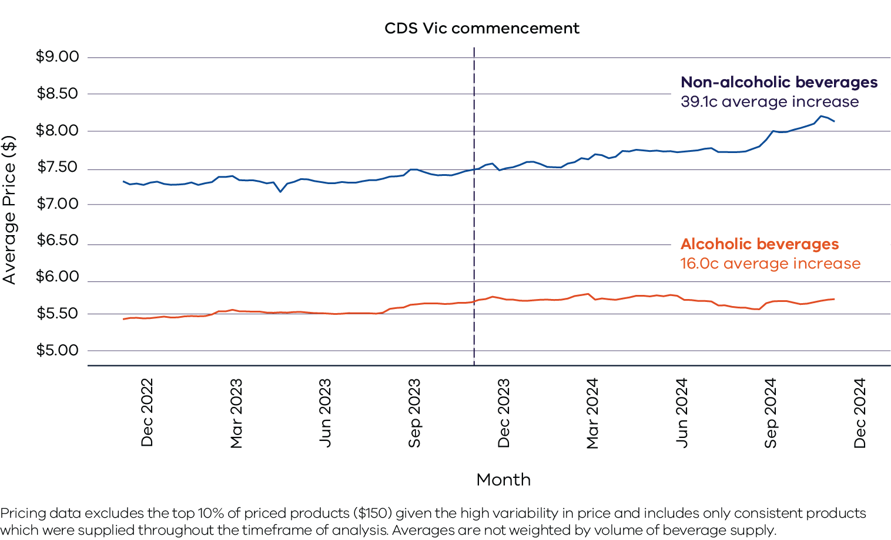

Alongside economy-wide inflationary pressures, specific beverage markets have faced additional cost pressures driving up price. For example, spirits prices increased by 1.8% and beer prices rose by 4.8% over the 12 months leading up to the September 2024 quarter.[30] This reflected the residual impact of the August 2024 alcohol excise increase, with beer excise rates rising and spirits experiencing a tax hike.[31]

Given that CDS Vic was introduced during a high-inflationary environment, it is important that this review seeks to isolate the impact of CDS Vic from other factors. The price trends in Figure 3 include these factors, such as seasonality or changes in retailer or brand strategies and therefore these changes in price cannot be solely attributed to the introduction of CDS Vic. The isolated results of CDS Vic’s impact, from econometric analysis, on beverage prices are discussed below.

## CDS Vic impact on beverage prices

### Overall impact

Econometric analysis of beverage price data from November 2022 to October 2024 estimates that prices for eligible alcoholic beverages in Victoria have, on average, increased by 3.6 cents and eligible non-alcoholic beverages, on average, by 9.1 cents due to the introduction of CDS Vic. These are relative to any increases experienced in the comparison states over the same period and reflect the change in average weekly prices over the first year of CDS Vic’s operation.

A breakdown of the impact of CDS Vic by beverage category is presented in Table 11.

Table : Estimated impact of CDS Vic on eligible beverage prices in the first year of operation

| Category | Estimated impact (cents) | Significance of impact | Average  price (dollars) | Sample  size (no. of  products) |
| --- | --- | --- | --- | --- |
| **Alcoholic (eligible)** | 3.6 | *** | $5.88 | 3,529 |
| **Beer and cider** | 4.6 | *** | $4.55 | 2,244 |
| **RTD spirits** | 1.1 |  | $7.28 | 1,285 |
| **Non-alcoholic (eligible)** | 9.1 | *** | $7.95 | 732 |
| **Juice** | 0.5 |  | $16.42 | 20 |
| **Water** | 5.1 | ** | $2.75 | 17 |
| **Soft drink** | 9.4 | *** | $7.41 | 695 |

Significance indicates the probability that the observed price difference from CDS Vic is not due to a random chance. A lower significance level indicates a stronger confidence that the difference is real. The levels of significance are indicated by the asterisks (*), where * indicates 10% significance, ** indicates 5% significance and *** indicates 1% significance. No asterisk indicates that the estimate is not statistically significant.

**Source:** Nous Group analysis of Yetta price data for alcoholic and non-alcoholic beverages, from 1 November 2022 to 4 November 2024.

Most eligible beverages are estimated to have increased in price due to the introduction of CDS Vic. Eligible soft drinks had the highest estimated non-alcoholic beverage price increase of 9.4 cents on average, while eligible beer and cider has the highest estimated price for alcoholic beverages, an estimated increase of 4.6 cents on average. Water is also estimated to have observed a price increase (5.1 cents) attributable to CDS Vic.

The analysis cannot reliably identify whether CDS Vic had an impact on juice prices. It estimated a small and statistically insignificant impact. This is likely because the available sample size for juice was small (relative to the large and diverse juice market, with only 20 products in the sample) and the variation in juice prices over the period within this sample was minimal. This is because sufficient variation in the data over time of an outcome variable is a prerequisite for robust and meaningful econometric analysis.

Analysis also did not find evidence of an effect on RTD spirits, despite the large sample size. This is explored further below.

### Impact on eligible multipacks

Further analysis was conducted on the impact of CDS Vic on the price of beverage multipacks (that is, a sub-sample of the available product sample). Analysis was conducted on the unit price of individual beverages within a multipack (that is, price divided by the number of units in the pack). Detailed results are provided in Table 12.

While analysis found a statistically insignificant and small result for all eligible RTD spirits, a large and statistically significant effect for eligible multipack RTD spirits is estimated; an average increase of 3.5 cents attributed to CDS Vic. The reason for the inconsistency in results for all eligible RTD spirits and eligible multipack RTD spirits is unclear.

Eligible beer and cider multipacks are estimated to have experienced a marginally higher average price increase (5.7 cents) than all eligible beer and cider beverages (4.6 cents). Estimates for eligible water multipacks indicated they are likely to have experienced a marginally lower average price increase (2.5 cents) than for all eligible water beverages (5.1 cents). CDS Vic’s effect on soft drink prices (9.4 cents) is estimated to be the same regardless of whether it is bought in a multipack.

Table : Estimated impact of CDS Vic on eligible multipack beverage prices in the first year of operation

| Category | Estimated impact (cents) | Significance of impact | Average  price (dollars) | Sample  size (no. of  products) |
| --- | --- | --- | --- | --- |
| **Beer and cider** | 5.7 | *** | $4.10 | 2,206 |
| **RTD spirits** | 3.5 | *** | $5.85 | 1,170 |
| **Juice** | 0.0 |  | $13.50 | 18 |
| **Water** | 2.5 | ** | $2.44 | 16 |
| **Soft drink** | 9.4 | *** | $5.52 | 577 |

Significance indicates the probability that the observed price difference from CDS Vic is not due to a random chance. A lower significance level indicates a stronger confidence that the difference is real. The levels of significance are indicated by the asterisks (*), where * indicates 10% significance, ** indicates 5% significance and *** indicates 1% significance. No asterisk indicates that the estimate is not statistically significant.

**Source:** Nous Group analysis of Yetta price data for alcoholic and non-alcoholic beverages, from 1 November 2022 to 4 November 2024.

### Sensitivity analysis

Figure 4 presents the average price estimates for each eligible beverage category due to the introduction of CDS Vic with 95% confidence intervals. It shows that the 95% confidence interval for most eligible beverages are within 1.1 to 4.0 cents of the central point estimate.

However, as the estimated scheme impact for eligible juice is statistically insignificant, its estimated confidence intervals are much wider with a range of -13.5 to 14.6 cents.

Figure : Impact of CDS Vic on eligible beverage prices to November 2024 with the 95% confidence interval

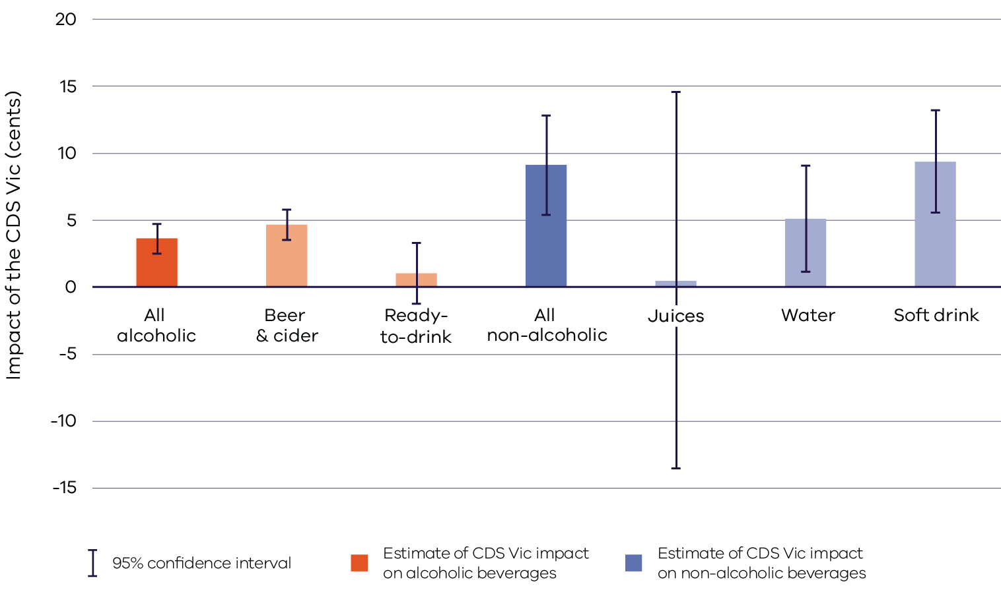

Findings on price impact

Analysis found an overall estimated average increase of 3.6 cents for eligible alcoholic beverages and 9.1 cents for eligible non-alcoholic beverages in Victoria due to the introduction of CDS Vic. These estimated impacts are less than CDS Vic’s contribution cost, which is 12.3 cents on average per container.

This suggests that suppliers, on average, have not passed on the full cost of their scheme supplier contributions onto to consumers during the assessment period. This could reflect that some suppliers have passed on the costs in full, while others have passed on a portion of their costs only.

Table 13 shows that the estimated price increases from separate beverage monitoring in other jurisdictions (relating to the container deposit scheme) were almost all greater than those in Victoria and in at least 3 cases were greater than the first-year cost impact on suppliers. There are various possible explanations for these findings. Suppliers may be:

* spreading some CDS Vic related costs across their national supply of containers
* absorbing some of the costs to maintain market share in the current challenging high inflation environment

intending to pass-on the additional costs more gradually over time.

Table : Estimated price change in Victoria compared to estimates in other jurisdictions and scheme contribution cost in the first year of operation

| Jurisdiction | Estimated change in eligible beverage prices | Scheme contribution cost |
| --- | --- | --- |
| **VIC** | 9.1 cents (non-alcoholic)  3.6 cents (alcoholic) | 12.3 cents per container[32] |
| **NSW** | 10.1 cents (non-alcoholic)[33]  5.1 cents (alcoholic) | Not reported− estimated direct cost to suppliers is 9.3 cents per container37 |
| **QLD** | 9.0 cents (non-alcoholic)[34]  9.9 cents (alcoholic) | Not reported38 |
| **WA** | 13.2 cents (non-alcoholic)[35]  3.9 cents (alcoholic) | 12.8 cents per container39 |
| **ACT** | 12.3 cents (wholesale price only)[36] | N not reported−, estimated direct cost to suppliers is 7.5 cents per container40 |
| **NT** | 12.8 cents[37] | Not reported41 |

# Consumption changes attributable to CDS Vic

This section provides context to how beverage consumption has trended, then presents analysis on the estimated impact of CDS Vic on the consumption of eligible non-alcoholic beverages.

## Consumption trend analysis

Product level consumption data was available only for the consumption of non-alcoholic beverages. To align the analysis to those undertaken by other jurisdictions, the data was standardised by applying annual ABS household estimates for each state to obtain a consumption per beverage per household figure.

Figure 5 provides the average consumption per household across all eligible beverages since November 2021[38]. The chart shows that consumption of non-alcoholic beverages is extremely seasonal, generally experiencing peaks in the December to January period and troughs around July to August.

Over the 12 months to November 2024, the consumption of eligible beverages increased by 1.1% across all states. To control for seasonality within years, this compares average consumption over the 12 months before scheme commencement to the 12 months post scheme commencement.

Figure : Changes in consumption of eligible beverages over time from November 2021 to November 2024

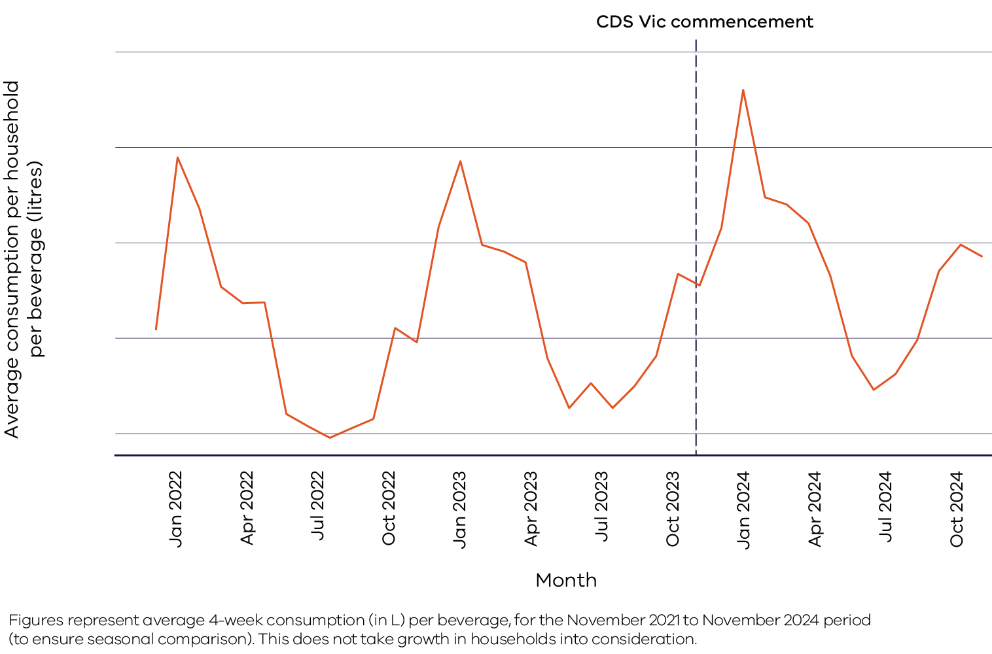

It is important to note that these trends are driven by a range of economic factors, such as changes in consumer preferences and product availability and not only the introduction of CDS Vic. The results of the econometric analysis, which controls for these trends, is presented below.

## Impact on non-alcoholic consumption

The introduction of CDS Vic is estimated to have led to a reduction in non-alcoholic beverage consumption of 2.6% per household per beverage. This result has weak statistical significance, with an estimated range of -5.4% and 0.1% at the 95% confidence interval.

This result for non-alcoholic consumption is consistent with economic theory, which suggests that if prices of a product increase due to a change in policy and no other factors change, consumption of the product would then decrease.

However, there is no evidence that the introduction of CDS Vic affected the consumption of specific non-alcoholic beverage categories, as the estimates for eligible water, soft drink and juice are not statistically significant. A breakdown of results across eligible non-alcoholic beverage categories is presented in Table 14.

Reliable data on alcoholic consumption was not available from Nielsen or the broader market and thus only non-alcoholic beverage econometric consumption analysis was undertaken. This approach is consistent with other jurisdictions.

Table : Estimated impact of CDS Vic on non-alcoholic beverage consumption in the first year of operation

| Category | Estimated change in average household consumption per beverage | Sample size (no. of products) |
| --- | --- | --- |
| **All eligible (non-alcoholic)** | -2.6%* | 2,918 |
| **Juice** | -3.8% | 605 |
| **Water** | -2.5% | 325 |
| **Soft drink** | -2.2% | 1,988 |

Significance indicates the probability that the observed price difference from CDS Vic is not due to a random chance. A lower significance level indicates a stronger confidence that the difference is real. The levels of significance are indicated by the asterisks (*), where * indicates 10% significance, ** indicates 5% significance and *** indicates 1% significance. No asterisk indicates that the estimate is not statistically significant.

**Source:** Nous analysis of Nielsen price data for non-alcoholic beverages, from 1 November 2021 to 3 November 2024. Alcoholic consumption was not available to Nous Group / Recycling Victoria.

Analysis on the effect of CDS Vic on the consumption of eligible multipack beverages was also undertaken, however it did not yield statistically significant results.

## Findings on consumption impact

The analysis found a weakly significant estimate (overall) and insignificant estimates of decreases in average consumption per beverage per household (at the beverage category level). This could be due to a range of reasons including the relatively lower estimates in beverage price increase attributable to CDS Vic.

It is also possible that household demand for the consumption of non-alcoholic beverages is inelastic, meaning that larger changes in price can correspond to a minimal change in consumption. This is combined with the fact that consumers could more than offset the average increase in beverage prices by redeeming eligible containers for a 10 cents refund.

It is not clear whether these findings would be the same for alcoholic beverages.

Estimates on eligible non-alcoholic beverage consumption per household relating to the introduction of CDS Vic are lower than those found in QLD and NSW from their respective scheme introductions. This is presented in Table 15, with Victoria estimated to have observed a reduction of 411 ml per household per month for non-alcoholic beverages. This may be due to Victoria experiencing a smaller price increase in eligible beverage than these jurisdictions when introducing their schemes.

For this Victorian analysis, the average decrease in consumption per household per beverage result (in ml) was converted into a per household result using the number of eligible beverages in the sample.

Table : Estimated impact on eligible non-alcoholic beverage consumption in Victoria compared to other jurisdictions in first year of operation

|  |  |
| --- | --- |
| Jurisdiction | Estimated change in consumption per month |
| **VIC** | **Reduction of 411 ml per household (2.6%)** |
| **NSW** | Reduction of 950 ml per household (6.7%)[39] |
| **QLD** | Reduction of 1.04 L per household (6.5%)[40] |

# Appendix A: Methodology

## Estimation of price and consumption impacts

A generalised linear model (GLM) has been conducted to isolate the influence of the introduction of CDS Vic on beverage prices and consumption. This model builds on those used by other jurisdictions (particularly QLD and WA).

The model used for both price and consumption takes the following regression equation format:

$Y_{itrs}= β_{0}+β_{1}SCHEME_{t}+β_{2}VIC_{st}+β_{3}SCHEME_{t}×VIC_{st}+β_{4}NSW_{st}+ α_{itrs}+ϵ_{itrs}$

The beta $(β)$ values of this function tell us how much the dependent variable (for example, beverage prices or household consumption) is expected to change when the independent variable (for example, the policy “SCHEME”) increases by one unit. It expresses the influence of each variable in the model. This section explains the meaning of each coefficient:

* The coefficient of interest is $β_{3}$, which captures the impact of CDS Vic – that is, how much price or consumption changed in Victoria due to the introduction of CDS Vic.
* $β_{0}$ is the baseline effect, which measures the average price of beverage for QLD at the start of the period (before scheme).
* $β_{1}$ measures the effect of CDS Vic being implemented across all states (Victoria, NSW and QLD). It does not separate out the specific effect in Victoria.
* $β_{2}$ measures the difference in the outcome variable for Victoria compared to NSW and QLD for the entire period, independent of whether CDS Vic is in place.

$β_{4}$ measures the state-specific effects in NSW.

Both pricing and consumption models used a logarithmic link function. The log transformation stabilises the variance across difference levels of predictors (for example, expensive beverages might have a higher variance in their prices than cheaper beverages).

## Estimation of average marginal effect

Given the complexity of the model, the effect of CDS Vic cannot be directly estimated using the coefficients from the model. Two methods have been employed to estimate the average marginal effect of CDS Vic on the price and consumption for the beverages in Victoria:

* parametric G-computation

marginal effect computation.

The results presented above use parametric G-computation for consumption and a marginal effects computation for price. This choice is based on the most appropriate method for the model specification. Each methodology is explained below.

### Parametric G-computation

Parametric G-computation is the gold standard for calculating marginal effects (that is, the impact of a change in in one variable on the outcome variable), especially for complex models. This method involves running the model twice, one where the variable of interest is present and one without, then taking the difference between the average predictions of the 2 models to understand the impact of the variable.

### Marginal effects computation

When employing a logarithmic link function, the coefficients reported by the model are in the natural log format. When this is exponentiated, the coefficient represents the percentage difference in the outcome (in this case, price), due to the variable increasing by one. The marginal effect computation involves taking the coefficient from the model, exponentiating the value, then applying this term as a percentage difference to the average price in Victoria before CDS Vic. The steps are:

* Take the coefficient for CDS Vic’s effect: The interaction term interest is $VIC1:CDSpost$, represented by the coefficient $β_{3}$. This represents the effect of the impact of CDS Vic in Victoria, in natural log format.
* Exponentiate the coefficient: The negative of the coefficient $β_{3}$ was exponentiated to transform the effect from the log scale back to the original scale.
* Percentage change: After exponentiating the coefficient, 1 was subtracted from the coefficient to arrive at the percentage change in beverage prices in Victoria that is attributed to CDS Vic's effect. This step converts the logarithmic effect into a more interpretable percentage change on the actual price.
* Multiply with pre-Victoria average price: The calculated percentage change was then multiplied by the average price for that beverage category in Victoria before CDS Vic. This yielded the average marginal effect of CDS Vic on beverage prices for that category.

# Appendix B: Treatment of data for analysis

## Pricing data

In preparing the Yetta pricing data for analysis, several key adjustments have been applied to ensure accuracy and consistency across the dataset, as described below:

1. Unit price calculation: If the pack size of beverages is missing (NA), zero or blank, unit price was set to the original price. This meant no adjustment was made and the original price was interpreted as a unit price. Otherwise, if the pack size of beverages was present and valid (that is, a positive number), the price was divided by pack size of beverages to calculate the unit price. This approach ensured that the price was standardised to a per-unit basis, allowing for comparison across different pack sizes.
2. Extraction and cleaning of container size: If container size (for example, 500 ml, 1 L) was not specified, the container size was extracted directly from the beverage product name. This ensured that even if the container size was not explicitly provided, it can still be inferred from the product name. Any entries where the container size was in grams (g) or kilograms (kg) was excluded, as these units were not relevant for liquid beverages.
3. Beverage size and unit standardisation: The numerical part of container size was extracted to determine the beverage size. The beverage size had been standardised to litres (L) across all entries.
4. Averaging unit price: As Yetta provides both promotional and non-promotional data, the average of the promotional and non-promotional price on a weekly basis was taken. To obtain this, the average unit price of beverage was first calculated for each state, beverage category, retailer, brand, beverage product, container type and beverage size for all conditions of sale (CoS) such as each, direct from supplier and member offer. The corresponding week for each daily date was identified and the average weekly unit price was computed using the same grouping as before.
5. Extreme unit prices: The top 10% of priced products ($150) were excluded given the high variability in prices which would skew the analysis. Finally, only products that were sold in both the pre- and post- Scheme periods were included to ensure consistency in analysis.
6. Common beverages sold before and after CDS Vic: Only those beverages that were sold in both the pre-scheme period (prior 1 November 2023) and post-scheme period (post 1 November 2023) were included to ensure consistency in analysis.

## Consumption data

In preparing the Nielsen consumption data for analysis, a few adjustments were applied to ensure accuracy and consistency across the dataset.

To capture the impact of CDS Vic, only those beverages that were available in both the pre-scheme period (prior to 1 November 2023) and the post-scheme period (after 1 November 2023) were retained to ensure consistency in analysis.

Additionally, to account for variations in household size and consumption patterns, the consumption data were scaled by household. By scaling the consumption data by household, the analysis accounted for these differences, ensuring that the analysis accurately reflected consumption patterns on a per-household basis. This adjustment allowed for more meaningful comparisons, as it normalised the data across households of different sizes, providing a clearer understanding of the actual changes in consumption before and after CDS Vic, without being skewed by household size variations. ABS data on the number of households in Victoria was drawn on to get a ‘per household’ figure.

## Eligible beverage containers

The beverages classifications in the data were sorted according to the eligibility criteria outlined in the Circular Economy (Waste Reduction and Recycling) (CDS) Regulations 2022. Due to the lack of data on container material, it is not possible to perfectly identify containers as eligible or ineligible. Therefore, a mix of product type and size variables in the Yetta pricing data and Nielsen consumption data were used to classify eligibility.

All beverages over 3 L or under 150 ml were classified as ineligible. Any beverage that does not meet the conditions for being ineligible or exempt in the Yetta pricing data and Nielsen consumption data will automatically be classified as eligible.

### Yetta pricing data

Table 16 summarises the detailed eligibility rules applied to the Yetta pricing data. The key variables used, drawn from the Yetta pricing data, comprise of beverage category, beverage subcategory, beverage size and product name to identify containers as eligible, exempt or ineligible.

Table : Application of container eligibility criteria to Yetta pricing data

All beverages

| Beverage type | Eligibility | Application of eligibility criteria to the Yetta pricing data |
| --- | --- | --- |
| All beverage types | Ineligible | All items with a beverage size more than 3 L are exempt.  All items with a beverage size less than 150 ml are exempt. |
| All else | Eligible | Any product that does not meet the conditions for being ineligible or exempt will automatically be classified as eligible. |

Non-alcoholic beverages

| Beverage type | Eligibility | Application of eligibility criteria to the Yetta pricing data |
| --- | --- | --- |
| Cordial | Exempt | Any items from any beverage subcategory that contain ‘cordial’ in their product name are exempt from CDS Vic. |
| Concentrated fruit or vegetable juice (or a mixture of both) | Exempt | Any items from the beverage subcategory ‘non-alcoholic RTDs’ that contain ’juice’ in the beverage subcategory and ‘concentrate’ or ’concentrated’ in the product name are exempt. |
| Fruit juice or vegetable juice (or a mixture of both) | Ineligible | Any items from the beverage subcategory ‘non-alcoholic RTDs’ that contain ’juice’ in the beverage subcategory and are greater than or equal to 1 L are ineligible. |
| Flavoured milk | Eligible | Any items from the beverage subcategories ‘dairy based drinks - RTD (shelf stable)’ and ‘dairy based drinks - RTD (perishable)’ that has a ‘flavoured’ in the product name and is less than 1 L are eligible. |
| Milk (other than flavoured milk and fermented milk product) | Exempt | Any items from the beverage subcategories ‘milk (shelf stable)’, ‘milk (perishable)’, dairy based drinks − RTD (shelf stable)’ and ‘dairy based drinks - RTD (perishable)’ are exempt from CDS Vic. |
| Registered health tonics | Exempt | There is no registered health tonics included in the Yetta dataset. |
| Water | Ineligible | Any items from the beverage subcategory ‘packaged water’ and are greater than 3 L are ineligible. |

Alcoholic beverages

| Beverage type | Eligibility | Application of eligibility criteria to the Yetta pricing data |
| --- | --- | --- |
| Spirits or whisky | Ineligible | Any items from the beverage category ‘spirits’ or ‘whisky’ are ineligible. |
| RTD spirits | Ineligible | Any items from the beverage category ‘RTD spirits’ that have a beverage size greater than 3 L are ineligible. |
| Wine (can) | Ineligible | Any items from the beverage category 'white wine' and 'red wine’ or contain 'wine' in the beverage subcategory and where the container type is 'can,' and are more than 3 L are ineligible. |
| Wine (glass bottle) | Ineligible | Any items from the beverage category 'white wine' and 'red wine’ or contain 'wine' in the beverage subcategory and where the container type is 'bottle’, are ineligible. |
| Wine (cask) | Eligible | Any items from the beverage category 'white wine' and 'red wine’ or contain 'wine' in the beverage subcategory and where the container type is a cask and less than 1 L are eligible. |

### Nielsen consumption data

Table 17 summarises the eligibility rules applied on the Nielsen consumption data. The key variables used, drawn from the Nielsen consumption data, comprise of beverage category, beverage size and product name to identify containers as eligible, exempt or ineligible.

Table : Application of container eligibility criteria to Nielsen consumption data

All beverages

| Beverage type | Eligibility | Application of eligibility criteria to the Nielsen consumption data |
| --- | --- | --- |
| All beverage types | Ineligible | All items with a beverage size more than 3 L are exempt.  All items with a beverage size less than 150 ml are exempt. |
| All else | Eligible | Any product that does not meet the conditions for being ineligible or exempt will automatically be classified as eligible. |

Non-alcoholic beverages

| Beverage type | Eligibility | Application of eligibility criteria to the Nielsen consumption data |
| --- | --- | --- |
| Milk (other than flavoured milk and fermented milk product) | Exempt | Any items from the beverage category ‘chilled milk’ are exempt. |
| Cordial | Exempt | Any items that have ‘cordial’ in their product name are exempt. |
| Registered health tonics | Exempt | There is no registered health tonics included in the Nielsen dataset. |
| Concentrated fruit or vegetable juice (or a mixture of both) | Exempt | Any items from the beverage category ‘chilled juices’ or ’long life juice and cordial’ that have ’concentrate’ or ‘concentrated’ in the product name are exempt. |
| Fruit juice or  vegetable juice | Ineligible | Any items from the beverage category ‘chilled juices’ or ‘long life juice and cordial’ that are greater than or equal to 1 L are ineligible. |
| Water | Ineligible | Any items from the beverage category ‘water’ and are greater than 3 L are ineligible. |
| Flavoured milk | Eligible | Any items from the beverage category ‘chilled milk’ that have a flavour in the product name and are less than 1 L are eligible. |

### Data availability across beverage categories

Data was not available for this study for some categories used in the analysis (for example, alcoholic consumption data is not readily available for purchase). Table 18 presents the availability of data for each beverage category.

Table : Data availability across beverage categories

Alcoholic beverages: Number of available eligible products in data

| Beverage category | Price | Consumption |
| --- | --- | --- |
| Beer and cider | 2,244 | - |
| RTD spirits | 1,285 | - |
| Wine | 9 | - |
| Spirits and whisky | 0 | - |
| **Total** | **3,538** | **-** |

Non-alcoholic beverages: Number of available eligible products in data

| Beverage category | Price | Consumption |
| --- | --- | --- |
| Soft drinks | 695 | 1,988 |
| Juice | 20 | 605 |
| Water | 17 | 325 |
| Milk | 0 | 0 |
| **Total** | **732** | **2,918** |

# Appendix C: Coverage of major supermarket chains

Non-alcoholic beverage data provided by Yetta only covers Coles Supermarkets Australia Pty Ltd (Coles) and Woolworths Group Limited (Woolworths) as retailers. While this may pose a risk that the price data may not cover all non-alcoholic products and competitive pricing efforts in Victoria, particularly in regional and remote areas, the size and scope of the 2 retailers covers a significant size of the market in Victoria.

Figure : Coverage of Coles supermarkets across Victoria

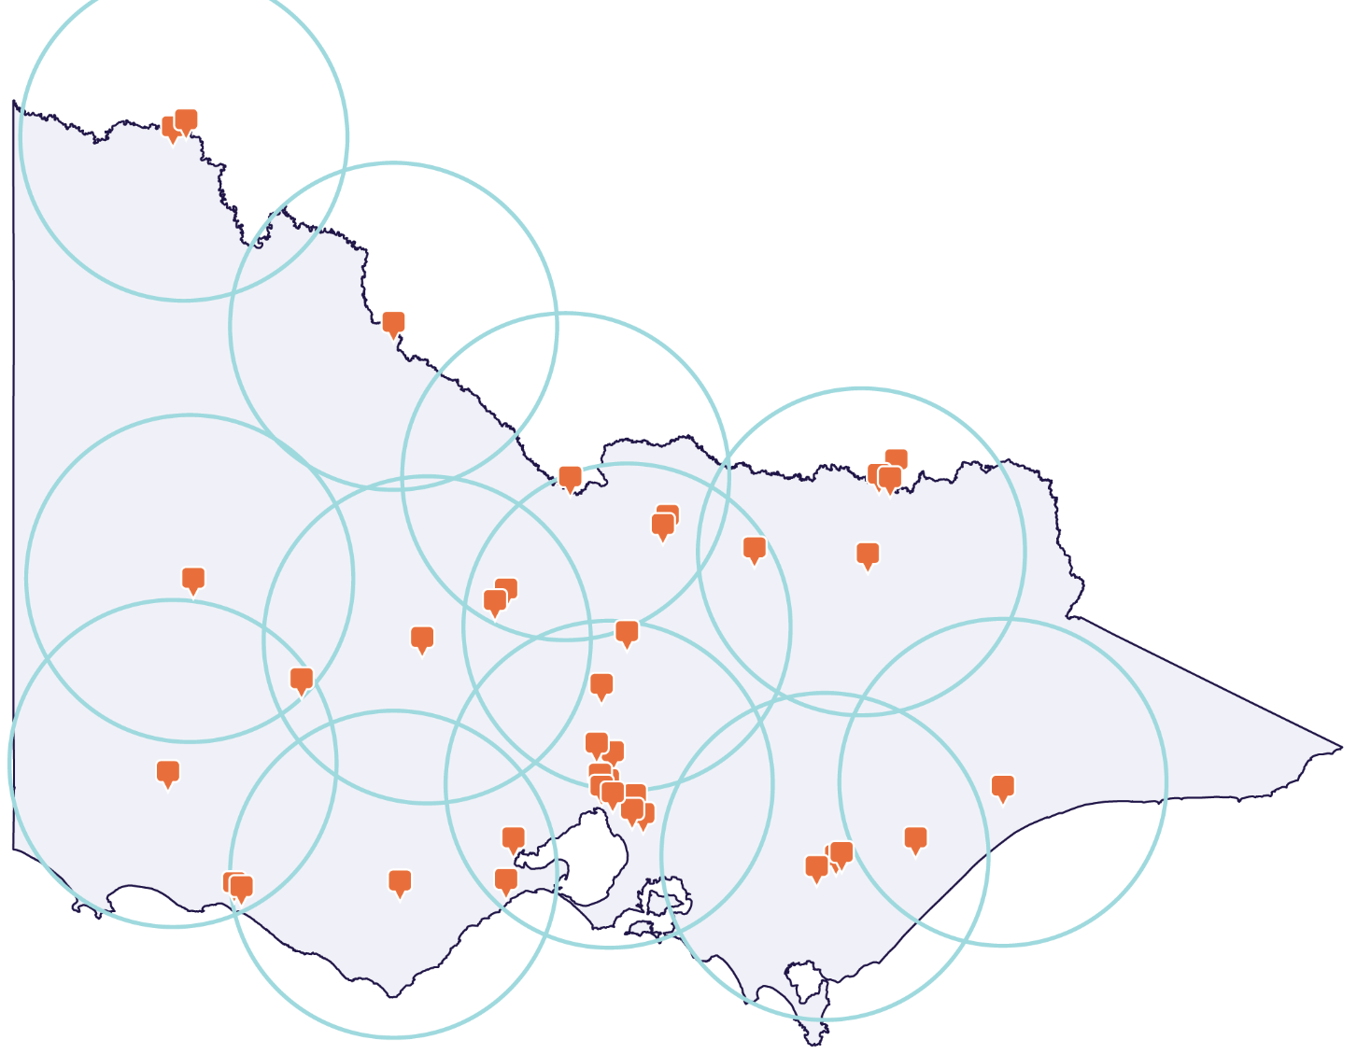

Coles delivers up to 100km from each store, with additional remote delivery options for those outside of this radius. Figure 6 represents the 100km radius for regional and rural Coles stores. The orange coverage demonstrates areas where residents have access to Coles products. The non-covered areas are rural and remote areas. This means the supermarkets cover between 96 to 100% of the Victorian population (the total non-regional and non-remote population).[41]

# Publication information

## Acknowledgements

We acknowledge and respect Victorian Traditional Owners as the original custodians of Victoria’s land and waters, their unique ability to care for Country and deep spiritual connection to it.

We honour Elders past and present whose knowledge and wisdom has ensured the continuation of culture and traditional practices.

DEECA is committed to genuinely partnering with Victorian Traditional Owners and Victoria’s Aboriginal community to progress their aspirations.

## Copyright

© The State of Victoria Department of Energy, Environment and Climate Action 2025.

## Creative Commons

This work is licensed under a Creative Commons Attribution 4.0 International licence, visit the [Creative Commons website](http://creativecommons.org/licenses/by/4.0/) (<http://creativecommons.org/licenses/by/4.0/>).

You are free to re-use the work under that licence, on the condition that you credit the State of Victoria as author. The licence does not apply to any images, photographs or branding, including the Victorian Coat of Arms, the Victorian Government logo and the Department of Energy, Environment and Climate Action (DEECA) logo. To view a copy of this licence, visit <http://creativecommons.org/licenses/by/4.0/>

Front image courtesy of VicReturn

ISBN978-1-76176-204-8 (pdf/online/MS word)

## Disclaimer

This publication may be of assistance to you but the State of Victoria and its employees do not guarantee that the publication is without flaw of any kind or is wholly appropriate for your particular purposes and therefore disclaims all liability for any error, loss or other consequence which may arise from you relying on any information in this publication.

## Accessibility

To receive this document in an alternative format, phone the Customer Service Centre on 136 186, email [customer.service@delwp.vic.gov.au](mailto:customer.service@delwp.vic.gov.au), or contact National Relay Service on 133 677. Available at DEECA website ([www.deeca.vic.gov.au](http://www.deeca.vic.gov.au/)).

**End of document.**

1. All prices quoted in this report are GST inclusive, unless stated otherwise.
2. A historically longer dataset (i.e. to 2021) was used for consumption analysis to account for significant seasonality effects on household consumption. Reliable data on alcoholic consumption was not available from Nielsen or the broader market and thus only non-alcoholic beverage econometric consumption analysis was undertaken. This approach is consistent with other jurisdictions.
3. Results reflect the change in average weekly prices over the first 12 months of the scheme’s operation.
4. A multipack of beverages refers to a package that contains multiple containers of a beverage, bundled together for purchase (for example, a 6 pack of water).
5. Sufficient variation in the data over time of an outcome variable is a prerequisite for robust and meaningful econometric analysis and this was not present in the small juice price data available.
6. VicReturn
7. IPART, 2018. [NSW Container Deposit Scheme: Monitoring the impacts on container beverage prices and competition](https://www.ipart.nsw.gov.au/sites/default/files/documents/final-report-nsw-container-deposit-scheme-monitoring-the-impacts-on-container-beverage-prices-and-competition-december-2018.pdf).
8. QLD Productivity Commission, 2020. [Container Refund Scheme price monitoring review.](https://s3.treasury.qld.gov.au/files/Review-Container-Refund-Scheme-final-report.pdf)
9. Economic Regulation Authority WA, 2022. [Report on the effects of the container deposit scheme on beverage prices in Western Australia](https://www.erawa.com.au/cproot/22482/2/-2019.CDS.Inq-Container-Deposit-Scheme-Price-Monitoring---Final-Report---For-tabling.PDF)
10. Independent Competition and Regulatory Commission, 2019. [Container Deposit Scheme Price Monitoring](https://www.icrc.act.gov.au/__data/assets/pdf_file/0020/1407602/Container-Deposit-Scheme-Price-Monitoring-Final-Report.pdf).
11. Boomerang Alliance, 2013. [Independent Review: The Northern Territory Container Deposit System.](https://www.bottlebill.org/assets/pdfs/campaigns/australia/NT%20CDS%20Report%20Final_180213.pdf)
12. IPART, 2018. [NSW Container Deposit Scheme: Monitoring the impacts on container beverage prices and competition.](https://www.ipart.nsw.gov.au/sites/default/files/documents/final-report-nsw-container-deposit-scheme-monitoring-the-impacts-on-container-beverage-prices-and-competition-december-2018.pdf) p 78-79.
13. Queensland Productivity Commission, 2020. [Container Refund Scheme price monitoring review.](https://s3.treasury.qld.gov.au/files/Review-Container-Refund-Scheme-final-report.pdf) p 27.
14. According to the Circular Economy (Waste Reduction and Recycling) (Container Deposit Scheme) Regulations 2022, pure spirituous liquor refers to an alcoholic beverage produced by distillation or a mixture of 2 or more alcoholic beverages produced by distillation.
15. Pre-mixed alcoholic beverages are referred to as RTDs in this report.
16. IPART, 2018. [NSW Container Deposit Scheme: Monitoring the impacts on container beverage prices and competition](https://www.ipart.nsw.gov.au/sites/default/files/documents/final-report-nsw-container-deposit-scheme-monitoring-the-impacts-on-container-beverage-prices-and-competition-december-2018.pdf).
17. QLD Productivity Commission, 2020. [Container Refund Scheme price monitoring review.](https://s3.treasury.qld.gov.au/files/Review-Container-Refund-Scheme-final-report.pdf)
18. Economic Regulation Authority WA, 2022. [Report on the effects of the container deposit scheme on beverage prices in Western Australia](https://www.erawa.com.au/cproot/22482/2/-2019.CDS.Inq-Container-Deposit-Scheme-Price-Monitoring---Final-Report---For-tabling.PDF)
19. Independent Competition and Regulatory Commission, 2019. [Container Deposit Scheme Price Monitoring](https://www.icrc.act.gov.au/__data/assets/pdf_file/0020/1407602/Container-Deposit-Scheme-Price-Monitoring-Final-Report.pdf).
20. Boomerang Alliance, 2013. [Independent Review: The NT Container Deposit System.](https://www.bottlebill.org/assets/pdfs/campaigns/australia/NT%20CDS%20Report%20Final_180213.pdf)
21. Reliable data on alcoholic consumption was not available from Nielsen or the broader market and thus only non-alcoholic beverage econometric consumption analysis was undertaken. This approach is consistent with other jurisdictions.
22. IBISWorld, 2024. Supermarkets and Grocery Stores in Australia.
23. Courier Mail, 2023. [Rural convenience: Woolworths Last Mile Delivery service saving remote Aussies up to 16hr grocery runs.](https://www.couriermail.com.au/bush-summit/rural-convenience-woolworths-last-mile-delivery-service-saving-remote-aussies-up-to-16hr-grocery-runs/news-story/41eebb592604700476f4c99f1eef2c70)

    Coles, 2024. [Remote delivery locations.](https://www.coles.com.au/help/delivery/remote-delivery-locations?srsltid=AfmBOorP_SvrMobYVd9BlIbXgtwiyOfz_eV-m38eMQih8UqOoEtsauME)
24. ABS, 2023. Population estimates by LGA, Significant Urban Area, Remoteness Area, Commonwealth Electoral Division and State Electoral Division, 2001 to 2023.
25. The approach of quoting 4-weekly results as “per month” or “monthly” is consistent with container deposit scheme monitoring reports from NSW and QLD. All reports acquired data on a 4-weekly basis but report results using a “per month” or “monthly” term.
26. Coefficients tell us how much the dependent variable (in this case, beverage prices or household consumption) is expected to change when the independent variable (in this case, the policy) increases by one unit. It expresses the influence of each variable in the model.
27. Many regression models assume that errors are normally distributed, which means they can be positive or negative and are symmetric about the mean of zero. However, a Gamma distribution was chosen here as it is strictly positive. This aligns with the nature of the data—since prices and consumption cannot be negative.
28. A zero-adjusted Gamma distribution was selected as there are some months where consumption of a beverage is zero. The model for this distribution includes 2 processes: a process to determine if a value will be zero or not and a process to determine the value of non-zero outcomes, in this case, a Gamma distribution.
29. Two months after CDS Vic commencement, the ABS reported a 4.1% annual increase in the CPI following a peak of 7.8% in the previous year.
30. ABS. (2024, July 31). Consumer Price Index, Australia. Australian Government. [https://www.abs.gov.au/statistics/economy/price-indexes-and-inflation/consumer-price-index-australia/latest-release.](https://www.abs.gov.au/statistics/economy/price-indexes-and-inflation/consumer-price-index-australia/latest-release)
31. Australian Taxation Office. (2024). Excise data. Australian Government. <https://data.gov.au/data/dataset/excise-data>.
32. VicReturn.
33. IPART, 2018. [NSW Container Deposit Scheme: Monitoring the impacts on container beverage prices and competition.](https://www.ipart.nsw.gov.au/sites/default/files/documents/final-report-nsw-container-deposit-scheme-monitoring-the-impacts-on-container-beverage-prices-and-competition-december-2018.pdf)
34. QLD Productivity Commission, 2020. [Container Refund Scheme price monitoring review.](https://s3.treasury.qld.gov.au/files/Review-Container-Refund-Scheme-final-report.pdf)
35. Economic Regulation Authority WA, 2022. [Report on the effects of the container deposit scheme on beverage prices in Western Australia](https://www.erawa.com.au/cproot/22482/2/-2019.CDS.Inq-Container-Deposit-Scheme-Price-Monitoring---Final-Report---For-tabling.PDF)
36. Independent Competition and Regulatory Commission, 2019. [Container Deposit Scheme Price Monitoring](https://www.icrc.act.gov.au/__data/assets/pdf_file/0020/1407602/Container-Deposit-Scheme-Price-Monitoring-Final-Report.pdf).
37. Boomerang Alliance, 2013. [Independent Review: The NT Container Deposit System.](https://www.bottlebill.org/assets/pdfs/campaigns/australia/NT%20CDS%20Report%20Final_180213.pdf)
38. Consumption figures in this report are quoted on a monthly basis.
39. IPART, 2018. [NSW Container Deposit Scheme: Monitoring the impacts on container beverage prices and competition.](https://www.ipart.nsw.gov.au/sites/default/files/documents/final-report-nsw-container-deposit-scheme-monitoring-the-impacts-on-container-beverage-prices-and-competition-december-2018.pdf) p 78-79.
40. QLD Productivity Commission, 2020. [Container Refund Scheme price monitoring review.](https://s3.treasury.qld.gov.au/files/Review-Container-Refund-Scheme-final-report.pdf) p 27.
41. ABS, 2023. Population estimates by LGA, Significant Urban Area, Remoteness Area, Commonwealth Electoral Division and State Electoral Division, 2001 to 2023