# Measuring the circular economy

## What is the circular economy?

A circular economy aims to keep products and materials at their highest value for as long as possible to reduce the need for virgin materials and keep overall material use within the planetary boundaries.

The circular economy is an economic model that seeks to address these challenges (Figure 2). It is a system where products are designed, marketed and delivered with a reduced reliance on raw or virgin materials, and are made to be reusable, durable, repairable and shareable, to achieve an extended life cycle (The State of Victoria 2021). A circular economy emphasises the design of products and systems for reuse and recovery, aiming to establish business models, production and consumption practices that create a closed-loop system for resource utilisation.

Governments around the world are making the shift to a more circular global economy and many businesses are employing circular economy principles. Progressing a circular economy will allow Victoria to strengthen and future proof its economy by fostering innovation, attracting investment and creating new jobs in recycling and remanufacturing. This will ensure future generations benefit from a cleaner, more sustainable environment.

A circular economy focuses on 3 key economic and industrial goals (Ellen Macarthur Foundation n.d.). Eliminating waste, maintaining and increasing the value of materials and products through repeated use and conserving natural resources.

Figure 2: Resource flows in a circular economy (Recycling Victoria 2020)

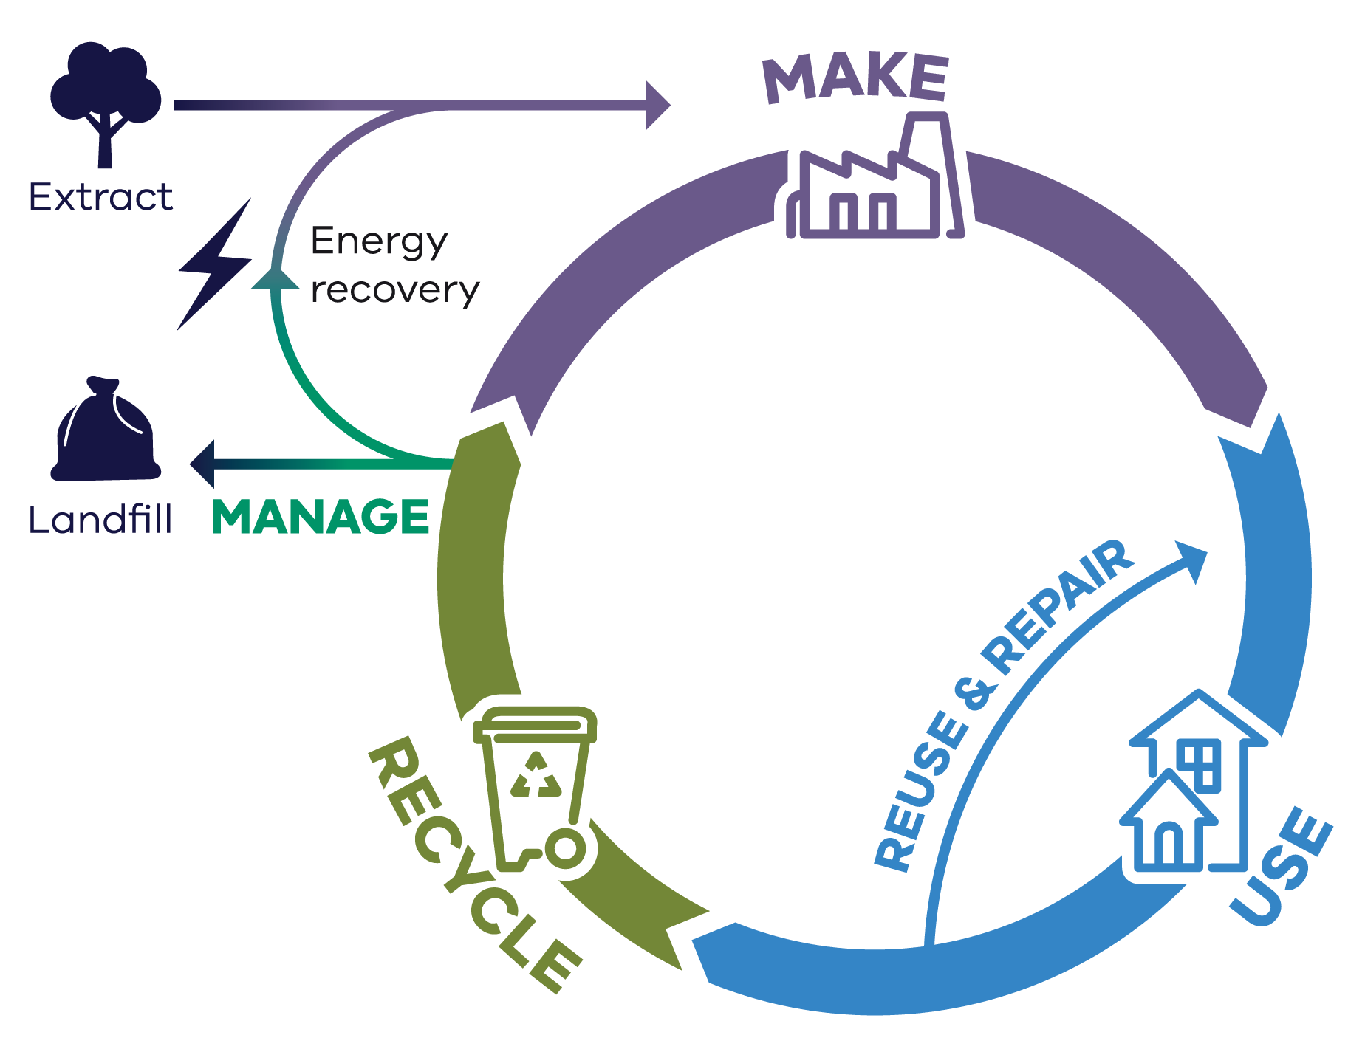

A more circular economy is consistent with economic growth and higher living standards. It drives sustainable growth by focusing on resource efficiency, avoiding and reducing waste, and promoting recycling and reuse.

The circular economy has become a mainstream focus for industry development, resource security and waste and resource recovery policies around the world. The European Union (EU) has taken a strong lead with *Closing the loop* – an EU action plan for a circular economy, supported by national strategies in Denmark (Danish Ministry of Environment and Gender Quality 2018), Finland (Laita 2019), France (French Government 2018), Germany (Circular Economy Initiative n.d.), the Netherlands (Government of the Netherlands n.d.) and Slovenia (Republic of Slovenia 2023), among others.

There are also non-government actors who focus on intervention points in global production systems, such as PACE (Platform for Accelerating the Circular Economy) (PACE n.d.), a neutral, public/private collaboration supported by the World Economic and the World Resources Institute.

Several key industry sectors in Australia (including mining, construction, manufacturing, agriculture, waste management and resource recovery) have core roles to play in the transition to a circular economy (Schandl et al. 2023).

This report focuses on measuring the potential of the Victorian waste, recycling and resource recovery industry.

## Circular economy and economic growth

Businesses and governments around the world are increasingly recognising the value of ‘going circular’. A global economy that minimises waste, has the potential to unlock $4.5 trillion dollars in value by 2030 (Accenture 2015). The economic benefit expected for Australia from adopting a circular economy has been estimated to be $210 billion by 2048. This equates to 11.4% of GDP and would lead to an additional 17,000 (FTE) jobs. (Schandl et al. 2023).

Victoria has a vibrant, diverse and growing economy. Victoria’s population is expected to exceed 10 million within the next 25 years. This growth will require more than 1.6 million new dwellings, requiring significant material resources for housing and infrastructure to accommodate this growth (DTP 2023).

The current economic climate has witnessed a sustained period of inflation, pushing up the price of groceries, household costs and other daily expenses. The costs of construction materials have significantly increased, elevating the overall costs of infrastructure projects across the state. The combination of historically low unemployment, high inflation and the continued impact of COVID-19 has created challenges in obtaining sufficient resources to deploy the workforce and materials for this work (DTF 2024). These factors underscore the need to transition to a circular economy that is resourceful and efficient in its use of materials to generate economic productivity.

Accompanying these challenges, Victoria continues to respond to the need to combat climate change. The transition to net zero emissions and to a more circular economy are complementary policies. Creating more efficient products with less waste and lower energy consumption reduces emissions and aligns with Victoria’s target of net zero emissions by 2045, and Victoria’s targets of maximising landfill diversion and minimising waste generation.

A transition to a circular economy will be a catalyst for Victoria’s future economic growth in the following ways:

* **Resource efficiency** – maximising the use of resources that can lower costs and increase productivity, leading to economic growth without the need for extra raw materials.
* **Innovation** – in product design and business models, creating new markets and jobs.
* **Sustainability and resilience** – reducing environmental impacts and protecting natural resources, thereby enhancing the long-term viability of industries and communities.
* **Decarbonisation and resilience** – achieving emissions targets and future-proofing Victoria in a rapidly decarbonising world.
* **Consumer demand** – promoting demand for circular products and services, fuelling economic activity.

**Investment opportunities** – attracting investment in green technologies, renewable energy and sustainable practices.

A circular economy values Victoria’s goals of sustainability, reduced emissions and efficient resource usage.

**Moving toward a circular economy will contribute to placing Victoria on the path to achieving net zero emissions by 2045 and aligning economic growth with Victoria’s environment.**

## Circular economy measurement

### Global context

International initiatives, such as the EU’s Circular Economy Action Plan and the UN’s Sustainable Development Goals, have inspired efforts to develop metrics that can track circularity at the global level. These initiatives focus on key indicators such as resource productivity, recycling rates, waste reduction and material efficiency. Despite these developments, challenges remain in establishing universally accepted measurement frameworks that account for differences in industrial practices, economic development and social contexts across countries (European Commission 2020).

The Circularity Gap Report, published annually by the Circular Economy Institute, is one example of a global effort to assess circularity. It uses indicators such as the share of recycled materials in global production and the percentage of resources reused or recycled within a given economy. While useful, these indicators are difficult to apply to certain industries or regions.

Recently, the Organisation for Economic Co-operation and Development (OECD) published a conceptual framework and indicator set to monitor progress in the transition towards a more circular economy and inform international circular economy policies at national levels (OECD 2024).

The purpose of the OECD report is to provide a clear, consistent and data-driven approach to measuring the circular economy, which will support informed decision making and policy development. By establishing common definitions, indicators and measurement approaches, it ensures progress towards a circular economy can be effectively tracked.

While the OECD report has progressed the thinking and approach to measuring circularity, it does highlight challenges in the measurement of boundaries and classifications, as well as data availability and quality.

With new international standards (ISO) recently released, (ISO 59020:2024) we can expect that measuring and assessing circularity performance will continue to evolve as global understanding and maturity in circular economy practices evolves.

While the work of international bodies and agencies in the creation and sharing of frameworks, data and reports is important, each nation needs to have a detailed understanding of local context and opportunities.

This is demonstrated by the findings of the United Nations Department of Economic and Social Affairs (United Nations n.d.b) that the material footprint per capita in high-income countries is 10 times the level of low-income countries, highlighting unequal responsibilities and consumption disparities between import oriented and export oriented and high income and low income countries.

### National context

The Australian Government plays a key role in partnering with the states and territories in the harmonisation of data collection and analysis. To provide specific advice to the Australian Government on the transition to a more circular economy, the Circular Economy Ministerial Advisory Group (Advisory Group) was created in February 2023.

An interim report was released by the Advisory Group in April 2024 (DCCEEW 2024a) recommending the development of the National Circular Economy Framework. The report recommended to set national and sector-based circular economy targets and routinely measure and report progress against the following upstream indicators of circularity in the Measuring What Matters framework (DCCEEW 2024a):

* National extent of circularity.
* Material footprint.
* Domestic material consumption.
* Resource productivity.
* Waste generated per person.

Resource recovery rate – portion of waste recovered for reuse, recycling or energy.

In December 2024, the Advisory Group released a final report, The Circular Advantage, (DCCEEW 2024b) recommending that 3 indicators (material footprint, material productivity and resource recovery rates) serve as the foundation for Australia’s circular economy targets.

## Victorian metrics overview

Effective measurement of the circular economy in Victoria will inform better decision making, allow government to monitor progress, highlight areas and opportunities for circularity improvement and help direct investment.

Recovery rates of individual material streams have historically been used as the best available proxy to provide insights into Victoria’s circular economy. While it provides a good representation of the performance of each material stream, it is limited in its ability to measure, monitor and progress Victoria’s circular economy transition.

This CEMR 2025 outlines the circular economy metrics to monitor and measure Victoria’s progress towards a circular economy. The metrics have been selected with a focus on what can be measured with the data available today, and to ensure alignment where possible with Australia’s Circular Economy Framework released in December 2024 (DCCEEW 2024j).

The new state-based metrics will add to the existing waste reporting metrics. Refer to Appendix 1: Data method and quality for calculations.

### Circularity rate

**Circularity rate:** This metric measures the percentage of all consumed materials that are recycled, serving as an indicator of material reuse. It includes materials recycled within Victoria as well as recycled material within imported products. In other words, it reflects the percentage of recycled materials within the total materials used in the national or state economy. A higher circularity rate means that a country or region uses a larger proportion of recycled materials. (DCCEEW 2024b).

### Material footprint

**Material footprint:** A key indicator of overall environmental sustainability, this metric measures the virgin (raw) material demand per capita within an economy, regardless of the source of those raw materials. Material footprint is a consumption-based indicator of the material requirements for final demand and provides a proxy for assessing the environmental pressures and impacts associated with material living standards. It can be described as how much material is used to create the products consumed or services provided in Victoria. It is measured in tonnes per capita. A lower material footprint means that a country or region is efficient in its use of raw materials to service the needs of the population.

### Material productivity

**Material productivity:** This metric measures the efficiency of raw material use in production processes, expressed as a ratio of economic output to the amount of material consumed. A higher material productivity means that the economy is generating more output with equal or less material input, reducing material waste and therefore environmental impact (DCCEEW 2024g). It is measured in Australian dollars (AU$) per kilogram (kg). The measure will increase as materials are used more than once, since reuse does not add to consumption, but it does contribute to the economy.

These 3 metrics have been informed by CSIRO research and modelling. They are also used in the Measuring What Matters Framework (Treasury 2023) for the circular economy domain. While the modelling was originally developed to measure these metrics at a national level, CSIRO has provided support and data to enable the calculation at a state level.

Table 1: New circular economy metrics for Australia and Victoria

| Circular metric | Unit | Australian comparator (2023) | Victoria (2022–23)# |
| --- | --- | --- | --- |
| Circularity rate | % | 4.4%* | 7.5%^ |
| Material footprint | Tonnes per capita | 31.0* | 28.1^ |
| Material productivity | AUD/kg | 2.04† | 3.49^ |

**\*** from “[Measuring What Matters](https://www.abs.gov.au/statistics/measuring-what-matters/measuring-what-matters-themes-and-indicators/sustainable/circular-economy)”, DCCEEW and ABS 2024

**†** calculated using Australia’s gross domestic product (GDP) in current prices. Australia’s 2023 value reported in “Measuring What Matters” is $1.58 AUD/kg, which was calculated using constant 2015 prices. DCCEEW and ABS 2024, CSIRO 2024.

**^** calculated using datasets maintained by Recycling Victoria, as well as data sourced from or provided by National Waste Database (Blue Environment 2024), CSIRO, ABS, and UNEP IRP (2024) Global Material Flow and Resource Productivity Database.

**#** at time of writing, no up-to-date values for domestic material consumption or material footprint in Victoria were available. A value has therefore been calculated by applying assumptions based on 2019 data (provided by CSIRO) to 2022–23 national material flow values to estimate values for Victoria in 2022–23.

Recycling Victoria acknowledges that, as the application of these metrics is new, future adjustments to the reported calculations may be required.

Image 1: Circularity rate, Material footprint and Material productivity

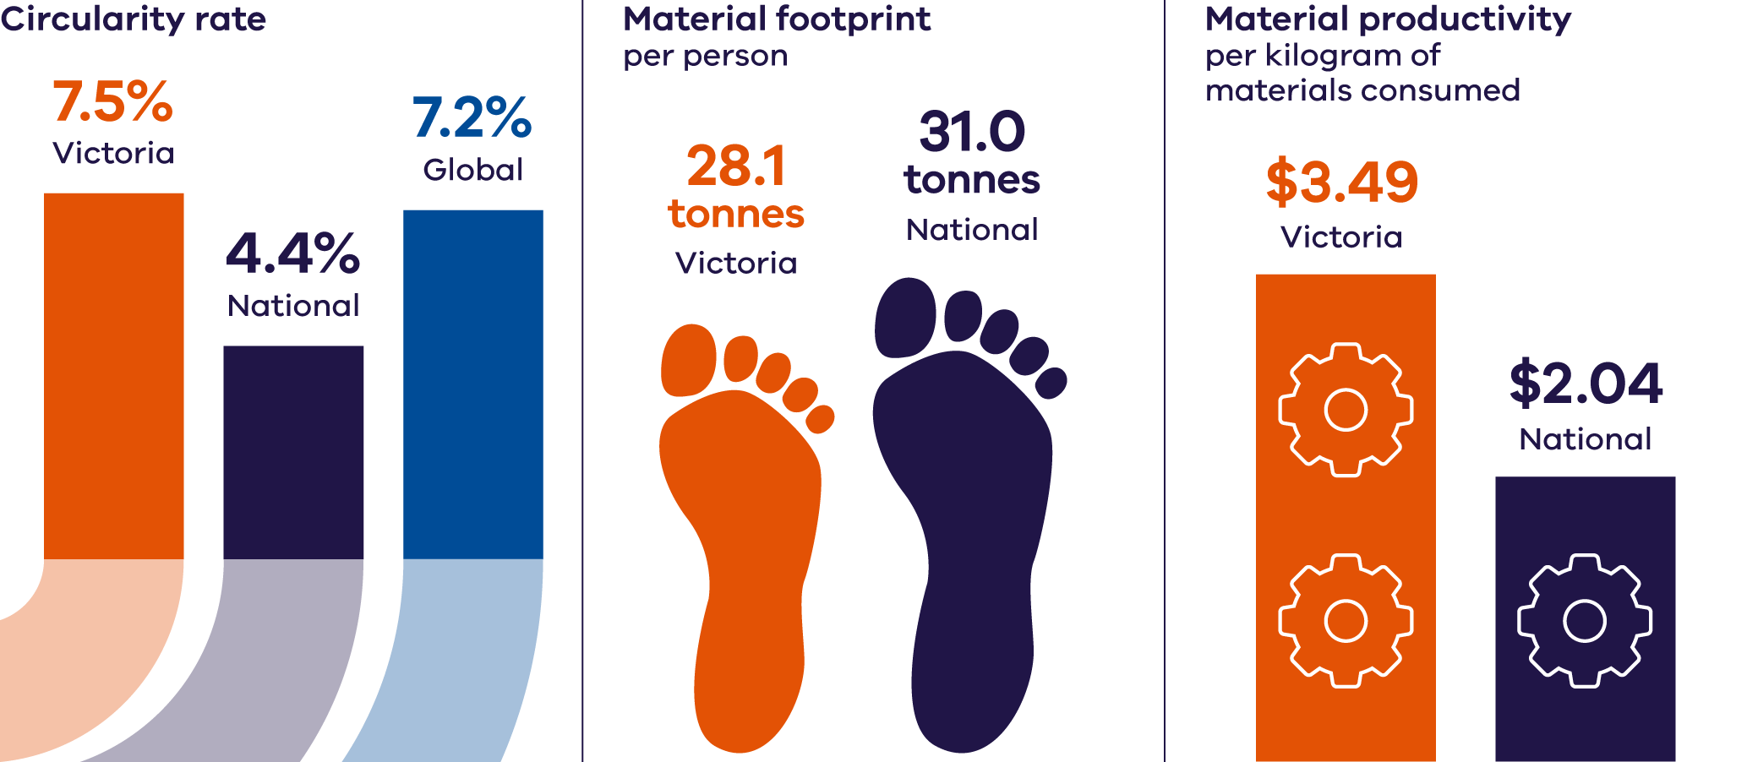

### Circularity rate

The rate for Victoria was calculated using secondary material consumption (SMC) in tonnes divided by domestic material consumption (DMC) in tonnes. Victoria’s SMC in 2022–23 is estimated to be 11.8 million tonnes and the DMC is estimated to be 156.8 million tonnes (for more detail on how these values are estimated see 1.4 circular economy metric methods).

**Victoria’s 2022–23 circularity rate is approximately 7.5%.**

That is, of all materials that Victoria consumed in 2022–23, 7.5% came from recycled material. Victoria has a higher circularity rate compared with the overall rate for Australia (4.4%) which is calculated using the same formula. The Victorian result also appears better than the global average (7.2%) but lower than the EU average (11.5%).

The best performing country internationally is the Netherlands with a circularity rate of 27.5% (DCCEEW 2024b). While a higher circularity rate is preferable, a 100% circularity rate is not achievable. The Australian Material Flow Analysis to Progress to a Circular Economy Report (CSIRO 2024) notes:

“a circularity rate of 100% is not achievable because several materials are irreversibly transformed during use, such as biomass used as food or fossil fuels used for energy. We measure the theoretical circularity maximum as the highest possible circularity rate under today’s economic and technical structure. At most, Australia could supply its economy with 32.5% of secondary materials, which are all the materials that are used for non-energetic purposes.”

### Material footprint

The result for Victoria was calculated using total material footprint (TMF) in tonnes divided by the estimated residential population (ERP). Victoria’s TMF in 2022–23 is estimated to be 189.7 million tonnes and the ERP is estimated to be 6.7 million people (for more detail on how these values are estimated see Appendix 1.4 Circular economy metric methods).

**Victoria’s 2022–23 material footprint is approximately 28.1 tonnes per person.**

This is lower than the Australian figure of 31.0 tonnes per person.

Reduced footprint could be achieved through improved product design, greater use of recycled materials in the built environment and preference for longer lasting and recycled materials in manufacturing.

### Material productivity

The result for Victoria was calculated using gross state product (GSP) in AUD divided by the DMC in kilograms. Victoria’s GSP in 2022–23 is estimated to be AUD $547.4 billion and the DMC is estimated to be 156.8 billion kilograms (for more detail on how these values are estimated see 1.4 Circulareconomy metric methods).

**Victoria’s 2022–23 Material Productivity is approximately $3.49 AUD/kg.**

This compares to the value for Australia of $2.04 AUD/kg indicating that Victoria is more efficient with its use of raw materials in generating economic value compared with the national result.