# 2025-2026 Multicultural Festival and Events (MFE) Program

Application Form Guidance

# Contents

Purpose of this document 2

Small stream application form: 2

Medium and large stream application forms: 2

Small stream application form 2

Assessment criteria 2

Budget 4

Medium and large stream application form 7

Assessment criteria 7

Project Plan 9

Budget 11

Total Event Budget template (Large stream applicants only) 15

# Purpose of this document

This document should be referred to when completing a 2025-26 Multicultural Festivals and Events (MFE) Program small or medium/large stream application form.

This document provides guidance on the level of detail and information that is required to respond to:

## Small stream application form:

#### Questions in the Assessment Criteria section, including questions that address the MFE objectives; and

#### The Budget section (the MFE Expenditure table).

## Medium and large stream application forms:

#### Questions in the Assessment Criteria section, including questions that address the MFE objectives

#### The Project Plan attachment (mandatory for medium and large stream)

#### The Budget section (the MFE Expenditure table in your application form); and

#### The Total Event Budget template (mandatory for large stream only).

# Small stream application form

## Assessment criteria

The following two questions relate directly to MFE objective 1 - Ensure Victorians can celebrate and preserve cultures and share traditions.

To verify that your event aligns with this objective, we are asking you to explain what cultures and traditions your event will be preserving or celebrating and what activities are taking place which will showcase cultural diversity.

### What cultures and/or traditions will your event be celebrating and why are they important?

Consider including in your response:

* A list of the cultures and traditions your event will share.
* If it is a specific celebration. For example, is it an anniversary or a significant cultural day and time of year (e.g., Lunar New Year or Holi)?
* The cultural significance of your event for the community.
* The positive impacts of holding your event for your community and the wider community.

### What cultural activities will occur at your event? Provide a description of each cultural activity and how it demonstrates cultural diversity.

Consider including in your response:

* A list of the activities that will take place at your event including a brief description in relation to your event. For example, will there be rituals, traditional dance lessons, art exhibitions or traditional food stalls.
* How each activity is significant to the cultures and traditions your event will be celebrating and/or preserving.
* If your event will have special guests and how they are involved. For example, community leaders, artists or special guests.
* The importance of sharing this with the wider community.

The following two questions relate to MFE objective 2 - Encourage the broader Victorian community to take part in events that further learning, understanding and respect for different cultures and traditions.

To verify that your event aligns with this objective, we need you to consider and explain how the wider community will participate in the activities at your event. We also need to see how you will promote this event and encourage all Victorians to attend. Promotion types you list must be able to reach audiences beyond your organisation and your community, for example a Council newsletter or your social media.

### What can the broader Victorian community learn from attending your event? How will attendees be engaged and participate?

Consider how the wider Victorian community/members outside of your organisation can benefit from participating in your event in terms of cultural awareness.

Consider including in your response:

* A list of the various ways attendees can engage with the cultures and participate in the traditions your event is celebrating and preserving. For example, attendees at an Eid event may learn about the tradition by listening to a panel discussion, or at an Indigenous event, attendees may participate in a traditional art workshop.

### How will you promote this event to encourage all Victorians to attend?

* List the planned ways of promoting the event.
* Provide a copy of planned or previous promotional material.

Consider including in your response:

* Which platforms you will use, you must list multiple ways you will promote your event to the wider community. For example, social media (Facebook, Twitter, Instagram are considered one type of promotion), digital newsletters, newspapers, TV, local radio, flyers and billboards.
* The following ways are not accepted:
  + ‘Word of mouth’
  + Closed membership channels.
* How this promotion will reach audiences beyond your immediate community. For example, ‘by advertising the event in a local newspaper, this ad will be distributed to homes in the City of Bendigo as well as a vast area of north and Central Victoria’.
* Outline targeted promotion methods if you plan to engage on a priority group (i.e. regional, new and emerging, multicultural youth, women or LGBTIQA+ communities).
* Local community facilities – you may consider contacting your local MP office, schools and childcare centres as well as local businesses and see if you can promote your event for free via their social media channels/newsletters/front windows.

Note: when attaching promotional material, this can be a planned social media post or other advertising material such as a poster.

## Budget

The event budget will be used to assess value for money. You must detail how the funds you have requested will be spent. This needs to be itemised in the MFE Expenditure section (see step-by-step overview below).

All costs listed in this table are costs that can be supported by the program.

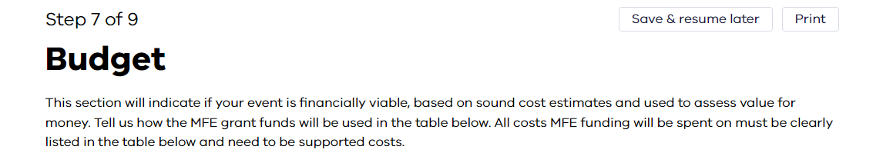

### Step 1: Indicate the amount requested from the grant program (income)

* This is where you indicate the amount of funding requested from this program
* You must input the total amount of funding you are requesting up to $5,000.

The amount below is an example only. The amount you are requesting may be different.

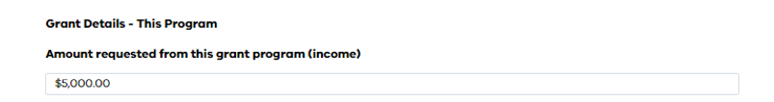

### Step 2: Add the expenses to the “What do you intend to spend your funding from this grant on?”

* Add your expenses separately on the table rather than grouping them. If you have grouped expenses, please make it clear how much is going towards each item (for example, $1,500 allocated to Promotion and Advertising. Description can include: $500 Radio, $500 Videographer and $500 for Posters).
* If costs are unclear, do not align with the list of supported and unsupported costs, and no explanation is provided, they may not be approved.

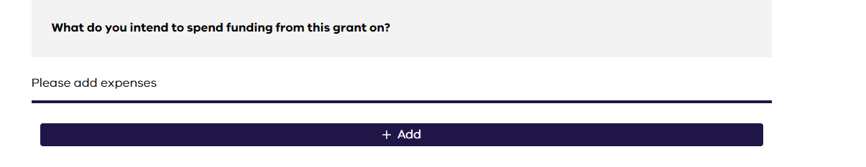

1. Click the “+ Add” button and the below will appear:

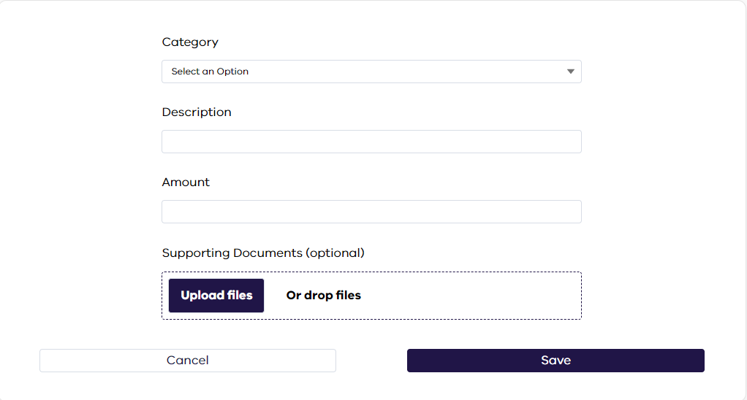

1. Select a category (i.e., Entertainment)
2. Add a description (i.e., Cultural band).
3. Add in the amount of MFE funding that will be spent on this item (i.e., $1,000)
4. Note uploading a file (such as an invoice) is an optional step for small stream applications.
5. Click ‘save’
6. This expense will now appear as Expense 1 in the budget section.

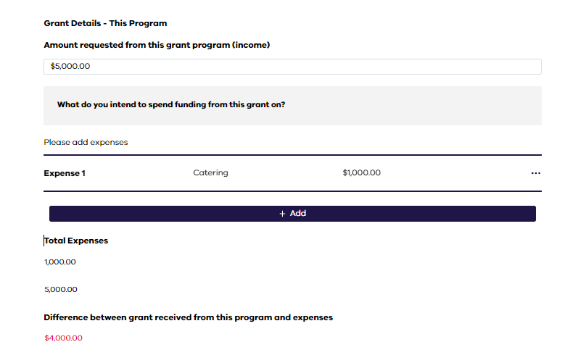

### Step 3: Continue to complete the expenses for your grant funding

* Continue with all your expenditure items as with step 2.

### Step 4: Once all your MFE expenditure items are added, it will populate and deduct from the total amount requested and the total expenses section will show as below:

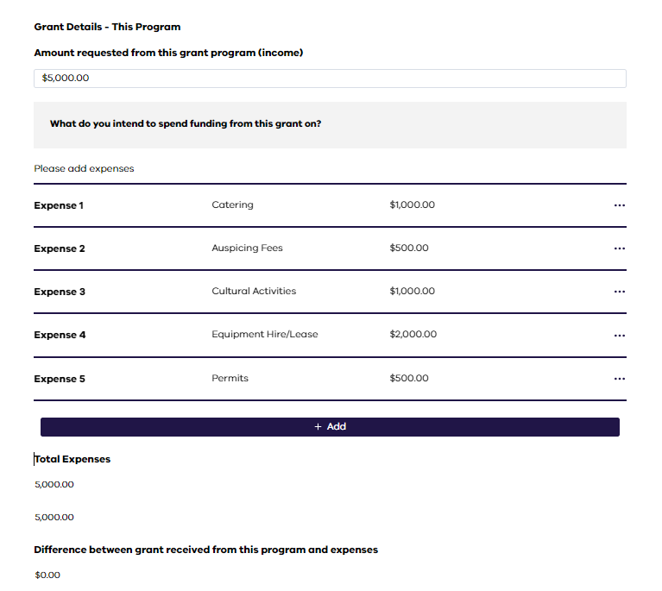

* This shows $5,000 requested from the MFE program, with $0 difference between what is requested and the expenses.
* You must list all expenses to cover the total amount of funding requested before you can proceed.

Medium and large stream application form

Assessment criteria

The following two questions relate directly to MFE objective 1 - Ensure Victorians can celebrate and preserve cultures and share traditions. This is part of the “Alignment with MFE Program objectives” assessment criterion.

To make sure that your event aligns with this objective, we are asking you to explain what cultures and traditions your event will be preserving or celebrating and what activities are taking place which will showcase cultural diversity.

Please note: a detailed response to these questions will ensure a stronger merit assessment score and impact how much funding you receive.

### What cultures and/or traditions will your event be celebrating and why are they important?

Consider including in your response:

* A list of the cultures and traditions your event will share.
* If it is a specific celebration. For example, is it an anniversary or a significant cultural day and time of year (e.g., Lunar New Year or Holi)?
* The cultural significance of your event for the community.
* The positive impacts of holding your event for your community and the wider community.

### What cultural activities will occur at your event? Provide a description of each cultural activity and how it demonstrates cultural diversity.

Consider including in your response:

* A list of the activities that will take place at your event including a brief description. For example, will there be rituals, traditional dance lessons, art exhibitions or traditional food stalls.
* How each activity is significant to the cultures and traditions your event will be celebrating and/or preserving.
* If your event will have special guests and how they are involved. For example, community leaders, artists or special guests.
* The importance of sharing this with the wider community.

The following two questions relate to MFE objective 2 - Encourage the broader Victorian community to take part in events that further learning, understanding and respect for different cultures and traditions.   
This is part of the “Alignment with MFE Program objectives” assessment criterion.

To make sure that your event aligns with this objective, we need you to consider and explain how the wider community will participate in the activities at your event. We also need to see how you will promote this event and encourage all Victorians to attend. Promotion types you list must be able to reach audiences beyond your organisation and your community, for example a Council newsletter or your social media.

### What can the broader Victorian community learn from attending your event? How will attendees be engaged and participate?

Consider how the wider Victorian community/members outside of your organisation can benefit from participating in your event in terms of cultural awareness.

Consider including in your response:

* A list of the various ways attendees can engage with the cultures and participate in the traditions your event is celebrating and preserving. For example, attendees at an Eid event may learn about the tradition by listening to a panel discussion, or at an Indigenous event, attendees may participate in a traditional art workshop.

### How will you promote this event to encourage all Victorians to attend?

* List the planned ways of promoting the event.
* Provide a copy of planned or previous promotional material.

Consider including in your response:

* Which platforms you will use, you must list multiple ways you will promote your event to the wider community. For example, social media (Facebook, Twitter, Instagram are considered one type of promotion), digital newsletters, newspapers, TV, local radio, flyers and billboards.
* The following ways are not accepted:
  + ‘Word of mouth’
  + Closed membership channels
* How this promotion will reach audiences beyond your immediate community. For example, ‘by advertising the event in a local newspaper, this ad will be distributed to homes in the City of Bendigo as well as a vast area of north and Central Victoria’.
* Outline targeted promotion methods if you plan to engage on a priority group (i.e. regional, new and emerging, multicultural youth, women or LGBTIQA+ communities).
* When attaching promotional material, this can be a planned social media post or other advertising material such as a poster.
* Local community facilities – you may consider contact your local MP office, schools and childcare centres as well as local business and see if you can promote your event for free via their social media channels/newsletters/front windows

The following question and your Project Plan attachment relates to the “Demonstrated Capacity” assessment criterion.

Your response to this question should relate to a previous event you have delivered, or the resources, expertise and/or equipment your organisation has, to be able to successfully deliver the planned event.

### Provide a detailed list of previous events and the resources/equipment your organisation has - this should demonstrate your organisation's capacity to deliver this event:

Consider including the following in your response:

* Past achievements: Provide details of an event of similar size/scale that your organisation has delivered. Consider the number of attendees, names of event partners and supporters, publicity in the media, sponsorships, fundraising efforts, and benefit to communities. Attach evidence of these (e.g., a flyer or photos from the listed events) at the end of your application as supporting documentation.
* Organisation’s capability: List the experience of key team members in organising a similar past event and/or your organisation’s community networks and connections, and professional relationships.
* Resources: List the available equipment, tools and materials that your organisation has access to that will support this event.
* For large stream applicants, we recommend you attach supporting evidence of past achievements, organisational capability and resources in order to score higher.

## Project Plan

This is a mandatory attachment for medium and large stream applications.

Your project plan must be clear and detailed – only providing minimal items in the project plan is not acceptable.

You need to outline across all parts of the event cycle (pre-event planning, at-event and post-event):

* the tasks that will be undertaken during the planning and delivery of your festival or event
* a timeline and a list of who is responsible to deliver each task.

For large stream applicants, attaching a detailed project plan will ensure a stronger merit assessment score and impact how much funding you receive.

### Project Plan

This plan outlines tasks that will be undertaken during the planning and delivery of your festival or event, a timeline for each key task and a list of who is responsible.

The project plan template prompts you to consider the following:

1. What needs to be done?
   * List items in the order they will be done (Example: create event, event schedule, marketing/promotion)
2. How long will it take?
   * Example: 1 day, 3 weeks
3. How will you do it?
   * Add individual steps as required (Example: identify tool, send invitations, promote the event)
4. Who will be responsible?
   * Example: Project Manager, Administration Officer, volunteer, Treasurer.

The following questions contribute towards the “Engagement with priority groups” criterion.

Applications must identify whether their event will primarily target a priority group to score on this criterion. If your event will not primarily benefit any of the below priority groups, select “Not applicable”.

### Please identify whether your event will primarily target one of these priority groups and why support will be provided:

* New and emerging communities (see NEC priority list on the [MFE webpage](https://www.vic.gov.au/multicultural-festivals-and-events-program))
* Regional communities
* Women
* Young people
* LGBTIQA+ communities.

### Provide an overview on how your event will primarily target this selected priority group

You must provide an overview of how your multicultural event supports the selected priority group(s).

Three key areas of need have been identified for the above groups:

* Engagement and participation – the need to promote the voices of the priority group and their participation in decision making.
* Development – the need to support the priority group to build new skills through training and mentoring.
* Celebration – the need to recognise the priority group’s contribution to the community and to showcase this to the wider community.

Identify which area of need your event addresses for the selected priority group. Consider including the following in your response:

1. Engagement and participation
   1. Describe how members from the priority group are involved in planning and delivery of the event. This should show that there is a focus on delivering a shared interest or vision.
   2. Provide examples of targeted strategies ensuring effective engagement and participation of the priority group prior, within and following the event.
   3. For example, establishing a youth support group to allow young people to collaborate in organising a mini-event or activities relating to shared interest such as music, culture or art. This is delivered as part of your multicultural event.
2. Development
   1. Provide examples of activities in your event which support members from the priority group to develop their skills to deliver events.
   2. Explain how your event supports personal and professional growth and enhances the skills of members from the priority group. This can be through volunteering, training or mentoring opportunities to support the delivery of events.
   3. For example, establish a mentoring or leadership opportunity for LGBTIQA+ members to build their experience in leading the delivery of events.

### Provide an overview on how your event will primarily target this selected priority group (cont’d)

1. Celebration
   1. Describe how your event showcases and recognizes the unique contributions of the priority group to the broader community.
   2. Explain the activities within the event that specifically highlight the achievements and positive impact of the priority group on the community.
   3. For example, collaborating with women to deliver an exhibit within your multicultural event which celebrates women’s contributions to the community.

We highly encourage applicants to work closely and collaborate with the selected priority group to co-design activities that meet the priority group’s needs.

The event budget and supporting documentation (if applicable) will contribute towards the “Budget” assessment criterion.

## Budget

The event budget and supporting documentation (if applicable) will contribute towards the “Budget” assessment criterion.

The event budget will indicate if your event is financially viable, based on sound cost estimates and used to assess value for money.

You will need to indicate the expected total cost of the event (not including the value of in-kind volunteer contributions or other in-kind sources). If for example your catering for the event will be provided entirely through in-kind sources, this expense should not appear in the total cost amount.

You must then detail how the funds you have requested will be spent. This needs to be itemised in the MFE Expenditure section (see below). All costs listed in this table are costs supported by the program. If there is a different cost you may want to seek funding for, speak to the MFE team first to ensure it is something that can be supported.

Quotes for any expenditure items over $10,000 where MFE funds will be used to support the cost are mandatory and must be attached in the budget section unless you have attached a separate budget that breaks down these costs further.

For large stream applicants, quotes for all costs (including below $10,000) are encouraged to score higher.



### Step 1: Indicate the expected total cost of your event

* This amount is the total cost of your event
* This includes the grant amount requested and any other contributions
* Please be mindful of any matched funding contributions needed. Note that matched funding is not required for applicants from regional locations or applicants with events being executed in regional locations.

The amount in the image below is an example only. Your total cost may be different.

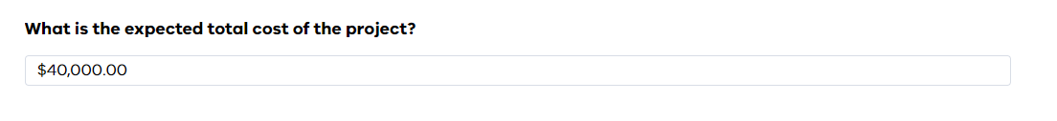

### Step 2: Indicate the amount requested from the grant program (income)

* This is where you indicate the amount of funding requested from this grant funding
* This does not include other funding contributions
* The amount below is an example only. The amount you are requesting may be different.

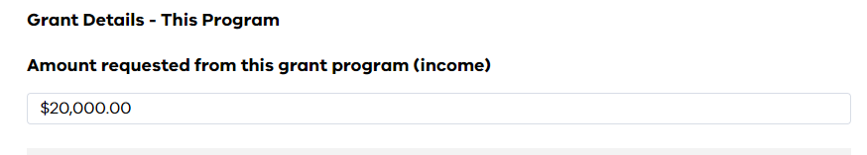

### Step 3: Add the expenses to the “What do you intend to spend your funding from this grant on?”

* Add your expenses separately on the table rather than grouping them. If you have grouped expenses, please make it clear how much is going towards each item (for example, $8,000 allocated to Promotion and Advertising. Description can include: $4,000 Radio, $2,000 Videographer and $2,000 for Posters)
* If costs are unclear or don’t align with the list of supported and unsupported costs and no explanation is provided, they may not be supported.



* Click the “+ Add” button and the below will appear:



* Select a category (i.e., Entertainment)
* Add a description (i.e., Cultural band)
* Add in the amount of MFE funding that will be spent on this item (i.e., $1,000)
* Upload a file (such as an invoice). Note that this is a mandatory requirement for any items over $10,000.
* Click ‘save’
* This expense will now appear as Expense 1 in the budget section (see image below).

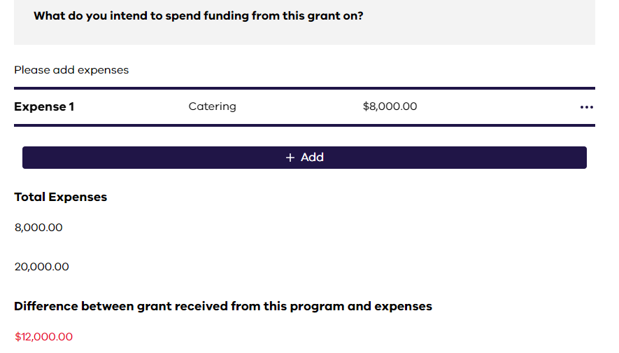

### Step 4: Continue to complete the expenses for your grant funding

* Continue with all your expenditure items as with step 3.

### Step 5: Once all your MFE expenditure items are added, the total expenses section will show as in the image below:

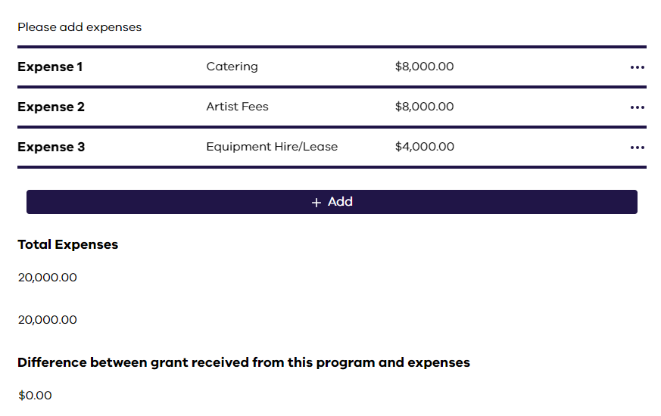

* This shows $20,000 requested from the MFE program, with $0 difference between what is requested and the expenses
* You must list all expenses to cover the total amount of funding requested before you can proceed.

### Step 6: Continue to show how your other sources of income will be spent (if applicable)

* Select the other income source (for example a contribution from your organisation or a local government grant)
* Provide the total dollar amount of this source
* Describe the contribution (cash contribution, Monash City Council grant).

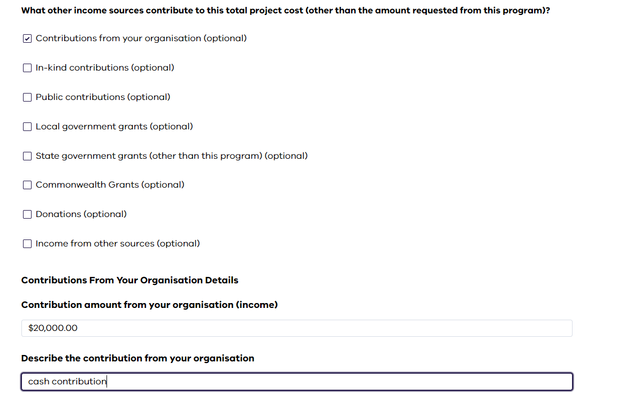

### Step 7: Add expenditure items for those where MFE funding will not be used

* Repeat steps 3 and 4 for any other expenditure items
* You can use other contributions to expenditure items where MFE funding is proposed
* For example, if your organisation proposes to use $8,000 of MFE funding towards catering, you can also use another $8,000 towards this from a cash contribution.

### Step 8: Once all expenditure items have been added, you can click next to continue

* The below shows the total income (total event cost) with the total expense (the combined MFE grant request and cash contribution):

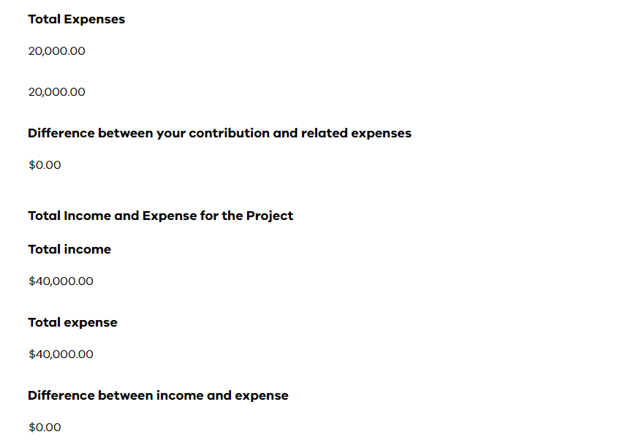

## Total Event Budget template (Large stream applicants only)

This is a mandatory attachment for large stream applicants only and will contribute towards the “Budget” assessment criterion.

The first section of this template is for your overall event budget, you will need to indicate how much income you have to deliver the event, including your matched funding contributions (through cash and/or in-kind sources), and the total planned expenditure for the event.

Your budget must show that the matched funding requirement for your organisation type is met. Matched funding contribution requirements can be found on the Program Guidelines. Note that matched funding requirements are no applicable for applicants from regional locations or applicants executing events in regional locations.

Your total income must be accounted for in the expenditure table. All costs where MFE funding will be spent on must be clearly listed and match with itemised expenses in the application form budget section.

You can list your in-kind financial contributions, and the value of in-kind volunteer hours separately.

#### 

We acknowledge the Traditional Owners of Country throughout Victoria and pay our respect to them, their culture, and their Elders past and present.

© State of Victoria (Department of Premier and Cabinet) March 2025

To receive this document in another format, [email multicultural-festivals.events@dpc.vic.gov.au](mailto:email%20multicultural-festivals.events@dpc.vic.gov.au) multicultural-festivals.events@dpc.vic.gov.au.

Except where otherwise indicated, the images in this document show models and illustrative settings only, and do not necessarily depict actual services, facilities or recipients of services. This document may contain images of deceased Aboriginal and Torres Strait Islander peoples.

In this document, ‘Aboriginal’ refers to both Aboriginal and Torres Strait Islander people. ‘Indigenous’ or ‘Koori/Koorie’ is retained when part of the title of a report, program or quotation.