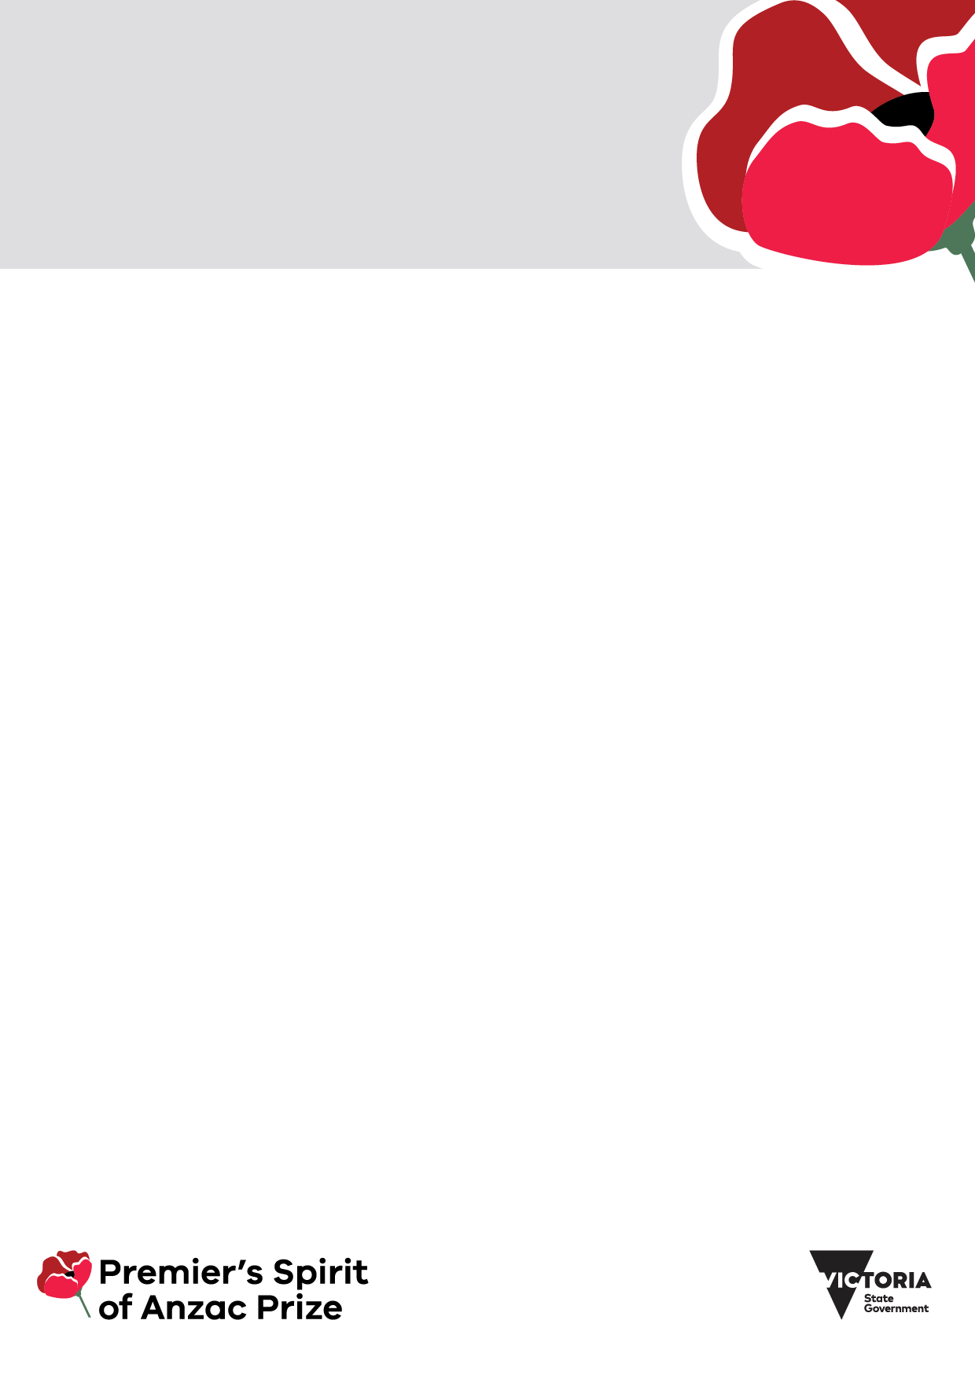

|  |
| --- |
| Premier’s Spirit of Anzac Prize competition 2025 |
| School representative statement  and declaration form for students |
|  |

The Premier’s Spirit of Anzac Prize is an annual competition open to eligible Victorian students enrolled in years 9 to 12.

The 2025 competition is open between 3 March 2025 and 28 April 2025. Students entering the competition may be selected to join a funded international study tour to Türkiye. We expect the 2025 study tour to take place during the Victorian September school holidays. All dates are indicative and subject to change.

The Office for Veterans in the Department of Families, Fairness and Housing (the department) administers the competition. For more information visit [Premier's Spirit of Anzac Prize](https://www.vic.gov.au/soap) https://www.vic.gov.au/soap.

# About this form

This form is for the **school representative** (preferably a head of house / year level coordinator) to complete.

The student applicant must attach this completed form to their entry to the Premier’s Spirit of Anzac Prize competition.

Please read this form carefully. Email the Spirit of Anzac Prize team at [soap@dffh.vic.gov.au](mailto:soap@dffh.vic.gov.au) if you:

* do not understand any part of the form
* have any questions
* would like more information.

# Student applicant information

Please include the student applicant’s information in the table below.

| Information required | Student information |
| --- | --- |
| **Student name** |  |
| **Student year** |  |

# School representative contact information

Please include contact information for the school representative in the table below.

| Information required | School representative information |
| --- | --- |
| **Contact name** |  |
| **School name** |  |
| **School ABN** |  |
| **School sector** |  |
| **Position at the school** |  |
| **Contact phone** |  |
| **Contact email** |  |

# School representative statement

Using your knowledge of the student applying to join the Premier’s Spirit of Anzac Prize study tour, please answer the following questions (maximum 300 words).

**How might the student’s experience, skills, and attributes support a safe and successful experience while on the study tour?**

**Would the student represent the school well and be a good ambassador for the Premier’s Spirit of Anzac Prize?**

| Statement |
| --- |
|  |

# School representative declaration

As the school’s representative:

* I support this student’s application to participate in the Premier’s Spirit of Anzac Prize overseas study tour in 2025.
* I endorse and recommend this student for this opportunity.
* I confirm that, if the student is selected for the program, the school will commit to supporting this student’s in-school-time participation in the Premier's Spirit of Anzac Prize 2025 study tour including:
  + any pre-tour and-post tour or events; and
  + any promotional activities.

| Information required | School representative signature |
| --- | --- |
| **Name** |  |
| **Signature** |  |
| **Date** |  |

# Privacy collection notice

## Use of your information

This privacy collection notice explains how we (the Department of Families, Fairness, and Housing) will manage your personal, sensitive, and health information. We commit to protecting your information in accordance with:

* the *Privacy and Data Protection Act 2014* (Vic)
* the *Health Records Act 2001* (Vic)
* applicable privacy laws.

We may collect personal, sensitive, and health information where it is reasonably necessary to perform our functions, including to conduct the Premier's Spirit of Anzac Prize competition.

We will use any personal, sensitive, and health information you provide to us using this form to:

* determine the eligibility of the student applicant
* assess the student’s application, submission, and personal statement
* contact you about the student’s application.

We will store any personal, sensitive, and health information you provide to us using this form on our grants management system. If you choose not to provide us with the information requested on this form, this may:

* affect the student's application
* impact the outcome of the Premier's Spirit of Anzac Prize competition.

You can email the department’s Privacy team [Privacy@dffh.vic.gov.au](mailto:Privacy@dffh.vic.gov.au) to request:

* access to your personal, sensitive, and health information
* corrections to your personal, sensitive and health information.

## Disclosure of personal information

We may add your personal information to a mailing list we manage to send notices or updates on the Premier's Spirit of Anzac Prize competition.

If you wish for us to remove you from this mailing list, please email Spirit of Anzac Prize [soap@dffh.vic.gov.au](mailto:soap@dffh.vic.gov.au).

|  |
| --- |
| To receive this form in another format, email Spirit of Anzac Prize [soap@dffh.vic.gov.au](mailto:soap@dffh.vic.gov.au).  Authorised and published by the Victorian Government, 1 Treasury Place, Melbourne.  © State of Victoria, Australia, Department of Families, Fairness and Housing, March 2025.  [Description: CC (Creative commons)_by](https://creativecommons.org/licenses/by/4.0/)  With the exception of any images, photographs or branding (including, but not limited to the Victorian Coat of Arms, the Victorian Government logo or the Department of Families, Fairness and Housing logo), this work, *Premier’s Spirit of Anzac Prize competition 2025 school representative statement and declaration form*, is licensed under a Creative Commons Attribution 4.0 International licence.  The terms and conditions of this licence, including disclaimer of warranties and limitation of liability are available at [Creative Commons Attribution 4.0 International](https://creativecommons.org/licenses/by/4.0/) https://creativecommons.org/licenses/by/4.0/.  You are free to use this work (subject to the exceptions above) under that licence, on the condition that you credit the State of Victoria, Australia (Department of Families, Fairness and Housing) as the author, indicate if any changes have been made to the work and comply with the other licence terms.  Available at [Premier's Spirit of Anzac Prize](https://www.vic.gov.au/soap) https://www.vic.gov.au/soap.  (2501276) |