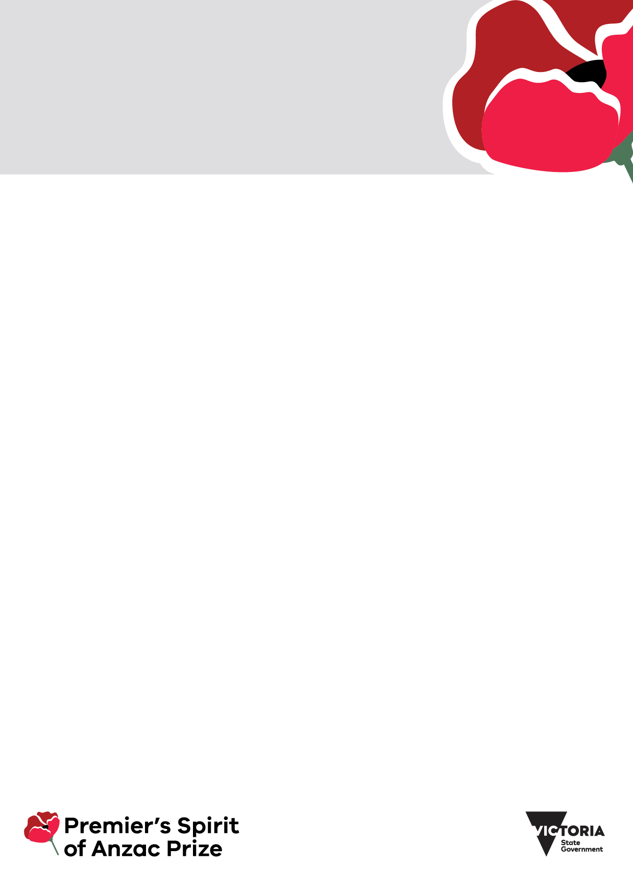

|  |
| --- |
| Premier’s Spirit of Anzac Prize competition 2025 |
| Parent/carer declaration, consent and copyright permission form |
|  |

The Premier’s Spirit of Anzac Prize is an annual competition open to eligible Victorian students enrolled in years 9 to 12.

The 2025 competition is open between 3 March 2025 and 28 April 2025. Students entering the competition may be selected to join a funded international study tour. We expect the 2025 study tour to take place between during the Victorian September school holidays. All dates are indicative and subject to change.

The Office for Veterans in the Department of Families, Fairness and Housing (the department) administers the competition. For more information visit [Premier's Spirit of Anzac Prize](https://www.vic.gov.au/soap) https://www.vic.gov.au/soap

# About this form

This form is for the student applicant’s **parent(s)/carer(s)** to complete. The student must attach this completed form to their entry for the Premier’s Spirit of Anzac Prize competition via the online portal [Grants Gateway](https://dhhsvicgovau.sharepoint.com/sites/FV-SeniorsCarersandVeterans/Shared%20Documents/Veterans/Veterans%20Programs%20Team/SOAP/SOAP%20Program%202023%20-%202026/SOAP%202024-25/Applications%202024/Application%20guidelines%20forms/FINAL%20Documents/Grants%20Gateway) https://grantsgateway.dffh.vic.gov.au.

Please read this form carefully. Email the Spirit of Anzac Prize team at [soap@dffh.vic.gov.au](mailto:soap@dffh.vic.gov.au) if you:

* do not understand any part of the form
* have any questions, or
* would like more information.

# Parent/carer contact information

Please include the student applicant’s information and parent/carer information in the table below.

Only the details of one parent/carer is required unless a Family Court order is in place identifying equal shared parental/carer responsibility.

| Information required | Parent/carer one | Parent/carer two  (if applicable) |
| --- | --- | --- |
| **Student applicant name** |  |  |
| **Parent/carer name** |  |  |
| **Your relationship to the student** |  |  |
| **Parent/carer phone number** |  |  |
| **Parent/carer email address** |  |  |
| **Is a Family Court order in place?** (yes/no) |  |  |

# Parent/carer consent for the student to enter the Premier's Spirit of Anzac Prize competition

I/we (the parent(s)/carer(s)) confirm that:

* I am/we are the parent(s)/carer(s) of the student applicant name on this form.
* I/we have read and understood the student’s application to enter the 2025 Premier’s Spirit of Anzac Prize competition to win an overseas study tour in September 2025 to Türkiye.
* I/we understand that if the student is selected to participate in the study tour, the Department of Families, Fairness and Housing (the department) on behalf of the State of Victoria will:
  + provide me/us further information about the study tour arrangements; and
  + ask me/us to provide further information and consent as a condition of their participation in the study tour.
* I/we understand that the department, on behalf of the State of Victoria, may:
  + publish the student’s submission to the Premier’s Spirit of Anzac Prize competition (the work) and attribute it to the student; and
  + disclose the student’s name, school and year level, and the title of the work in publications or online.
* I/we have read and understood the privacy collection notice in this form.
* I/we consent to the student entering the Premier's Spirit of Anzac Prize competition.

Parent/carer consent for the student to enter the Premier's Spirit of Anzac Prize competition

Please include the parent/carer information in the table below.

Only the details and signature of one parent/carer is required unless a Family Court order is in place identifying equal shared parental responsibility.

| Information required | Parent/carer one | Parent/carer two (if applicable) |
| --- | --- | --- |
| **Name** |  |  |
| **Relationship to the student** |  |  |
| **Signature** |  |  |
| **Date** |  |  |

# Information about the student

Does the student have any specific requirements in relation to participating in the Spirit of Anzac Prize study tour?

Providing information in this section:

* is completely voluntary
* will not impact the student’s application,
* will help us understand the student’s needs in planning for the tour if they are successful.

## Student’s requirements to participate in the Spirit of Anzac Prize study tour (optional)

| Information required | Information about the student |
| --- | --- |
| **Dietary requirements** |  |
| **Cultural or religious requirements** |  |
| **Access requirements** |  |
| **Medical condition** |  |
| **Anything else?** |  |

# Privacy collection notice

## Use of information

This privacy collection notice explains how we (the Department of Families, Fairness, and Housing) will manage your personal, sensitive, and health information. We commit to protecting your information in accordance with:

* the *Privacy and Data Protection Act 2014* (Vic)
* the *Health Records Act 2001* (Vic)
* applicable privacy laws.

We may collect personal, sensitive, and health information where it is reasonably necessary to perform our functions, including to conduct the Premier's Spirit of Anzac Prize competition.

We will use any personal, sensitive, and health information you provide to us using this form to:

* determine the eligibility of the student applicant
* assess the student’s application, submission, and personal statement
* contact you about the student’s application.

We will store any personal, sensitive, and health information you provide to us using this form on our grants management system. If you choose not to provide us with the information requested on this form, this may:

* affect the student's application, and/or
* impact the outcome of the Premier's Spirit of Anzac Prize competition.

You can email the department’s Privacy team [Privacy@dffh.vic.gov.au](mailto:Privacy@dffh.vic.gov.au) to request:

* access to your personal, sensitive, and health information, and/or
* corrections to your personal, sensitive and health information.

## Disclosure of personal information

We may share personal information you provide to us using this form with other Victorian Government departments, ministerial offices, and Members of Parliament for the purpose of sending notices or updates on topics of interest such as:

* other funding opportunities
* information on community consultations
* policy
* programs
* legislative announcements
* multicultural information.

If you do not wish for us to share the personal information you provide to us in this form with other Victorian Government departments, ministerial offices, and Members of Parliament, please email Spirit of Anzac Prize [soap@dffh.vic.gov.au](mailto:soap@dffh.vic.gov.au).

# Copyright consent

## Permission to reproduce, publish and communicate work created by the student

The department may choose to reproduce, publish and communicate to the public, in whole or part, the work that the student submits to the Premier’s Spirit of Anzac Prize competition to highlight outstanding student achievement. We seek consent from the student’s parent(s)/carer(s) to reproduce, publish and communicate to the public the student’s work, in whole or part, in the following ways:

* publication on the Premier’s Spirit of Anzac Prize web page of the Victorian Government’s website (indefinitely)
* referred to, listed, or profiled in a media release, social media or other publication, by the department, the Premier’s office or the Minister for Veterans office
* referred to or published in a presentation at events hosted by the department.

| Information required | The student’s preferred information |
| --- | --- |
| **Name of the student to be shown with their submission**  Please choose how you and the student would like the student’s name to appear, using the following examples:   * full first and last name/preferred name  (for example Tracy-Anne Collins) * first initial and last name (for example T Collins) * first name/preferred name and last initial (for example Tracy-Anne C).   We may also show the name of the school, year level, and title of the work. |  |

### Parent/carer consent

We/I (the parent(s)/carer(s)) have read this form, and we/I consent to the Department of Families, Fairness and Housing reproducing, publishing and communicating to the public the student's name and their work (n whole or in part).

We/I acknowledge that:

* the department may use the student’s work, or copies of the work, in the ways described in this form from the date that we/I sign this form
* if we/I wish to withdraw consent for future reproduction, publication, and communication of the work, we/I must notify the department by emailing Spirit of Anzac Prize soap@dffh.vic.gov.au.

Parent/carer permission to reproduce, publish and communicate to the public, in whole or in part, work created by the student

Only the details and signature of one parent/carer is required unless a Family Court order is in place identifying equal shared parental responsibility.

| Information required | Parent/carer one | Parent/carer two (if applicable) |
| --- | --- | --- |
| **Name** |  |  |
| **Relationship to student** |  |  |
| **Signature** |  |  |
| **Date** |  |  |

To receive this form in another format, email Spirit of Anzac Prize [soap@dffh.vic.gov.au](mailto:soap@dffh.vic.gov.au)

Authorised and published by the Victorian Government, 1 Treasury Place, Melbourne.

© State of Victoria, Australia, Department of Families, Fairness and Housing, March 2025.

[](https://creativecommons.org/licenses/by/4.0/)

With the exception of any images, photographs or branding (including, but not limited to the Victorian Coat of Arms, the Victorian Government logo or the Department of Families, Fairness and Housing logo), this work, *Premier’s Spirit of Anzac Prize competition 2025 parent/carer declaration, consent and copyright permission form – student application*, is licensed under a Creative Commons Attribution 4.0 International licence.

The terms and conditions of this licence, including disclaimer of warranties and limitation of liability are available at [Creative Commons Attribution 4.0 International](https://creativecommons.org/licenses/by/4.0/) https://creativecommons.org/licenses/by/4.0/.

You are free to use this work (subject to the exceptions above) under that licence, on the condition that you credit the State of Victoria, Australia (Department of Families, Fairness and Housing) as the author, indicate if any changes have been made to the work and comply with the other licence terms.

Available at [Premier's Spirit of Anzac Prize](https://www.vic.gov.au/soap) https://www.vic.gov.au/soap.

(2501276)