**Self-paced guide**Full club licence

**Introduction**

This guide is if for anyone who needs to know about a full club licence and its conditions. This may include:

* new club committee members, nominees or managers
* existing committee members
* staff at a club with a full club licence.

Once you have completed this guide, you should be able to:

* identify when and where you are allowed to supply alcohol to members and their guests
* identify any special conditions that apply to your licence type
* identify possible breaches of a full club licence.

This guide includes:

* **general information** – about a full club licence (page 3 to 6)
* **licence conditions** – explaining in detail parts of your licence (page 7)
* **Q&A** – to test your understanding (page 8 to 10).

**Please note:** Information about the law may have been summarised or expressed in general statements. This information should not be relied upon as a substitute for professional legal advice or reference to the [*Liquor Control Reform Act 1998*](https://www.legislation.vic.gov.au/in-force/acts/liquor-control-reform-act-1998/105) (the Act).

Relevant information about the full club licence can be found on our website at [vic.gov.au/apply-club-liquor-licence](https://www.vic.gov.au/apply-club-liquor-licence)

# General information

|  |  |
| --- | --- |
|  |  |
| **Trading hours** | Trading hours for a full club licence are defined in the *Liquor Control Reform Act 1998* (the Act):   * Sunday: 10am to 11pm * Good Friday and ANZAC Day: 12 noon to 11pm * Monday to Saturday (excluding ANZAC Day and Good Friday): any time. |
| **Extended trading hours** | A full club licence allows the licensee to supply alcohol:   * for consumption **on** the licensed premises for members, members’ guests, authorised gaming visitors and the general public at club events or functions: * during trading hours **and** * between 11pm on December 31 to 1am on 1 January **and** * during any other times **only if specified in the licence**. * for consumption **off** the licensed premises by members: * during trading hours **and** * during any other times **only if specified in the licence**.   If your licence specifies trading hours for specific areas of the venue you will need to comply with those specific trading hours.  You must have planning permission from your local council to trade during the trading hours displayed on your liquor licence.  You have a 30-minute period after closing time for customers to finish purchased drinks. During this time, you cannot sell customers any more alcohol. |
| **Liquor licence and posters** | The licensee is required to display:   * a copy of the current liquor licence where customers can see it * the following posters (signage): * ‘Intoxicated, Drunk Disorderly?’ * ‘Under 18? No supply’.   Posters must be printed in colour on A4 (210 x 297mm) paper and displayed so members, guests and visitors can see the information. |
| **Red line plan** | Your red line plan (the plan) shows where alcohol can be sold, served and consumed on the licensed premises.  The plan is submitted with a licence application. If the licence is transferred to you from an existing licence owner, Liquor Control Victoria (LCV) will have an approved plan.  If Victoria Police or an LCV inspector visits you, they will likely request a copy of your plan to check that you are operating within the red line area. |
| **Amenity** | Amenity is the impact your club, members or visitors may have on the surrounding area.  Your club should consider the following amenity impacts:   * **Parking facilities** Do you have a car park? Do members or visitors park in nearby residential streets? * **Traffic movement and density** Is there a high volume of traffic in the surrounding area from members or visitors coming to your club? * **Noise levels** What measures do you have in place to minimise noise from your club (if you have amplified music) or from members or visitors leaving your club? * **Possibility of nuisance or vandalism** Are your members or visitors likely to cause a nuisance to nearby residents? Could they cause noise, nuisance or damage to property? * **Harmony and coherence of the environment** What general effect does your club have on the local community and neighbouring businesses/residents? |
| **Liquor deliveries** | Only club members can order alcohol via an off-premises request (that is orders taken by phone, fax, internet or mail order). You must notify LCV before taking off-premises orders. For more information see [vic.gov.au/supplying-liquor-person-who-makes-premises-request](https://www.vic.gov.au/supplying-liquor-person-who-makes-premises-request)  You must comply with the following conditions set out in section 18C of the Act:   * **Display your licence number** and any other notice required by LCV: * on your website or other platform where customers can order alcohol * in any promotional or advertising materials regarding off-premises orders. * **Instruct delivery drivers** that: * alcohol can only be delivered within trading hours * they do not deliver alcohol if no one is at the address provided for same day deliveries. * **For first time orders** (that are not gifts): * customers must confirm they are aged 18 or over * delivery drivers must be instructed that: * alcohol must be delivered to the customer who made the order and * they must see an ID document confirming the person is aged 18 or over. * **For subsequent orders** by the same customer, you are required to: * obtain instructions where to leave the order if the customer is not at home * provide these instructions to the driver and advise that the order must be delivered per the customer’s instructions. * **For gift orders**: * customer must confirm that they and the person receiving the gift are aged 18 or over * you must obtain the name and address of the gift recipient * delivery driver must be instructed to only deliver the alcohol to: * the address provided * the gift recipient or a person who is aged 18 years or over * the recipient, who must provide an[acceptable form of identification](https://www.vic.gov.au/acceptable-forms-identification-for-licensed-premises).   A report of failed alcohol deliveries must be provided to LCV by 30 July each year. For further information see [vic.gov.au/failed-packaged-liquor-deliveries](https://www.vic.gov.au/supplying-liquor-person-who-makes-premises-request) |
| **Registers** | Clubs must keep the following registers:   * **Members’ register** * showing the name and address of each member and their membership subscription. Members are not required to sign in each time they use the club; the register is to show who the members are. * **Guests' register** * showing guest/visitor’s names and addresses (residential or email), the member they are a guest of (if applicable), and the date they visited the club. * **Gaming visitors’ register** for clubs with a venue operator’s licence (that is gaming machines) * must contain the gaming visitors’ names and addresses and the date they visited the premises.   Gaming visitors should produce identification before being allowed into the club and always carry it with them.  The club secretary is responsible for ensuring registers are available for inspection by Victoria Police or an LCV inspector. |
| **Underage members and visitors (minors)** | **Minors are not allowed to be served or drink alcohol on licensed premises  under any circumstances.**  Many sporting clubs have junior teams training and playing games at the club. Clubs must apply to LCV for permission to allow anyone under 18 years old to participate in club activities. The permanent underage authority form is available at: [vic.gov.au/vary-or-transfer-liquor-licence](https://www.vic.gov.au/vary-or-transfer-liquor-licence)  Where permission is granted, your club licence will state the terms and conditions. This usually includes a set time by which minors must leave your club premises and any other conditions that may apply.  Persons under 18 years of age may be in your club if they are:   * in the company of a ‘responsible adult’, or * having a meal, or * employed in duties other than the supply of alcohol (for example, preparing food, taking orders (other than for alcohol)), or * in an LCV approved hospitality training program, or * otherwise approved by LCV to be there.   A responsible adult is a person who is over the age of 18 years and who is:   * the younger person’s parent, step-parent, guardian or grandparent * the younger person’s spouse (over the age of 18 years) * a person acting instead of a parent and supervising the young person (for example, an aunt or uncle). |
| **Sub-letting** | You must seek LCV approval to sublet all or part of the licensed premises to another business. To apply, complete the *Sublet premises or right to supply alcohol* form available at [vic.gov.au/vary-or-transfer-liquor-licence](https://www.vic.gov.au/vary-or-transfer-liquor-licence) |
| **Allowing other persons to carry on a business of supplying alcohol** | You must seek approval of LCV if anyone else, except you or your employee, is to supply alcohol at your club. To apply, complete the *Sublet premises or right to supply alcohol* form available at [vic.gov.au/vary-or-transfer-liquor-licence](https://www.vic.gov.au/vary-or-transfer-liquor-licence) |
| **Other** | Relevant information about your licence:   * Annual licence renewal is due on 31 December. A good compliance history can reduce your fees see [vic.gov.au/demerit-point-star-rating-systems-liquor-licensing](https://www.vic.gov.au/demerit-point-star-rating-systems-liquor-licensing) * Join the Liquor Portal at [liquorportal.vcglr.vic.gov.au/liquorportal/](https://liquorportal.vcglr.vic.gov.au/liquorportal/) to access your licence, renewal notice and update your details. * Apply for a temporary licence at [vic.gov.au/apply-temporary-limited-liquor-licence](https://www.vic.gov.au/apply-temporary-limited-liquor-licence) if you wish to extend your trading hours or red line area for a one-off event. * Vary your licence by completing the variation to an existing licence form at [vic.gov.au/vary-or-transfer-liquor-licence](https://www.vic.gov.au/vary-or-transfer-liquor-licence) * Surrender your licence when you no longer need it at [vic.gov.au/surrender-liquor-licence](https://www.vic.gov.au/surrender-liquor-licence) * Find out more about your obligations as a licensee at [vic.gov.au/liquor-licensee-obligations](https://www.vic.gov.au/liquor-licensee-obligations) |

# Licence condition

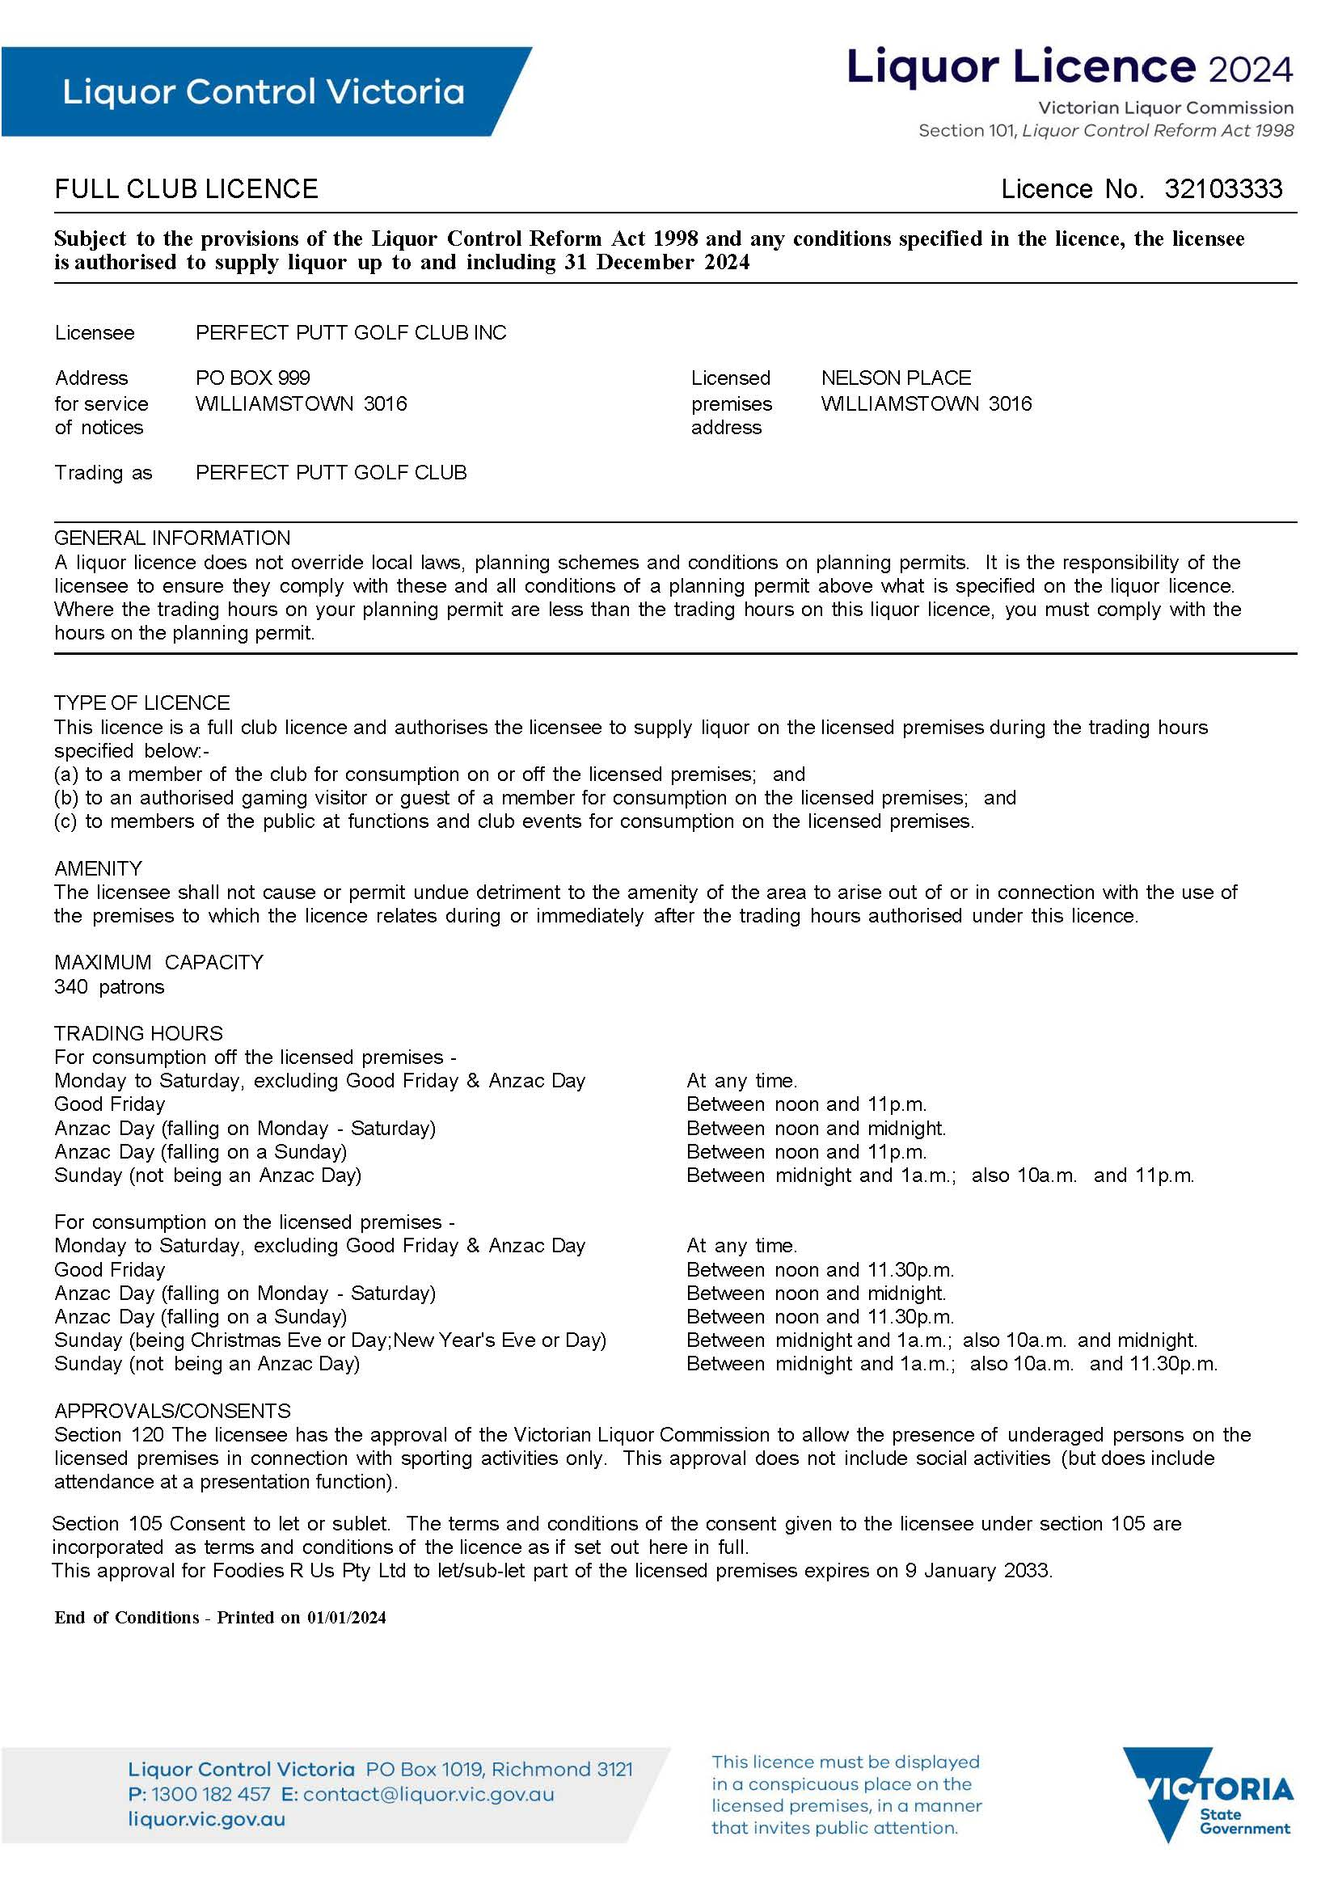

This consent allows a person (other than the licensee) to let or sub-let part of the club   
(for example the bistro).

Persons under 18 years may be at the club accompanied for:

* sporting activities and presentation functions only.
* training (preparation) or participating in sporting events in the specified   
  trading hours.

You are responsible for your customers when they are at your club and as they leave.

# Questions

It’s time to check your understanding of what has been covered in this guide. Please complete the questions below and check your responses against the answers provided at the back of this guide.

Q.1 A member drinks one glass out of a bottle of wine they have purchased with dinner in the club dining room. Can they take the bottle of wine home with them?

Yes  No

Q.2 Your on and off-premises trading hours finish at 11pm. At 10.55pm a member’s guest orders a six-pack of beer. Will you serve them?

Yes No

Explain your answer:

Click or tap here to enter text.

Q.3 Name three pieces of information that the guests’ and gaming visitors’ register contain?

1. Click or tap here to enter text.

2. Click or tap here to enter text.

3. Click or tap here to enter text.

Q.4 Friends of a member book a 21st birthday party in the function room. They want full bar facilities for the party, including staff and alcohol. Does your full club licence allow this type of function?

Yes  No

Click or tap here to enter text.

Q.5 Using the plan below can a member take alcohol into the grandstand or out onto the club grounds?

Yes  No

Sample red line plan for The Club Club

Q.6 Using the plan above, anyone using the club may take alcohol from the dining area into the Star Bar.

True  False

Q.7 Your best friend is an excellent chef and has won many awards. Your bistro area is not doing well, you have agreed to sublet the kitchen and bistro area to her on a six-month trial. Are you in breach of your liquor licence?

Yes  No

Explain your answer

Click or tap here to enter text.

Q.8 You have regular member functions with live music on Saturday nights. On occasions, the under-25s teams bring along guests who can get a bit rowdy when they leave the club. What are the issues in this scenario?

Click or tap here to enter text.

Q.9 You have a full club licence with no additional approvals or consents. Jan and Stan attend a member function on a Saturday evening and bring Joey their 17-year-old son and Margie their 19-year-old daughter. Is the club in breach of their licence?

Yes  No

Explain your answer:

Click or tap here to enter text.

Q.10 Your club has a condition on its licence that allows persons under 18 years on the premises for training, to play sporting games and on presentation nights. What strategies could you put in place to ensure anyone under 18 years old is not served alcohol or given alcohol by other members?

Click or tap here to enter text.

# Answers

Q.1 Yes, members may take alcohol off the premises during off-premises trading hours.

Q.2 No, you are not allowed to sell alcohol for off-premises consumption to non-members at any time.

Q.3 1. Name

2. Residential or email address

3. Date of visit.

Q.4 Yes, a full club licence allows for supply of alcohol to members of the public at functions on your licensed premises.

Q.5 No, these areas are outside the red plan.

Q.6 True.

Q.7 Yes, a licensee must not let or sublet any part of the licensed premises or assign the right to supply alcohol without the consent of LCV.

Q.8 Possible amenity concerns:

* Noise—music and the group being louder due to alcohol
* Alcohol related violence
* Traffic—there could be additional traffic when members and guests are leaving the club
* Possibility of nuisance or vandalism to the local area.

Q.9 No, Joey is in the company of a responsible adult.

Q.10 Possible strategies to ensure anyone under 18 years old is not served alcohol:

* Have ‘Under 18? No supply’ poster displayed in a place that is visible to your members and their guests.
* Ensure staff are RSA trained and they always ask for ID when someone looks underage.
* Provide information regarding underage laws to members.
* Consider issuing coloured wristbands to persons who have shown acceptable ID.