# Introduction to Arrival

## Information for users

This guide supports all Arrival users to understand common features used across the Arrival system.

Arrival utilises a role-based access model. This means that a user's role will determine the functionality they will have access to when they log in to Arrival.

Users will need to complete a registration process, including setting up a security method (multi-factor identification) the first time they use Arrival. Information about this process can be found in the ‘Complete your Arrival registration’ quick reference guide. Each time you log in, you will be prompted to enter your security verification code.

Once you access Arrival, the tiles on the Dashboard or Welcome page will represent the functionality you have access to.

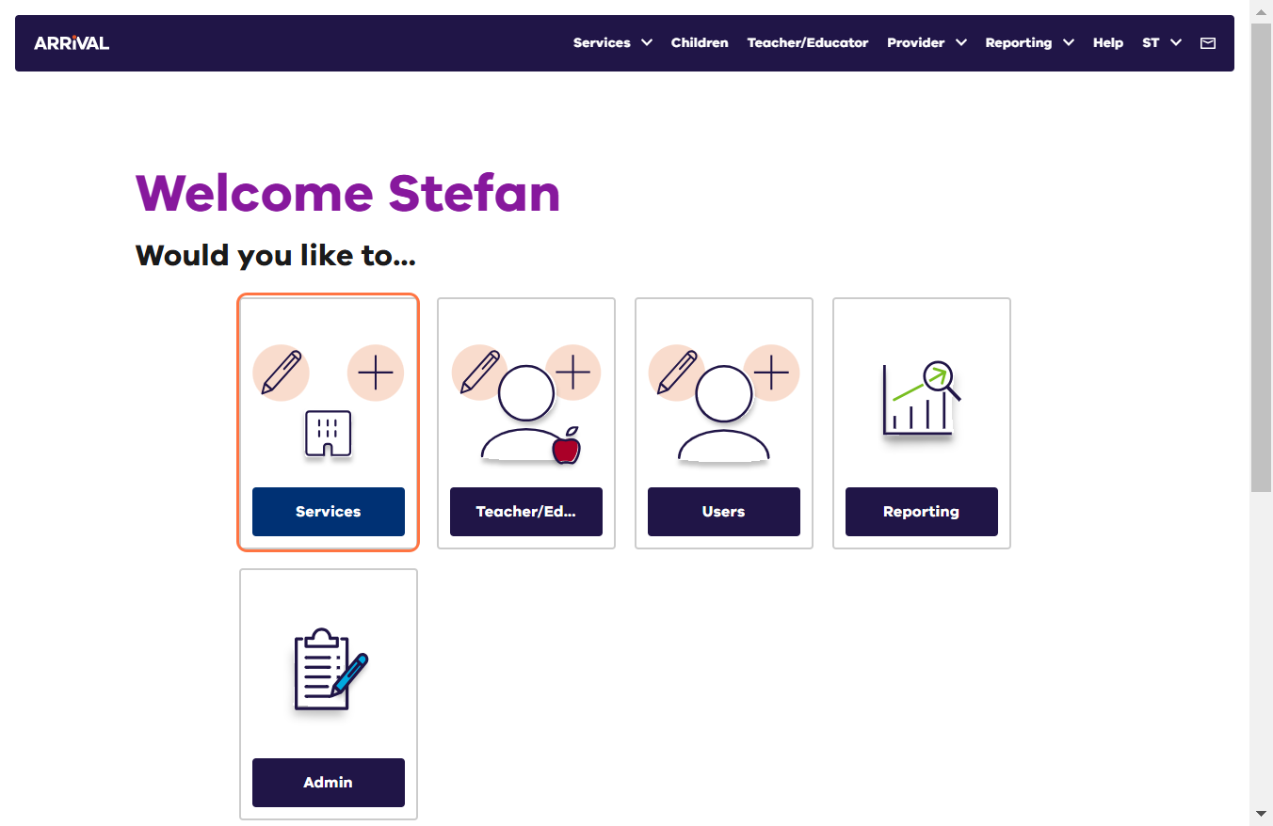

### Navigating Arrival

Arrival has been designed to have a consistent look and feel. Selecting a tile will take you to a new screen with a list view. Users will find navigation icons such as search and filter, as well as icons to indicate record status, completion (%) or manage/edit a record. These features are located just above the list or alongside a record. Hovering the mouse over an icon will display its function.

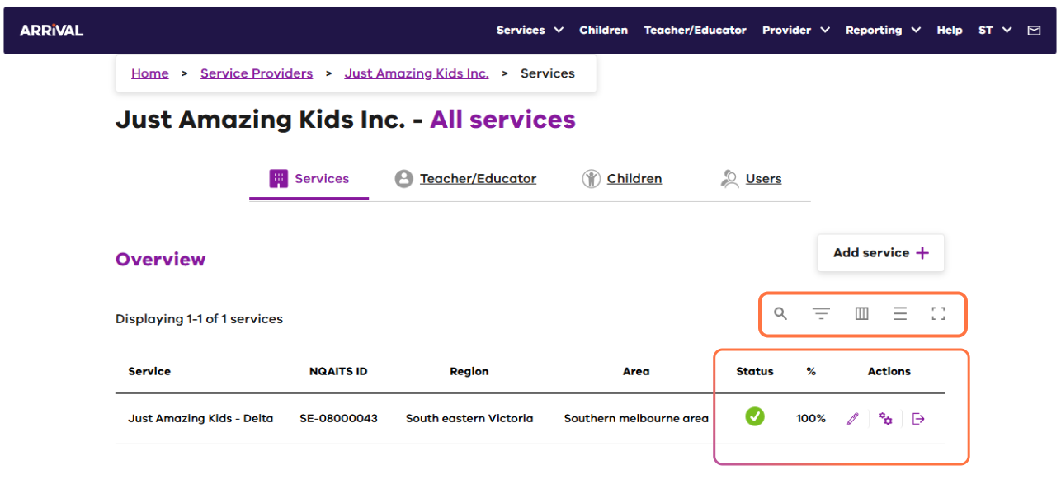

| **Feature** | **Function** |
| --- | --- |
| Breadcrumbs | The breadcrumbs area is located at the top of the screen underneath the ‘Primary navigation bar’ and will display when one of the dashboard tiles are clicked on.  It will show the user where they are currently located in the system. Links in the breadcrumb area can be used to navigate to other pages. |
| Seach field | Searches the displayed list for the entered value |
| Display or hide filters Display/hide filters | Click to turn on filtering. Use the drop-down arrow to the right of a filter to choose a value to filter by |
| Display or hide columns Display/hide columns | Customise the columns displayed on screen |
| Modify row density icon Modify row density | Increase/decrease spacing between table rows |
| **Full screen icon** Full screen | Display the table in full screen format |
| Status | **Tick icon** Active or **Cross icon** Inactive record |
| % | Indicates the amount of the record completed |
| Manage icon with a pencil | Open the selected record to view/edit/manage details |
| Configure settings icon | Configure settings |
| Go to the record icon | Go to the record to access further information and action requests |

### Workflow queue and Notifications

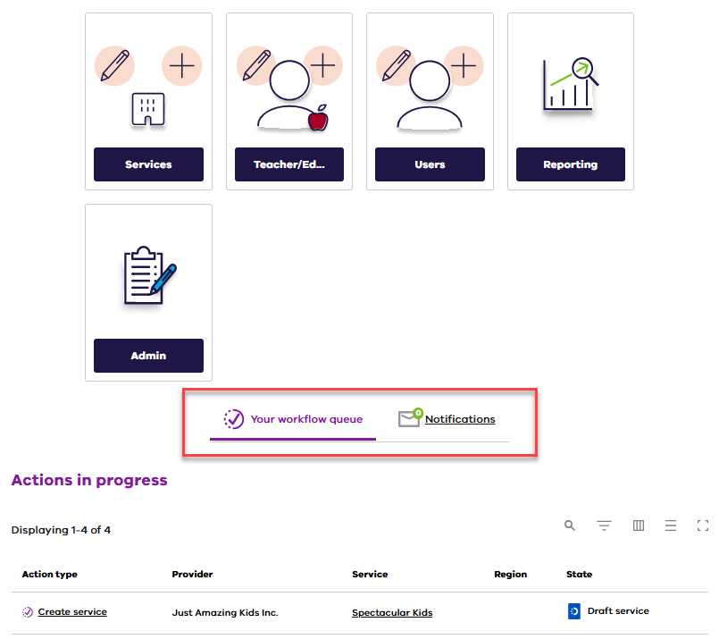

|  |  |
| --- | --- |
| Your workflow queue | Lists workflow activity that is in progress for the logged in user. This area will also display activities that are not yet submitted or in a draft state. |
| Notifications | Displays important information for Arrival users. These notifications are used to communicate key pieces of information about the system that you need to know as an Arrival user.  A number inside the green circle will indicate the number of new notifications since the previous login.  Notifications are a one-way communication process.  The notification envelope will also display in the top right corner of the screen. |

### Dialog Boxes in Arrival

Things to be aware of when entering data into Arrival:

* Optional fields are marked (Optional). All unmarked fields are mandatory.

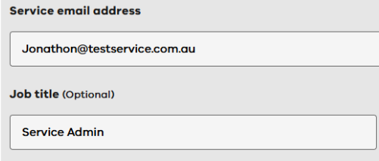

* Tooltips where available provide helpful information about what to include in that field.

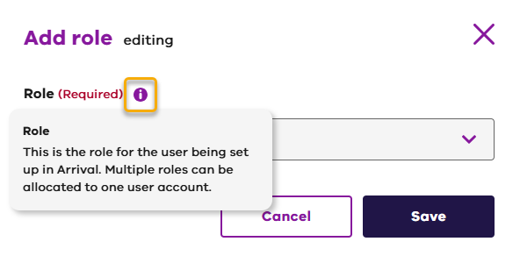

* Arrival uses address validation. When entering address information, simply begin typing and then select the correct address from the displayed list. It is also possible to enter the address manually.

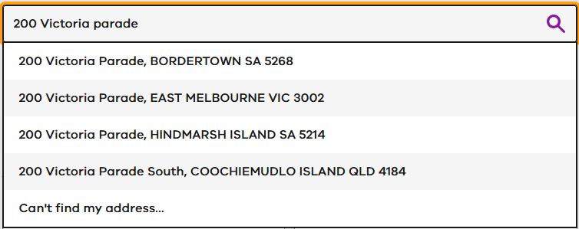

* Help (guidance including FAQs and knowledge base, including terms of use and roles and responsibilities), notifications and quick access options (navigational shortcuts), are available via the menu bar at the top right of your Arrival screen.



### Timeout functionality

Arrival uses a timeout function that will automatically log users out of the system after 10 minutes of inactive use. A countdown timer will be presented after 8 minutes of inactivity, allowing a further two minutes for the user to click to continue the session. Users will need to log in again with their email, password and two-factor authentication after each log out.

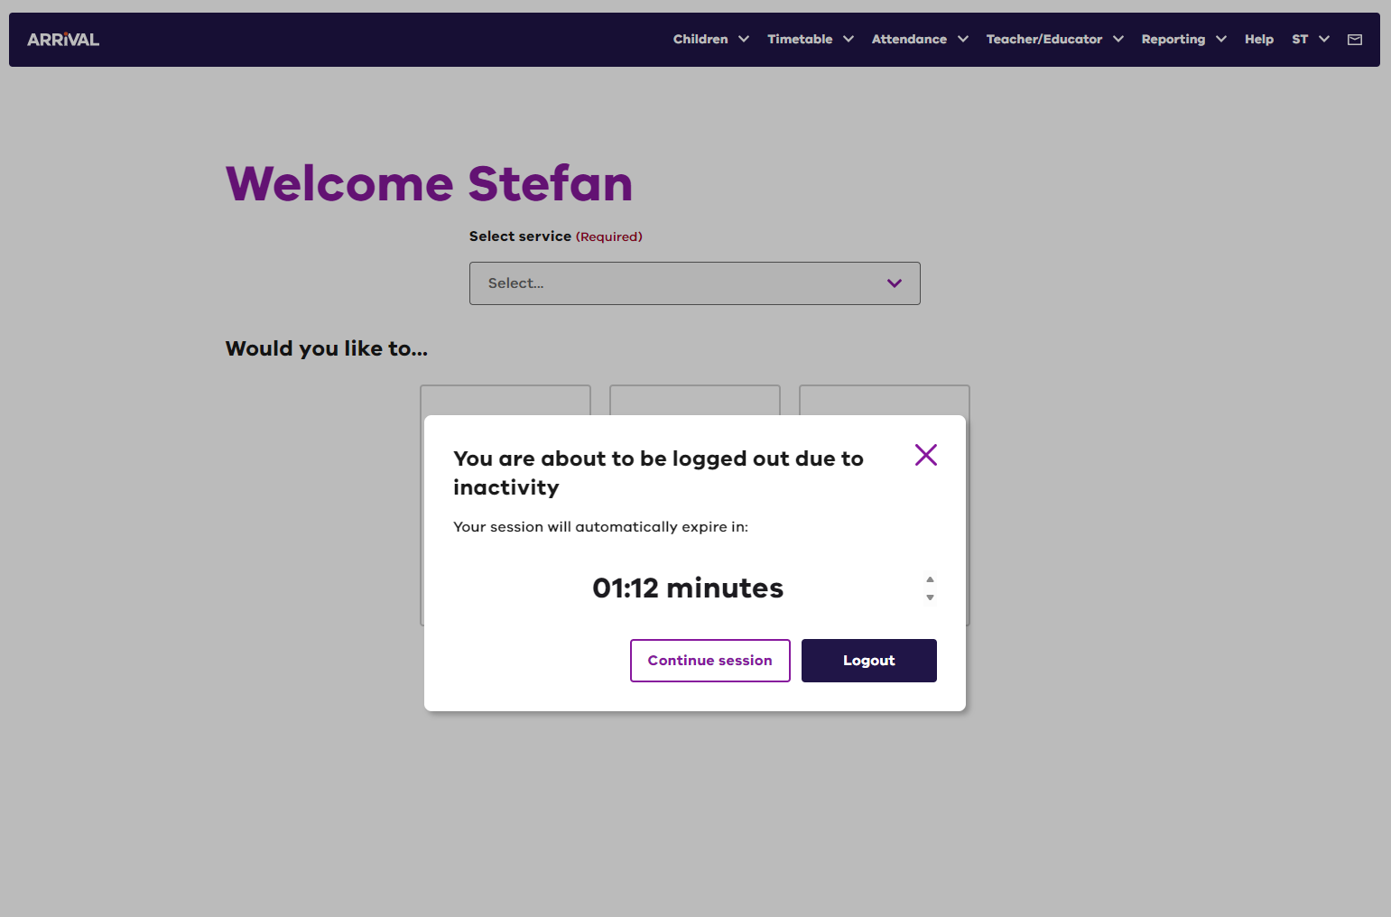

### Further information

For further support contact the Arrival Helpdesk on 1800 614 810 or email [**Arrival.Helpdesk@education.vic.gov.au**](mailto:Arrival.Helpdesk@education.vic.gov.au)**.**