Child Link: managing access for council-delivered Early Childhood services

Why do I need Child Link?
Child Link is a digital tool that displays key factual information about every child in Victoria. It is a key enabler of the information sharing reforms.
Child Link shows limited but critical information about a child and their family including:
- the child’s name, date and place of birth, and sex
- names of the child’s siblings and the parents or people who have day-to-day care of the child
- whether the child is identified as Aboriginal and/or Torres Strait Islander,
- if the child or their sibling has a past or current child protection order, and
- details of any government childhood services the child has participated in, such as Maternal and Child Health, Supported Playgroups, kindergartens and schools.
Child Link also displays key vulnerability indicators, such as whether the child or any of their siblings have been in out-of-home care.
Child Link draws all this information from existing government systems and consolidates it into a single entry for every child from birth to 18 in Victoria.

Who can access Child Link?
Security and privacy are core to the design of Child Link and strict safeguards are in place to protect information.
The information displayed on Child Link can only be accessed by a prescribed group of authorised Child Link Users who have responsibility for the wellbeing or safety of children. Most Child Link Users will only be able to access the information relating to children attending their service, and those children’s siblings.
In early childhood settings, registered early childhood teachers may become Child Link Users.

How will Child Link help?

Child Link aims to promote positive outcomes for children by assisting authorised professionals to:
 | Make more informed decisions about the wellbeing, safety and support needs of a child in their school or service. |  | Better identify risks and vulnerabilities and provide the necessary support to prevent any escalation of harm. |  | Encourage cross-service collaboration to facilitate more holistic support around a child. |  | Provide support earlier by linking together information from across schools and services. |  | Facilitate smoother transitions between early childhood and education services by responding to gaps in participation.

How can my service get started with Child Link?
Councils that deliver early childhood education services will first need to confirm who will be the Child Link Authoriser for their service. The Authoriser is the person responsible for creating and managing Child Link Users for their service.
In council settings, the CEO (or equivalent) is the Head Authoriser for each service. The CEO may delegate their Authoriser responsibilities in writing to one or more of staff members in the service or council. This will allow these staff members to create and manage Users on behalf of the service.
In each service, delegates should have a senior role with management responsibilities. Appropriate roles include early years managers, coordinators of children’s services, and educational leaders.

How this works in councils with different structures

Example 1: Authorisers and Users at a local council that directly delivers ECE services
In this example, the CEO has delegated Authoriser responsibility for early childhood teachers to either the Family and Children’s Services Manager and/or the Team Leader/Coordinator.
Note: A Family and Children’s Services Manager or Team Leader can also be a Child Link User if they are also a VIT-registered early childhood teacher, providing education and care and related services to children enrolled at their service. Their User access would be authorised by the Director.
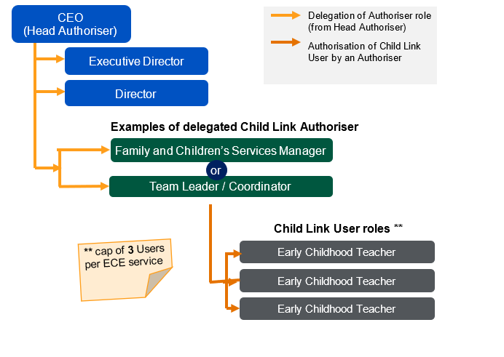

Example 2: councils with one manager with oversight of MCH and ECE staff
Some councils have one managerial position that directly supervises both Maternal and Child Health (MCH) and early childhood staff. These councils will need to nominate one Authoriser to manage MCH Child Link Users, and another Authoriser to manage early childhood Users.
Child Link does not allow an Authoriser to authorise two separate workforces.
If this applies to your council and your council has already nominated Authorisers for MCH services, then your council should nominate a more senior role to be the Authoriser for the early childhood services.
For example, if the Family and Children’s Services Manager is an Authoriser for the MCH service, then appropriate roles for the early childhood service Authoriser could include the CEO, Executive Director or Director. You should confirm who will authorise each workforce in writing to childlink@education.vic,gov.au.
In the example diagram below, the council has one role responsible for managing MCH nurses and EC services within their council structure. The CEO has delegated the authoriser responsibility for the EC service to the Director, as the Family and Children’s Services Manager is already responsible for authorising MCH nurses and cannot authorise both services.
