# Add and update Arrival users

## Information for Service Provider Administrators and Service Administrators

A guide to support service provider administrators and service administrators to manage users in Arrival.

Service provider administrators and service administrators can add, update (and remove) users to Arrival as well as assign a role and service or multiple services within that provider.

This guide includes information on:

* Add a new user
* Additional roles
* Arrival user roles
* Resend access invitation to a new user
* [Remove (Deactivate) a user](#_Remove_(Deactivate)_a)
* Reactivate a user
* Update a user

### Add a new user

1. Log in to Arrival. From the Welcome dashboard click the ‘Users’ tile.

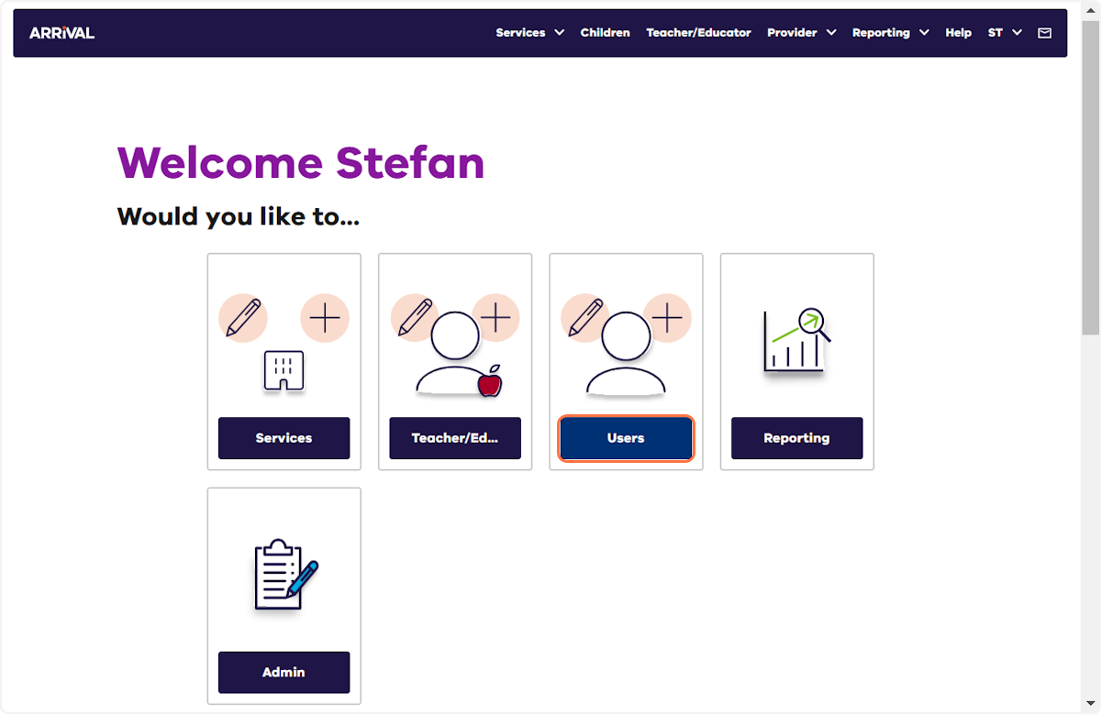

1. Click ‘Add user +’.

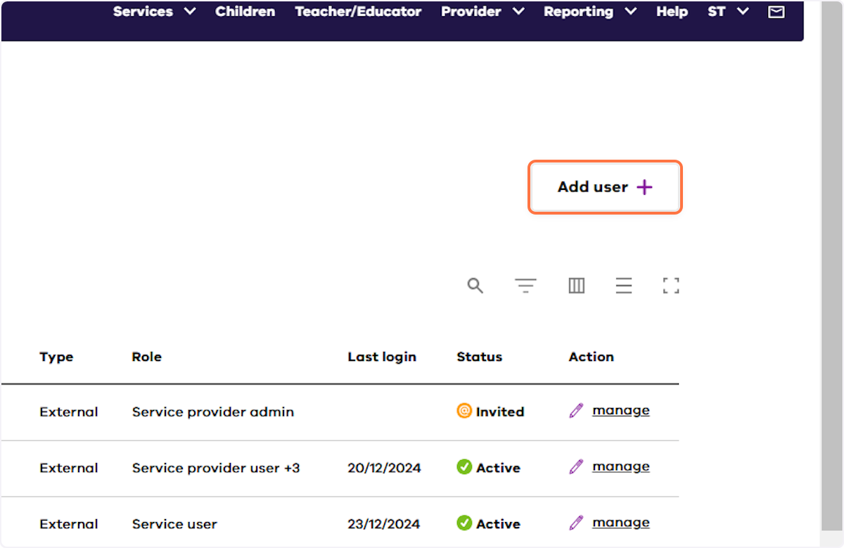

1. Click ‘Add role +’.

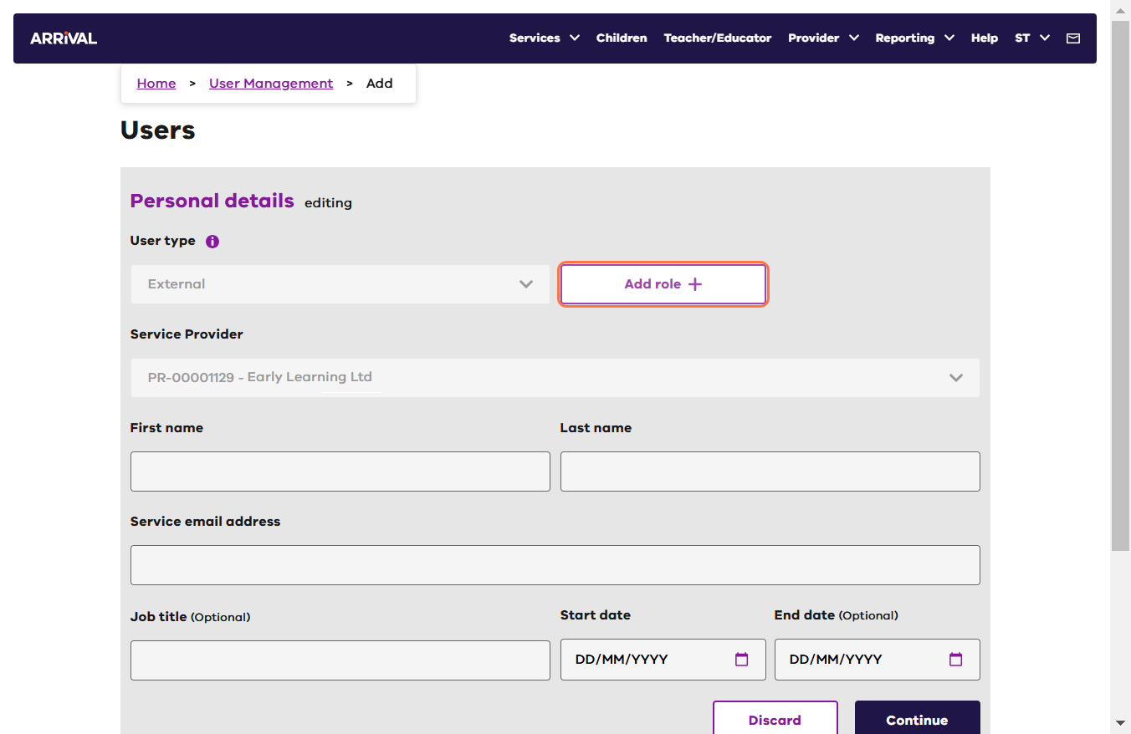

1. Select the required role from the drop-down list.

N.B.: refer to the Arrival user roles table below for roles and permissions.

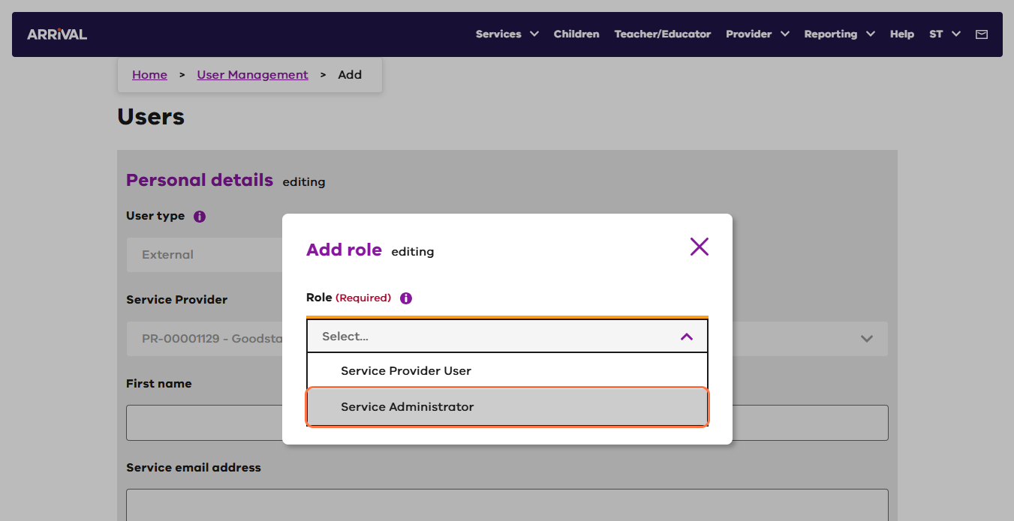

1. Select the required services from the drop-down list and Click ‘Save’.

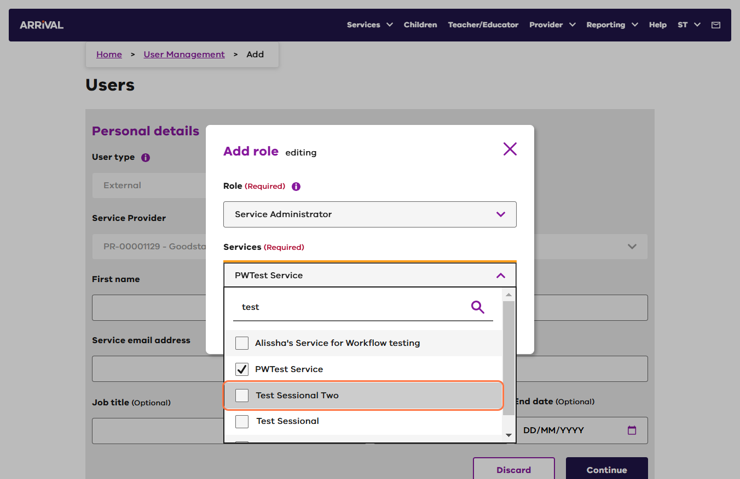

1. Complete the remaining user details (First name, Last name, Service email address, Job title - optional, Start date, End date - if required) and click ‘Continue’.

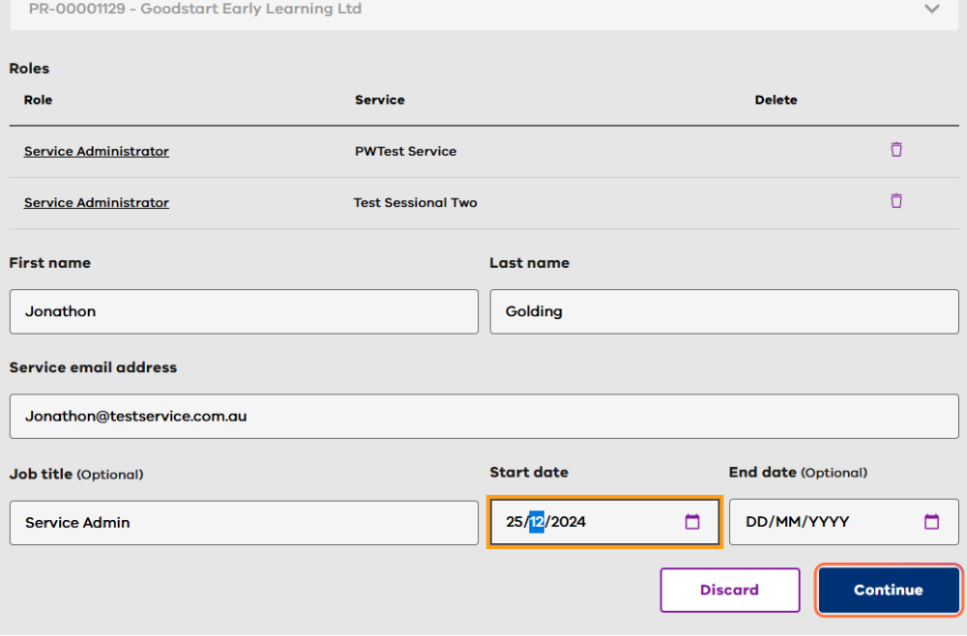

|  |  |
| --- | --- |
| Start Date | Date from which the user will be invited to access Arrival. If today’s date is entered, an email will be sent to the service email address entered as soon as the record is saved. |
| End Date | Enter a date here if there is a specific date from which the user will no longer need Arrival access. The user will be deactivated on this date. |

The new user details will be saved with an onscreen success message indicating the user is ‘pending’. In the background, an invitation to access Arrival will be sent to the user on the required start date.

### Additional Roles

1. Additional roles can be added to a User, by clicking **Add role +**, and then selecting a role.

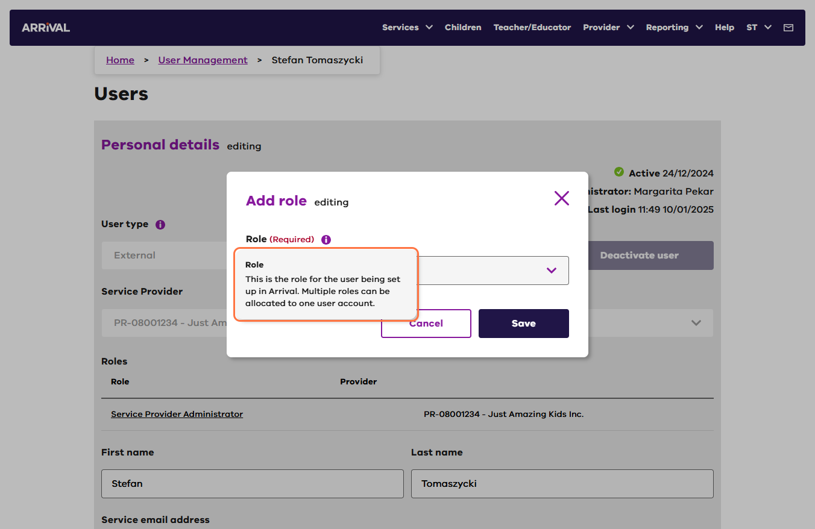

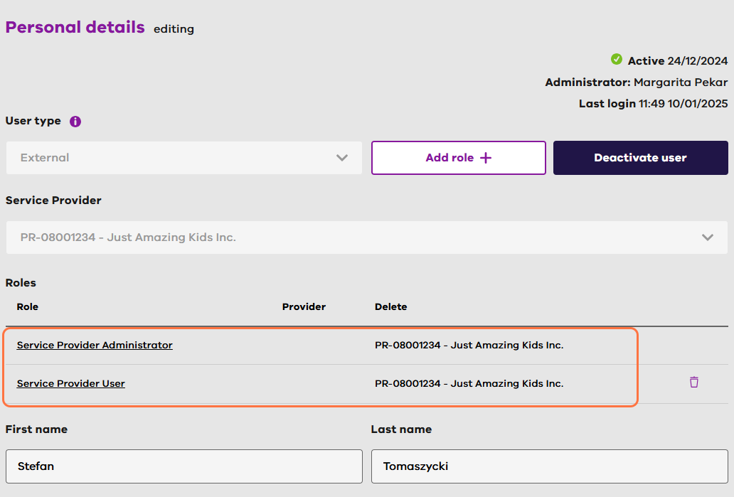

### Arrival user roles

Please see information below regarding user roles and permissions. Additional guidance for users is available in the guidance document: Arrival User Roles and Responsibilities in the Arrival Help.

|  |  |  |  |  |  |
| --- | --- | --- | --- | --- | --- |
| **Role** | **Description** | **Create/Manage/View Access** | **View Access** | **Create/**  **Manage Users** | **Administration** |
| Service Provider Administrator | Role is for staff from service providers who are the person who is responsible for administering Arrival access | Service Provider (*edit/view only*)  Service  Teacher/Educator  Program/Group  Child  Parent/Guardian  Attendance | All | Yes | **Administered by:** Arrival Administrator  **Administrator for:** Service Provider User and Service Administrator User |
| Service Provider User | Role is for staff from service providers who require view and edit access to Arrival | Teacher/Educator  Program/Group  Child  Parent/Guardian | Service Provider  Service | No | **Administered by:** Service Provider Administrator |
| Service Administrator | Role is for staff from services who are the person who is responsible for administering Arrival access | Teacher/Educator  Program/Group  Child  Parent/Guardian  Attendance | Service | Yes | **Administered by:** Service Provider Administrator  **Administrator for:** Service User |
| Service User | Role is for staff from services who require view and edit access to Arrival | Teacher/Educator  Program/Group  Child  Parent/Guardian  Attendance | Service | No | **Administered by:** Service Administrator |

### Resend access invitation to a new user

If the invitation email sent to a user expires, another invitation can be sent with a new 7-day expiry.

1. Log in to Arrival and click on the ‘Users’ tile.
2. Click the manage (pencil) icon for the required user.

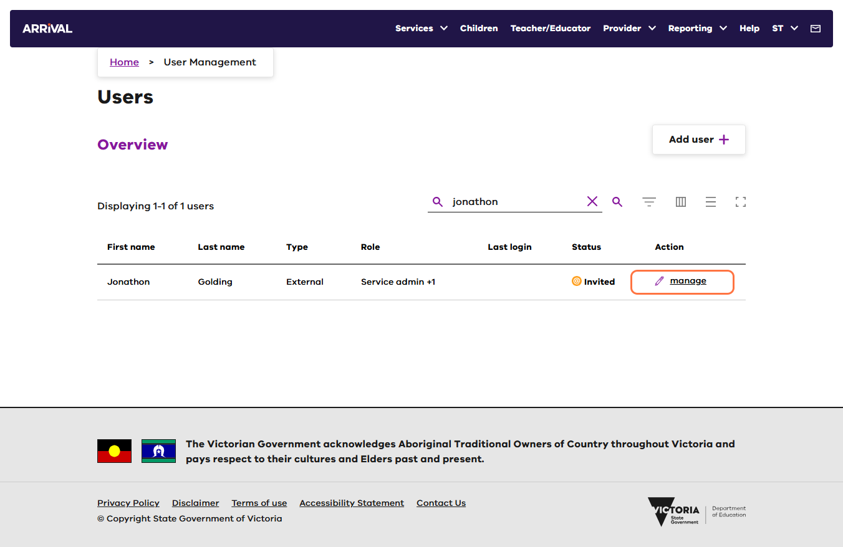

1. Click the Edit icon link located toward the top of the page.
2. Click ‘Resend Invitation’.

N.B.: The Resend Invitation initiates a new email with a new 7-day expiry.

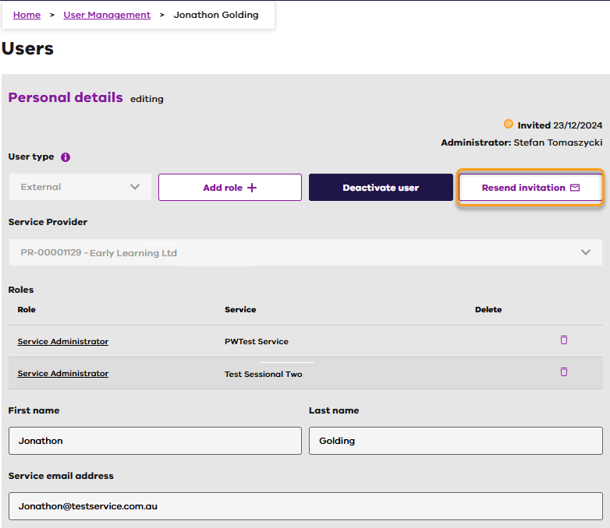

### Remove (Deactivate) a user

1. Log in to Arrival and click on the ‘Users’ tile.
2. Click the manage (pencil) icon for the required user.
3. Click the Edit icon link located toward the top of the page.
4. Click ‘Deactivate user’.

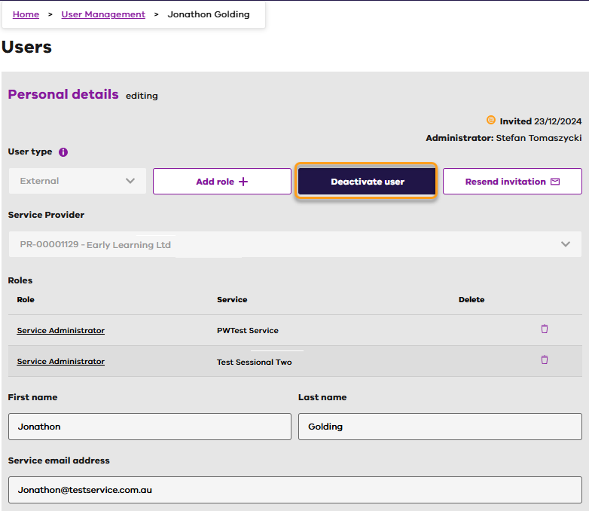

1. Click Continue. (No other information is required to deactivate the user).

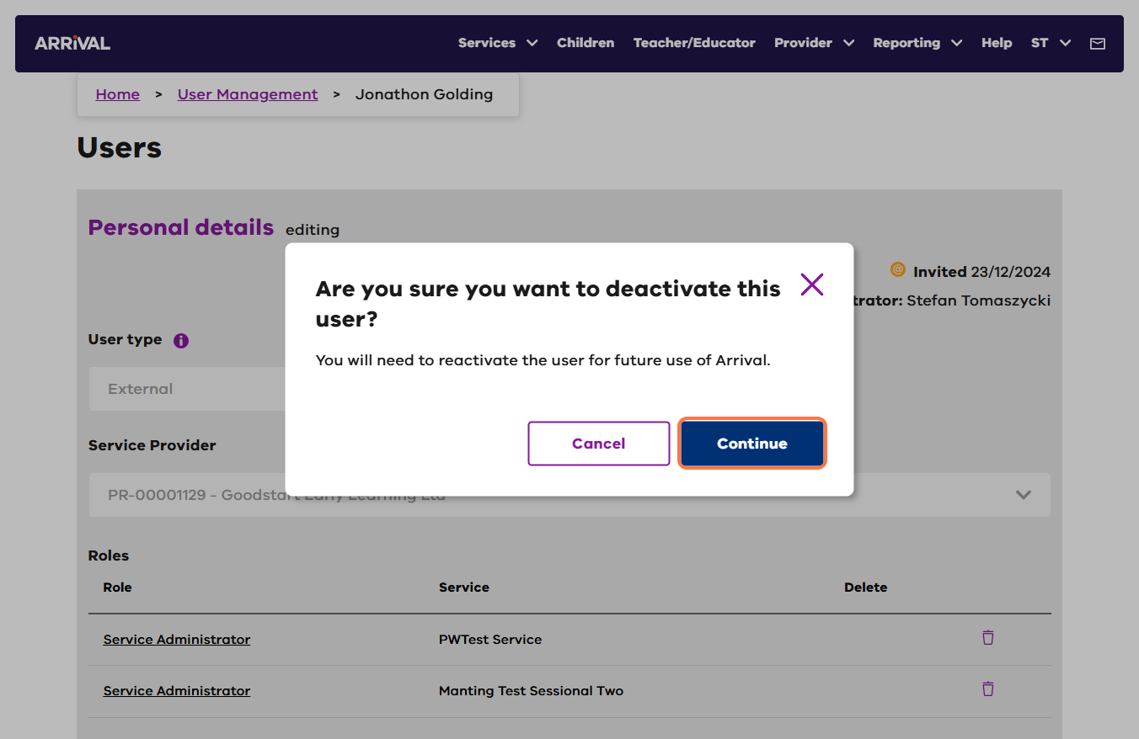

1. Arrival will pop a message to confirm ‘You’ve successfully deactivated this user’.

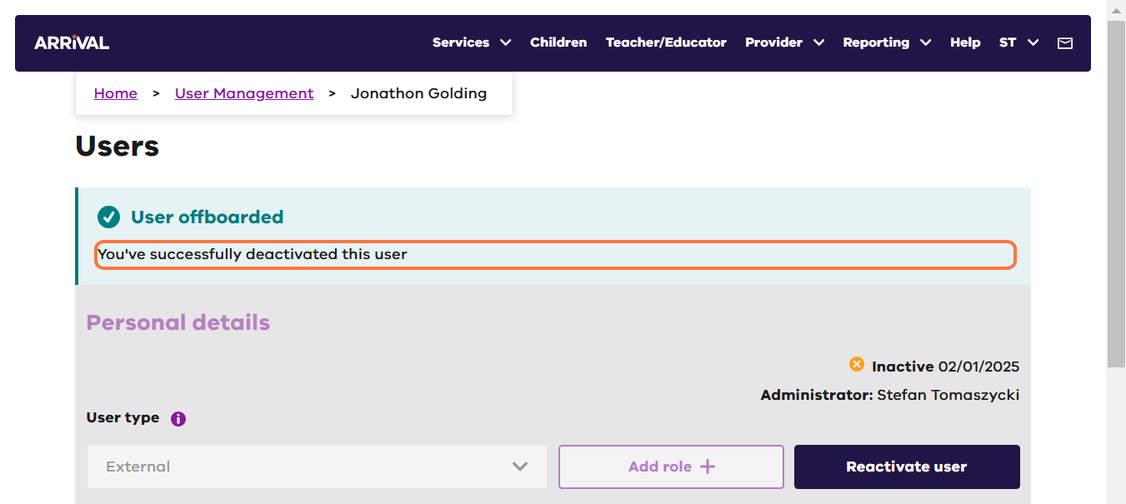

1. The user will be sent an email to advise their account is deactivated.

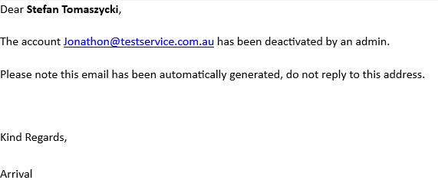

### Reactivate a user

1. Log in to Arrival and click on the ‘Users’ tile.
2. Click the manage (pencil) icon for the required user.

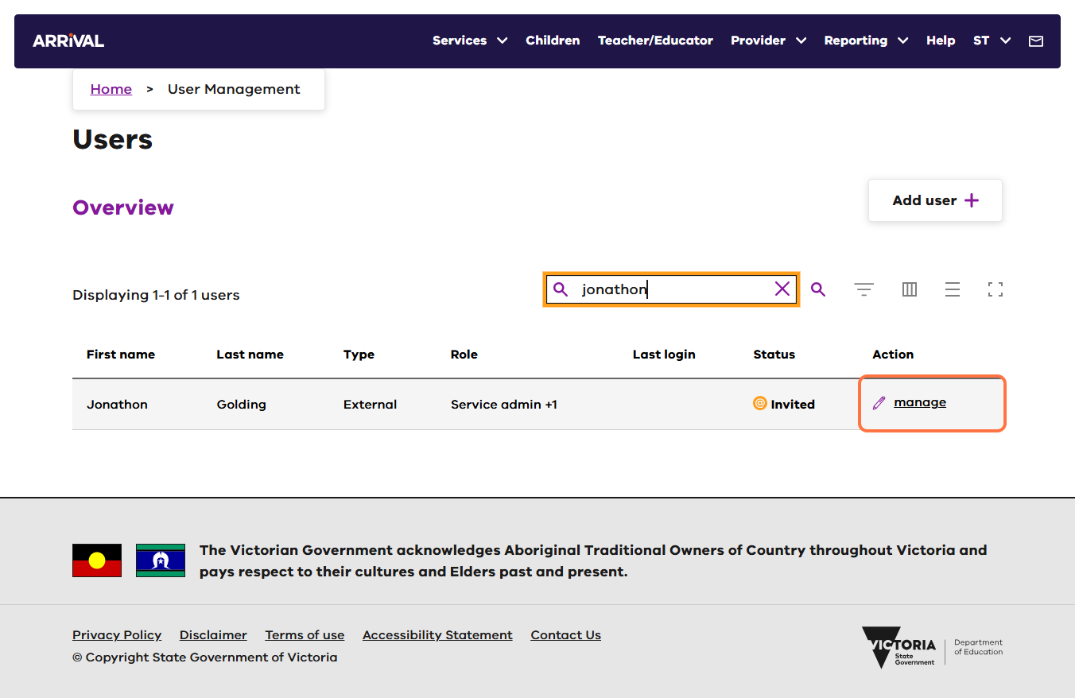

1. Click the Edit (edit) link located toward the top of the page.
2. Select Reactivate user.

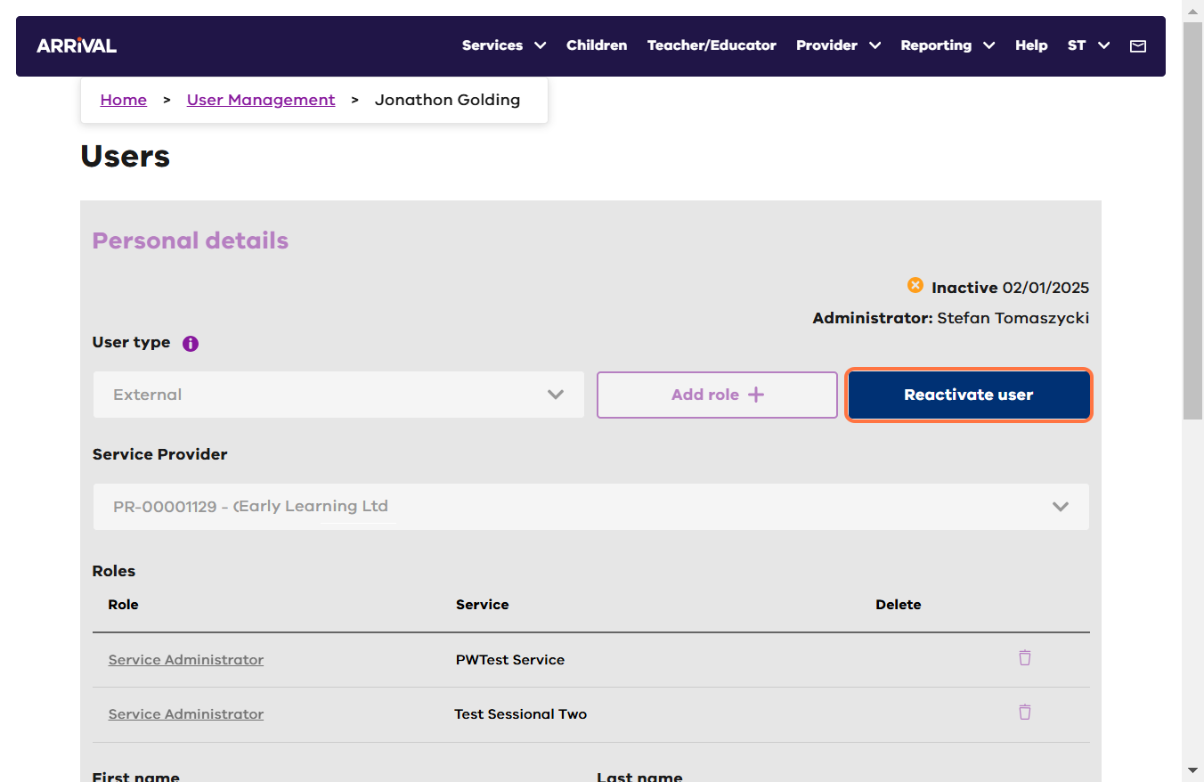

1. Arrival will pop a message to confirm ‘You’ve successfully reactivated this user’.

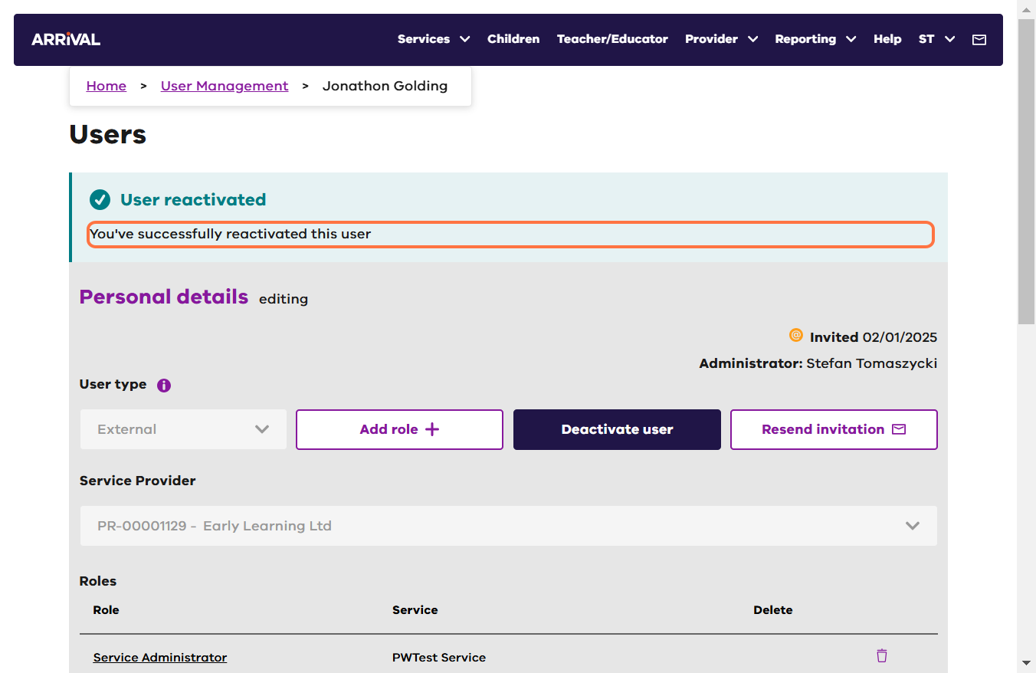

### Update a user

1. Log in to Arrival and click on the ‘Users’ tile.
2. Click the manage (pencil) icon for the required user.



1. Click the Edit icon (edit) link located toward the top of the page.
2. Update any information including the email address of the user.
3. Click ‘Save’.

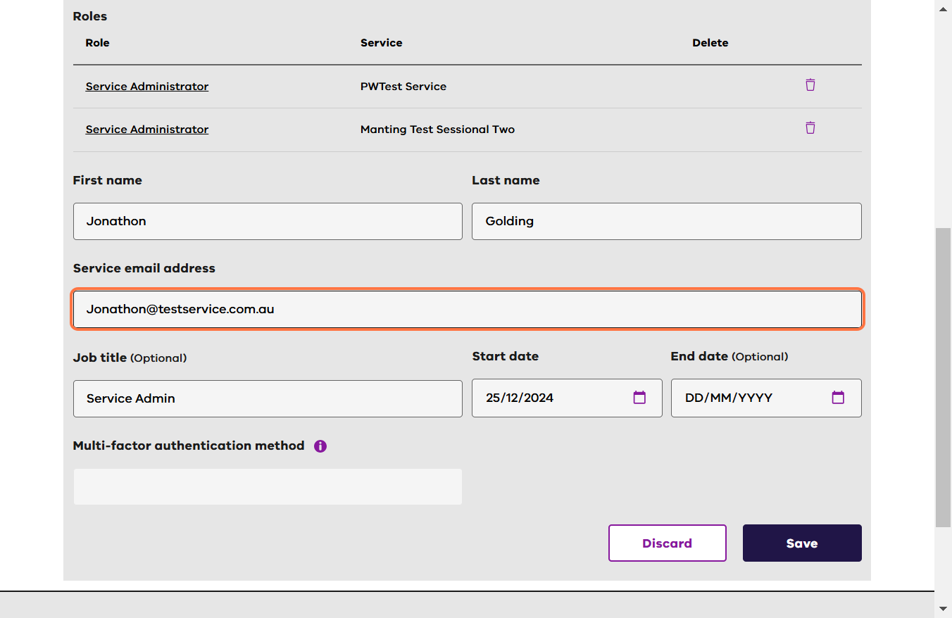

### Further information

For further support contact the Arrival Helpdesk on 1800 614 810 or email [**Arrival.Helpdesk@education.vic.gov.au**](mailto:Arrival.Helpdesk@education.vic.gov.au)**.**