|  |
| --- |
| Reflective supervision |
| Best practice supervision and video discussion guide |
| OFFICIAL |



To receive this document in another format [email the Centre for Workforce Excellence](mailto:cwe@dffh.vic.gov.au) <cwe@dffh.vic.gov.au>.

Authorised and published by the Victorian Government, 1 Treasury Place, Melbourne.

© State of Victoria, Australia, Department of Families, Fairness and Housing, December 2024.

[](https://creativecommons.org/licenses/by/4.0/)

With the exception of any images, photographs or branding (including but not limited to the Victorian Coat of Arms, the Victorian Government logo or the Department of Families, Fairness and Housing logo), this work, *Reflective supervision: Best practice supervision and video discussion guide*, is licensed under a Creative Commons Attribution 4.0 licence.

The terms and conditions of this licence, including disclaimer of warranties and limitation of liability are available at [Creative Commons' Deed – Attribution 4.0 International page](https://creativecommons.org/licenses/by/4.0) <https://creativecommons.org/licenses/by/4.0>

You are free to re-use the work under that licence, on the condition that you credit the State of Victoria, Australia (Department of Families, Fairness and Housing) as the author, indicate if any changes have been made to the work and comply with the other licence terms.

ISBN 978-1-76130-721-8 (online/PDF/Word)

Available at https://www.vic.gov.au/best-practice-supervision-videos-reflective-supervision

Contents

How to use this discussion guide 4

Who this guide is for 4

Key messages 5

Discussion questions 5

General questions for everyone 5

Questions for organisational leaders 8

Questions for supervisors 9

Questions for supervisees 10

More resources 11

Reflective supervision information sheet 11

Guidance for professionals around family violence 11

# How to use this discussion guide

This discussion guide accompanies the:

* *Best practice supervision guidelines* (‘Guidelines’) [1]
* *Reflective supervision* video.

This guide is designed to strengthen your understanding of key supervision concepts.

This guide includes:

* a summary of the messages in the Guidelines and video
* discussion questions to your deepen understanding of key concepts
* discussion questions to consider how these concepts apply to your supervisory practice or organisation
* links to more resources.

The family violence, sexual assault and child wellbeing sectors are diverse. Supervision practices need to reflect the unique challenges and opportunities of each sector. This guide offers options and guidance, rather than a set of instructions to apply in all situations.

The reflective questions can be used and adapted for different contexts.

## Who this guide is for

The guide focuses on the family violence, sexual assault and child wellbeing sectors. However, many of the concepts and questions are relevant to broader community service sectors.

Use this guide with:

* ‘Reflective supervision’, Guidelines (pages 34 to 39)
* *Reflective supervision* video.

### Supervisees and supervisors

Supervisees and supervisors may use this guide:

* for self-directed learning
* to inform discussions in scheduled supervision
* in peer supervision.

### Organisations

Organisations may use the video and this guide in a range of situations, including:

* induction and onboarding programs
* communities of practice
* team meetings
* planning sessions
* leadership meetings.

### Trainers

Trainers may use discussion guide to:

* facilitate discussions after showing the *Reflective supervision* video.

# Key messages

* Supervision is a discussion. Open and reflective questions are an important part of it.
* Reflective supervision gives us the chance to explore how our biases and subconscious can affect our practice with clients. Our attitudes affect our work.
* Reflective supervision relies on a positive and supportive relationship between supervisor and supervisee.
* Supervision needs to balance both supporting and challenging the supervisee.

# Discussion questions

The discussion questions may include:

* **Context**: framing for you to open the discussion with – lead with this then ask the question.
* **Prompts**: to encourage more reflection and discussion if needed.

## General questions for everyone

### Question 1: Why is reflective supervision important?

#### Prompts

* Helps with learning and insight.
* Facilitates using emotions as sources of useful information.
* Reduces reactive practice.
* See ‘Why is reflective supervision so important’, Guidelines (page 34).

### Question 2: What topics can be part of reflective supervision?

#### Prompts

* You can talk about any work-related experience during reflective supervision, including:
  + case practice with clients
  + relationships with other professionals
  + colleagues
  + systemic issues
  + dynamics of the supervisory relationship.

### Question 3: How do you know when you are doing reflective supervision?

#### Prompts

* Open and curious questions are mainly used.
* Questions rarely have an agenda or outcome attached to them.
* Supervisee does most of the talking and processing.
* Discussion goes deeper, exploring dynamics and use of self in the practice.
* There is a sense of uncovering and greater insight (‘aha moments’) by the supervisee (and possibly the supervisor).

### Question 4: In the video, how could the supervisor have delved deeper, going into critical and process reflection?

#### Prompts

* Further explore conscious and unconscious aspects of practice.
* Explore the psychological aspects of the work
* Consider the dynamic between the supervisee and client.
* See ‘Four levels of reflection’, Guidelines (page 37).

### Question 5: How can you use the Kolb cycle when practicing reflective supervision?

#### Context

The Kolb learning cycle has 4 categories:

* Experience – the telling.
* Reflection – feeling.
* Analysis – thinking or making sense.
* Action – the doing.

Figure 1: Kolb cycle

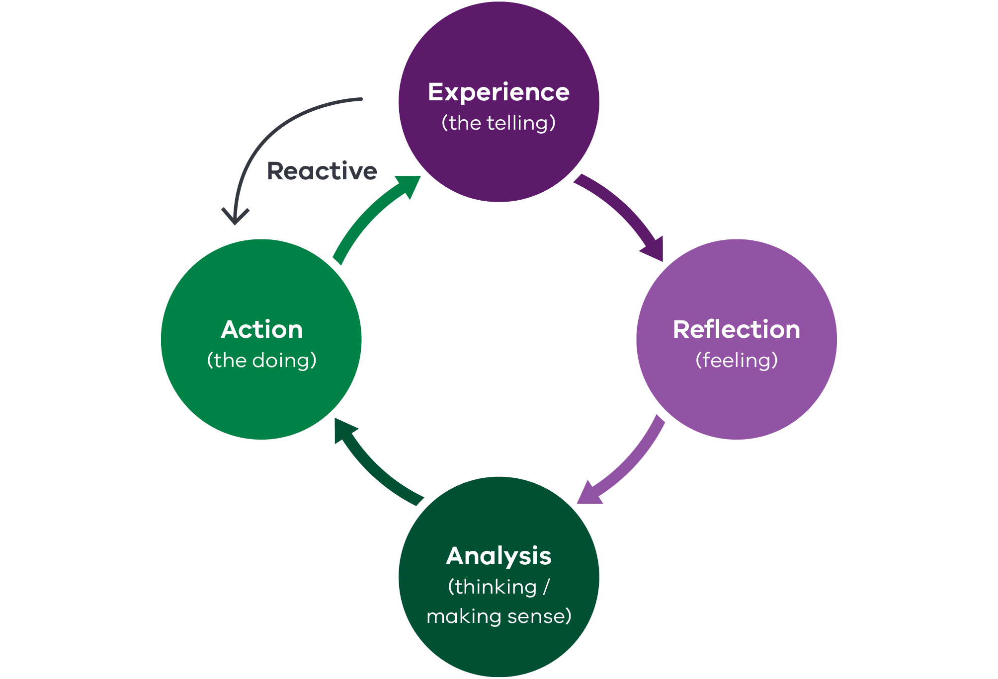

Prompts

* The Kolb cycle (**Figure 1**) helps structure the reflective process. Note: you can go backwards and forwards between the categories.
* The Kolb cycle helps explain why reactive (going from experience to action) thinking and practice occurs.
* Suggest using the 4x4x4 supervision model (which incorporates the Kolb cycle) in practice.
* See ‘What is reflection’ (page 35) and ‘Questions that accompany the learning cycle process’ (page 36) in the Guidelines.

### Question 6: Why is it important to discuss feelings and emotions during supervision?

#### Context

Often when people get stuck in supervision, they’re busy trying to block their intrusive feelings so they can concentrate on their thoughts. They don’t realise that the feelings will tell them more.  
– Hewson & Carroll, 2016

#### Prompts

* Recognise that people have difference levels of comfort around discussing and sharing feelings.
* Emotions are a valuable source of information. Exploring them can improve insight, self-awareness, coping strategies and decisions.
* They can uncover subconscious biases and processes occurring.
* Discussing emotions can tap into our intuition, which can guide our practice.
* Normalising discussions on emotions can reduce stigma and make them more routine.
* Empathic listening by the supervisor helps build a trusting supervisory relationship. This can positively affect supervisee wellbeing.

### Question 7: When can expressing emotions cross over into counselling? How do you know when this happens as a supervisor and as a supervisee (self‑awareness)?

#### Prompts

* It is not work related.
* Supervisee has trouble regulating their emotions over time.
* Someone is ‘flooded’ with emotions and having trouble processing them.
* The topic and emotions keep being revisited during supervision sessions.

### Question 8: How do you handle situations where you feel supervision is crossing over into counselling?

#### Prompts

* Discuss the possibility of this happening in one of the first supervision sessions and when setting up the supervision agreement.
* Empathise and listen. When the time is right, reflect on what you have observed and possibly offer or suggest other supports.

### Question 9: How important is it to include trauma- and violence-informed principles and ways of interacting with supervisees?

#### Context

Trauma- and violence-informed principles are:

* safety
* trust
* choice
* collaboration
* empowerment
* respect for inclusion and diversity.

#### Prompts

* Trauma- and violence-informed practice is about being sensitive to the impacts of trauma and ongoing structural inequality (*MARAM foundation knowledge guide*, 2021).
* Helps stop trauma-organised systems developing.
* Adopting trauma- and violence-informed ways of interacting will encourage relationships that are safe enough and can help sustain us in the work.
* We heal in relationships.
* Practitioners, supervisors and managers cannot do the work without supportive relationships.
* See ‘Trauma-informed principles’ (page 29) and ‘Trauma-informed framework’ (pages 30 and 31) in the Guidelines.

‘Trauma experience is common in our community. It is more common in those who work in human services than in other sectors. These two statements help us to understand the importance of services and systems being trauma- and violence-informed for all who use them, as well as all who work within them’  
– *Framework for trauma-informed practice*, 2023.

### Question 10: Why did the supervisor in the video intentionally ask if the supervisee was willing to do reflective supervision?

#### Prompts

* Reflection is not always a positive experience. Both supervisees and supervisors need to be ready to move into this space.
* See ‘Reflection readiness’, Guidelines (page 38).

## Questions for organisational leaders

### Question 1: How does your organisation make sure reflective supervision occurs?

#### Prompts

* Communicates the importance of reflective supervision.
* Makes sure there are enough resources for reflective supervision such as manageable supervisor‑to‑supervisee ratios, work demands and private spaces.
* Adequate resourcing helps staff slow down and gives them the uninterrupted time and space needed.
* Schedules reflective group or peer supervision.

### Question 2: How do senior leaders show reflection in their leadership style?

#### Prompts

* Leaders share their own reflections and lessons learned with staff.
* Leaders adopt and embody an intersectional feminist approach.

## Questions for supervisors

### Question 1: Watching the video, what questions would you have asked, or areas would you have explored further? Why?

#### Prompts

* Explore the supervisee’s comment about building rapport. Examine if this was the supervisee’s way of rationalising why they did not invite the man to take more responsibility for his actions. You may consider whether the supervisee thought this was a pattern in their thought process with other clients too.
* Explore the supervisee’s fear about the client’s behaviour and presentation.

### Question 2: Is the comment in the video about collusion accurate? If so, how easy or difficult is it for practitioners to share this (and mistakes more generally) in supervision?

#### Context

The video includes a comment that it is difficult to completely rule out being collusive.

Collusion occurs when professionals, organisations and the service system act in ways that reinforce, support, excuse or minimise a person’s use of family violence and its impacts.[2]

#### Prompts

* Experts talk about resisting collusion, recognising that it is not easy and is an ongoing process.
* Discuss how shame and wanting to be competent in their role (and viewed as such) can silence supervisees.
* Explore how not being open about the concerns of collusion affects supervisee:
  + practice
  + learning
  + stress levels
  + risk of burnout.
* Discuss how creating a just culture (see Guidelines, page 43) encourages talking about mistakes.
* It is tricky to find the balance between:
  + connecting with clients
  + resisting invitations to collude
  + inviting adults to take responsibility for their violence.

### Question 3: In the video, what stopped the conversation between the supervisor and supervisee from becoming strained?

#### Context

Towards the end of the video, we see the supervisor challenge the supervisee. This kind of conversation could become strained and awkward.

#### Prompts

* The positive relationship between the two people.
* The way the supervisor ‘held the space’ and stayed calm, contained and persistent.
* The supervisor’s open body language.
* The supervisor’s confidence that the supervisee had the answers.

## Questions for supervisees

### Question 1: How easy or difficult is it to ask for reflective supervision? How would you ask?

Prompts

* It can be difficult to request reflection due to time pressures and workload demands.
* To do reflection, both parties need to be in the right ‘headspace’ – calm, present in the moment and curious.
* Explain why you need or want to be more reflective during supervision.

### Question 2: How do you know when supervision is truly reflective?

#### Prompts

* Supervisor uses open, curious questions.
* Supervisee does most of the talking.
* Discussion feels slower and goes deeper, exploring dynamics and use of self in the practice. See ‘Four levels of reflection’, Guidelines (page 37).
* There is a sense of uncovering and greater insight (‘aha’ moments) for the supervisee and possibly the supervisor.
* Both supervisor and supervisee can better understand what may be happening:
  + for clients
  + in relationships
  + how they are experienced by others.

### Question 3: Is the comment in the video about collusion accurate? If so, how easy or difficult is it to share this (and mistakes more generally) in supervision?

#### Context

The video includes a comment that it is difficult to completely rule out being collusive. Collusion occurs when professionals, organisations and the service system act in ways that reinforce, support, excuse or minimise a person’s use of family violence and its impacts.[3]

#### Prompts

* Experts recognise that resisting collusion is not always easy. It is an ongoing process.
* Discuss how shame and wanting to be competent – and viewed as competent – in their role can silence supervisees.
* Explore how not being open about concerns of collusion affects practice, learning, stress levels and risk of burnout.
* Discuss how creating a just culture (Guidelines page 43) encourages talking about mistakes.
* It is tricky to find the balance between:
  + connecting with clients
  + resisting invitations to collude
  + inviting adults to take responsibility for their violence.

# More resources

For more information on reflective supervision, see pages 34 to 39 of the Guidelines.

The Guidelines are available on the [Victorian Government's Best practice supervision guidelines: Family violence, sexual assault and child wellbeing | vic.gov.au](https://www.vic.gov.au/best-practice-supervision-guidelines)

## Reflective supervision information sheet

* Reflective supervision information sheet – see the [Reflective supervision | vic.gov.au](https://www.vic.gov.au/best-practice-supervision-information-sheets/reflective-supervision)Victorian Government's Reflective supervision page.[4]

## Guidance for professionals around family violence

* The MARAM practice guides have guidance for professionals working with child or adult victim‑survivors, and adults who use family violence.
* See the [Victorian Government's MARAM practice guides: Guidance for professionals working with adults using family violence page](https://www.vic.gov.au/maram-practice-guides-professionals-working-adults-using-family-violence).[5]

1. The Guidelines are available on the [Victorian Government's Role of the organisation, supervisor and supervisee page](https://www.vic.gov.au/best-practice-supervision-guidelines/role-organisation-supervisor-and-supervisee). <https://www.vic.gov.au/best-practice-supervision-guidelines/role-organisation-supervisor-and-supervisee>
2. # Responsibility 3: Intermediate Risk Assessment

   Responsibility 3 of the Family Violence Multi Agency Risk Assessment and Management Framework: Practice Guides.
3. # Victorian Government MARAM practice guides: Responsibility 3 of the Family Violence Multi Agency Risk Assessment and Management Framework: Practice Guides.

  
4. <https://www.vic.gov.au/best-practice-supervision-information-sheets/reflective-supervision>
5. <https://www.vic.gov.au/maram-practice-guides-professionals-working-adults-using-family-violence>