|  |
| --- |
| Child Safe Standards – documented evidence mapping |
| For organisations funded and/or regulated by the Social Services  Regulator  **OFFICIAL** |

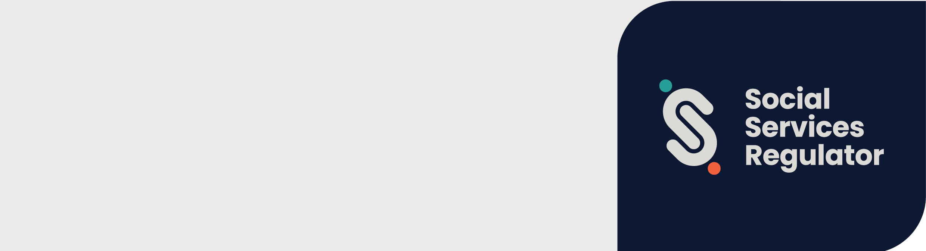

|  |
| --- |
| Name of organisation: |

| No. | Document title | Standard 1 | Standard 2 | Standard 3 | Standard 4 | Standard 5 | Standard 6 | Standard 7 | Standard 8 | Standard 9 | Standard 10 | Standard 11 |
| --- | --- | --- | --- | --- | --- | --- | --- | --- | --- | --- | --- | --- |
| *1* | *e.g., Child Wellbeing and Safety Policy* | *1.1, 1.2, 1.3, 1.4, 1.5* |  |  |  |  |  |  |  |  |  |  |
|  |  |  |  |  |  |  |  |  |  |  |  |  |
|  |  |  |  |  |  |  |  |  |  |  |  |  |
|  |  |  |  |  |  |  |  |  |  |  |  |  |
|  |  |  |  |  |  |  |  |  |  |  |  |  |
|  |  |  |  |  |  |  |  |  |  |  |  |  |
|  |  |  |  |  |  |  |  |  |  |  |  |  |
|  |  |  |  |  |  |  |  |  |  |  |  |  |
|  |  |  |  |  |  |  |  |  |  |  |  |  |
|  |  |  |  |  |  |  |  |  |  |  |  |  |
|  |  |  |  |  |  |  |  |  |  |  |  |  |
|  |  |  |  |  |  |  |  |  |  |  |  |  |
|  |  |  |  |  |  |  |  |  |  |  |  |  |
|  |  |  |  |  |  |  |  |  |  |  |  |  |
|  |  |  |  |  |  |  |  |  |  |  |  |  |
|  |  |  |  |  |  |  |  |  |  |  |  |  |
|  |  |  |  |  |  |  |  |  |  |  |  |  |
|  |  |  |  |  |  |  |  |  |  |  |  |  |
|  |  |  |  |  |  |  |  |  |  |  |  |  |
|  |  |  |  |  |  |  |  |  |  |  |  |  |
|  |  |  |  |  |  |  |  |  |  |  |  |  |
|  |  |  |  |  |  |  |  |  |  |  |  |  |
|  |  |  |  |  |  |  |  |  |  |  |  |  |
|  |  |  |  |  |  |  |  |  |  |  |  |  |
|  |  |  |  |  |  |  |  |  |  |  |  |  |
|  |  |  |  |  |  |  |  |  |  |  |  |  |
|  |  |  |  |  |  |  |  |  |  |  |  |  |

|  |
| --- |
| To receive this document in another format, phone 1300 310 778, using the National Relay Service 13 36 77 if required, or [email child safe orgs](mailto:childsafeorgs@ssr.vic.gov.au) orgs<childsafeorgs@ssr.vic.gov.au>.  Authorised and published by the Victorian Government, 1 Treasury Place, Melbourne.  © State of Victoria, Australia, Department of Families, Fairness and Housing, October 2024  Except where otherwise indicated, the images in this document show models and illustrative settings only, and do not necessarily depict actual services, facilities or recipients of services. This document may contain images of deceased Aboriginal and Torres Strait Islander peoples.  In this document, ‘Aboriginal’ refers to both Aboriginal and Torres Strait Islander people. ‘Indigenous’ or ‘Koori/Koorie’ is retained when part of the title of a report, program or quotation.  **ISBN** 978-1-76130-632-7  Available [Social Services Regulator social services standards](https://www.vic.gov.au/social-services-regulator-social-services-standards) <https://www.vic.gov.au/social-services-regulator-social-services-standards> |