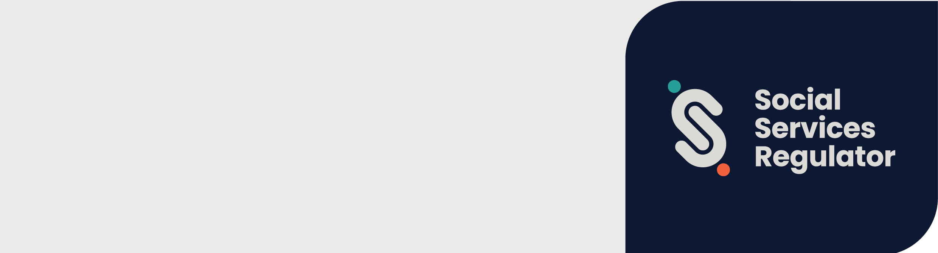

|  |
| --- |
| Policy – Compliance and  enforcement |
|  |
|  |

Contents

About this document 2

Background 2

Our role 3

Our expectation of duty holders 3

Minimising harm 4

Assessing risk 4

Consequence of harm 5

Likelihood of risk and harm 5

Overall risk 6

Attitude and culpability 7

Regulatory toolkit 8

Figure 2: Graduated approach to compliance 8

Table 4: Regulatory tools and levers 9

Table 5: Compliance and enforcement actions 9

Monitoring compliance 10

Responding to non-compliance 10

Reviews and appeals 10

# About this document

This document outlines the compliance and enforcement approach of the Social Services Regulator (the Regulator) and expectations of duty holders.

Through this document, the Regulator aims to:

* outline the regulatory tools used by the Regulator
* describe the Regulator’s approach to compliance and enforcement
* replace the **Compliance & Enforcement Policy** previously published by the Human Services Regulator.

This document should be considered in conjunction with the Regulator’s:

* **Regulatory Approach**
* **Annual Plan/Strategic Plan (to be developed)**

Key terms used in this document are defined on the Social Services Regulator’s website.

# Background

The *Social Services Regulation Act 2021* (the Act) prescribes the regulatory functions and powers of the Regulator. This policy provides clear direction on how the Regulator intends to use its compliance and enforcement powers under the Act.

We use a graduated, risk-based approach to regulation. We identify and assess risks presented by sectors and duty holders to help us make decisions, prioritise our resources and use our powers to make the greatest difference. This helps us to ensure the safety, health, and wellbeing of vulnerable Victorians. Our regulatory principles are reflected and applied at all stages of any regulatory response or action taken. The regulatory principles are outlined in our **Regulatory Approach***.*

The key elements of the Regulatory Approach include:

* Implementing a robust registration process that will identify risk of harm through assessing suitability, attitude, practice and adherence to organisational requirements.
* Support compliance through duty holder guidance and education.
* Reduce risk through proactive and planned monitoring and responding to incoming information about actual or alleged non-compliance.

Under the Act, service providers have a duty to provide social services that are safe and free from physical, emotional, sexual, and financial abuse, neglect, and exploitation. Service providers within scope of the Regulator, depending on organisational scope, will have duties arising from legislation, Social Service Standards, Child Safe Standards, guidelines and compliance codes.

As these duties arise from a service provider being registered, throughout this document, we will use the term ‘duty holders’.

The SSR will provide duty holders with guidance to assist them in understanding their obligations and recognises good performers in its risk-based approach to compliance monitoring. There are, however, those duty holders who fail to comply and may be deliberately non-compliant. The SSR responds more firmly and will escalate its compliance and enforcement response if a duty holder is resistant, uncooperative, evasive or does not take responsibility.

# Our role

The Regulator’s role is to protect the safety and rights of service users. The Act and Regulations provide us with a range of powers and regulatory tools to monitor and enforce compliance with that duty. These powers[1] allow us to:

* register social service providers[2]
* collect, analyse, and investigate[3] intelligence relating to confirmed or suspected non-compliance through incident reporting or compliance monitoring
* engage with co-regulators or other oversight bodies in joint regulatory activities and share information where warranted and legally permissible[4]
* investigate, monitor and enforce compliance with statutory obligations under the Social Services Standards and Child Safe Standards[5]
* impose, monitor and remove conditions on service provider registration under the Act[6]
* revoke service provider registration under the Act[7]
* Implement and administer the Worker Carer Exclusion Scheme under the Act[8].

## Our expectation of duty holders

The responsibility for compliance will always rest with the duty holder. The Regulator expects duty holders to comply with their obligations, and to engage in the following practices:

* review and understand guidelines, guidance and compliance codes published by the Regulator
* continuously work to maintain safe service delivery and quality
* engage and cooperate with the Regulator
* have processes in place to identify, manage, mitigate and communicate risks
* seek feedback from and act on complaints by clients, family members, carers, guardians and community visitors
* seek out relevant information and stay up to date with changing industry practices.

The Regulator understands that many duty holders want to comply with regulatory requirements and are seeking to improve their practice as part of delivering quality services.

The Regulator provides duty holders with guidance to improve compliance and recognises good performers in its approach to compliance monitoring.

There are, however, those who fail to comply and may be deliberately non-compliant. The Regulator responds more firmly and will escalate its compliance and enforcement response if a duty holder is resistant, uncooperative, evasive or does not take responsibility.

# Minimising harm

One of the Regulator’s primary objectives is to minimise risks of avoidable harm caused by abuse, exploitation or neglect in connection with the delivery of social services. The types of harm we seek to prevent, minimise and where possible, eliminate include but are not limited to:

* physical
* sexual
* emotional
* psychological
* financial
* cultural.

We also respond to harm or risks of harm caused by neglect and exploitation.

In directing its regulatory efforts, the Regulator will prioritise risks or instances of ‘Serious harm’. ‘Serious harm’ is defined under the Act as harm, whether a single instance of harm or repeated or persistent instances of harm, that results in one or more of the following:

* death
* loss of a foetus
* permanent or long-term serious impairment
* permanent or long-term serious disfigurement
* permanent or long-term severe psychological injury or developmental delay.

This definition is used for various purposes under the regulatory framework and is also used by the Regulator when assessing risk before determining a compliance and enforcement response.

# Assessing risk

Our graduated, risk-based approach uses compliance monitoring data and intelligence to analyse the likelihood of risks occurring and their harm to determine effective and proportionate regulatory responses to non-compliance.

To assess non-compliance, we analyse the:

* **consequence of harm** – the severity of potential or actual impact of harm on service users
* **likelihood of harm occurring or continuing** – how likely it is that the duty holder will breach their obligations, based on their compliance history, systems in place to identify and manage risk, capability to manage risk, the resources they dedicate to risk management and compliance attitude.

We also consider **duty holder attitude and culpability** as part of assessing risk. Culpability refers to the level of responsibility and attitude a duty holder displays in relation to risk, harm, and non-compliance.

These three elements form the Regulator’s overall assessment of non-compliance for each matter the Regulator receives within jurisdiction. The **overall risk** rating guides how we apply our compliance and enforcement powers in a predictable and proportionate manner.

## Consequence of harm

There are two key components the Regulator considers in the assessment of consequences of harm:

* identifying and assessing risk type
* identifying and assessing harm.

Risk can injure people in multiple ways. Often, the degree of harm to a person may worsen over time or be dependent on the individual. Therefore, the Regulator’s assessment of the consequences of harm considers both actual harm and potential for harm in each individual matter.

Table 1 provides a guide on the scale of harm or the consequences of harm the Regulator considers when it is determining the overall risk of a matter.

Table 1: Assessing consequence

| Rating | Description |
| --- | --- |
| Minor | * Minor injury * Minor temporary impairment * Restriction of activity and food choices * Short term loss of choice |
| Medium | * Moderate injury, exacerbation of existing illness or development of injury requiring regular treatment * Developmental issues * Financial harm with short-term impact |
| Major | * Premature expected death * Substantial or long-lasting injury or disability * Financial harm with long-term impact |
| Severe | * Death * Loss of a foetus * Permanent or long-term serious impairment * Permanent or long-term serious disfigurement * Permanent or long-term severe psychological injury or developmental delay * Severe, permanent or life-changing injury or disability |

## Likelihood of risk and harm

The Regulator considers the likelihood of non-compliance leading to risk and harm occurring or continuing based on the duty holder’s:

* compliance history (where applicable)
* quality of the systems in place to manage risks and harms
* quality of the systems in place to prevent future risks and harms
* knowledge, skills and capacity
* willingness to co-operate and remedy non-compliance.

Table 2 lists the most common factors the Regulator considers when assessing the likelihood of non-compliance occurring or continuing leading to risk and harm.

Table 2: Assessing the likelihood of risk and harm

| Rating | Description |
| --- | --- |
| Unlikely | * Duty holders who are willing to comply * Only isolated previous incidents of non-compliance * Good systems in place that identify risk and manages them efficiently |
| Possible | * Repeated non-compliance * Inadequate knowledge or skills * Poor risk identification and management |
| Likely | * Repeated patterns of non-compliance * Limited resources to meet regulatory requirements * High volume of notifiable incidents * Limited processes and systems in place to identify and manage risks |
| Certain | * History of repeated severe non-compliance * Failure to implement processes and systems to manage and identify risks * Refusal to comply, provide information and/or cooperate |

## Overall risk

The overall risk of harm is scaled and aligned with an appropriate regulatory response.

For example, where the **consequence** of risk of harm is ‘major’ and the **likelihood** of harm occurring or continuing might be ‘possible’, the regulatory response may be higher proportionate to the matter.

Figure 1 is the risk analysis scale the Regulator uses when determining an appropriate regulatory response. It combines the consequence of risk and likelihood of harm to determine the **overall risk** of a matter.

Figure 1: Risk analysis matrix

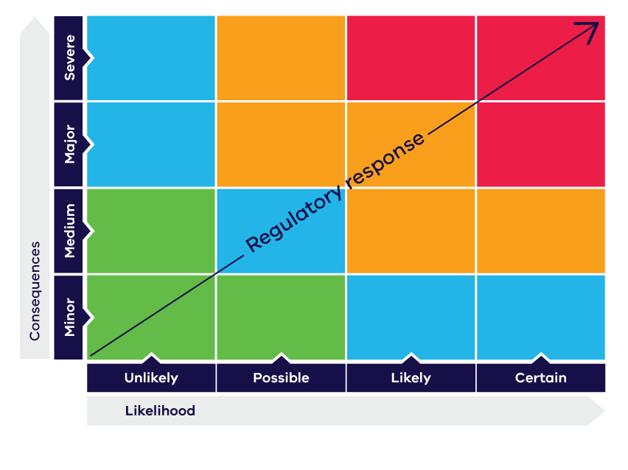

## Attitude and culpability

In addition to the **overall risk**, the Regulator will also consider the duty holder’s attitude, behaviour, and degree of culpability in relation to the matter.

Culpability refers to the level of responsibility, fault or wrongdoing of the duty holder if risk or harm occurs. For example, if a duty holder was aware of the risk of harm or potential for non-compliance, and wilfully chose not to take appropriate steps to mitigate the risk of harm or non-compliance, the Regulator will take this into consideration when deciding on the most appropriate regulatory response.

Table 3 outlines some of the risk factors the Regulator takes into consideration when assessing the compliance attitude of the duty holder prior to taking any compliance and enforcement action.

Table 3: Assessment of attitude and culpability

| Rating | Description |
| --- | --- |
| Minor | * Has no intention to cause harm * Proactively engages with regulatory process * Implements changes to prevent harms from recurring * No history of non-compliance |
| Medium | * Acknowledges regulatory process but lacks capacity to comply * Has lax attitude to compliance, requiring intervention by regulator * Demonstrates patterns of disregard towards compliance requirements * Fails to address reoccurrence of non-compliance |
| Major | * Reckless conduct that gives no thought to risk * Repeated non-compliance or systemic avoidance of compliance * Ignorant of compliance requirements * Exhibits behaviour that enables others' non-compliance * Failing to act despite knowing of existing harms and consequences of non-compliance * Non-acknowledgement or non-engagement with regulatory process |
| Severe | * Deliberate, wilful or misleading conduct that includes ongoing non-compliance * Deliberate omissions and action driven by personal gain * Deliberately inflicting harm, exploitative acts, predatory behaviour and criminal acts * No regard to obvious harm or consequences, or actively hindering regulatory action |

# Regulatory toolkit

The Regulator has a suite of regulatory tools and levers to promote, maintain and ensure compliance with the requirements of the scheme. We achieve our regulatory outcomes by adopting a risk-based, graduated approach to compliance (refer to Figure 2 below) and combining a variety of actions where required.

Table 4 sets out the five broad categories of regulatory tools and levers we use to facilitate our regulatory approach. The Regulator may take a range of compliance and/or enforcement actions including but not limited to those listed in Table 5.

## Figure 2: Graduated approach to compliance

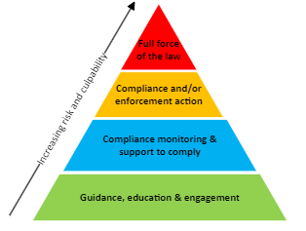

## Table 4: Regulatory tools and levers

| Tool | Role |
| --- | --- |
| Registration | Preventative risk management by identifying and screening applicants to ensure that they understand their legislative obligations and meet the suitability requirements.  Imposing interim or ongoing conditions to minimise risk or risk of harm. |
| Guidance and support to comply | Capacity building in response to identified minor non-compliances. |
| Information gathering and monitoring | Proactive and responsive measures to monitor compliance, identify risks and guide our decision making. |
| Referrals and co-regulation | Sharing information, joint operations and referrals to allow better targeting and broader reach in preventing non-compliances or addressing harms. This also seeks to reduce regulatory burden. |
| Compliance and enforcement actions | Interventions to stop or prevent non-compliances by duty holders from occurring and to prevent or minimise harm or risk of harm to service users. |

## Table 5: Compliance and enforcement actions

|  |  |
| --- | --- |
| Type of action | Scope |
| Requests for information | Multiple parties including service providers (including for the purposes of Child Safe Standards) |
| Enter premises with or without search warrant | Service providers (including for the purposes of Child Safe Standards) and unregistered providers in some circumstances |
| Improvement notices | Service providers (including for the purposes of Child Safe Standards) |
| Prohibition notices | Service providers |
| Verbal direction to cease activity | Service providers |
| Enforceable undertaking | Service providers (including for the purposes of Child Safe Standards) |
| Public warning notices | Service providers (including for the purposes of Child Safe Standards) |
| Adverse publicity orders | Service providers (including for the purposes of Child Safe Standards) |
| Suspension of service user intake notices | Service providers |
| Imposing conditions | Service providers and individuals |
| Variation of condition of registration by the Regulator | Service providers |
| Suspension of registration | Service providers |
| Revocation of registration | Service providers |
| Appointment of administrator | Service providers and unregistered providers in some circumstances |
| Infringement notices | Service providers (including for the purposes of Child Safe Standards) |

The Act also contains a range of indictable offences and civil penalties relating to the requirements of the scheme. In line with our graduated approach to regulation and where an unacceptable level of risk has been identified, the Regulator may pursue these sanctions and/or prosecution.

# Monitoring compliance

The Regulator takes a risk-based approach to monitoring compliance by duty holders with the Social Services Standards, Child Safe Standards (where applicable) and other requirements such as those specifically for supported residential services.

We use data and intelligence from notifications, incident reporting and other sources to inform our risk profiling and compliance monitoring frequency.

Compliance monitoring activities vary and may include requests for information from duty holders and on-site inspections of premises where social service delivery occurs.

## Responding to non-compliance

The Regulator’s response to identified non-compliance will be outcome focused, proportionate, predictable, fair and appropriate. The Regulator will consider a number of factors before taking regulatory action including but not limited to:

* the regulatory tools available
* the severity of harm or risk of harm
* the impact or potential impact on service user rights
* behaviour and compliance attitude of the duty holder
* the duty holder’s compliance history including frequency of non-compliance
* the impact to any service users, the duty holder and the community of any action we might take.

Considering the factors above allows the Regulator to respond to non-compliance and risk to the best of our ability and to the extent permitted under the Act and Regulations.

## Reviews and appeals

Where a duty holder is directly affected by a decision made by the Regulator, they can seek a review or appeal the decision. When the Regulator undertakes this review, it is called an internal review.

Where a duty holder affected by a decision is not satisfied with the outcome of an internal interview, in some circumstances the duty may apply for a review or appeal the decision through the Victorian Civil Administrative Tribunal (VCAT).

The Regulator does not provide legal advice to duty holders. Duty holders should always seek their own legal advice regarding their ability to have a decision reviewed or appealed.

|  |
| --- |
| To receive this document in another format, phone 1300 310 778 using the National Relay Service 13 36 77 if required, or email Social Services Regulator <enquiries@ssr.vic.gov.au>  Authorised and published by the Victorian Government, 1 Treasury Place, Melbourne.  © State of Victoria, Australia, Department of Families, Fairness and Housing, August 2024.  ISBN 978-1-76130-633-4 **(pdf/online/MS word)**  Available at <https://www.vic.gov.au/compliance-and-enforcement-policy-social-services-regulator> |

1. Functions and powers of the Regulator are outlined in section 13, SSR Act*.* 
2. SSR Act*,* Part 3, Division 1. *Social Services Regulations 2023* ss 17, 19 and 26.
3. SSR Act*,* ss 47, 48, 55, 57, 60, 108,109, 112, 113, 114, 119 and 122.
4. SSR Act, ss 14, 193, 195, 196 and 197.
5. SSR Act*,* ss14, 55, 57, Part 6 and Part 7.
6. SSR Act,ss 26, 103, 138, 143, 167, 169, 170 and 172.
7. SSR Act, ss 109, 171 and 172.
8. SSR Act, *ss* 57, 59. *Social Services Regulations 2023,* Part 5.