Koo Wee Rup Bypass pre-predator control and pre-construction Southern Brown Bandicoot and predator monitoring

Project: 13-025

Prep ared for:

VicRoads

©

This publication is copyright. It may only be used in accordance with the agreed terms of the commission. Except as provided for by the Copyright Act 1968, no part of this publication may be reproduced, stored in a retrieval system, or transmitted in any form or by any means, without prior written permission from Ecology Australia Pty Ltd.

Document information

This is a controlled document. Details of the document ownership, location, distribution, status and revision history are listed below.

All comments or requests for changes to content should be addressed to the document owner.

**Bioregion:**

|  |  |  |  |
| --- | --- | --- | --- |
| Owner | VicRoads | | |
| Author |  | | |
| Location |  | | |
| Distribution | Nadia Arkoudis | Senior Project Delivery Engineer | VicRoads |

|  |  |  |  |
| --- | --- | --- | --- |
| Document History | | | |
| Status | Changes | By | Date |
| **Final 1.0** | **Minor changes at the request of VicRoads** | **Jonathon Ricciardello** | **04-09-2013** |

Contents

Summary 1

1 Introduction 2

2 Study Area 4

3 Methods 5

3.1 Site selection 5

3.2 Data collection 5

3.3 Data Analysis 5

3.4 Limitations 6

4 Results 7

4.1 Southern Brown Bandicoot 7

4.2 European Red Fox 10

4.3 Feral/ Domestic Cat 11

5 Discussion 15

6 Recommendations 16

Acknowledgments 17

7 References 18

Tables

Table 1 Frequency that Southern Brown Bandicoot were recorded at sites surveyed during Spring 2011 and Autumn 2013 surveys. Shaded cells indicate sites that were surveyed during both 2011 and 2013 7

Table 2 Frequency that Red Foxes were recorded at sites surveyed during Spring 2011 and Autumn 2013 surveys. Shaded cells indicate sites that were surveyed during both 2011 and 2013 10

Table 3 Frequency that Feral/Domestic Cats were recorded were recorded at sites surveyed during both the 2011 and 2013 surveys. Shaded cells indicate sites that were surveyed during both 2011 and 2013 12

Figures

Figure 1 Koo Wee Rup Bypass Southern Brown Bandicoot records at Koo Wee Rup, April to May 2013. 9

Figure 2 Koo Wee Rup Bypass Red Fox and Cat records at Koo Wee Rup, April to May 2013. 14

Plates

Plate 1 Remote camera and lure setup, Autumn 2013 21

Appendices

**Appendix 1** 2011 Site activity data for SBB, foxes and cats 19

**Appendix 2** 2012 Site activity data for SBB, foxes and cats 20

**Appendix 3** Remote infra-red camera setup 21

Summary

#### Background

Ecology Australia was commissioned by VicRoads to undertake pre-predator control and pre-construction monitoring for the Southern Brown Bandicoot (*Isoodon obesulus obesulus*) (EPBC- Endangered; FFG-Listed, and classified as Near Threatened in Victoria) the Red Fox and Feral/domestic cat for Stage 1A of the Healesville - Koo Wee Rup Road upgrade.

#### Discussion

The Southern Brown Bandicoot was again found to be widespread across the study area and at sites consistent with previous surveys (Ecology Australia 2010 and 2013) with levels of activity consistent with the previous survey.

While foxes continued to occur across the study area, activity levels were significantly reduced between the 2011 and 2013 surveys. The reason for this may be due to seasonal differences in survey timing (Spring 2011 and Autumn 2013) or could be a result of predator control programs occurring across the surrounding landscape. Future surveys may provide information that will help to clarify this.

Activity levels for cats were low during both surveys periods with no significant difference between the 2011 and 2013 surveys.

#### Recommendations

* Continue to monitor Southern Brown Bandicoots within the study area, in accordance with the FMP to ascertain Southern Brown Bandicoot persistence within the study area, and ensure mitigation measures are effective in protecting the population;
* Maintain predator control program within and surrounding the study area to protect the Southern Brown Bandicoot from predation by foxes in line with the Koo Wee Rup Bypass EPBC Offset management Plan (Ecology Australia 2013b); and
* Take an adaptive approach to management of the Southern Brown Bandicoot population and respond to management issues as they are identified as outline in the Koo Wee Rup Bypass EPBC Offset management Plan (Ecology Australia 2013b).

# Introduction

Ecology Australia was commissioned by VicRoads to undertake pre-predator control and pre-construction baseline monitoring for the Southern Brown Bandicoot [(*Isoodon obesulus obesulus*) (EPBC- Endangered; FFG-Listed, and classified as Near Threatened in Victoria) for Stage 1A of the Healesville - Koo Wee Rup Road upgrade. Stage 1A represents a bypass of Koo Wee Rup township, from Manks Road to the South Gippsland Highway. This survey constitutes the second part of an ongoing monitoring program targeting the Bunyip River Drain Complex and Railway Road/disused South Gippsland Railway Line, within and surrounding the area proposed for the Koo Wee Rup Bypass. The monitoring program involves the use of infrared motion-sensing cameras set within and around the development footprint, before, during and post-construction, and prior to and during predator control works.

Surveys for the Southern Brown Bandicoot have previously been undertaken along the Healesville - Koo Wee Rup Road, between the Pakenham Bypass and South Gippsland Highway (Ecology Australia 2005, 2008, 2010, 2013). Southern Brown Bandicoots were recorded from the majority of levees associated the Bunyip River Drain Complex, within vegetation along the Railway Road/disused South Gippsland Railway line corridor, and at two sites along the existing Healesville – Koo Wee Rup Road north to Manks Road (Ecology Australia 2010, 2013).

This report provides the results of the combined pre-predator control and pre-construction monitoring survey undertaken for the Southern Brown Bandicoot along the Bunyip River Drain Complex, Railway Road/disused South Gippsland Railway Line and Healesville – Koo Wee Rup Road north to Manks Road. Monitoring surveys were undertaken between 17 April and 21 May 2013. Data collected from infrared cameras pertaining to introduced predators were also analysed to assist the predator control program with pre-predator control baseline data on predators in the area.

The purpose of on-going monitoring of the Southern Brown Bandicoot is to:

* assess the effectiveness of mitigation and success of management procedures implemented to protect Southern Brown Bandicoot populations (including the predator control program);
* determine the success of habitat rehabilitation as a remediation measure;
* ensure that construction of the Bypass does not significantly impact on the Southern Brown Bandicoot or its habitats;
* address any potentially threatening processes that may arise; and
* review, refine, develop and introduce new mitigation and management procedures, if needed, for this and future stages of the road upgrade (i.e. adaptive management).

Fox control will be undertaken as a mitigation strategy in the study area to:

* To provide a strategic measure to significantly reduce predation pressure in surrounding habitat, namely the Bunyip River Drain Complex.
* To enhance the viability of the local Southern Brown Bandicoot population to help mitigate the impacts of the Bypass.
* To reduce the risk of higher levels of predation of bandicoots associated with removal of vegetation for construction of the Bypass.
* To assist with re-colonisation of the area post-construction.

Mitigation and management measures that will be implemented for the Southern Brown Bandicoot are presented in the Fauna Management Plan (FMP) for the Koo Wee Rup Bypass (Ecology Australia 2013). Monitoring techniques are also presented in the FMP and will generally target the population and not individual animals.

# Study Area

The study area comprises the area around the Bunyip River Drain Complex, located south-west to north-east and 1.5 km west of Koo Wee Rup township (Figure 1). The area is part of the Healesville – Koo Wee Rup Road upgrade that runs from the Pakenham Bypass in the north, through to the South Gippsland Highway in the south. The project area is located c. 65 km south-east of Melbourne and within the Shire of Cardinia.

Stage 1A of the Healesville - Koo Wee Rup Road upgrade runs from Manks Road an constitutes a bypass of Koo Wee Rup, including a crossing over the Railway Road/disused South Gippsland Railway Line corridor, and the Bunyip River Drain Complex, and a connection to Rossiter Road to the southeast (Figures 1 and 2).

The Bunyip River Drain Complex comprises McGregors Drain, McDonalds Drain, North West Catch Drain, Bunyip River Main Drain and South East Catch Drain and is part of a resulting system that drained the former Koo Wee Rup Swamp.

The Southern Brown Bandicoot is restricted to remnant and exotic vegetation along drains and road reserves in the study area and surrounding landscape, which provides cover from predators. The Bypass alignment intersects habitat for the Southern Brown Bandicoot along the existing Healesville - Koo Wee Rup Road to the south of Manks Road, Railway Road/disused South Gippsland Railway Line and levees of the Bunyip River Drain Complex (Ecology Australia 2013).

# Methods

## Site selection

Site selection was predominantly based on the previous pre-construction monitoring undertaken in 2011 (Ecology Australia 2013). Sites included:

* two sets of non-impact reference sites downstream and south-west of the impact zone (sites, 16, 17, and 18, and sites 19, 20 and 21);
* two non-impact reference sites (sites 3 and 4) along the Bunyip River Drain Complex north of the Healesville – Koo Wee Rup Rd;
* six cameras deployed in impact sites immediately adjacent (three either side) of the bypass footprint along the Bunyip River Drain Complex (cameras 10, 11, 12, 13 ,14 and 15);
* three cameras north-east of the footprint along the Bunyip River Drain Complex (cameras 7, 8 and 9);
* two cameras either side of the footprint at Railway Road (cameras 5 and 6), and two cameras along the Healesville – Koo Wee Rup Road, north to Manks Road (cameras 1 and 2)(see Figure 1).

## Data collection

Twenty one Reconyx infrared cameras were deployed along the Bunyip River Drain Complex, Railway Road/disused South Gippsland Railway Line corridor, and along the existing Healesville – Koo Wee Rup Road north to Manks Road (See Figure 1) for a period of four weeks. Cameras were secured to small trees/shrubs with a cable and padlock. An attractant consisting of peanut butter, rolled oats, golden syrup and pistachio essence secured c. 2 m from the cameras in a purpose built bait holder (see Appendix, 3 Plate 1). Baits were refreshed in the middle of the four week deployment to maintain attractiveness to bandicoots, and to allow for camera maintenance (e.g. battery and/or memory card refreshing). All cameras were set to take still images.

At the end of the survey period cameras were collected and images were downloaded from memory cards onto a computer to for analysis.

## Data Analysis

Images were analysed for the Southern Brown Bandicoot, and two introduced predators, the Red Fox (*Vulpes vulpes*) and Feral Cat (*Felis catus)*. Each day or night that a target species was recorded at a site the site was given a score of one (1) for that species. In the instance where a target species was recorded in a sequence of images that crossed from day to night or *vice versa*, a period of at least one hour had to elapse prior to the next observation before the awarding of a point for that day or night (i.e. an hour between observations was considered adequate time for the observation to be considered independent).

The score was then tallied for each species at each site and then divided by the number of days the cameras were deployed to produce a standardised indication of the activity for that species at each site (no. visits per day).

This was then tallied and divided by the number of sites to produce a mean level of activity across the entire study area for each of the target species.

Data from the previous pre-construction monitoring (Spring 2011) was reviewed and analysed using the same methodology, and a comparison of (activity) data between the two surveys has been made using data from sites that were assessed during both survey periods. To determine if a significant difference in activity levels for each target species occurred between the two surveys a paired T-Test was run on these data. The difference was considered to be significant when the T-value attained a probability of less than 0.05.

## Limitations

There are a number of limitations associated with the use of cameras for monitoring populations as cameras provide data on the presence or absence of a species as opposed to data about the population size and/or abundance of the species. The use of the activity index is an attempt to reduce the risk of not detecting change within the population by providing an indication of animal activity across the site which can be compared between surveys.

# Results

The results of the camera monitoring are presented in Figures 1 and 2, and described below.

## Southern Brown Bandicoot

Southern Brown Bandicoots were recorded at 14 sites (67% of sites), comprising:

* Both camera sites along Railway Road/disused South Gippsland Railway Line, adjoining the Koo Wee Rup Bypass crossing (Sites 5 and 6);
* two impact sites either side of the Bypass footprint on levees associated with the Bunyip River Drain Complex (Sites 12 and 13);
* five of the six reference sites to the southwest of the proposed bypass along the Bunyip River Drain Complex (Sites 16, 17, 18, 19 and 21);
* two of the three sites between the Healesville- Koo Wee Rup Road and Bypass footprint along the Bunyip River Drain Complex (Sites 7 and 9);
* both sites along the existing Healesville - Koo Wee Rup Road, north of the Bunyip River Drain Complex (Sites 1 and 2); and
* one of the reference sites north of the existing Healesville - Koo Wee Rup Rd along the Bunyip River Drain Complex (Site 4).

Seventeen sites were surveyed during both the 2011 and 2013 surveys, allowing a comparison of activity data between the two surveys (Table 1).

Activity levels (based on the activity index of each site) varied between surveys. However, when comparing the overall activity from sites that were surveyed in 2011 and 2013 the level of activity is consistent survey periods. The paired t-test indicates that there is not a statistically significant difference in the level of Southern Brown Bandicoot activity between surveys (P>0.05).

Table Frequency that Southern Brown Bandicoot were recorded at sites surveyed during Spring 2011 and Autumn 2013 surveys. Shaded cells indicate sites that were surveyed during both 2011 and 2013

| **Site Spring 2011** | **Activity Spring 2011 (visits/day)** | **Site Autumn 2013** | **Activity Autumn 2013 (visits/day)** |
| --- | --- | --- | --- |
| **Not Surveyed** | | 1 | 0.03 |
| 2 | 0.22 |
| 3 | 0.00 |
| 4 | 0.09 |
| 21, 9 | 0.09 | 5 | 0.81 |
| 11, 23 | 0.24 | 6 | 0.78 |
| 20,17 | 0.10 | 7 | 0.12 |
| 27, 14 | 0.09 | 8 | 0.00 |
| **Not surveyed** | | 9 | 0.03 |
| 16, 19 | 0.45 | 10 | 0.00 |
| 34 | 0.00 | 11 | 0.00 |
| 26 | 0.00 | 12 | 0.06 |
| 4, 25 | 0.03 | 13 | 0.15 |
| 13, 31 | 0.00 | 14 | 0.00 |
| 35 | 0.08 | 15 | 0.00 |
| 1 | 0.15 | 16 | 0.03 |
| 3 | 0.46 | 17 | 0.21 |
| 5 | 0.15 | 18 | 0.03 |
| 18 | 0.45 | 19 | 0.09 |
| 24 | 0.15 | 20 | 0.00 |
| 29 | 0.00 | 21 | 0.06 |
| 22, 10 | 0.45 | **Not Surveyed** | |
| 6, 30 | 0.00 |
| 32 | 0.00 |
| 12 | 0.00 |
| 36 | 0.38 |
| 8 | **Not Surveyed** |
| 7, 33 | 0.18 |
| **Study area activity index (repeat sites)** | **0.15** | **0.15** | |
| **Paired T-Test T=** | **0.94** | | |
| **% of sites SBB recorded (repeat sites)** | **75** | **63** | |
| **Study area activity index (all sites)** | **0.18** | **0.13** | |
| **% of sites recorded (all sites)** | **65** | **67** | |

Figure Koo Wee Rup Bypass Southern Brown Bandicoot records at Koo Wee Rup, April to May 2013.

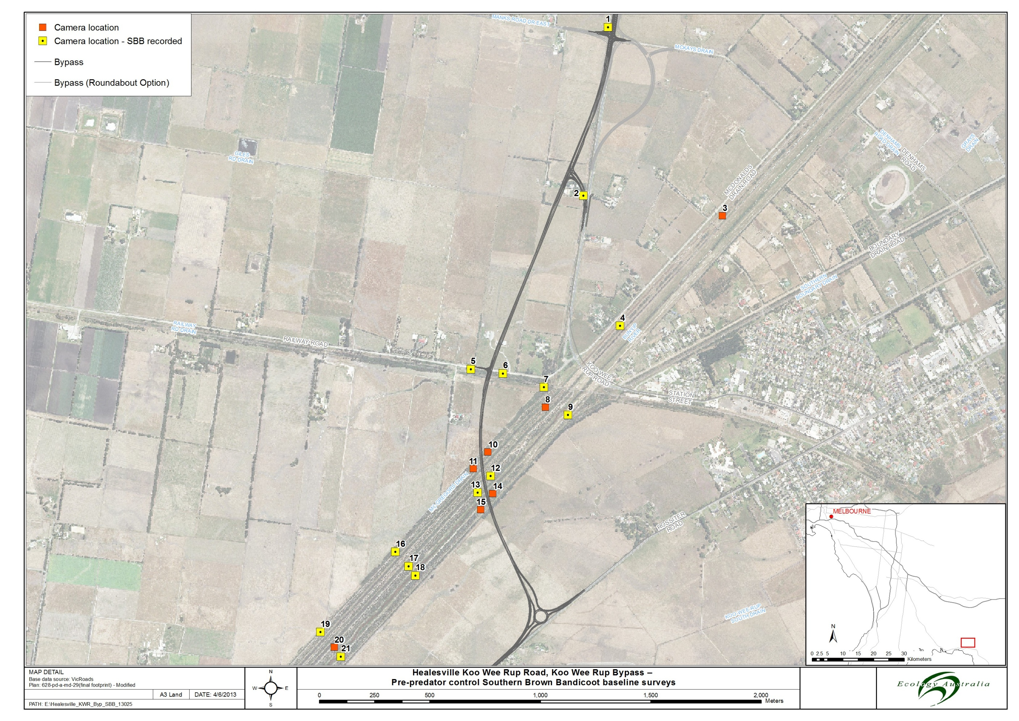

*The above pictures show the Koo Wee Rup Bypass alignment with Southern Brown Bandicoot Monitoring survey reference points of the following: camera locations as orange squares, camera locations where Southern Brown Bandicoots are located as a yellow squares.*

## European Red Fox

European Red Foxes were recorded from ten of the 21 sites across the study area, representing 48% of the sites surveyed. Red foxes were recorded at:

* The intersection of Manks Road and the Healesville – Koo Wee Rup Road (Site 1);
* Both camera sites along Railway Road/disused South Gippsland Railway Line, adjoining the Koo Wee Rup Bypass crossing (Sites 5 and 6);
* Both sites along the Buniyp River Drain Complex to the north of the existing Healesville – Koo Wee Rup Road (Site 3 and 4).
* Sites 7 and 9 along the Bunyip River Drain Complex near the disused South Gippsland Railway Line;
* Site 14 adjacent to the Bypass crossing of the Bunyip River Drain Complex; and
* Reference Sites 16 and 17 to the south-west of the Bypass crossing of the Bunyip River Drain Complex.

The comparison of activity data between for the 17 sites that were surveyed during the 2011 and 2013 surveys is presented in Table 2.

This data demonstrated that activity levels of foxes was overall lower during the 2013 survey when compared to the 2011 survey. The paired t-test indicates that there is a statistically significant difference in the level of Red Fox activity between surveys (P<0.05).

Table Frequency that Red Foxes were recorded at sites surveyed during Spring 2011 and Autumn 2013 surveys. Shaded cells indicate sites that were surveyed during both 2011 and 2013

| **Site Spring 2011** | **Activity Spring 2011 (visits/day)** | **Site Autumn 2013** | **Activity Autumn 2013 (visits/day)** |
| --- | --- | --- | --- |
| **Not Surveyed** | | 1 | 0.16 |
| 2 | 0.00 |
| 3 | 0.03 |
| 4 | 0.06 |
| 21, 9 | 0.03 | 5 | 0.03 |
| 11, 23 | 0.03 | 6 | 0.03 |
| 20,17 | 0.00 | 7 | 0.03 |
| 27, 14 | 0.09 | 8 | 0.00 |
| **Not surveyed** | | 9 | 0.03 |
| 16, 19 | 0.00 | 10 | 0.00 |
| 34 | 0.00 | 11 | 0.00 |
| 26 | 0.10 | 12 | 0.00 |
| 4, 25 | 0.18 | 13 | 0.00 |
| 13, 31 | 0.21 | 14 | 0.03 |
| 35 | 0.00 | 15 | 0.00 |
| 1 | 0.00 | 16 | 0.09 |
| 3 | 0.15 | 17 | 0.03 |
| 5 | 0.00 | 18 | 0.00 |
| 18 | 0.00 | 19 | 0.00 |
| 24 | 0.10 | 20 | 0.00 |
| 29 | 0.10 | 21 | 0.00 |
| 22, 10 | 0.03 | **Not Surveyed** | |
| 6, 30 | 0.15 |
| 32 | 0.00 |
| 12 | 0.46 |
| 36 | 0.00 |
| 7, 33 | 0.00 |
| **Study area activity index (repeat sites)** | **0.06** | **0.02** | |
| **Paired T-Test T** | **0.03** | | |
| **% of sites Red fox recorded (repeat sites)** | **56** | **38** | |
| **Study area activity index (all sites)** | **0.07** | **0.03** | |
| **% of sites Red fox recorded (all sites)** | **55** | **48** | |

## Feral/ Domestic Cat

Cats were recorded at six of the 21 sites, representing 29% of the sites surveyed. Cats were recorded at:

* Both camera sites along Railway Road/disused South Gippsland Railway Line, adjoining the Koo Wee Rup Bypass crossing (sites 5 and 6);
* Both sites along the Buniyp River Drain Complex to the north of the Healesville – Koo Wee Rup Road (Site 3 and 4);
* Site 14 adjacent to the proposed bypass crossing of the Bunyip River Drain Complex
* Reference site 21 to the south-west of the proposed bypass crossing of the Bunyip River Drain Complex.

Activity levels (based on the activity index of each site) were generally low with relatively consistent activity levels when comparing activity at sites sampled during both 2011 and 2013 surveys (Table 3). The paired t-test indicates that there is no statistically significant difference in the level of Cat activity between surveys (P>0.05).

Table Frequency that Feral/Domestic Cats were recorded were recorded at sites surveyed during both the 2011 and 2013 surveys. Shaded cells indicate sites that were surveyed during both 2011 and 2013

| **Site Spring 2011** | **Activity Spring 2011 (visits/day)** | **Site Autumn 2013** | **Activity Autumn 2013 (visits/day)** |
| --- | --- | --- | --- |
| **Not Surveyed** | | 1 | 0.00 |
| 2 | 0.00 |
| **3** | 0.13 |
| **4** | 0.09 |
| 21, 9 | 0.00 | 5 | 0.03 |
| 11, 23 | 0.09 | 6 | 0.03 |
| 20,17 | 0.00 | 7 | 0.00 |
| 27, 14 | 0.00 | 8 | 0.00 |
| **Not surveyed** | | 9 | 0.00 |
| 16, 19 | 0.00 | 10 | 0.00 |
| 34 | 0.00 | 11 | 0.00 |
| 26 | 0.00 | 12 | 0.00 |
| 4, 25 | 0.00 | 13 | 0.00 |
| 13, 31 | 0.00 | 14 | 0.03 |
| 35 | 0.00 | 15 | 0.00 |
| 1 | 0.00 | 16 | 0.00 |
| 3 | 0.00 | 17 | 0.00 |
| 5 | 0.00 | 18 | 0.00 |
| 18 | 0.00 | 19 | 0.00 |
| 24 | 0.00 | 20 | 0.00 |
| 29 | 0.00 | 21 | 0.06 |
| **22, 10** | 0.09 | **Not Surveyed** | |
| **6, 30** | 0.00 |
| **32** | 0.00 |
| **12** | 0.00 |
| **36** | 0.00 |
| **7, 33** | 0.00 |
| **Study area activity index(repeat sites)** | **0.01** | **0.01** | |
| **Paired T-Test T** | **0.62** | | |
| **% of sites Cats recorded(repeat sites)** | **6** | **25** | |
| **Study area activity index(all sites)** | **0.01** | **0.02** | |
| **% of sites recorded(all sites)** | **9** | **29** | |

Figure Koo Wee Rup Bypass Red Fox and Cat records at Koo Wee Rup, April to May 2013.

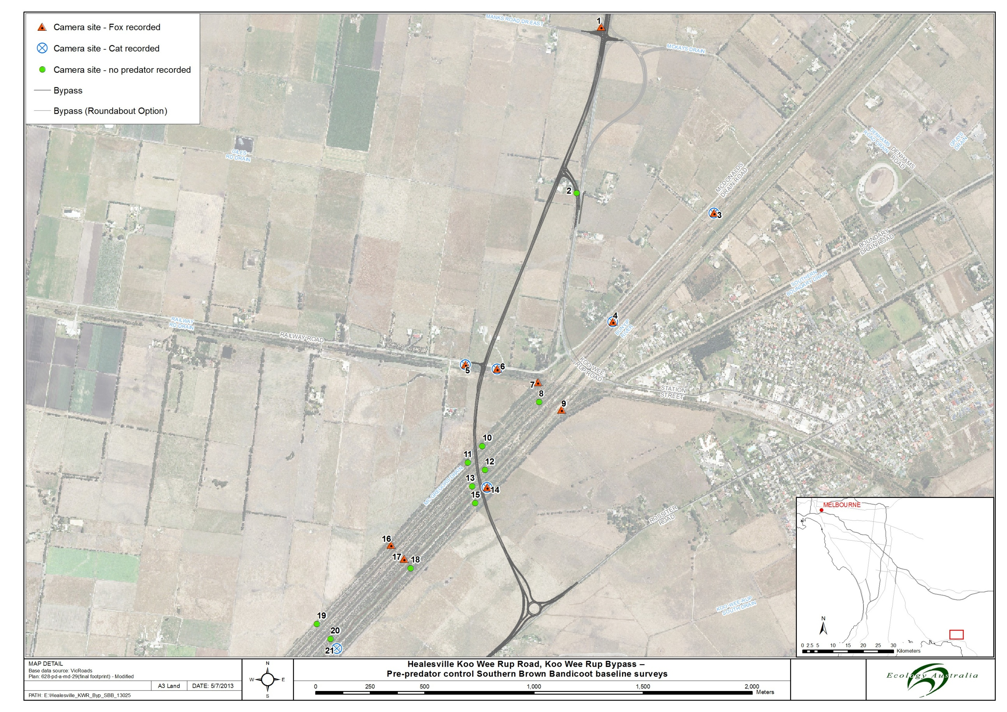

*The above pictures show the Koo Wee Rup Bypass alignment with Red Fox and Cats recorded survey reference points of the following: Camera site where Red fox’s recorded as orange triangle, camera sites where cats were recorded as blue line circle with an x in the centre, camera site where no predators were recorded as green circle.*

# Discussion

The Southern Brown Bandicoot was again found to be widespread across the study area and at sites consistent with previous surveys (Ecology Australia 2010 and 2013). This survey confirmed:

* The presence of Southern Brown Bandicoots to the north-east of the Healesville – Koo Wee Rup Road along the Bunyip River Drain Complex;
* Its continued presence along the Healseville – Koo Wee Rup Road north to Manks Rd; and
* The importance of the study area as habitat for the species.

Activity levels of the Southern Brown Bandicoot were found to be consistent with the previous survey.

While foxes continued to occur across the study area, activity levels were significantly reduced between the 2011 and 2013 surveys. The reason for this may be due to seasonal differences in survey timing (Spring 2011 and Autumn 2013) or could be a result of predator control programs occurring across the surrounding landscape. Future surveys may provide information that will help to clarify this.

Activity levels for cats were low during both surveys periods with no significant difference between the 2011 and 2013 surveys.

# Recommendations

* Continue to monitor Southern Brown Bandicoots within the study area, particularly during construction to ascertain Southern Brown Bandicoot persistence within the study area, and ensure mitigation measures are effective in protecting the population;
* Maintain predator control program within and surrounding the study area to protect the Southern Brown Bandicoot from predation by foxes in line with the Koo Wee Rup Bypass EPBC Offset management Plan (Ecology Australia 2013b); and
* Take an adaptive approach to management of the Southern Brown Bandicoot population and respond to management issues as they are identified as outline in the Koo Wee Rup Bypass EPBC Offset management Plan (Ecology Australia 2013b).

# Acknowledgments

We would like to thank the following people for assistance with field work and the production of this report:

* Nadia Arkoudis (VicRoads); and
* Jamie McMahon (Ecology Australia).

# References

Ecology Australia (2005). Healesville – Koo Wee Rup Road Southern Brown Bandicoot Survey. Report prepared for VicRoads by Renowden, C., Quin, D.G. and Moysey, E. (Ecology Australia Pty Ltd: Fairfield).

Ecology Australia (2008). Healesville – Koo Wee Rup Road Upgrade: Southern Brown Bandicoot Survey. Report prepared for VicRoads by Renowden, C. and Marr, R. (Ecology Australia Pty Ltd: Fairfield).

Ecology Australia (2009). Southern Brown Bandicoot Strategic Management Plan for the former Koo Wee Rup Swamp Area. Report prepared for Cardinia Shire Council, Casey City Council and Melbourne Water by Schmidt, B., Renowden, C. and Quin, D.G. (Ecology Australia Pty Ltd: Fairfield).

Ecology Australia (2010a). Healesville – Koo Wee Rup Road Southern Brown Bandicoot Remote Camera Survey. Schmidt, B. (Ecology Australia Pty Ltd: Fairfield.)

Ecology Australia (2013a). Koo Wee Rup Bypass: Southern Brown Bandicoot Pre Construction Monitoring. McMahon J, Quin D and McMahon A (Ecology Australia Pty Ltd: Fairfield.)

Ecology Australia (2013b). Koo Wee Rup Bypass Environment Protection and Biodiversity Conservation Act 199 Offsets Management Plan. Quin D and McMahon A (Ecology Australia Pty Ltd: Fairfield.)

**Appendix 1** 2011 Site activity data for SBB, foxes and cats

Shaded cells indicate sites surveyed during both 2011 and 2013.

| **2011 Survey** | **Days surveyed** | **SBB activity score** | **SBB standardised activity score** | **Fox activity score** | **Fox standardised activity score** | **Cat activity score** | **Cat standardised activity score** |
| --- | --- | --- | --- | --- | --- | --- | --- |
| 21 and 9 | 33 | 3 | 0.09 | 1 | 0.03 | 0 | 0 |
| 11 and 23 | 33 | 8 | 0.24 | 1 | 0.03 | 3 | 0.09 |
| 20 and 17 | 20 | 2 | 0.10 |  | 0.00 | 0 | 0.00 |
| 27 and 14 | 33 | 3 | 0.09 | 3 | 0.09 | 0 | 0.00 |
| 16 and 19 | 20 | 9 | 0.45 | 0 | 0.00 | 0 | 0.00 |
| 34 | 13 | 0 | 0.00 | 0 | 0.00 | 0 | 0.00 |
| 26 | 20 | 0 | 0.00 | 2 | 0.10 | 0 | 0.00 |
| 4 and 25 | 33 | 1 | 0.03 | 6 | 0.18 | 0 | 0.00 |
| 13 and 31 | 33 | 0 | 0.00 | 7 | 0.21 | 0 | 0.00 |
| 35 | 13 | 1 | 0.08 | 0 | 0.00 | 0 | 0.00 |
| 1 | 13 | 2 | 0.15 | 0 | 0.00 | 0 | 0.00 |
| 3 | 13 | 6 | 0.46 | 2 | 0.15 | 0 | 0.00 |
| 5 | 13 | 2 | 0.15 | 0 | 0.00 | 0 | 0.00 |
| 18 | 20 | 9 | 0.45 | 0 | 0.00 | 0 | 0.00 |
| 24 | 20 | 3 | 0.15 | 2 | 0.10 | 0 | 0.00 |
| 29 | 20 | 0 | 0.00 | 2 | 0.10 | 0 | 0.00 |
| 22 and 10 | 33 | 15 | 0.45 | 1 | 0.03 | 3 | 0.09 |
| 6 and 30 | 20 | 0 | 0.00 | 3 | 0.15 | 0 | 0.00 |
| 32 | 20 | 0 | 0.00 | 0 | 0.00 | 0 | 0.00 |
| 12 | 13 | 0 | 0.00 | 6 | 0.46 | 0 | 0.00 |
| 36 | 13 | 5 | 0.38 | 0 | 0.00 | 0 | 0.00 |
| 7 and 33 | 33 | 25 | 0.76 | 0 | 0.00 | 0 | 0.00 |

**Appendix 2** 2012 Site activity data for SBB, foxes and cats

Shaded cells indicate sites surveyed during both 2011 and 2013.

| **2013 survey** | **Days surveyed** | **SBB activity score** | **SBB standardised activity score** | **Fox activity score** | **Fox standardised activity score** | **Cat activity score** | **Cat standardised activity score** |
| --- | --- | --- | --- | --- | --- | --- | --- |
| **1** | **32** | 1 | 0.03 | 5 | 0.16 | 0 | 0.00 |
| **2** | **32** | 7 | 0.22 | 0 | 0.00 | 0 | 0.00 |
| **3** | **32** | 0 | 0.00 | 1 | 0.03 | 4 | 0.13 |
| **4** | **32** | 3 | 0.09 | 2 | 0.06 | 3 | 0.09 |
| **5** | **32** | 26 | 0.81 | 1 | 0.03 | 1 | 0.03 |
| **6** | **32** | 25 | 0.78 | 1 | 0.03 | 1 | 0.03 |
| **7** | **33** | 4 | 0.12 | 1 | 0.03 | 0 | 0.00 |
| **8** | **33** | 0 | 0.00 | 0 | 0.00 | 0 | 0.00 |
| **9** | **33** | 1 | 0.03 | 1 | 0.03 | 0 | 0.00 |
| **10** | **32** | 0 | 0.00 | 0 | 0.00 | 0 | 0.00 |
| **11** | **32** | 0 | 0.00 | 0 | 0.00 | 0 | 0.00 |
| **12** | **33** | 2 | 0.06 | 0 | 0.00 | 0 | 0.00 |
| **13** | **33** | 5 | 0.15 | 0 | 0.00 | 0 | 0.00 |
| **14** | **33** | 0 | 0.00 | 1 | 0.03 | 1 | 0.03 |
| **15** | **33** | 0 | 0.00 | 0 | 0.00 | 0 | 0.00 |
| **16** | **32** | 1 | 0.03 | 3 | 0.09 | 0 | 0.00 |
| **17** | **33** | 7 | 0.21 | 1 | 0.03 | 0 | 0.00 |
| **18** | **33** | 1 | 0.03 | 0 | 0.00 | 0 | 0.00 |
| **19** | **32** | 3 | 0.09 | 0 | 0.00 | 0 | 0.00 |
| **20** | **32** | 0 | 0.00 | 0 | 0.00 | 0 | 0.00 |
| **21** | **33** | 2 | 0.06 | 0 | 0.00 | 2 | 0.06 |

**Appendix**  Remote infra-red camera setup in Koo Wee Rup area

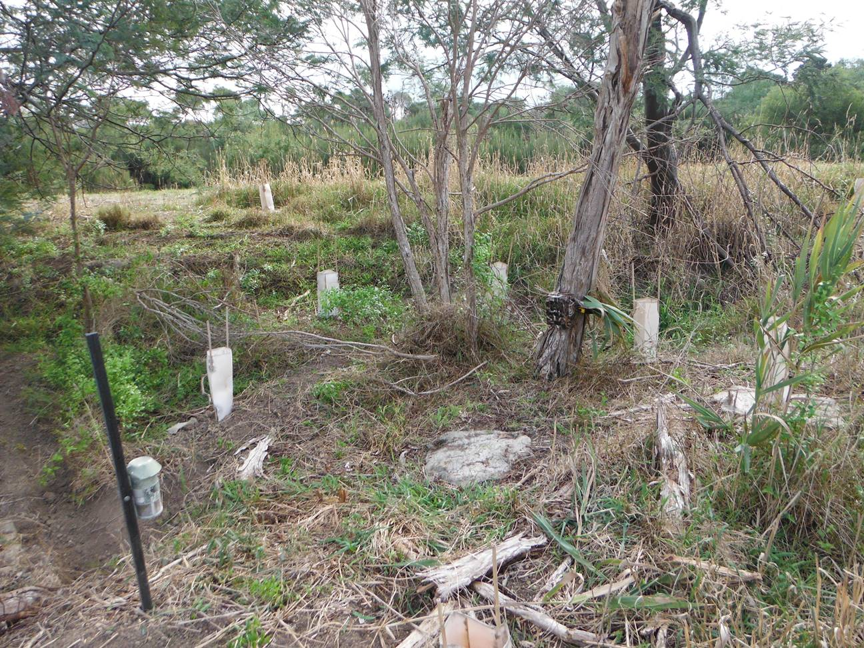

Plate Remote camera and lure setup, Autumn 2013