Koo Wee Rup Bypass Project
Pest Predator Control Program
Results for August 2013

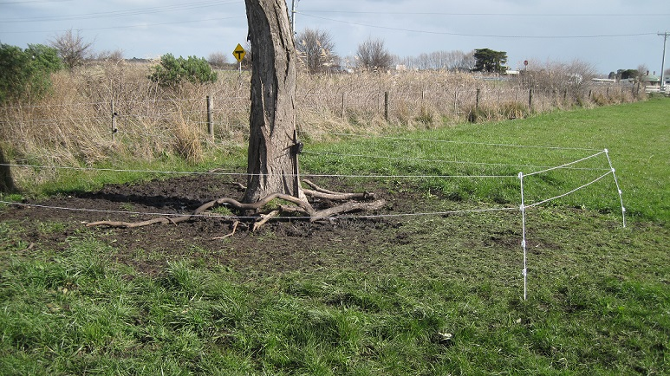

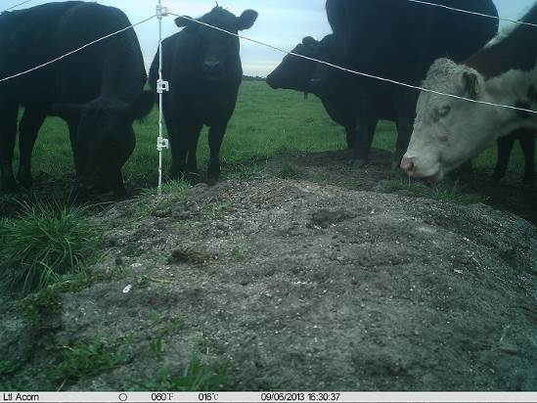

Prepared for VicRoads, South Eastern Projects
by Kathy Himbeck & Andrew Douglas

Report 13018-2, Version 1.0
November 2013

Contents
1 Introduction 3
2 Background 4
2.1 Baited area 4
2.2 Site Selection 5
3 Installation of bait stations 7
3.1 Notification 7
3.2 Bait Stations 8
3.3 Remote Sensing Camera 8
3.4 Signage 9
4 Monitoring bait stations 10
4.1 Bait stations 10
4.2 Camera Data 10
5 Results 12
5.1 Bait station 1 & 2 (property 1) 12
5.2 Bait station 3, 4, 5 & 6 (property 2) 12
5.3 Bait station 7, 8 & 9 (property 3) 13
5.4 Bait station 10 & 11 (property 4) 13
6 Targeted Fauna Surveys 14
6.1 Site Selection 14
6.2 Data Collection 16
6.3 Data Analysis 16
6.4 Results 17
7 Discussions 18
7.1 Predator Control 18
7.2 Fauna Surveys 18
8 Recommendations 20
APPENDIX 21

Front cover: The image on the left shows an electric fence setup at bait station one, set around a paddock tree and on the right is an image taken from bait station eight showing cattle access being restricted from trampling the station due to the electric fence.

Introduction
In April 2013, Vic Roads, South Eastern Projects, commissioned Vermin Control, with assistance from Abzeco Pty Ltd to undertake a pest predator control program to reduce the predation pressure on the population of Southern Brown Bandicoots within the area of the Bunyip River Drain Complex and the vegetation corridor between the disused railway line and Railway Road that is associated with the construction of the Koo Wee Rup Bypass.
The pest predator control program for the Koo Wee Rup Bypass Project, has exclusively used the technique of pulse baiting with 1080 baits to strategically control the population of foxes in the study area. Pulse baiting is the term used for short periods of baiting (4-5 weeks) with a break of no baiting in between (4 weeks) and is employed in preference over continuous baiting (eg. 10-20 weeks).
The initial pulse baiting period was completed from 17 May to 1 July 2013 with nine bait stations, complete with cameras, operating over differing periods as accessibility to private property was established. A total of nine bait stations were monitored over three properties. The second period of pulse baiting commenced on 6 August 2013 and was completed on 29 September 2013, with cameras installed at the same nine bait stations and operational for the duration of the baiting period. The original nine bait stations were reactivated with two additional bait stations installed on a fourth property as it became accessible later during the baiting period. All participating and surrounding properties were notified and 1080 baiting signs were refreshed, installed and updated with the current information.
To further inform on the current status of the fox population across the entire project site, a camera fauna survey program was conducted over a two week period targeting the more suitable habitat along the Bunyip drainage channel network. At this stage, this area is not able to be baited and so has not been included in the ongoing monitoring that the Pest Predator Control Program has achieved.
This report presents the results of the second period of pulse baiting of the pest predator control program undertaken for the Koo Wee Bypass Project in June 2013 and is intended to inform future predator control programs on the site.

Background
The Koo Wee Rup Bypass will link the Healesville - Koo Wee Rup Road with the South Gippsland Highway. The area of pest predator control program extends from Manks Rd to the South Gippsland Highway following the proposed alignment. The Bypass alignment intersects areas of known core habitat for the Southern Brown Bandicoot, a threatened species, listed under the Commonwealth Environment Protection and Biodiversity Conservation Act 1999 (EPBC) and Victorian Flora and Fauna Guarantee Act 1988. These areas include remnant and exotic vegetation along drains and road reserves along:
- the Healesville - Koo Wee Rup Road near Manks Rd,
- the area of Railway Road and the disused South Gippsland Railway Line, and
- levees of the Bunyip River Drain Complex.
Reduction of habitat and fragmentation are likely impacts to the Southern Brown Bandicoot from the construction of the project. One of the strategic mitigation tools being implemented to protect this threatened and iconic species of the area, is intensive predator control to significantly reduce predation pressure along those areas of known habitat that the Bypass alignment intersects.
The Pest Predator Control Program involved the use of pulse baiting with 1080 baits as the predominant method for fox control. In urban areas where domestic animals are within relatively close proximity to the baited area, pulse baiting is considered most effective compared to continuous baiting, reducing the time 1080 poison is present in the environment yet still retaining its effectiveness as a form of fox control. Of the parcels of land that the Bypass alignment intersects, only those properties that provided consent were able to be involved in the pest predator control program.

Baited area
The area of extent of the Pest Predator Control Program includes a selection of properties that are directly impacted by the construction of the Koo Wee Rup Bypass Project. Properties extend from north of Manks Road, along the Healesville – Koo Wee Rup Road and alongside the Bunyip River Drain Complex to the South Gippsland Highway.
A description of the location of all of the participating properties includes:
- Property 1 – the property in the north east corner of the junction of McKays and Healesville - Koo Wee Rup Roads, Koo Wee Rup (Bait station 1 and 2).
- Property 2 – the property lies between Rossiter Road and the Bunyip River Drain Complex to the south east, extending south of the disused railway (Bait station 3, 4, 5 and 6).
- Property 3 – the property lies between Rossiter Road and the Bunyip River Drain Complex to the south east, extending north of the South Gippsland Highway (Bait station 7, 8 and 9).
- Property 4 – the property in the south west corner of the junction of Railway Road and Bunyip River, Koo Wee Rup (Bait station 10 and 11).
Appendix 1 provides a map that shows the location of these baited properties.

Site Selection
Sites were chosen predominately using the same location previously located as it was considered they still met all the original desirable requirements. These included:
- In accordance with any landholder requests;
- The most suitable position in the vicinity that a fox would be attracted to;
- Within close proximity to suitable habitat/harbor for the Southern Brown Bandicoot;
- Suitably elevated to provide sufficient protection to the baits to minimise any denaturing of the 1080 from existing environmental elements such as water logging;
- Protected where possible from cattle present in the paddock;
- Relatively easily accessible.
The location of each of the new and previously used bait stations were also determined by the following minimum distance criteria that 1080 bait users must adhere to in accordance with the ‘Directions for the Use of 1080 Pest Animal Bait Products in Victoria’ as prescribed by the Victorian Department of Environment and Primary Industries (DPI, 2007):
A minimum distance of 150m from a dwelling;
- A minimum distance of 20m from permanent or flowing water bodies;
- A minimum distance of 20m from domestic drinking water supply;
- A minimum distance of 5m from boundary fences;
- A minimum distance of 5m from the edge of formed public roadways.
A description of the location of each of the bait stations in operation during this second period of pulse baiting includes:
- Station 1 – at the base of a tree, in a paddock used for cattle, in close proximity to thick, weedy roadside vegetation along McKays Road.
- Station 2 – approximately 300m north of Station 1 in the junction of four paddocks.
- Station 3 – amongst an established, mature shelter belt along the fence line of a paddock used for cattle within property 2, more than 200m west of the homestead.
- Station 4 – Approximately 200m west of Station 3 on the north side of a large mature patch of Blackberry and farm debris (within property 2).
- Station 5 – Approximately 200m north-north-west of Station 4, along an internal fence line of a paddock used for cattle, within close proximity of thick vegetation along the Bunyip River Drain Complex (within property 2).
- Station 6 – Approximately 300m north-east of Station 5, amongst a small pile of woody debris in a paddock used for cattle, within close proximity of thick vegetation along the Bunyip River Drain Complex (within property 2).
- Station 7 – More than 500m north-north-west of the homestead , along an internal fence line of a paddock used for cattle, within close proximity of thick vegetation along the Bunyip River Drain Complex, 1.2km north-east of the South Gippsland Highway (within property 3).
- Station 8 - Over 300m south-west of Station 7along an internal fence line of a paddock used for cattle, within close proximity of thick vegetation along the Bunyip River Drain Complex (within property 3).
- Station 9 - Over 400m south-west of Station 8along an internal fence line of a paddock used for cattle, within close proximity of thick vegetation along the Bunyip River Drain Complex (within property 3).
- Station 10 – Over 300m roughly east of the homestead, on the edge of thick vegetation that is contiguous with vegetation along the Bunyip River Drain Complex in a paddock that has cattle recently removed.
- Station 11 - Over 250m roughly south of the homestead, on the edge of thick vegetation that is contiguous with vegetation along the Bunyip River Drain Complex in a paddock that has cattle recently removed.
Appendix 1 provides this information in a map.

Installation of bait stations
A risk assessment for the use of 1080 was carried out for the site prior to the installation of the bait stations.

Notification
On 5 August 2013 all of the participating properties and those adjoining, adjacent or in close proximity to the properties participating in the baiting program were provided notification of the baiting program through the mail. The parameters of this notification included those properties associated with bait stations one through to nine and potential cat trapping activities. In addition, the two veterinary clinics in the town of Koo Wee Rup were also provided with the same notification information via hand delivery.
From the data collected from the initial round of fox baiting and the information gathered from pre-predator and pre-construction fauna and predator monitoring surveys (Ecology Australia), it is evident that cat and fox activity is present along the habitat corridors of the drainage channels. This area is not able to be baited, so given these restricted parameters the ability to use cage traps and/or legholds traps as another potential method of predator control was initiated. A notification letter was distributed to adjoining properties providing residents with information on the responsibilities of cat owners by law, the proposed trapping area and potential impacts to domestic cats caught during the trapping program.
Included in the mail out was:
- a letter from Vermin Control providing information about the program and contact details if required,
- An appropriately completed ‘Neighbour Notification of Vertebrate Pest Control using 1080 Pest Animal Bait Products’ provided by the Department of Primary Industries (DPI), and
- A map showing the indicative location of the bait stations, properties participating and neighbours notified.
- Prospective Feral Cat Control Program notification.
A fourth property became accessible to conduct predator control late into the second round of pulse baiting, so the current 1080 baiting period was extended until the end of September. Another round of notification was delivered on 3 September to all existing properties but also extending to those properties adjoining, adjacent or in close proximity of the additional baited property. The same, but updated information was provided as detailed above.
A description of the location of the properties that were issued with the notification package include:
- All 3 properties that are involved in the pest predator control program (refer to the details in Section 2.1 Baited Area).
- The five properties to the north, east, west, south and adjacent to property 1.
- Two properties to the north of Railway Road, immediately west of Healesville - Koo Wee Rup Road.
- Two properties to the south of Railway Road, immediately west of the junction of Healesville - Koo Wee Rup Road and the Bunyip River Drain Complex.
- Five bounding properties to the east of baited properties 2 and 3, extending from the disused railway line within the town centre to the Southern Gippsland Highway.
- The single large property south of the junctions of the South Gippsland Highway and Rossiter Road.
Appendix 1 provides this information in a map that shows the extent and location of each of the participating properties, the location of the bait stations, plus all of the properties that were issued with a notification package.

Bait Stations
The original bait stations 1, 2, 3, 4, 5, 6, 7, 8, 9 were reactivated on 6 August 2013. Given the high level of cattle activity that negatively impacted on the majority of the stations during the initial period of pulse baiting of the pest predator control program, all bait stations were protected with a temporary electric fence that was either continuously active or only activated when cattle were moved into that paddock. Two new bait stations, 10 & 11, were set on 26 August in property 4 when it became accessible.
A non-poisonous ‘free-feed’ bait was buried to a depth of 8cm in the middle of each station and covered with 0.08m² sand pad. Tuna Oil was sparingly used as the main olfactory attractant to increase the visitation potential of foxes to the bait station from the nearby vicinity. A small amount was drizzled in the middle, on the top of each bait station. It has been found that the use of tuna oil assists in luring the fox into the bait stations and hence increases the potential for bait uptake.
Each bait station was marked with pink flagging tape and the locations were recorded on a GPS. Each station was set in accordance with the requirements of the ‘Directions for the Use of 1080 Animal Bait Products in Victoria’ as prescribed by the Victorian Department of Primary Industries. Following the general guidelines discussed with each participating landowner, baits stations were installed in locations that a fox would likely utilize, out of the way of landowner activities and easily accessible.

Remote Sensing Camera
Every bait station was installed with an infrared motion-triggered camera directed at the sand pad. Each camera was set approximately 3m from the bait station, 40-50 cm above the ground, attached to star pickets or trees/fence post and positioned to enable a field of unobstructed vision of the bait station. The camera was set to take three single photos in quick succession, when the motion sensor on the camera was triggered, with a period of 1 minute before the camera was set to function again. A series of three photos provides great accuracy for the identification of very similar looking species that are known to occur in the area, without compromising on available data storage space. The area encompassing the field of view of the camera, extending out beyond the bait station and both sides, were cleared of vegetation. The vegetation, being mainly grassy and woody weeds, may prevent animals from being obscured in the photos and it also reduces the likelihood of moving vegetation causing ‘false triggers’ of the camera. Care was taken on successive monitoring visits to ensure any regrowth of the grass did not interfere with the cameras.

Signage
A standard 1080 poison bait notification sign was attached to the gate used to access the bait location, and will remain in place until four weeks after the completion of the predator control program. In addition, large Fox Baiting in Progress’ banners were secured at prominent locations along fences or next to locked access gates associated with most of the baited properties.

Monitoring bait stations

Bait stations
Each of the nine bait stations (1, 2, 3, 4, 5, 6, 7, 8, & 9) were checked on the 8, 14, 17 and 22 August 2013 during the free feed period. As no fox activity was present during this period, no poison 1080 FOXOFF baits were utilised. The weather was unfavourable with high levels of rainfall, requiring baits to be replaced each check during this period to ensure the baits were as fresh as possible. On 26 August two new stations were installed plus the existing nine bait stations were also checked. All 11 bait stations were then checked on 29 August, 2, 7, 12, 23 and 29 September. Again free feeding was utilised predominately during this period across all stations due to the absence of fox activity.
See the attached record sheet in Appendix 5 for information on bait takes and activity for each bait station.
The procedure used when checking a bait station included:
- Inspection of the sand pad and the area in the immediate vicinity of the bait stations for any signs of activity.
- If there is activity, determination of what caused it using the evidence present.
- Inspection of the buried bait.
- Visual determination if the bait is still viable and considered still in a ‘fresh’ condition to be attractive to foxes.
- If required replace the bait with a fresh bait, burying it again to a depth of 8cm.
- Smoothing over the sand pad, removing any evidence of previous activity.
- Applying a small amount of olfactory attractant to the sand pad itself.
Baits were replaced on a regular basis, as required, to ensure they were fresh and attractive to foxes.
Only a single poison 1080 FOXOFF bait was laid during the entire baiting program and that was at bait station 6 on 2 September 2013 following potential fox activity. The bait was replaced with a free feed on 7 September, at the next check, following the return of no fox activity.
Following the continuous absence of fox activity at the bait stations small portions of fresh meat were placed at each bait station on 29 August 2013 as an additional method of luring foxes onto the bait stations. The fresh meat was allowed to remain at each of the bait stations to cure and potentially become more odorous and attractive to foxes or predators in general.
Tuna Oil was predominately used across all bait stations as it is considered the most effective olfactory lure available, found to reliably attract foxes onto the bait station.

Camera Data
Each of the 11 cameras was pulled in on 29 September 2013, at the end of the second period of pulse baiting and all images were downloaded. Each photo was individually viewed and the data summarised into a spreadsheet. The cameras are set up to take a series of three images in relatively quick succession, when the motion sensor on the camera is triggered, with a period of a minute before the camera is set to function again. A series of three shots provides for the opportunity to record a clear quality image to allow for more certainty in identification. The camera data is analysed taking this into consideration.
A description of the results is provided in detail for each camera under section 6 Results and a summary is provided in Appendix 2. The presence of bird species has been included in the summary table for each station.

Results
Over the 54 day 1080 baiting period, based on the poison bait uptake data, it is determined that there was no fox deaths. There was no definite uptake of a bait by a fox and no signs of fox activity was recorded for the duration of the baiting period. Small mammals, birds and an unknown activity, that could have potentially been a fox, were the only signs recorded for bait uptake. The reason for this could be attributed to:
- Potentially low fox densities in the area,
- Above average rainfall for August (146%) and September (120%). Added to this for the month of August 20 out of the 26 days of baiting recorded rainfall and similarly for September, 17 out of the 29 days of baiting recorded rainfall.
- Rainfall reduces the palatability of non-toxic baits and toxicity of the 1080 baits to foxes,
- Increased levels of ground moisture impacts on the attractiveness of sodden paddocks to fox movement.
A summary of findings from each property is provided below:

Bait station 1 & 2 (property 1)
- Both were in operation from the 6 August to 29 September 2013.
- The temporary electric fences successfully reduced all destructive activity by cattle to the bait stations (see Image 1 in Appendix 4). However, cattle still did trigger the cameras on a number of cameras.
- No bait uptakes or kills were recorded (see Appendix 3 for a summary of this data).
- A single, and the only one across all bait stations, sighting of a fox activity was recorded at 2.28am on 16 August (see Image 4 in Appendix 4).
- The fox was wary and was not lured into close proximity of the bait station.
- Low fox density is estimated in the area and were supported by landowner and neighbour communications.
- One cat was recorded, different to June; a small number of hare activity records (6) and a few common birds (Australian Raven, Common Blackbird, Australina Magpie, Medlark, Common Starling and Pacific Black Duck)were recorded (see Appendix 2 for a summary of this data).
- No Southern Brown Bandicoots were recorded.

Bait station 3, 4, 5 & 6 (property 2)
- All bait stations were in operation for the full baiting period from the 6 August to 29 September 2013.
- A single non-toxic bait was taken by an ‘unknown’ source that after reviewing the camera data, at the end of the program, it was determined to be a Kookaburra.
- As a result of this take, a single 1080 bait was laid but was replaced at the next visit with a free feed when there was no presence of fox activity see Appendix 3 for a summary of this data).
- A small mammal, most likely a rat, was also responsible for the uptake of one other free feed bait.
- No fox was recorded by the cameras.
- The temporary electric fences successfully reduced all destructive activity by cattle to the bait stations (see Image 2 in Appendix 4). However, cattle still did trigger the cameras on a number of the cameras.
- Soil was imported to each of the stations, elevating them slightly to combat the problem of water inundation. This provided some degree of success, but the paddocks were still sodden.
- Abundant introduced rat activity (65) was recorded at bait station 4, several records of hare activity (16) at bait station 3 and a range of common farmland birds (Australian Magpie, Common Myna, Common Starling, Willie Wagtail, Common Blackbird, Crested Pigeon, Turtle Dove, House Sparrow, Mudlark, Superb Fairy-wren, Australian Raven, Yellow-rumped Thornbill, Flame Robin, Australian White Ibis, Pacific Black Duck and Kookaburra) (see Appendix 2 for a summary of this data).
- No Southern Brown Bandicoots were recorded.

Bait station 7, 8 & 9 (property 3)
- Station 7 was setup on 6 August, with stations 8 and 9 setup on 8 August. All three stations were pulled in on 29 September 2013.
- No fox bait uptakes, visits or kills were recorded (see Appendix 3 for a summary of this data).
- Small mammals were responsible for the uptake of two free feed baits.
- The temporary electric fences successfully reduced all destructive activity by cattle to the bait stations. However, cattle still did trigger the cameras on a number of occasions.
- Soil was imported to each of the stations, elevating them slightly to combat the problem of water inundation. This provided some degree of success, but the paddocks were still sodden.
- A small number of hare activity (4) were recorded and a range of common farmland birds (Australian Magpie, Willie Wagtail, Flame Robin, Australian White Ibis , Superb Fairy Wren, Australian Raven, Common Starling ) (see Appendix 2 for a summary of this data).
- No Southern Brown Bandicoots were recorded.

Bait station 10 & 11 (property 4)
- Station 10 was in operation from 3 to 29 September 2013 and Station 11 was in operation from 29 August to 29 September 2013.
- One Southern Brown Bandicoots were recorded (see Image 3 in Appendix 4).
- No fox bait uptakes, visits or kills were recorded (see Appendix 3 for a summary of this data).
- Both bait stations active for 26 to 32 days.
- A small mammal (most likely a black rat) and a bird were responsible for the uptake of two free feed baits.
- No cattle activity.
- A few records of rat (6) and rabbit activity (5), a couple of hare records (2) and a range of common farmland birds (Australian Raven, Superb Fairy Wren, Red Browed Finch and Common Blackbird) (see Appendix 2 for a summary of this data).

Targeted Fauna Surveys
VicRoads commissioned Vermin Control in conjunction with Abzeco, to undertake a camera fauna survey over a two week period to assess predator and Southern Brown Bandicoot (SBB) activity in the area of habitat along the Bunyip Drain complex. Pre-predator control fauna surveys conducted by Ecology Australia in April/May 2013 showed the presence of foxes in the study area, particularly within the habitat areas along the drainage lines. Results of fox activity during the initial predator control program conducted in June 2013 showed low fox activity in the farmland areas adjacent to the drainage lines, with even lower level of fox activity recorded in the second extended round of baiting. Recommendations from the initial predator control report included to investigate the current level of fox activity in areas of more suitable habitat along the drainage lines where fox control was not permitted.

Site Selection
The study area includes the area around the Bunyip River Drain Complex, extending from 600m north-east of Healesville – Koo Wee Rup Road and south to the South Gippsland Highway. The Bunyip River Drain Complex comprises McGregors Drain, McDonalds Drain, North West Catch Drain, Bunyip River Main Drain and South East Catch Drain which are all part of a system created to drain the former Koo Wee Rup Swamp. The study area supports remnant and exotic vegetation along the drains and road reserves that the SBB, over time, has become restricted to due to the clearing and disturbance activities. These areas of habitat provides cover for the SBB from predators. The Bypass alignment intersects habitat for the SBB along the Healesville – Koo Wee Rup Road to the south of Manks Road, Railway Road, disused South Gippsland Railway Line and levees of the Bunyip River Drain Complex (Ecology Australia, 2013)
A total of 21 “Little Acorn” infrared motion-triggered cameras were set at approximately the same locations used for the previous camera fauna surveys conducted by Ecology Australia, using the GPS co-ordinates provided in their report. Sites included:
- Site 1 – Along Healesville – Koo Wee Rup Road in roadside vegetation, just north of Manks Road.
- Site 2 – Along Healesville – Koo Wee Rup Road in roadside vegetation, approximately 700m south of Manks Road.
- Site 3 – Non-impact reference site along the Bunyip River Drain Complex approximately 600m north of Healesville – Koo Wee Rup Road.
- Site 4 – Non-impact reference site along the Bunyip River Drain Complex approximately 130m north of Healesville – Koo Wee Rup Road.
- Site 5 – Set of 2 (site 6) either side of the bypass alignment along Railway Road, approximately 200m west of the Bunyip River Drain Complex.
- Site 6 – Set of 2 (site 5) either side of the bypass alignment along Railway Road, approximately 320m west of the Bunyip River Drain Complex.
- Site 7 – Set of 3 (sites 8 and 9) north-east of the bypass alignment, approximately 190m south-west of the Healesville – Koo Wee Rup Road along the Bunyip River Drain Complex.
- Site 8 – Set of 3 (sites 7 and 9) north-east of the bypass alignment, approximately 260m south-west of the Healesville – Koo Wee Rup Road along the Bunyip River Drain Complex.
- Site 9 – Set of 3 (sites 7 and 8) north-east of the bypass alignment, approximately 290m south-west of the Healesville – Koo Wee Rup Road along the Bunyip River Drain Complex.
- Site 10 – Part of a set of 6 cameras (sites 11, 12, 13, 14 and 15) located in impact sites immediately adjacent of the bypass alignment approximately 600m south-west of the Healesville – Koo Wee Rup Road along the Bunyip River Drain Complex.
- Site 11 – Part of a set of 6 cameras (sites 10, 12, 13, 14 and 15) located in impact sites immediately adjacent of the bypass alignment approximately 700m south-west of the Healesville – Koo Wee Rup Road along the Bunyip River Drain Complex.
- Site 12 – Part of a set of 6 cameras (sites 10, 11, 13, 14 and 15) located in impact sites immediately adjacent of the bypass alignment approximately 650m south-west of the Healesville – Koo Wee Rup Road along the Bunyip River Drain Complex.
- Site 13 – Part of a set of 6 cameras (sites 10, 11, 12, 14 and 15) located in impact sites immediately adjacent of the bypass alignment approximately 750m south-west of the Healesville – Koo Wee Rup Road along the Bunyip River Drain Complex.
- Site 14 – Part of a set of 6 cameras (sites 10, 11, 12, 13 and 15) located in impact sites immediately adjacent of the bypass alignment approximately 700m south-west of the Healesville – Koo Wee Rup Road along the Bunyip River Drain Complex.
- Site 15 – Part of a set of 6 cameras (sites 10, 11, 12, 13 and 14) located in impact sites immediately adjacent of the bypass alignment approximately 800m south-west of the Healesville – Koo Wee Rup Road along the Bunyip River Drain Complex.
- Site 16 – Part of 3 (sites 17 and 18) in a set of 6(sites 19, 20 and 21) of non-impact reference sites downstream and south-west of the bypass alignment, approximately 1.2km south-west of Healesville – Koo Wee Rup Road on a levee bank of the Bunyip River Drain Complex.
- Site 17 – Part of 3 (sites 16 and 18) in a set 6 (sites 19, 20 and 21)of non-impact reference sites downstream and south-west of the bypass alignment, approximately 1.2km south-west of Healesville – Koo Wee Rup Road on a levee bank of the Bunyip River Drain Complex.
- Site 18 – Part of 3 (sites 16 and 17) in a set 6 (sites 19, 20 and 21) of non-impact reference sites downstream and south-west of the bypass alignment, approximately 1.2km south-west of Healesville – Koo Wee Rup Road on a levee bank of the Bunyip River Drain Complex.
- Site 19 – Part of 3 (sites 20 and 21) of a set 6 (sites 16, 17 and 18) of non-impact reference sites downstream and south-west of the bypass alignment, approximately 1.7km south-west of Healesville – Koo Wee Rup Road on a levee bank of the Bunyip River Drain Complex.
- Site 20 – Part of 3 (sites 19 and 21) of a set 6 (sites 16, 17 and 18) of non-impact reference sites downstream and south-west of the bypass alignment, approximately 1.7km south-west of Healesville – Koo Wee Rup Road on a levee bank of the Bunyip River Drain Complex.
- Site 21 – Part of 3 (sites 19 and 20) of a set 6 (sites 16, 17 and 18) of non-impact reference sites downstream and south-west of the bypass alignment, approximately 1.7km south-west of Healesville – Koo Wee Rup Road on a levee bank of the Bunyip River Drain Complex.
Appendix 5 shows the location of all the fauna survey cameras. The numbering is consistent with the previous surveys.

Data Collection
The cameras were set up to take a short 30 second video clip, when the motion sensor on the camera is triggered, with a period of 30 seconds before the camera is set to function again. A short video provides the greatest accuracy for the identification of very similar looking species that are known to occur in the same area. Following the methodology adapted for the previous surveys, the cameras were secured to small trees/shrubs and an attractant consisting of peanut butter, rolled oats, golden syrup and pistachio oil was secured to the ground approximately 2m from the camera using two irrigation pins (see Appendix 7, Image 5). The cameras were positioned to avoid detection by the public. The cameras were deployed for two weeks, from 15 to 30 October 2013. As the sampling period was only two weeks, the lure was not refreshed for the duration of the survey.
At the end of the survey period cameras were collected and all data downloaded from memory cards onto a computer for analysis.
See the camera fauna survey summary table provided in Appendix 6 for information on small mammal recorded for each bait station and any significant or interesting records. The presence of bird species has been included in the summary table for each station.

Data Analysis
All video clips were analysed, recording all activity present but particularly for the Southern Brown Bandicoot, the Red Fox and Feral Cat. For each activity the date, time and species that triggered the camera was recorded. To allow for the comparison between surveys, the analysis methodology formulated by Ecology Australia was followed. A score of one (1) was given for each day and night that the species was recorded, with a minimum of an hour between sightings when the activity crossed over to the next day. To produce a standardized indication of the activity for the target species, each tallied score was divided by the number of days the cameras were deployed (number of visits per day).
To provide a percentage of activity for a species, the total number of each site that showed activity was divided by the number of camera survey sites that were considered viable/active during the survey period.

Results
The results of the camera fauna survey over two weeks in November showed activity levels of the Southern Brown Bandicoot (SBB) across the sites was 60% and fox activity was 20%. The results for the SBB was comparable with that recorded by Ecology Australia in April/May 2013 with their presence at 67%, but the activity level of foxes during the same period was more than halved from 47% to 20%. No cats were recorded during the recent survey but a 28% presence was recorded earlier in the year. The sites that recorded fox activity also recorded SBB, but they also recorded a relatively high activity level of the introduced Black Rat.
It should be noted that some of the cameras were not considered to be viable/active during the two week survey period because of extenuating circumstances relating to consistent high winds. Some of the cameras were secured to small trees/shrubs that displayed an unexpected amount of movement when very strong winds impacted the area for a consistent period on the 16th of October. This triggered the camera consistently to the extent that the memory card was filled very quickly. The results from the data analysis has taken this biased sampling into consideration.
Very high activity scores for the SBB was recorded at sites 1, 2, 5, 6, 7 which is comparable to that recorded in Autumn 2013 leading to the assumption that these areas support good populations of the Southern Brown Bandicoot.
Spring 2013 did record a very large number of visits per day of the introduced Black Rat and a visit from the native Swamp Rat. Site 17 showed no activity of any species. Site 15 showed SBB in Spring 2013, none in Autumn 2013 but back in Spring 2011 SBB were present.
The data showed the presence of a few interesting species including:
- Site 13 - activity of Lewins’s Rail Rallus pectoralis pectoralis, a species listed as threatened under the FFG Act and vulnerable in the 2013 advisory list of threatened fauna in Victoria.
- Site 13 – activity over three sessions of an ‘Egernia’ type species that could possibly be a Swamp Skink Lissolepis coventryi, a species listed as threatened under the FFG Act and vulnerable in the 2013 advisory list of threatened fauna in Victoria. The footage was inconclusive to confirm it as this species as a close relative White’s Skink Egernia whitii has very similar characteristics and is also known to occur in the area.
- Site 15 – activity of a single Ring-tail Possum Pseudocheirus peregrinus, a species which is uncommon in those areas but not unexpected to occur. Its presence may need to be noted when clearance of habitat and construction commences.
- Sites 13 & 18 – The presence of the Swamp Rat Rattus lutreolus can at times be confused with a SBB if the quality of the camera image is poor and can be mistaken for the introduced Black Rat.
- Sites 7, 13 & 18 – Three separate recordings of the Short-beaked Echidna Tachyglosus aculeatus indicate the presence of three individuals inhabiting the Bunyip Drainage Channels.
It is important to note that these records do not have any legislative implications, they were simply noted and included to provide more information of the range of species inhabiting the project area.

Discussions

Predator Control
As the pest predator control program continues it is important to maintain an open communication pathway to those landowners directly impacted and any concerned neighbouring landowners. It has been ensured that each of the landowners, associated with the baiting program, are kept well informed. No negative feedback has been received and all participating landowners have been very accommodating and available for communication.
The very limited fox activity reflected in the camera data and bait uptake records further support the results from the initial round of baiting. The home range of a fox is the most stable during the winter period. During late August to October the female gives birth to cubs and rarely leaves the den, relying on the male to bring food. The female progressively spends more time away from the den during November and December. This behaviour reduces the number of foxes actively moving throughout the landscape during Winter/Spring and hence reduces the potential for successful fox control. The baited area is predominantly farmland, supporting cattle, in low lying areas that can become inundated with water for long periods of time over the winter months. This year the winter months have consistently recorded well above average amounts of rainfall with very few rain free days. This condition of the landscape is not favourable for fox movement.
The methods employed for the second period of pulse baiting to reduce the destructive impacts of cattle proved to be very successful. Along with this, the extra soil imported, where necessary, to raise the level of the bait stations to improve drainage, also resulted in positive outcomes. All bait stations were active for the duration of the extended second pulse baiting period. The temporary electric fences were installed to ensure the fox was still able to approach the bait station without any inhibitions. These different conditions should not have greatly impacted on the fox to the extent that there activity levels was almost absent from the baited area.
As discussed in the previous report, the control of 17 foxes in June 2013 at The Inlets has a very strong potential to be linked with the very low levels of fox activity recorded during the second period of pulse baiting for the Koo Wee Rup Bypass Project. The home range of a fox, depending on the landscape, can potentially cover 383 ha with the ability of a fox to travel 4 – 16km in a straight line, over a single night. The Inlets are directly connected to the Bunyip River Drains by the disused railway line by a distance of 3.5km. Given the connectivity and easy access it is highly likely that the home range of some of the foxes controlled at The Inlets also extended to the study area of the Bunyip River Drains, removing them from the population.

Fauna Surveys
The purpose of the survey was to record predator and Southern Brown Bandicoot activity To enable the greatest accuracy of identification, the use of short video clips were the preferred method instead of a series of still photos. There are many pros and cons regarding the numerous combination of settings a camera can be set on, depending on the specific situation. The slight noise the camera makes each time it is activated is known to make wary animals very cautious, to the extent that they trigger the camera off but have fled the area before an image has been taken, and thus not capturing a record of their presence. The information captured in a series of still photos can be impossible to provide a positive identification because depending on the amount of information captured in each photo, the slight differences in key characteristics between similar animals may not be obvious. A blurred or partial object are commonly recorded on still photos, making it frustrating for interpretation and analysis. Short clips of video footage capture the movement of the animal, allowing for, in most cases, more reliable and accurate identification of species to be completed. Swamp Rats can look very similar to Southern Brown Bandicoots if the image is not clear and the inaccurate identification could provide incorrect results.
The activity levels of the Southern Brown Bandicoot in Spring 2013 have remained consistent with the Autumn 2013 survey with results of 60% and 67% respectively. They are still present at good levels at those sites where they have previously recorded the most activity. It may be important to note that two activities may have implicated the level of fauna activity of the Spring 2013 survey period. Over the preceding few months of the Spring survey, desilting works were undertaken along two of the drainage channels in the Bunyip River Drain Complex. This may have resulted in some level of displacement of the SBB and impacted on the results. Whilst the works may have been conducted as environmental and ecologically considerate as possible, some sections of the habitat were disturbed. Also, during the period the cameras were in operation, all of the access tracks along the drainage channels on both sides of Healesville - Koo Wee Rup Road, were slashed. This may also have impacted on the presence of SBB recorded on the cameras. Other reason such as different time of the year, or different stage in their life cycle and hence activity levels may also account for the slight differences.
The low level of fox activity recorded on the cameras located within the higher quality habitat along the Bunyip River Drain Complex supports the very low level of fox activity recorded in the adjacent farmland recorded during the predator control program. Since surveys conducted in Autumn 2013 by Ecology Australia, fox number across the landscape of the study area have significantly declined to low levels. Foxes will always be present in the environment, but it is important to reduce the population to a low level to sufficiently protect the native species to enable them to survive and co-habitat. It is unrealistic to expect or to achieve a total control of foxes in the local area.
It was considered important to include the results of other species such as introduced rodents (Black Rat & Rabbit), native mammals (Ring-tail Possum & Swamp Rat) and significant species (Egernia sp., which has the potential to be a Swamp Skink & Lewin’s Rail) into the table of results. This information had already been collected, it was available and it has the potential to assist in providing further information on the health of the habitat.
Foxes will always prefer to inhabit areas of good habitat with good resources including harbour and food resources over lower quality areas. When populations expand, foxes can extend out into less suitable, surrounding habitat due to competition pressure. As fox numbers in the project area have been shown to be low in the areas that support more suitable habitat (ie drainage channels), it is highly unlikely then, that foxes would be inhabiting areas of less suitable habitat (ie. The farmland). The results from the predator control program and the camera fauna survey clearly reflect this scenario.

Recommendations
Based on the data collected during the second period of pulse baiting and from the two week camera survey along the drainage lines, recommendations for future predator control activities for the Koo Wee Rup bypass project to protect the Southern Brown Bandicoot include:
- Commence baiting in the four existing participating properties utilising all or some of the bait stations for a third round of baiting in November/December.
- Extend the baiting area into key properties that now might be available following the completion of compulsory acquisition processes and install new bait stations.
- Strongly recommend approaching Melbourne Water to conduct another predator control baiting program at The Inlets, Tooradin. Where possible, a coordinated, strategic approach to fox control across the greater landscape historically produces better results.
- Continue with the pulse baiting program to meet predator control objectives and to ensure the continuing use of 1080 within the local community is received without negative impact.
- Continue to reduce the impact of the cattle on the bait stations through the use of temporary electric fences.
- Continue to regularly monitor the level of predator and Southern Brown Bandicoot activity within the areas of good habitat along the disused railway line and drainage channel complex.
- Continue to liaise with the local community and the landowners in vicinity of the project area.

APPENDIX

Appendix 1 - Map of study area (baiting) 22
Appendix 2 – Camera data summary (baiting) 23
Appendix 3 – Bait uptake data summary 24
Appendix 4 – Photos (baiting) 25
Appendix 5 – Map of fauna survey locations 26
Appendix 6 – Fauna survey camera data summary 27
Appendix 7 – Fauna survey photos 29
Appendix 8 – Fox baiting record sheet 30

Appendix 1 - Map of study area (baiting)
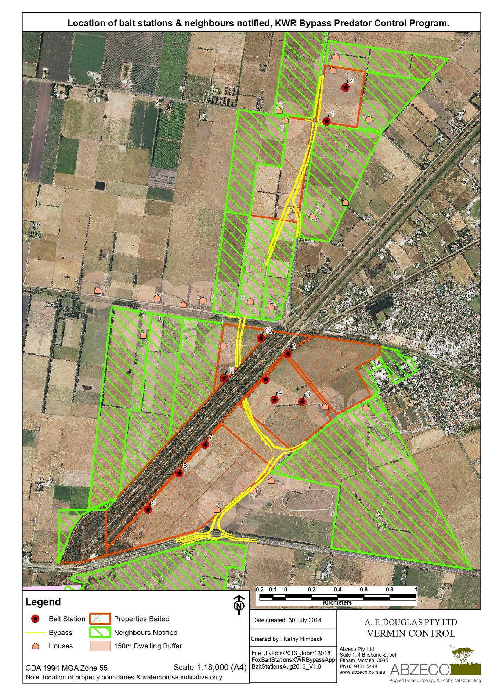
Map showing the extent and location of each of the participating properties, the location of the bait stations and the neighbours notified, Koo Wee Rup Bypass Predator Control Project. Details of the location description are provided in the report.

Appendix 2 – Camera data summary (baiting)
Table showing the summary of the data collected from the bait station camera, Koo Wee Rup Bypass Predator Control Project. A full description of the data shown in the table is provided within the report.
Camera | Operational date range | Nights | Red Fox  (adult) | Cat | Rat | Hare | Rabbit | SBB | Cattle present | Birds & other animals
KWR1 | 6/8 - 29/9/2013 | 45 | 1 | 1 |  | 2 | 0 | 0 | Yes | Australian Raven, Common Blackbird, Magpie, Mudlark
KWR2 | 6/8 - 29/9/2013 | 45 | 0 | 0 | 0 | 4 | 0 | 0 | Yes | Mudlark, Common Blackbird, Common Starling, Pacific Black Duck.
KWR3 | 6/8 - 29/9/2013 | 45 | 0 | 0 | 0 | 16 | 0 | 0 | Yes | Pacific Black Duck, Australian Magpie, Common Myna, Cattle, Common Starling.
KWR4 | 6/8 - 29/9/2013 | 45 | 0 | 0 | 65 | 1 | 0 | 0 | No | Willie Wagtail, Common Blackbird, Common Starling, Crested Pigeon, Turtle Dove, Australian Magpie, Australian Mudlark, House Sparrow.
KWR5 | 6/8 - 29/9/2013 | 45 | 0 | 0 | 0 | 0 | 0 | 0 | Yes | Superb Fairy Wren, Australian Raven, Yellow-rumped Thornbill, Common Blackbird, Flame Robin, Australian White Ibis, Pacific Black Duck.
KWR6 | 6/8 - 29/9/2013 | 45 | 0 | 0 | 0 | 0 | 0 | 0 | Yes | Australian Raven, Superb Fairy Wren, Kookaburra
KWR7 | 7/8 - 29/9/2013 | 44 | 0 | 0 | 0 | 2 | 0 | 0 | Yes | Australian Magpie, Willie Wagtail, Flame Robin, Australian White Ibis (7), Superb Fairy Wren, Australian Raven, Common Starling.
KWR8 | 3 - 29/9/2013 | 26 | 0 | 0 | 0 | 2 | 0 | 0 | Yes | Australian Raven, Australian Magpie, Flame Robin, Willie Wagtail.
KWR9 | 7/8 - 2/9/2013 | 27 | 0 | 0 | 0 | 0 | 0 | 0 | Yes | Australian Raven, Superb Fairy Wren, Australian Magpie, Flame Robin.
KWR10 | 3 - 29/9/2013 | 26 | 0 | 0 | 0 | 2 | 1 | 0 | No | Australian Raven, Superb Fairy Wren, Red Browed Finch, Common Blackbird.
KWR11 | 29/8 - 29/9/2013 | 32 | 0 | 0 | 6 | 0 | 4 | 1 | No | Superb Fairy Wren, Red Browed Finch, Common Blackbird, Australian Raven

Appendix 3 – Bait uptake data summary
The table shows a summary of the daily uptake of baits from baiting stations between 6 August and 29 September 2013, Koo Wee Rup Bypass Predator Control Project. The information contained within the table is explained in detail within the report.
Legend: FF = Free Feed; Yes = Bait taken; No = Bait not taken; NA = Station not baited
Bait Station | 6/08/13 | 8/08/13 | 14/08/13 | 17/08/13 | 22/08/13 | 26/08/13 | 29/08/13 | 02/09/13 | 07/09/13 | 12/09/13 | 23/09/13 | 29/09/13
Bait | Free Feed | Free Feed | Free Feed | Free Feed | Free Feed | Free Feed | Free Feed | Free Feed | Free Feed | Free Feed | Free Feed | Removed
1 | Set-up | No | No | No | No | No | No | No | No | No | No | No
2 | Set-up | No | No | No | No | No | No | No | No | No | No | No
3 | Set-up | No | No | No | No | No | No | No | No | No | No | No
4 | Set-up | No | No | No | No | No | No | No | No | No | No | No
5 | Set-up | No | No | No | No | No | No | No | No | No | No | No
6 | Set-up | No | No | No | No | No | No | Yes | (1080) No | No | No | No
7 | Set-up | No | No | No | No | No | No | No | No | No | No | No
8 |  | Set-up | No | No | No | No | No | No | No | No | No | No
9 |  | Set-up | No | No | No | No | No | No | No | No | No | No
10 |  |  |  |  |  | Set-up | No | No | No | No | No | No
11 |  |  |  |  |  | Set-up | No | No | No | No | No | No
Total Baits Taken |  | 0 | 0 | 0 | 0 | 0 | 0 | 1 | 0 | 0 | 0 | 0
Estimated Deaths |  | 0 | 0 | 0 | 0 | 0 | 0 | 0 | 0 | 0 | 0 | 0

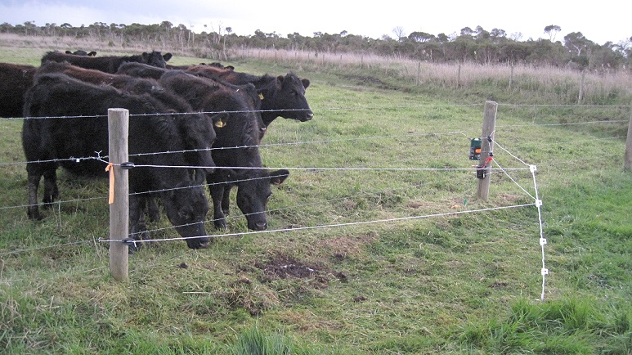
Appendix 4 – Photos (baiting)
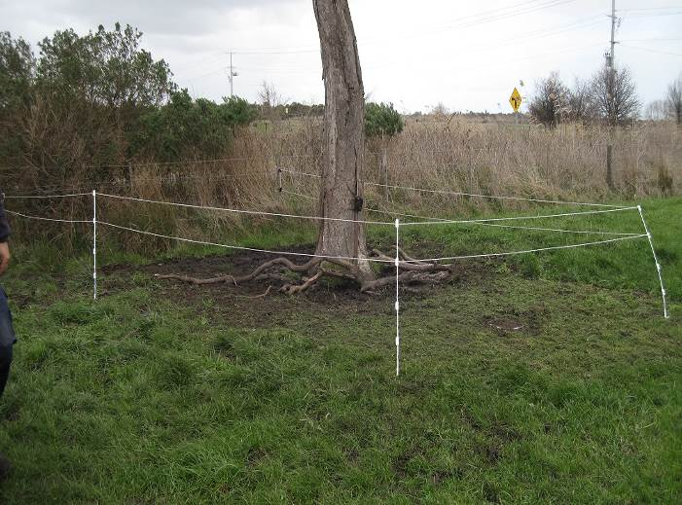
Photos taken of the setup of a bait station and from the bait station cameras.

Image 1. Set up of Bait Station 1, with a temporary electric fence around the bait station that is activated when cattle are moved into the paddock.
Image 2. Setup of bait station 8 showing cattle in the paddock being restricted from interfering with the station with the installation of a temporary electric fence around the bait.

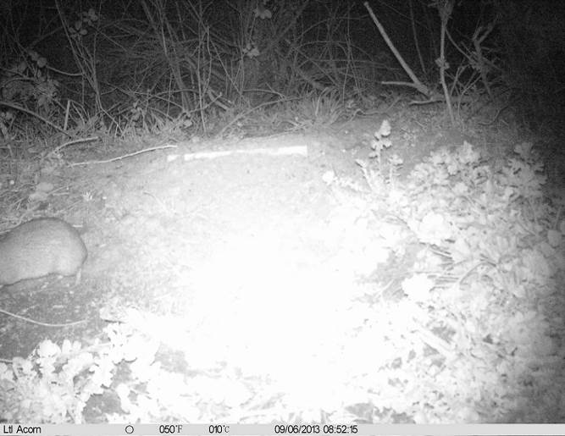
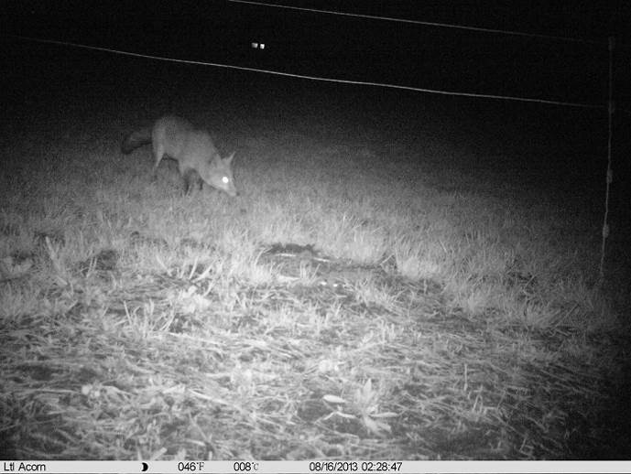
Image 1. Bait station #5 showing the camera fixed to the fence post pointing to the plot of bare soil under the fence line.

Image 3. Photo taken from Bait Station 11, at 8:52pm on the 6/9/2013, showing an adult Southern Brown Bandicoot moving away from the bait station.
Image 4. Photo taken at 2.28am on the 16/8/2013 from Bait Station 1, showing a very wary fox showing interest in the bait but hesitant to come closer than 1m..

Appendix 5 – Map of fauna survey locations
Map showing the location of fauna survey camera sites for the VicRoads Koo Wee Rup Bypass Project. Details of the location description are provided in the report.
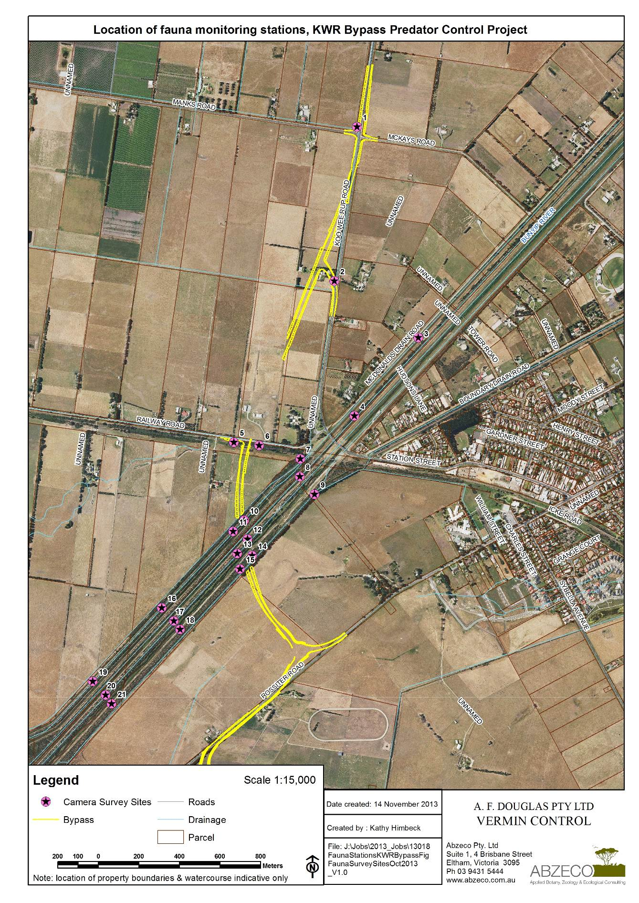

Appendix 6 – Fauna survey camera data summary
Table shows a summary of the data collected from the fauna survey cameras, Koo Wee Rup Bypass Predator Control Project. A full description of the data shown in the table is provided within the report.
Camera | Date Set | Date Retrieved | SBB  Activity Index |  | Red Fox | Rabbit | Swamp Rat | Black Rat | Birds & other fauna
Site 1 | 15/10/13 | 30/10/13 | 1 | 1 |  | 3 |  | 0
Site 2 | 15/10/13 | 30/10/13 | 2 | 0.5 |  |  |  | 0 | Superb Fairy-wren, Spotted Turtle-dove
Site 3 | 15/10/13 | 30/10/13 |  |  |  | 1 |  | 0 | Common Blackbird
Site 4 | 15/10/13 | 30/10/13 |  |  |  | 0 |  | 1 | Superb Fairy-wren, Red-browed Finch, Common Blackbird, Little Raven.
Site 5 | 15/10/13 | 30/10/13 | 9 | 0.6 | 1 | 7 |  | 8 | Common Blackbird, Grey Fantail, Little Raven, Spotted Turtle-dove, Brown Thornbill
Site 6 | 15/10/13 | 30/10/13 | 5 | 1.7 |  |  |  | 4 | White-browed Scrubwren.
Site 7 | 15/10/13 | 30/10/13 | 8 | 2 |  | 1 |  | 7 | Echidna (2), White-browed Scrubwren, Superb Fairy-wren, Grey Fantail, Grey Shrike-thrush.
Site 8 | 15/10/13 | 30/10/13 |  |  |  | 3 |  | 2 | White-browed Scrubwren.
Site 9 | 15/10/13 | 30/10/13 |  |  |  |  |  | 2
Site 10 | 15/10/13 | 30/10/13 |  |  |  | 1 |  | 0
Site 11 | 15/10/13 | 30/10/13 |  |  |  | 1 |  | 0
Site 12 | 15/10/13 | 30/10/13
Site 13 | 15/10/13 | 30/10/13 |  |  |  |  | 1 | 20 | Egernia sp. (3), Lewin’s Rail (1), Echidna (1), Superb Fairy-wren, White-browed Scrubwren, European Goldfinch, Silvereye, Common Blackbird
Site 14 | 15/10/13 | 30/10/13 |  |  |  |  |  | 1
Site 15 | 15/10/13 | 30/10/13 | 1 | 0.07 | 1 | 3 |  | 6 | Ring-tail Possum (1), Eastern Yellow Robin, White-browed Scrubwren, Grey Fantail, Common Blackbird.
Site 16 | 15/10/13 | 30/10/13 |  |  |  | 1 |  | 2
Site 17 | 15/10/13 | 30/10/13
Site 18 | 15/10/13 | 30/10/13 |  |  |  | 9 | 1 |  | Echidna (1), White-browed Scrubwren, Superb Fairy-wren, Spotted Turtle-dove.
Site 19 | 15/10/13 | 30/10/13 |  |  |  |  |  | 2
Site 20 | 15/10/13 | 30/10/13 |  |  |  |  |  |  | White-browed Scrubwren
Site 21 | 15/10/13 | 30/10/13

Appendix 7 – Fauna survey photos
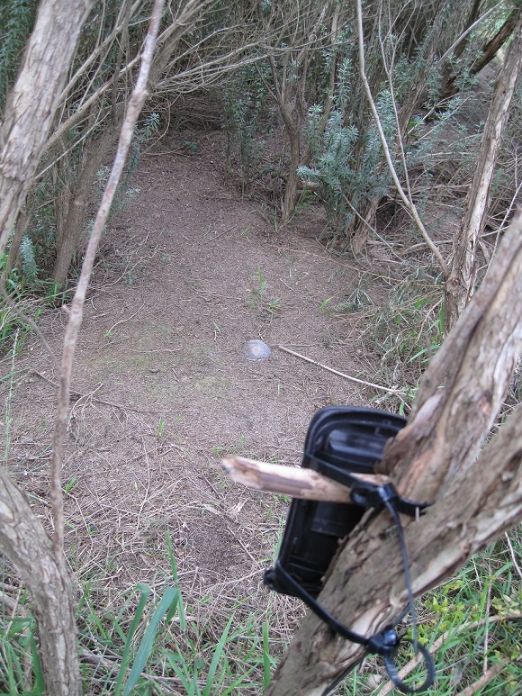
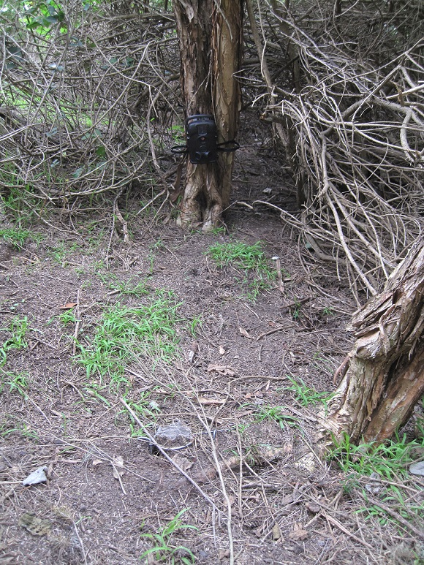
Images taken of areas of habitat that were assessed during the camera fauna survey, VicRoads Koo Wee Rup Bypass Project

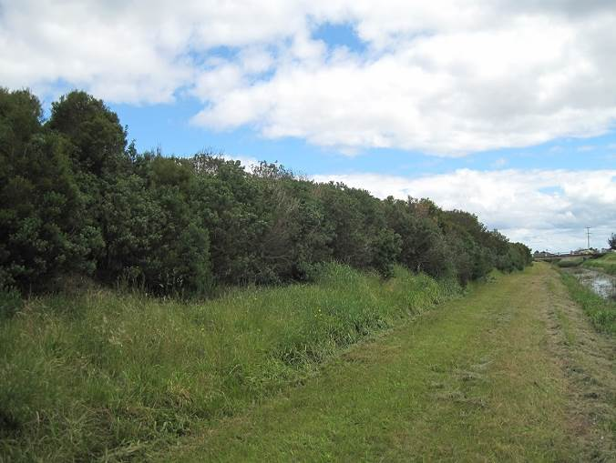
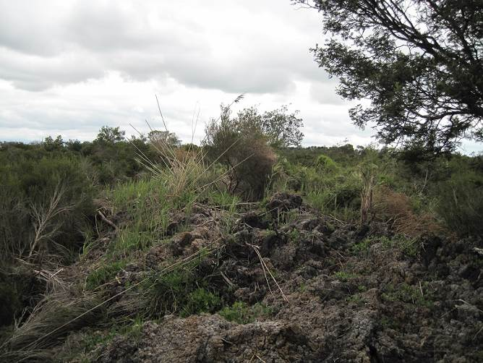
Image 5. Setup of camera at site 4, showing the camera secured low to a small tree and the bait pinned to the ground in a metal mesh container.

Image 7. Recent slashing activity along all access tracks of the Bunyip River Drain Complex both north and south of Healesville - Koo Wee Rup Road.
Image 6. Setup of camera at site 7, showing the camera secured high to a small tree angled down into an open patch with the bait pinned to the ground towards the centre.
Image 8. The debris from recent desilting works along two drainage channels of the Bunyip River Drain Complex has been dumped on top of levee banks, impacting on areas of SBB habitat.

Appendix 8 – Fox baiting record sheet
Fox baiting record sheets completed during the second period of pulse baiting of the Pest Predator Control Program for the VicRoads Koo Wee Rup Bypass Project
Reserve: |  | Koo Wee Rup Bypass Project
Service provider: |  | Vermin Control/Abzeco
Dates: |  | Free feed | 6/08/2013 | Poison start | 26/08/2013 | Finish | 29/09/2013
Most stations were set up with electric units and electric wire or utilising existing electric fences.
Bait station #3 moved 30m from previous round.
Tuna oil used on all bait stations as an olfactory attractant.
Station # | GPS |  | Date Set | Bait type | Site description
Station # | Easting | Northing
1 | 366887 | 5772766 | 6/08/2013 | FF | Property 1
2 | 367033 | 5773026 | 6/08/2013 | FF | Property 1
3 | 366699 | 5770615 | 6/08/2013 | FF | Property 2
4 | 366487 | 5770629 | 6/08/2013 | FF | Property 2
5 | 366420 | 5770788 | 6/08/2013 | FF | Property 2
6 | 366591 | 5770983 | 6/08/2013 | FF | Property 2
7 | 365954 | 5770288 | 6/08/2013 | FF | Property 3
8 | 365756 | 5770067 | 8/08/2013 | FF | Property 3
9 | 365516 | 5769788 | 8/08/2013 | FF | Property 3
10 | 366384 | 5771095 | 26/08/2013 | FF | Property 4
11 | 366114 | 5770805 | 26/08/2013 | FF | Property 4

Reserve: |  | Koo Wee Rup Bypass Project
Service Provider: |  | Vermin Control/Abzeco
Dates: |  | Free feed | 6/8-?/9/2013 |  | Poison start | 26/08/2013 | Finish | 29/09/2013
Notes: No takes being recorded so remained with free feed.  Electric fences working well to discourage cattle and reduce impacts on bait stations. |  |  | Bait codes |  |  |  | Species Codes
 |  |  | FF: Fee feed |  |  |  | F: Fox | SM: Small mammal
 |  |  | PO: Poison |  |  |  | B: Bird | L: Livestock
 |  |  | RB: Replacement bait |  |  |  | C: Cat | O: Other
 |  |  | NT: Not taken |  |  |  | D: Dog | U: Unknown
 |  |  | NR: Not Replaced |  |  |  | H: Human
Site No. | Inspection 1: Date |  | 8/08/2013 | Inspection 2: Date |  | 14/08/2013 | Inspection 3: Date |  | 17/08/2013
Site No. | Taken by | Disturbed by | New Bait | Taken by | Disturbed by | New Bait | Taken by | Disturbed by | New Bait
1 | NT | N | RB | NT | N | RB | NT | N | RB
2 | NT | N | RB | NT | N | RB | NT | N | RB
3 | NT | N | RB | NT | N | RB | NT | N | RB
4 | NT | N | RB | NT | N | RB | NT | N | RB
5 | NT | N | RB | NT | N | RB | NT | N | RB
6 | NT | N | RB | NT | N | RB | NT | N | RB
7 | NT | N | RB | NT | N | RB | NT | N | RB
8 |  |  | FF | NT | N | RB | NT | N | RB
9 |  |  | FF | NT | N | RB | NT | N | RB

Reserve: |  | Koo Wee Rup Bypass Project
Service Provider: |  | Vermin Control/Abzeco
Dates: |  | Free feed | 6/08/2013 |  | Poison start | 26/08/2013 | Finish | 29/09/2013
Notes: Still no takes so no poison out.  22/8: All baits wet. Lifted and replaced.  26/8: New property (Male) baited #10 & #11. Cameras set 29/8/13 |  |  | Bait codes |  | M: Fresh meat (beef) buried just below the surface. |  | Species Codes
 |  |  | FF: Fee feed |  |  |  | F: Fox | SM: Small mammal
 |  |  | PO: Poison |  |  |  | B: Bird | L: Livestock
 |  |  | RB: Replacement bait |  |  |  | C: Cat | O: Other
 |  |  | NT: Not taken |  |  |  | D: Dog | U: Unknown
 |  |  | NR: Not Replaced |  |  |  | H: Human
Site No. | Inspection 4: Date |  | 22/08/2013 | Inspection 5: Date |  | 26/08/2013 | Inspection 6: Date |  | 29/08/2013
Site No. | Taken by | Disturbed by | New Bait | Taken by | Disturbed by | New Bait | Taken by | Disturbed by | New Bait
1 | NT | N | RB | NT | N | RB | NT | N | RB
2 | NT | N | RB | NT | N | RB | NT | N | RB
3 | NT | N | RB | NT | N | RB | NT | N | RB, M
4 | NT | N | RB | NT | SM | RB | NT | N | RB, M
5 | NT | N | RB | NT | N | RB | NT | N | RB, M
6 | NT | N | RB | NT | N | RB | NT | N | RB, M
7 | NT | N | RB | NT | N | RB | NT | N | RB, M
8 | NT | N | RB | NT | N | RB | NT | N | RB, M
9 | NT | N | RB | NT | N | RB | NT | N | RB, M
10 |  |  |  |  |  | FF | NT | N | RB, M
11 |  |  |  |  |  | FF | NT | N | RB, M

Reserve: |  | Koo Wee Rup Bypass Project
Service Provider: |  | Vermin Control/Abzeco
Dates: |  | Free feed | 6/08/2013 |  | Poison start | 26/08/2013 | Finish | 29/09/2013
Notes: 2/9: 1st 1080 bait in, but only #6. Remaining are Free Feed and/or fresh meat. |  |  | Bait codes |  |  |  | Species Codes
 |  |  | FF: Fee feed |  |  |  | F: Fox | SM: Small mammal
 |  |  | PO: Poison |  |  |  | B: Bird | L: Livestock
 |  |  | RB: Replacement bait |  |  |  | C: Cat | O: Other
 |  |  | NT: Not taken |  |  |  | D: Dog | U: Unknown
 |  |  | NR: Not Replaced |  |  |  | H: Human | B: Bird
Site No. | Inspection 7: Date |  | 2/09/2013 | Inspection 8: Date |  | 7/09/2013 | Inspection 9: Date |  | 12/09/2013
Site No. | Taken by | Disturbed by | New Bait | Taken by | Disturbed by | New Bait | Taken by | Disturbed by | New Bait
1 | NT | N | RB, M | NT | N | NR | NT | N | FF
2 | NT | N | RB, M | NT | N | NR | NT | N | FF
3 | NT | N | NR | NT | N | NR | NT | N | FF
4 | SM | SM | RB | NT | N | FF | NT | N | FF
5 | NT | N | NR | NT | N | NR | NT | N | FF
6 | U | U | PO | NT | N | FF | NT | N | FF
7 | SM | SM | RB | NT | N | NR | L | L | FF
8 | NT | N | RB | NT | N | NR | NT | N | FF
9 | SM | SM | RB | NT | N | NR | NT | N | FF
10 | NT | N | NR | SM | SM | FF | B | B | FF
11 | NT | N | NR | NT | N | NR | B | B | FF

Reserve: |  | Koo Wee Rup Bypass Project
Service Provider: |  | Vermin Control/Abzeco
Dates: |  | Free feed | 6/08/2013 |  | Poison start | 26/08/2013 | Finish | 29/09/2013
Notes: All baits and cameras removed on the 29/9/2013. |  |  | Bait codes |  |  |  | Species Codes
 |  |  | FF: Fee feed |  |  |  | F: Fox | SM: Small mammal
 |  |  | PO: Poison |  |  |  | B: Bird | L: Livestock
 |  |  | RB: Replacement bait |  |  |  | C: Cat | O: Other
 |  |  | NT: Not taken |  |  |  | D: Dog | U: Unknown
 |  |  |  |  |  |  | H: Human | B: Bird
Site No. | Inspection 10: Date |  | 23/09/2013 | Inspection 11: Date |  | 29/09/2013 | Inspection 12: Date
Site No. | Taken by | Disturbed by | New Bait | Taken by | Disturbed by | New Bait | Taken by | Disturbed by | New Bait
1 | NT | N | RB | NT | N
2 | NT | N | RB | NT | N
3 | NT | N | RB | NT | N
4 | NT | N | RB | NT | N
5 | NT | N | RB | NT | N
6 | NT | N | RB | NT | N
7 | NT | N | RB | NT | N
8 | NT | N | RB | NT | N
9 | NT | N | RB | NT | N
10 | NT | B | RB | NT | N
11 | NT | N | RB | NT | N

