Koo Wee Rup Bypass Growling Grass Frog and Swamp Skink Surveys

Project: 11-077

Prep ared for:

VicRoads

©

This publication is copyright. It may only be used in accordance with the agreed terms of the commission. Except as provided for by the Copyright Act 1968, no part of this publication may be reproduced, stored in a retrieval system, or transmitted in any form or by any means, without prior written permission from Ecology Australia Pty Ltd.

Document information

This is a controlled document. Details of the document ownership, location, distribution, status and revision history are listed below.

All comments or requests for changes to content should be addressed to the document owner.

**Bioregion:**

|  |  |  |  |
| --- | --- | --- | --- |
| Owner | Ecology Australia Pty Ltd | | |
| Author |  | | |
| Location |  | | |
| Distribution | Nadia Arkoudis | Senior Project Delivery Engineer | VicRoads |

|  |  |  |  |
| --- | --- | --- | --- |
| Document History | | | |
| Status | Changes | By | Date |
| **Final 2.0** | **Reviewed by client** | **Jonathon Ricciardello** | **26-10-2012** |

Contents

Acknowledgments vi

Summary 1

1 Introduction 3

1.1 Previous work undertaken for VicRoads 3

1.2 Objectives of this study 3

2 Study Area 5

3 Methods 6

3.1 Growling Grass Frog monitoring surveys 6

3.1.1 Bunyip River Drain Complex frog presence and salinity 6

3.1.2 Pasture transect survey 7

3.1.3 South Gippsland Railway Line drains and swampy areas survey 7

3.1.4 Dam Surveys 7

3.1.5 Limitations 8

3.2 Swamp Skink Surveys 8

3.2.1 Site selection 8

3.2.2 Trapping survey 8

3.2.3 Limitations 9

4 Results 12

4.1 Growling Grass Frog survey 12

4.1.1 Frog species recorded 12

4.1.2 Bunyip River drain complex frog survey and salinity monitoring 12

4.1.3 Paddock transects 16

4.1.4 Railway drains and swampy areas 16

4.1.5 Farm dam monitoring 16

4.2 Swamp skink survey 26

4.3 Other species captured 26

5 Discussion 27

5.1 Potential impacts 27

5.1.1 Growling Grass Frog 27

5.1.2 Swamp Skink 29

6 Implications 31

7 References 32

Tables

Table 1 The conservation status of the Growling Grass Frog and Swamp Skink 4

Table 2 Conductivity (uS/cm) measurements taken from the Bunyip River Drain Complex 13

Table 3 Conductivity of various water types as described by Waterwatch Australia National Technical Manual 2012. 13

Table 4 Healesville – Koo Wee Rup Road Upgrade: tabulated results of the Growling Grass Frog survey. 18

Table 5 Vertebrate species captured during survey for Swamp Skinks (*Lissolepis coventryi)* (19, 20 and 22 March 2012) A total of 270 trap days were undertaken 26

Table 6 Salinity tolerances of the Green and Golden Bell Frog (*Litoria aurea*) tadpole taken from Christy and Dickman 2002. 28

Figures

Figure 1 Location of Growling Grass Frog assessments within the Koo Wee Rup area. Reference dams at Ballarto Rd are not shown on this map. 10

Figure 2 Location of Swamp Skink Survey traplines in relation to the proposed Koo Wee Rup Bypass 11

Figure 3 Salinity monitoring results for the Bunyip River Drain Complex December 2011 – March 2012) 14

Figure 4 14 year salinity levels for Bunyip Main Drain at Healesville – Koo Wee Rup Road Bridge (Source – Melbourne Water) 15

Plates

Plate 1 Ballato Reference Dam 1. 38 Growling Grass Frog recorded during survey in December 2011 and January 2012. (Photo taken in December 2011) 39

Plate 2 Ballarto Reference Dam 2. Four Growling Grass Frogs recorded in December 2011 (Photo taken in December 2011) 39

Plate 3 Rossiter Dam 1 (Photo taken December 2011) 40

Plate 4 Rossiter Dam 2 (Photo taken December 2011) 40

Plate 5 Rossiter Dam 3 (Photo December 2011). 41

Plate 6 Rossiter Dam 4 (Photo December 2011) 41

Plate 7 Rossiter Dam 5. Three Growling Grass Frogs recoded in December 2011 (Photo December 2011) 42

Plate 8 Rossiter Dam 6 (Photo December 2011) 42

Plate 9 Rossiter Dam 7 (Photo December 2011) 43

Plate 10 Rail Dam 1. 12 Growling Grass Frogs recorded in December 2011 and 4 in January 2012 (Photo December 2011) 43

Plate 11 Rail Dam 2 (Photo December 2012) 44

Appendices

Appendix 1 Spotlighting standard procedures 34

Appendix 2 Habitat assessment proforma 35

Appendix 3 Habitat proforma results for dams and drains covered in this survey 37

Appendix 4 Dams assessed as part of this survey 39

# Acknowledgments

* Nadia Arkoudis, Andrew Robilliard, Robert Pearson, Raymond Paterson, Tony Hillman and Kate Bar (VicRoads);
* Gavin Brock and Trish Grant (Melbourne Water);
* Jamie McMahon, Bernadette Schmidt and Cathy Cavallo (Ecology Australia); and
* John Harris (Fauna Consultant).

Summary

#### Background

Ecology Australia was commissioned by VicRoads, South Eastern Projects, to undertake a targeted fauna survey for the Growling Grass Frog (*Litoria raniformis*) and Swamp Skink (*Lissolepis coventryi*) as part of a planning study to determine the impacts of the proposed Koo Wee Rup Bypass.

This study involved targeted surveys for Growling Grass Frogs and Swamp Skink within the vicinity of the proposed Koo Wee Rup Bypass. The study area for this project comprises of land immediately adjacent to the proposed Koo Wee Rup Bypass that is located to the west of the Healesville – Koo Wee Rup Rd and extends south from Manks Rd, crosses Railway Road, and the Bunyip Drain Complex and then extends south, southeast across Rossiter road to the South Gippsland Highway

The study area falls within the Gippsland Plain Bioregion, the Westernport Catchment and the Shire of Cardinia administrative boundary. It forms part of the original Koo Wee Rump Swamp prior to drainage and clearance of extensive areas of the Swamp vegetation in the early 19th Century. The majority of the study area and surrounding landscape comprises pastoral land, with smaller areas under crop cultivation. Relatively, small, narrow and linear patches of remnant vegetation remain along Railway Rd, and on the levees of the Bunyip River Drain Complex.

Nine target dams within the vicinity of the proposed Koo Wee Rup Bypass were surveyed twice for the presence of Growling Grass Frogs. A further two dams where the Growling Grass Frog is known to occur north of the study area at Ballarto Rd were surveyed to provide a reference for species within the landscape.

Four pasture transects were surveyed four times to examine the use of terrestrial habitat by the Growling Grass Frog across the study area.

Seven drains were surveyed for the presence of the Growling Grass Frog four times and the five drains associated with the Bunyip Drain Complex had basic water quality (pH and conductivity) sampled within the vicinity of the proposed Koo Wee Rup bypass. This water quality data was supplemented with data taken by Melbourne Water over the past 14 years.

Nine trap lines, consisting of ten traps were established to survey for the Swamp skink

#### Results and Discussion

Previous assessments (Ecology Australia 2006, 2008) identified the Growling Grass Frog, which is listed as a Vulnerable species under the Commonwealth Environment Protection and Biodiversity Conservation Act 1999 (EPBC) and a threatened taxon under the Victorian Flora and Fauna Guarantee Act 1988 (FFG), as being a significant factor to be considered when planning the Koo Wee Rup Bypass because of its distribution across the landscape and level of habitat connectivity that is present within the study area.

The Growling Grass frog was recorded from two of the target dams within the vicinity of the proposed Koo Wee Rup Bypass, and from both of the reference dams near Ballarto Rd. No Growling Grass frogs were recorded from any of the pasture transects or from within any of the drain transects.

Salinity levels within the Bunyip River Drain Complex have been recorded at levels that would be potentially fatal to Growling Grass Frogs and their tadpoles only twice in the past 14 years (Melbourne Water 2012). This, combined with high flow levels during the breeding season suggests that it is unlikely that the Growling Grass Frogs would breed within the Bunyip River Drain Complex. However, as salinity is commonly at levels not considered not to be detrimental to the Growling Grass Frog, the use of the Bunyip River Drain Complex for dispersal is possible.

While the Swamp Skink, which is listed as a threatened taxon under the FFG Act, was not recorded during the current study, this species is difficult to detect even in areas where it is known to occur (Clemann 2006). As known records of this species in habitat contiguous with the study area exist there is a moderate likelihood of this species being present.

#### Implications

* Data has been collected on Growling Grass Frogs within the vicinity of the Koo Wee Rup Bypass which will be used to address potential impacts of the bypass, as well as provide baseline data to assess the success of mitigation measures;
* Pre-cautionary measures to salvage Growling Grass Frogs along the Bunyip River Drain Complex prior to any works being undertaken should occur;
* While no Swamp Skinks were recorded during the survey any individuals encountered during the construction phase of the bypass should be salvaged and translocated to appropriate habitat.

# Introduction

In Ecology Australia Pty Ltd was commissioned by VicRoads, South East Metropolitan Region, to undertake pre-construction monitoring for the Growling Grass Frog (*Litoria raniformis*) and a targeted survey for the Swamp Skink (*Lissolepis coventryi*) for Stage 1A of the Healesville – Koo Wee Rup Road Upgrade, the Koo Wee Rup Bypass. The Growling Grass Frog monitoring constitutes the first part of an ongoing monitoring program, while the targeted Swamp Skink survey aims to determine the presence of the species and if sop develop an ongoing monitoring program for the species. Both the Growling Grass Frog monitoring and Swamp Skink surveys target the Bunyip River Drain Complex and Railway Road/disused South Gippsland Railway Line, and pastoral land within and surrounding the area proposed for the Koo Wee Rup Bypass.

## Previous work undertaken for VicRoads

Ecology Australia has previously undertaken surveys for the Growling Grass Frog along the alignment of the Healesville - Koo Wee Rup Upgrade between the Pakenham Bypass and South Gippsland Highway in 2006 and 2008, and for Swamp Skink at the Bunyip River and Cardinia Creek drain complexes near the South Gippsland Highway (Ecology Australia 2006, and 2008). These previous studies recorded Growling Grass Frogs from a number of sites adjacent to the Healesville - Koo Wee Rup Road, and records of Swamp Skinks near the junction of the South Gippsland Hwy and the Cardinia Creek drains. Ecology Australia (2008) recommended that further assessment of Growling Grass Frog habitat be undertaken to assess the significance of each water body within or adjoining the alignment, once further refinements of the bypass alignment have been made and finalised.

## Objectives of this study

This study aims to meet a number of objectives including:

* Identify the presence of Growling Grass Frogs and Swamp Skinks and any important populations within the vicinity of the Koo Wee Rup Bypass;
* To assess the effectiveness of mitigation and success of management procedures implemented to protect Growling Grass Frogs and Swamp Skinks;
* To ensure that construction of the Bypass does not significantly impact on the species or their habitats;
* Address any potentially threatening processes which may arise, and introduce new management actions should these be deemed necessary; and
* Determine the success of habitat rehabilitation as a remediation measure.

Further objectives regarding information gaps in Growling Grass Frogs include:

* Are Growling Grass Frogs using paddock habitat for dispersal between water bodies and for foraging?
* Are salinity levels due to the tidal nature of the Bunyip River Drain Complex regularly high enough to exclude use by Growling Gras Frogs?

By addressing these questions we hope to gain a better understanding of the impacts of the Koo Wee Rup bypass on movement and dispersal of the Growling Grass Frog.

Table 1 The conservation status of the Growling Grass Frog and Swamp Skink

| Growling Grass Frog *Litoria raniformis* | | | | |
| --- | --- | --- | --- | --- |
| Australia | | | Victoria | |
| IUCN Red List 2004 | *Environment Protection and Biodiversity Conservation Act* *1999* | Tyler 1997 – National Action Plan for Frogs | Victorian *Flora and Fauna Guarantee Act* *1988* | Department of Sustainability and Environment (2007) – Advisory List of Threatened Vertebrate Fauna in Victoria |
| Endangered | Vulnerable | Vulnerable | Listed | Endangered |

| Swamp Skink *Lissolepis coventryi* | | | | |
| --- | --- | --- | --- | --- |
| Australia | | | Victoria | |
| IUCN Red List 2004 | *Environment Protection and Biodiversity Conservation Act* *1999* | Cogger et al. 1993 – National Action Plan for Reptiles | Victorian *Flora and Fauna Guarantee Act* *1988* | Department of Sustainability and Environment (2007) – Advisory List of Threatened Vertebrate Fauna in Victoria |
| ‑ | ‑ | Rare or Insufficiently Known | Listed | Vulnerable |

# Study Area

The study area for this project comprises land immediately adjacent to the proposed Koo Wee Rup Bypass that is located to the west of the Healesville – Koo Wee Rup Road and extends south west from Manks Rd, crosses Railway Road, and then extends south, southeast across the Bunyip River Drain Complex and Rossiter Road to the South Gippsland Highway (Figure 1).

The study area forms part of the original Koo Wee Rup Swamp prior to drainage and clearance of extensive areas of the Swamp vegetation in the early 19th Century (Yugovic and Mitchell 2006). It would have originally supported reed- and rush-dominated vegetation in an inner swamp, Swamp Paperbark (*Melaleuca ericifolia*) Scrub on the outskirts in seasonally inundated areas, Swampy Riparian Woodland on natural levees along watercourses and sand ridges, and grassland and *Acacia* woodland outside the band of *Melaleuca* (Yugovic and Mitchell 2006; DSE 2012a and 2012b). Remnant Swampy Riparian Woodland and Swamp Scrub habitats can be found at the Bayles Fauna Park and Koo Wee Rup Swamp Lookout, respectively.

The study area has been highly modified and subjected to a long history of disturbance since drainage of the Koo Wee Rup Swamp, construction of drainage channels, and land clearance for agriculture. The majority of the study area and surrounding landscape comprises pastoral land, with smaller areas under crop cultivation. What little native vegetation is present across the study site is confined to the margins of Road reserves and the disused South Gipplsand Railway line, and Bunyip River Drain Complex.

The study area falls within the Gippsland Plain Bioregion, which experiences a relatively uniform, temperate climate of warm, dry summers and cool, wet winters. The mean daily maximum temperatures at Tooradin, the closest weather station, range from 13.1°C in July and 26.0°C in January (Bureau of Meteorology data). Mean daily minimum temperatures range between 3.8°C in July to 12.1°C in February. Mean annual rainfall is 853 mm at Tooradin.

The soils are sedimentary, formed during the Pleistocene, comprising stream alluvium, and floodplain and low level terrace deposits. They are comprised of Quaternary alluvium consisting primarily of stream alluvium, sand, silt, clay and gravel (Geological Survey Map Warragul Series, Mines Department, Melbourne 1971).

# Methods

## Growling Grass Frog monitoring surveys

A series of surveys were conducted to examine the relationship between the various habitat components that are likely to be used by the Growling Grass Frogs within, and adjacent to the Koo Wee Rup bypass footprint.

### Bunyip River Drain Complex frog presence and salinity

To determine the suitability of the Bunyip River Drain Complex for the Growling Grass Frog water monitoring and spotlighting of each of the five drains were conducted four times over the survey period.

**Water quality monitoring**

A handheld Hannah Combo (Hannah Instruments, Keysbourough, Victoria) water quality meter was used to measure:

* Water electric conductivity (millisiemens/cm2);
* Suspended salts (parts/thousands); and
* pH.

Water sampling was undertaken at the midpoint of where the Koo Wee Rup Bypass will cross the Bunyip River Drain Complex. This was supplemented by long term monitoring data collected by Melbourne Water for the Bunyip River Main Drain collected from the rail bridge that crosses the Drain Complex approximately 500 m upstream of the water sampling sites. It is understood that the drain complex is tidal to a small weir located adjacent to the Koo Wee Rup water tower, approximately 1.5 km upstream from the water sampling sites (Gavin Brock, Melbourne Water, pers. comm.), and as such the drains within the study area are considered tidal.

The data was interpreted by examining salinity parameters that constitute fresh, brackish and saline water (WaterWatch 2012), and by looking at the salinity tolerances of the closely related Green and Golden Bell Frog (*Litoria aurea*) as determined by Christy and Dickman [(2002) (see Table 4)] and predicted salinity tolerance for the Growling Grass Frog from Smith *et al.* [(2008) (see section 5.1.1)] .

#### Spotlighting surveys

Spotlighting surveys of the Bunyip River Drain complex were conducted on 29 November and 21 December, 2011, and 23 January and 19 March 2012.

Surveys of flowing water bodies (i.e. drains) focused on the edge of the water, and extended up the bank to include the management vehicle access track. Any emergent or floating vegetation within the water body was also scanned with binoculars. (See Appendix 1 for the detailed spotlighting methodology).

### Pasture transect survey

Four, 200m pasture transects were established across the study site between Manks Road and Rossiter Road (see Figure 1). Transects were surveyed by two zoologists walking parallel 10m apart with the ground five meters either side of each zoologist scanned with a spotlight for the presence of frog species (refer to section 3.1.5 for the standard spotlighting procedures).

Pasture transect surveys were undertaken four times during the project, and conducted on the 29 November 2011, 21 December 2011, 23 January 2012 and 19 March 2012.

### South Gippsland Railway Line drains and swampy areas survey

#### Spotlight Survey

A series of drains and swampy areas associated with the disused South Gippsland Rail Line (Figure 2), were considered likely to act as habitat links for the Growling Grass Frog. Spotlighting surveys of these drains and associated swampy areas were conducted on 29 November and 21 December, 2011, and 23 January and 19 March 2012.

Surveys of these drains and swampy areas focused on the edge of the water, and extended up the bank five meters from the water. Any emergent or floating vegetation within the water body was also scanned with binoculars. The species and number of frogs encountered (seen and heard) were recorded for each of the four visits to these sites.

### Dam Surveys

#### Site Selection

Assessment of aerial photography was used to identify farm dams within the vicinity of the Koo Wee Rup Bypass footprint. A habitat assessment proforma (Appendix 2) was then used to guide selection of dams to be monitored. In total 12 dams were visited and assessed during daylight hours using the habitat proforma.

While dam selection generally targeted sites with moderate-high quality Growling Grass Frog habitat, previous studies (i.e. Ecology Australia 2008) found the presence of Growling Grass Frogs in dams considered support low habitat quality. Therefore, a number of dams of low habitat quality and in close proximity to the bypass route were selected for surveying during this study.

Nine dams were selected for monitoring as part of this study. These consisted of two dams located between railway road and the Bunyip River drain complex, and a further seven dams located between Rossiter Road and the Bunyip River Drain Complex. A tenth dam located to the south of Rossiter Road was selected, however, access to this dam was denied by the landowner. No dams to the north of Railway Rd were considered suitable for monitoring as part of this study.

#### Spotlighting surveys

Spotlight surveys of target dams were carried out on the 29 and 30 November 2011, 7 December 2011, and 21 and 24 January 2012, with each target dam being surveyed twice during the study.

Surveys of standing water bodies (i.e. dams) covered the entire circumference of the water body and a strip of bank c. 10 m in width, incorporating 5 m either side of the water-line. Any emergent or floating vegetation within the water body was also scanned with the aid of binoculars for the presence of Growling Grass Frogs.

#### Reference Dams

Two dams near the intersection of the Healesville - Koo Wee Rup Rd and Ballarto Road were used as reference sites. These reference sites are considered important as they contain known populations of Growling Grass Frogs, and can help give an indication of population trends across the landscape. These two dams were surveyed concurrently with the farm dams.

### Limitations

Access to the water’s edge within the Bunyip River Drain Complex and at Reference Dam 2 was limited due to the steep nature of the banks and the presence of dense vegetation. Therefore the ability to spotlight individuals on the water’s edge was limited.

## Swamp Skink Surveys

### Site selection

Previous targeted surveys by Ecology Australia (2008) had established the presence of Swamp Skink in the lower reaches of the Cardinia Creek Drain Complex, c. 3 km south-west of the current study site. The same habitat type (Coastal Saltmarsh and Estuarine Flats Grassland EVC’s) have been identified along the Bunyip River Drain Complex and Swamp Skinks have been recorded at the Bunyip River mouth [(i.e. the Inlets)(DSE 2011)]. Thus the current survey targeted both banks of all the major drains that form part of the Bunyip River Drain Complex. A separate trap line was located along a drain adjacent to the disused rail line due to the presence of suitable habitat.

### Trapping survey

Small mammal traps were used to survey for Swamp Skinks along the Bunyip River Drain complex, and along a drain associated with the disused South Gippsland Railway line Figure 2). Each trap line consisted of ten Elliott type A aluminium folding traps (measuring 33 x 10 x 9 cm) (Elliott Scientific Equipment Co., Upwey, Victoria) spaced at c. 10 m intervals. Traplines were operated (kept open) over a period of three days resulting in a total survey effort of 270 trap days.

Traps were placed on the ground, or on the tops of grass or sedge tussocks and baited with a mixture of peanut butter, rolled oats, honey and sardines.

Traps were opened between 0830 and 1130 h DST of each morning (i.e. 19, 20 and 22 March), checked each afternoon/evening between 1630 and 1930 h DST for any animals (e.g. Swamp Skink or small mammals) captured during daylight hours. Al traps were kept closed overnight and re-opened the following morning. Traps were not set on 21 March due to cool weather that was not conducive to Swamp Skink activity.

Captured animals were identified and released at the point of capture.

### Limitations

The Swamp Skink is an incredibly difficult animal to survey and can often remain undetected at sites where it is known to occur (Clemann 2006). While the use of Elliott traps is considered the standard trapping technique for the Swamp Skink, their use does not guarantee that detection is a certainty (Cleamann 2006). As such, the assessment of habitat and know records of this species provide an important surrogate for the likelihood of occurrence of this species.

The trapping session for Swamp Skinks was also cut short (from five days to three) due to unfavourable (cool and wet) weather conditions during the time of the survey, as a result opportunities to capture Swamp Skink were reduced.

Figure Location of Growling Grass Frog assessments within the Koo Wee Rup area. Reference dams at Ballarto Rd are not shown on this map.

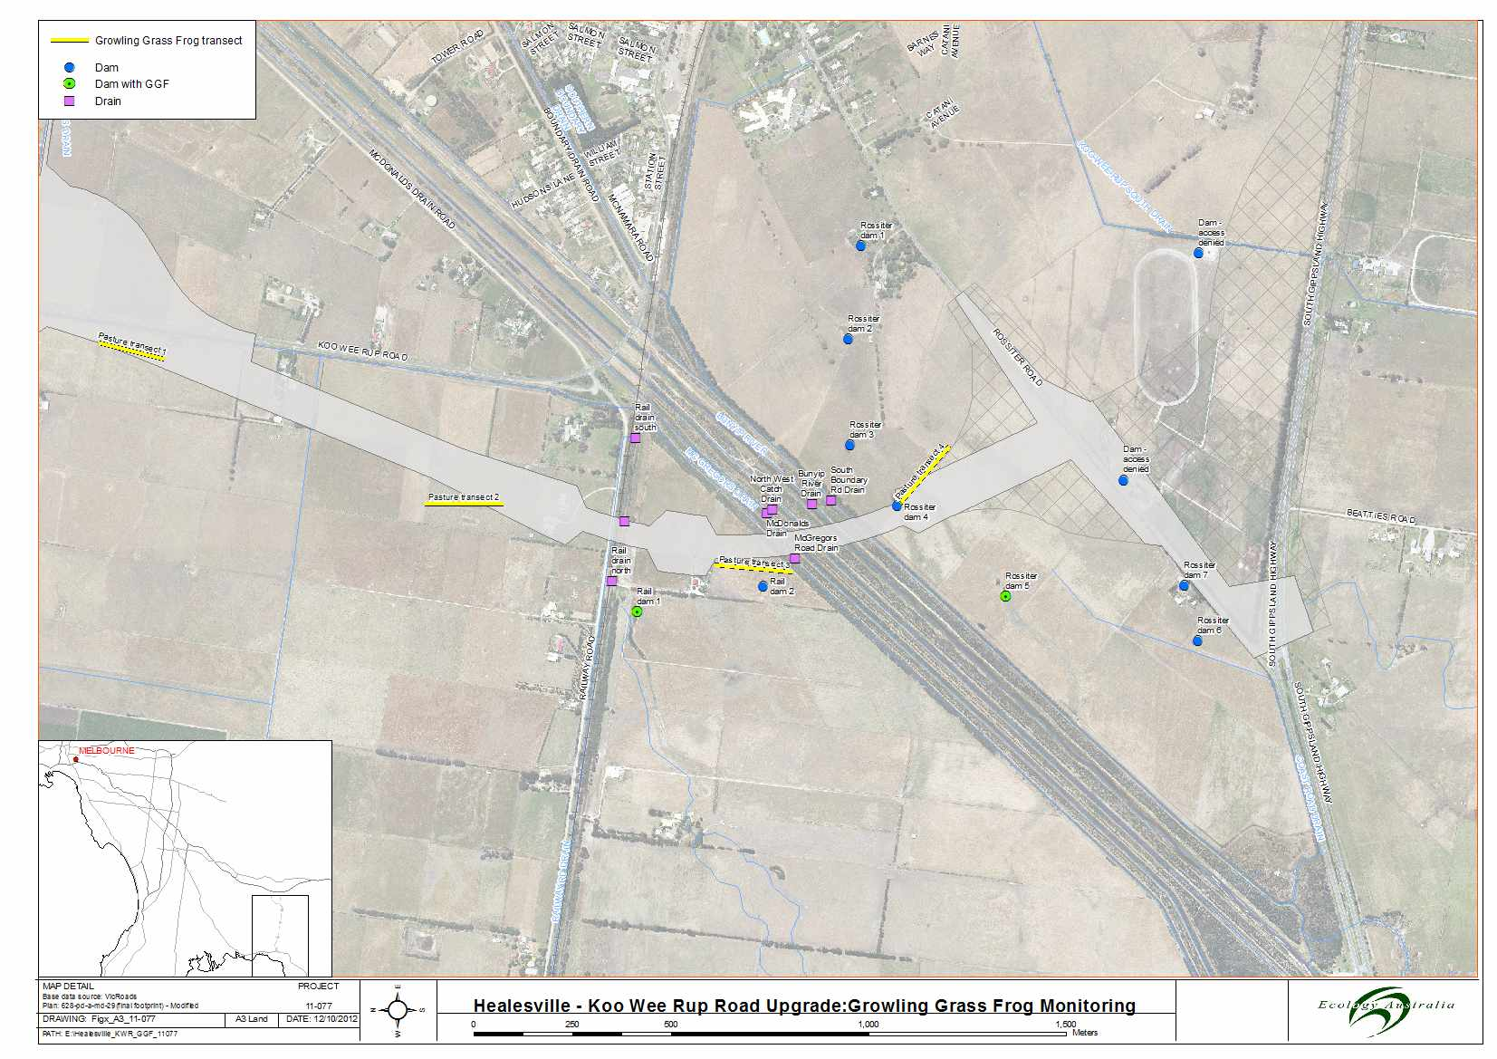

*The above pictures show the Koo Wee Rup Bypass alignment with survey reference points of the following: transect surveys as yellow lines, dams as a blue circle, dams with Growling Grass Frogs as green circles and areas of the drains monitored as purple squares.*

Figure Location of Swamp Skink Survey traplines in relation to the proposed Koo Wee Rup Bypass

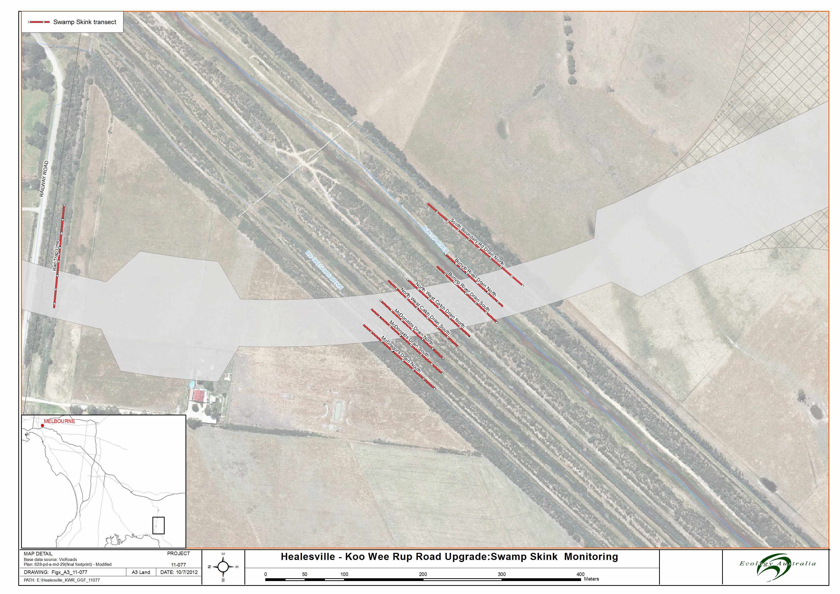

*The above pictures show the Koo Wee Rup Bypass central alignment between Railway Road and the Bunyip River Drains, illustrating Swamp Skink survey reference points in maroon coloured dashed lines.*

# Results

## Growling Grass Frog survey

### Frog species recorded

Seven frog species were recorded during the current survey: Growling Grass Frog, Southern Brown Tree Frog (*Litoria ewingii*), Whistling Tree Frog (*Litoria verreauxii*), Spotted Marsh Frog (*Limnodynastes tasmaniensis*), Striped Marsh Frog (*Limnodynastes perronii*), Pobblebonk Frog or Southern Bullfrog (*Limnodynastes drumerillii*) and the Common Froglet (*Crinea signifera*)*.* The tabulated results showing sites where the different species were recorded are given in table 1.

### Bunyip River drain complex frog survey and salinity monitoring

#### Frog Survey

Spotted Marsh Frogs and Common Froglets were recorded during the surveys of the Bunyip River Drain Complex. Three individual spotted Mash Frogs were seen on the management vehicle track during the period of the surveys, while on one occasion five Common Froglets were heard calling. Growling Grass Frogs could be heard calling while undertaking the survey of the Drain Complex, however, it was determined that the calling was emanating from the paddocks to the south of the drains along Rossiter Road. Access to the water’s edge along the drains was limited due to the steep banks and presence of dense vegetation. This may have limited the efficacy of the survey for Growling Grass Frogs within the Drain Complex.

#### Salinity monitoring

Water quality monitoring was undertaken for each drain on 6 December and 21 December 2011, and 24 January and 19 March 2012. In total, each drain was sampled four times. Figure 1 shows the results of conductivity measurements (measured in Micro-siemens) which can be used to determine salinity levels in water. The figure indicates thresholds for water quality as outlined in the Waterwatch Australia National Technical Manual (Waterwatch 2012).

Three of the five drains (McDonald Drain, North West Catch Drain and the Bunyip Main Drain) generally maintained levels of salinity consistent with that of fresh water rivers for the period of the survey (Table 2, Figure 3). Meanwhile, salinity in the South Boundary Road Drain peaked during January to levels considered to be consistent with mid-level marginal river water quality and salinity in the McGregor Road Drain peaked near brackish levels (Table 2, Figure 3). Observations of the two drains where salinity levels had increased indicated that water flow through these drains had ceased over January due to low rainfall, reducing the drains to a series of small isolated pools of stagnant water. This would suggest that the increase in salinity levels are a result of salt becoming concentrated as water evaporated from the drains over January, as opposed to tidal influxes during this period. The reduction in salinity levels recorded in March is likely to be a result of autumn rainfall that has seen these drains fill and flow once again.

Table Conductivity (uS/cm) measurements taken from the Bunyip River Drain Complex

| **Drain/date** | **McGregor Rd Drain** | **McDonalds Drain** | **North West Catch Drain** | **Bunyip River Drain** | **South Boundary Rd Drain** |
| --- | --- | --- | --- | --- | --- |
| 06-12-11 | 380 | 380 | 460 | 200 | 410 |
| 21-12-11 | 1060 | 500 | 570 | 170 | 750 |
| 24-01-12 | 1580 | 540 | 650 | 140 | 1090 |
| 19-03-12 | 650 | 550 | 700 | 160 | 690 |

Table Conductivity of various water types as described by Waterwatch Australia National Technical Manual 2012.

| **Water Type** | **Conductivity (uS/cm)** |
| --- | --- |
| Distilled water | 0.5-3 |
| Pure Rain Water | <15 |
| Fresh water rivers | 0-800 |
| Marginal river water | 800-1600 |
| Brackish water | 1600-4800 |
| Saline Water | >4800 |
| Sea water | 51500 |
| Industrial waters | 100-10 000 |

Melbourne Water salinity data for the Bunyip Main Drain, taken monthly over the past 14 years at a site 500 m upstream from the proposed Koo Wee Rup Bypass bridge is displayed in Figure 3. The data indicates that the Bunyip Rivers salinity up until 2007 generally remained at levels consistent with fresh river water. Between 2007 and late 2010, salinity levels in the twice recorded at levels consistent with that of saline (sea) water. Also, during this period salinity levels in the Bunyip River approached or reached levels consistent with marginal river water on nine of occasions.

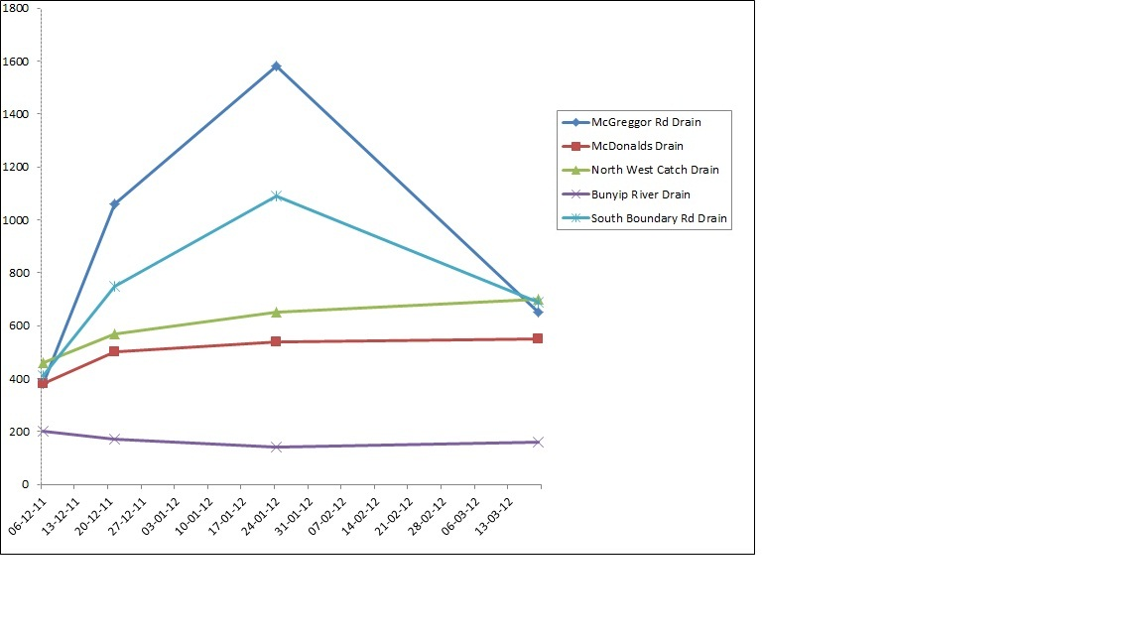

Fresh Water

uS/cm

Marginal River Water

Brackish Water

**Figure Salinity monitoring results for the Bunyip River Drain Complex December 2011 – March 2012)**

*The above graph illustrates the salinity levels along the Bunyip River Drain Complex during the period December 2011 and March 2012. The McGregors Drain measured at 1600us/cm, whilst the remaining three drains were found to measure between 400 and 1100 us/cm. The Bunyip River was measured to approximately 200 us/cm indicating freshwater presence.*

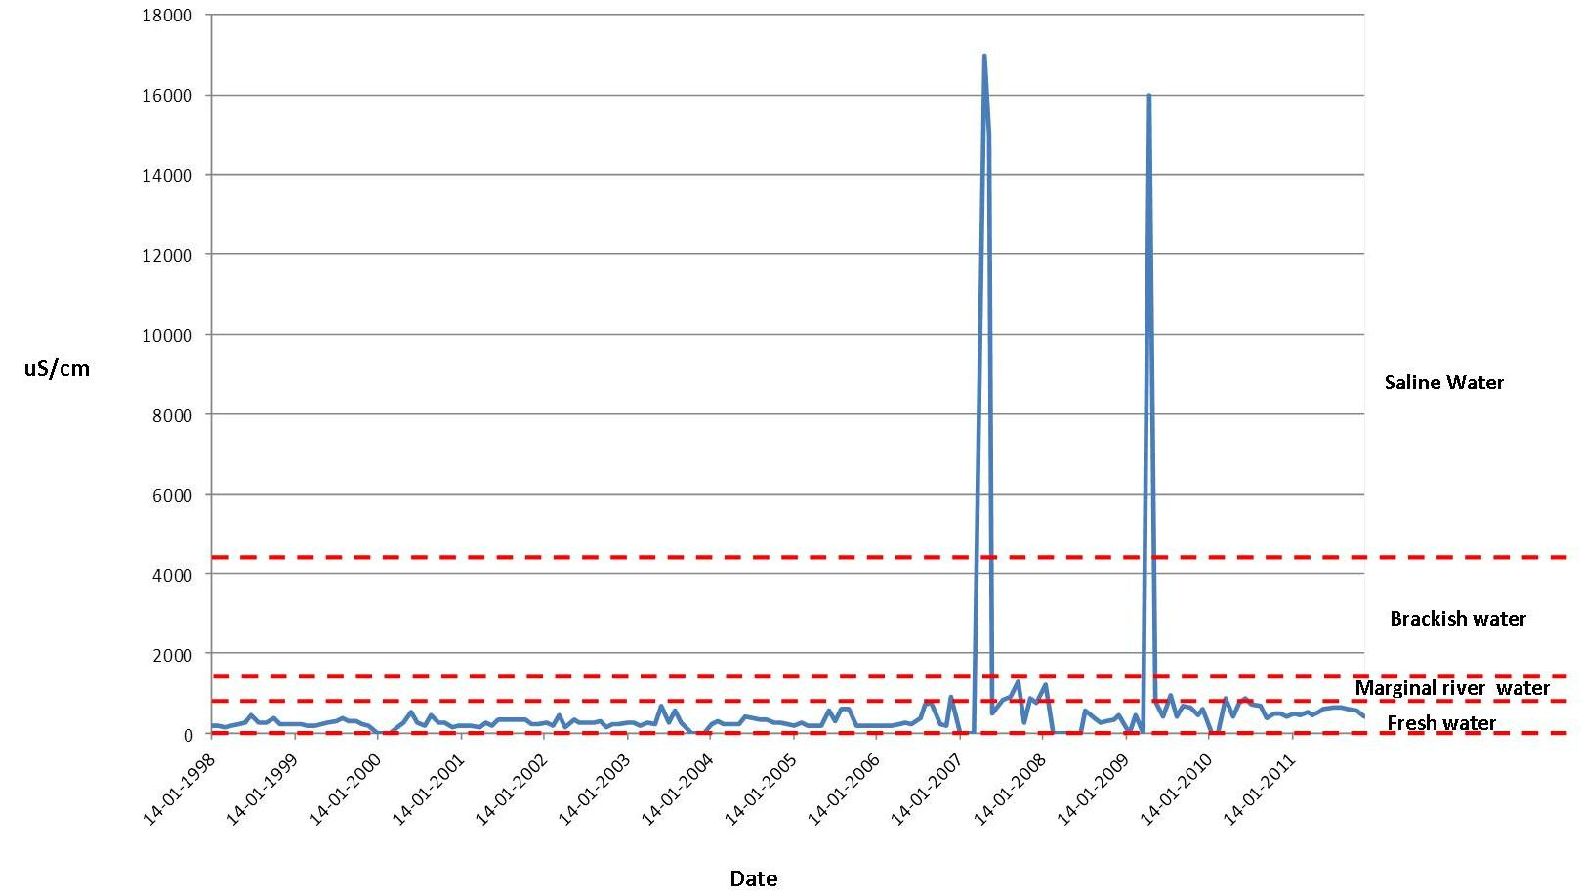

**Figure 14 year salinity levels for Bunyip Main Drain at Healesville – Koo Wee Rup Road Bridge (Source – Melbourne Water)**

*The above graph illustrates the salinity levels along the Bunyip River Drain Complex during the period January 1998 and January 2011. A significant spike of approximately 16000 us/m was identified during 2007 and 2009.*

### Paddock transects

No Growling Grass Frogs were recorded along any of the paddock transects during the four survey sessions. Common frog species such as the Spotted Marsh Frog, Common Froglet, and Whistling Tree Frog were recorded during the initial survey period in November/December. Subsequent surveys detected little frog activity with no frogs recorded during the second and third surveys and only one Spotted Marsh Frog recorded at each of transects 2, 3 and 4 during the final survey. Habitat conditions changed dramatically between the first survey and the subsequent surveys. During the first survey in November/December, large areas of standing water were present due to above average rainfall over spring. Also, numerous minor paddock drains intersected transects, all of which were flowing at the time of the initial survey. During all subsequent surveys, no standing water was observed along transects, and all minor drains had dried out.

### Railway drains and swampy areas

No Growling Grass Frogs were recorded during the spotlight surveys of the railway drains and associated swampy areas. The Common Froglet, Spotted Marsh Frog and Stripped Marsh Frog were all recorded during these surveys. The conditions of these habitats changed rapidly during the survey period with a significant reduction in water levels. The sites changed from being inundated in water during the November/December survey, to being completely dry by the third survey session conducted in January. The ephemeral nature of these drains, and the high levels of vegetative cover observed, supports the theory that they could act as dispersal routes across the landscape for the Growling Grass Frog, particularly during wet seasonal conditions as experienced during spring and early summer in 2011, but are unlikely to support resident populations of Growling Grass Frogs.

### Farm dam monitoring

The Growling Grass Frog records are mapped in figure 1, and the habitat assessments are provided in Appendix 3. Records of Growling Grass Frogs were recorded from two of target dams, including one, just south of Railway Road (Rail Dam 1, 8 GGF on 30 December 2011 and 4 GGF on 23 January 2012) and one located between Rossiter Road and the Bunyip River Drain Complex (Rossiter Dam 5, 3 GGF on 30 November 2012) and from both the reference dams on Ballarto Road [(Reference Dam 1 1GGF on 20 November 2011 and 37 GGF on 24 January 2012)(Reference Dam 2 4 GGF on 30 November 2012)(Table 4)] .

The dam to the south of Railway Rd (Rail Dam 1) was previously identified as containing moderate Growling Grass Frog habitat quality (Ecology Australia 2008) due to the presence of emergent aquatic and semi aquatic vegetation (Appendix 4, Plate 10). However, no Growling Grass Frogs were recorded over the two nights of the previous survey (Ecology Australia 2008). In contrast, Growling Grass Frogs were recorded during both visits of this study, making use of fringing and emergent vegetation around the periphery of the dam. Individuals ranged from adult males and females, juveniles to small metamorphs, indicating that successful breeding had been taking place at the dam.

The dam located to the north of Rossiter Road and south of the Bunyip River Drain Complex (Rossiter Dam 5, Appendix 4, Plate 7) was identified as containing low quality Growling Grass Frog habitat due to the presence of little or no floating and submergent vegetation, and recent cattle grazing of the dams edges (Appendix 3). While this was the case, two Growling Grass Frogs were heard calling within this dam, and one Growling Grass Frog was observed during the first survey conducted on 7 December 2011. During the subsequent survey on the 24 January 2012, the habitat quality appeared to have further degraded with recent cattle trampling causing major pugging around the dam, including the trampling of emergent vegetation where the Growling Grass Frogs had previously been recorded. No Growling Grass Frogs were observed during this visit.

A third dam just north of Rossiter Road (Rossiter Dam 1) was considered to be of moderate Growling Grass Frog habitat quality due to its high cover of emergent and fringing vegetation (Appendix 3). Previous surveys have recorded Growling Grass Frogs from this dam (Ecology Australia 2006), however, spotlight and call playback surveys undertaken for this study failed to record any Growling Grass Frogs within this dam.

The two reference dams (Appendix 4, plates 1 and 2) near the intersection the Healesville – Koo Wee Rup Road and Ballarto Road again yielded records of Growling Grass Frogs. The dam to the east of the Koo Wee Rup Road (Reference Dam 1) resulted in Growling Grass Frogs being recorded during both surveys [(1 GGF on 29 November 2011 and 37 GGF on 24 January 2012) (Table4)]. This high number of Growling Grass Frogs is consistent with the previous survey in 2008, when 49 Growling Grass Frogs were recorded from this site. Four Growling Grass Frogs were heard calling from the dam to the west of the Healeseville Koo Wee Rup Road [(Reference Dam 2)(Table 4)], however, steep banks and a high cover of weeds, especially *Blackberries (*Rubus frutcosis sp agg*.), limited access to conduct effective spotlight surveys, and therefore it is likely that the number of Growling Grass Frog present at the site are higher than this survey recorded.

It was noted that during site selection on the property at the intersection of Rossiter Road and South Gippsland Highway that the property had changed ownership since 2006. As a consequence a number of changes to dams present on the property had occurred. This included, a dam in the southwest corner of the property where Growling Grass Frogs had been previously recorded has been in-filled. A dam along Rossiter Road where Growling Grass Frogs had previously been recoded had been partially filled in. A third dam, in the east of the property has been modified but still supports Growling Grass Frog habitat. While habitat assessments were conducted for these dams, access was denied to undertake nocturnal surveys for Growling Grass Frogs.

**Table Healesville – Koo Wee Rup Road Upgrade: tabulated results of the Growling Grass Frog survey.**

*Survey Session 1 -* undertaken on 29 and 30 November and 7 December, 2011

*Survey Session 2 –*undertaken on 21 December, 2011

*Survey session 3-* undertaken on 23 and 24 January, 2012

*Survey session 4 –* undertaken on 19 March, 2012

*\** Surveys of dams were only undertaken during Survey Sessions 1 and 3.

| **Site No.** | **Type of Water body and Location** |  |
| --- | --- | --- |
| *Reference Dam 1 | Large market garden dam, currently grazed by cattle, east side of Healesville ‑ Koo Wee Rup Road and along south side of Ballarto Road. **Moderate Growling Grass Frog habitat** | *Survey session 1*  **1 Growling Grass Frog seen**, 1 Southern Brown Tree Frog heard, 25-50 Whistling Tree Frogs heard, 5-10 Common Froglets heard, 5-10 Pobblebonk Frogs heard. Dam full at time of survey  *Survey session 3*  **37 Growling Grass Frogs** seen on bare banks of dam, in cattle pugs and on algae at water’s edge during second survey, 15 Whistling Tree Frogs heard. Dam drawn down to exposed banks. |
| *Reference Dam 2 | Large market garden dam west side of Healesville ‑ Koo Wee Rup Road and along north side of Ballarto Road. **Moderate Growling Grass Frog habitat** | *Survey session 1*  **4 Growling Grass Frogs heard,** 20-50 Whistling Tree Frogs heard, 10-20 Spotted Marsh Frogs, 10-20 Pobblebonk Frogs  *Survey session 3*  2 Whistling Tree Frogs heard, 3 Spotted Marsh Frogs heard |
| Paddock transect 1 | Transect through grazed paddock on western side of Healesville ‑ Koo Wee Rup Road and south of Manks Rd. Small drainage channels flowing during first survey | *Survey session 1*  5-10 Whistling Tree Frogs heard, 5-10 Common Froglets heard, 25-50 Spotted Marsh Frogs heard.  *Survey session 2*  No frogs  *Survey session 3*  No frogs  *Survey session 4*  No frogs |
| Paddock transect 2 | Transect through grazed paddock on north side of Railway Rd. | *Survey session 1*  No frogs  *Survey session 2*  No frogs  *Survey session 3*  No frogs  *Survey session 4*  1 Spotted Marsh Frog seen |
| Paddock transect 3 | Transect through grazed paddock south of Railway Rd | *Survey session 1*  5-10 Common Froglets heard, 25-50 Spotted Marsh Frogs heard  *Survey session 2*  1 Spotted Marsh Frog seen  *Survey session 3*  No frogs  *Survey session 4*  1 Spotted Marsh Frog seen |
| Paddock transect 4 | Transect through grazed paddock north of Rossiter Rd and south of Bunyip Main Drain Complex | *Survey session 1*  No frogs  *Survey session 2*  No frogs  *Survey session 3*  No frogs  *Survey session 4*  1 Spotted Marsh Frog seen |
| Bunyip River Drain | Main drain in the Bunyip River drain complex fast flowing water. **Low Growling Grass Frog habitat** due to fast flowing nature of water body. | *Survey session 1*  No frogs  *Survey session 2*  No frogs  *Survey session 3*  No frogs  *Survey session 4*  No frogs |
| McDonalds Drain | Linear drain with dense fringing and emergent vegetation. **Moderate Growling Grass Frog habitat**. | *Survey session 1*  No frogs  *Survey session 2*  No frogs  *Survey session 3*  No frogs  *Survey session 4*  5 Common Froglets heard |
| North West Drain | Linear drain with dense fringing and emergent vegetation. **Moderate Growling Grass Frog habitat**. | *Survey session 1*  1 Spotted Marsh Frog seen  *Survey session 2*  No frogs  *Survey session 3*  No frogs  *Survey session 4*  No frogs |
| McGregors Road Drain | Linear drain with dense fringing vegetation, degraded banks with blackberries, broom and Melaleuca **Low** **Growling Grass Frog habitat** due to heavy shading by surrounding vegetation | *Survey session 1*  1 Spotted Marsh Frog seen  *Survey session 2*  No frogs  *Survey session 3*  No frogs  *Survey session 4*  1 Spotted Marsh Frog seen |
| Southern Boundary Drain | Linear drain with dense fringing vegetation, degraded banks with blackberries, broom and Melaleuca **Moderate** **Growling Grass Frog habitat** | *Survey session 1*  No frogs  *Survey session 2*  No frogs  *Survey session 3*  No frogs  *Survey session 4*  No frogs |
| *Rossiter Dam 1 | Farm dam with Growling Grass Frogs previously recorded. High cover of emergent and fringing vegetation with areas of floating vegetation. Evidence of grazing. **Moderate Growling Grass Frog habitat** | *Survey session 1*  50-100 Southern Brown Tree Frogs heard, 50-100 Whistling Tree Frogs heard, 30-50 Striped Marsh Frogs heard, 20-30 Spotted Marsh Frogs heard  *Survey session 3*  No frogs |
| *Rossiter Dam 2 | Degraded stock dam, low floating and emergent cover. High fringing cover. **Low-moderate Growling Grass Frog habitat**. | *Survey session 1*  5-10 Whistling Tree Frogs heard, 20-50 Spotted Marsh Frogs heard  *Survey session 3*  No frogs |
| *Rossiter Dam 3 | Degraded stock dam high cover of floating red algae, high fringing vegetation cover and low emergent cover – **Moderate Growling Grass Frog habitat** | *Survey session 1*  1 Southern Brown Tree Frog heard, 30 Whistling Tree Frogs heard, 2 Striped Marsh Frogs heard, 50-100 Spotted Marsh Frogs heard, 2 Pobblebonk Frogs heard  *Survey session 3*  1 Whistling Tree Frog heard |
| *Rossiter Dam 4 | Good fringing vegetation. Low emergent cover and no floating or submergent vegetation – **Moderate Growling Grass Frog habitat** | *Survey session 1*  20-30 Whistling Tree Frogs heard, 50-100 Spotted Marsh Frogs heard  *Survey session 3*  No frogs |
| *Rossiter Dam 5 | Degraded stock dam, not full since 1996-97. Little floating vegetation and emergent vegetation. Recently grazed with signs of pugging. **Low Growling Grass Frog habitat** | *Survey session 1*  **2 Growling Grass Frogs heard and 1 seen**. 25 Whistling Tree Frogs heard, 25-50 Spotted Tree Frogs heard  *Survey session 3*  No frogs |
| *Rossiter Dam 6 | Degraded stock dam with little or no floating and submergent vegetation. Signs of cattle grazing (cow pats and pugging). **Low Growling Grass Frog habitat** | *Survey session 1*  1Striped Marsh Frog heard  *Survey session 3*  No frogs |
| *Rossiter Dam 7 | *Phragmities* dominated dam with high emergent and fringing cover. **Low Growling Grass Frog habitat** | *Survey session 1*  No frogs  *Survey session 3*  No frogs |
| *Rail Dam 1 | Good cover of fringing and emergent vegetation. Some floating vegetation and logs within water present. **Moderate to High Growling Grass Frog habitat** | *Survey session 1*  **8 Growling Grass Frogs heard, 4 seen**, 2 Southern Brown Tree Frogs heard, 50-100 Whistling Tree Frogs heard, 5-10 Striped Marsh Frogs heard, 50-100 Spotted Marsh Frogs heard, 10-20 Pobblebonk Frogs heard  *Survey session 3*  **4 Growling Grass Frogs heard**, 30-40 Whistling Tree Frogs heard |
| *Rail Dam 2 | Degraded stock dam, currently grazed, pugging occurring throughout. **Low Growling Grass Frog habitat** | *Survey session 1*  10-20 Spotted Marsh Frogs heard.  *Survey session 3*  No frogs |
| Rail Drain South | Drain at base of disused rail line – swampy marsh areas continuous to Bunyip Drain complex, **High Growling Grass Frog habitat** | *Survey session 1*  1 Southern Brown Tree Frog heard, 1 Striped Marsh Frog heard  *Survey session 2*  No frogs  *Survey session 3*  No frogs  *Survey session 4*  No frogs |
| Rail Drain North | Drain at base of old rail line – swampy marsh areas and areas of degraded swampy wetland, continuous to Bunyip Drain complex. **High Growling Grass Frog habitat** | *Survey session 1*  1 Whistling Tree Frog heard, 2 Stripped Marsh Frogs heard  *Survey session 2*  25-50 Striped Marsh Frogs heard  *Survey session 3*  No frogs  *Survey session 4*  No frogs |

## Swamp skink survey

No Swamp Skinks were captured over the 270 trap days of surveying. As mentioned previously Swamp Skinks are extremely difficult to survey for and their absence from surveys does not necessarily mean that they are not present.

## Other species captured

Non-target species incidentally captured include three small mammal species and one reptile species (table 3).

Small mammal species captures included the native Swamp Rat (*Rattus lutreolus*), the introduced *House Mouse (*Mus musculus*), and the introduced Black Rat (*Rattus rattus).* The Swamp Rat and Black Rat were captured on the southern side of the North West Catch Drain, while House Mice were captured on the north and south side of the Bunyip River Drain, the north side of the North West Catch Drain, and the trap line set along the Railway line.

Four Whites Skinks (*Egernia whitii*) were captured, including three along the southern side of the North West Catch Drain, and one along the southern side of McGregors Drain.

**Table Vertebrate species captured during survey for Swamp Skinks (*Lissolepis coventryi)* (19, 20 and 22 March 2012) A total of 270 trap days were undertaken**

| **Species** | **McGregor Drain** | **McDonalds Drain** | | | **North West Catch Drain** | | | **Bunyip River Drain** | | | **South Boundary Rd Drain** | **Railway Line** |
| --- | --- | --- | --- | --- | --- | --- | --- | --- | --- | --- | --- | --- |
|  | **South** | **North** | | **South** | **North** | | **South** | **North** | | **South** | **North** |  |
| **Trap days** | **30** | **30** | | **30** | **30** | | **30** | **30** | | **30** | **30** | **30** |
| ***Mammals*** | | | | | | | | | | | | |
| **Swamp Rat** |  |  |  | |  | 1 | |  |  | |  |  |
| **House Mouse** |  |  |  | |  | 2 | | 1 | 3 | |  | 5 |
| **Black Rat** |  |  |  | |  | 1 | |  |  | |  |  |
| ***Reptiles*** | | | | | | | | | | | | |
| **White’s Skink** | 2 |  | | 2 |  |  | |  |  | |  |  |

# Discussion

## Potential impacts

### Growling Grass Frog

**Salinity levels**

Examination of the salinity data taken from the Bunyip River Drain Complex during the field work and analysis of the 14 years of Melbourne Water Data taken from the Bunyip River 500m upstream from the Koo Wee Rup Bypass crossing site suggests that while fluctuations in salinity occur, levels rarely go above that of what is considered fresh water in the larger drains. The Melbourne Water data indicate that the Bunyip river only twice in the past 14 years has recorded levels of salinity that are consistent with that of sea water, both of which have occurred in the past five years (2007 and 2009). It is likely that low flows associated with drought conditions combined with spring tides resulted in a tidal push of saline water as far as the Melbourne Water monitoring site. The data also suggest that around the same period incidences where salinity levels reached that of marginal river water (as opposed to fresh) increased, although the trend appears to have subsided with the past couple of years of average rainfall.

The two smaller drains (McGregor Drain and South Boundary Road Drain) are worth mentioning as their salinity levels fluctuated during the current study. Observations made during the sampling suggest this is a result of the evaporation of water concentrating salt over the summer months as opposed to tidal saline influences. Both of these drains were reduced to isolated pools during the peak of summer when their salinity levels rose to that of marginal river water for South Boundary Rd drain, and very nearly brackish water in the case of the McGregor Drain. Once a number of late summer rainfall events had occurred and flow returned to these drains the salinity levels fell back to that of fresh water.

Impacts of salinity levels on the Growling Grass Frog are poorly understood (Smith et al.2008). However, it is thought that they can safely tolerate salinity levels of less than 8% seawater, or about 4000 micro-siemens (Smith et al. 2008). Research conducted on the tadpoles of the closely related Green and Golden Bell Frog (*Litoria aurea)* by Christy and Dickman (2002) provide the closest comparison for the impacts of salinity on Growling Grass Frog tadpoles as outlined in Table 6.

**Table Salinity tolerances of the Green and Golden Bell Frog (*Litoria aurea*) tadpole taken from Christy and Dickman 2002.**

| Micro Siemens | Effect on tadpoles |
| --- | --- |
| 2060 | No apparent effect |
| 2832 | Decreased growth rate and increased mortality |
| 5150 | Mortality in all individuals within 72 days |
| 10300 | Mortality in all individuals within 4 |
| 12875 | Mortality in all individuals within 5 hours |
| 5150-7725 | tolerated for up to 3 weeks before any major impacts |
| <2832 | No metamorphosis occurred |

Based on both Smith et al.(2008) and Christy and Dickman (2002), salinity levels within the Bunyip River Drain predominantly exist within the range that are unlikely to have any major impacts on the life cycle of the Growling Grass Frog. The saline spikes observed from the Melbourne Water data in 2007 and 2009 reach levels well above which the tadpoles of the closely related Green and Golden Bell Frog suffered from 100% mortality after just five hours exposure. The increase in salinity levels of both McGregors Drain and South Boundary Rd Drain do not reach levels that are considered to impact on the related Green and Golden Bell Frog tadpoles.

This analysis suggests that the Bunyip River Drain Complex in the vicinity of the proposed Koo Wee Rup Bypass has the potential to support the Growling Grass Frogs. Whilst this is the case, occasional saltwater intrusion may impact on seasonal use, possibly by causing mortality on adult frogs during certain years if they were to be resident within the drains during major salt water intrusion events. This combined with fluctuations in flow that are likely to result in frog eggs and/or tadpoles being washed downstream into Westernport Bay suggests a resident (breeding) population of Growling Grass Frogs are unlikely in the Bunyip River Drain Complex. It is possible however, that the Bunyip River Drain Complex is used by Growling Grass Frogs for dispersal.

**Growling Grass Frog Distribution**

The results of the surveys for Growling Grass Frog indicate that the species is likely to be spread across the landscape with records within the vicinity of the Bunyip River Drain Complex and to both the north and the south of the Drain Complex. Furthermore, the records of Growling Grass Frogs at the two reference sites at Ballarto Road suggest that the Growling Grass Frog is likely to occur in appropriate habitat to the north of Railway Road. This survey has highlighted the dynamic nature of Growling Grass Frog populations with the Growling Grass Frogs recorded in dams where they have not been previously recorded and recorded as absent in dams where they have been previously recorded. It also highlights that making assumptions about the quality of habitat based on the physical and biological attributes of water bodies can be problematic, with Growling Grass Frogs recorded in severely degraded stock dams during this study. It is understood that Growling Grass Frogs make use of degraded habitat when it is adjacent to higher quality breeding habitat (Pyke 2002; Robertson and Heard 2002; Heard and Robertson 2003; Wilson 2003; Heard et al. 2004; Wassens et al. 2008), or habitat links (Ecology Australia 2006) highlighting the need for maintaining connectivity between wetlands.

Biosis (2005) suggested that at a landscape scale suitable Growling Grass Frog Habitat comprises of:

* high density of suitable wetlands (with fringing, emergent, submergent and floating aquatic and semi-aquatic vegetation for breeding) and terrestrial habitats in close proximity to one another (e.g. less than 500 m) for foraging and over-wintering;
* the presence of drainage lines, creeks, rivers, water channels and artificial drains adjacent to suitable wetlands which enable dispersal and movement between sites; and
* no, or very few barriers to dispersal (e.g. housing development and sealed roads).

Observations made during the first survey session after a very wet spring indicates that the landscape surrounding the proposed Koo Wee Rup Bypass meets all of these criteria for landscape scale Growling Grass Frog habitat, with a high level of connectivity, a high density of suitable water bodies, and few barriers to dispersal.

While no Growling Grass Frogs were observed during the pasture transects, areas such as open pastures (grasslands) are considered to form important habitat for foraging and movement between breeding sites (Commonwealth of Australia, 2009). As such, the maintenance of pasture areas surrounding wetland habitat is crucial for maintaining Growling Grass Frog populations across the landscape

Furthermore, above average rainfall in the lead up to December meant that areas of pasture habitat were covered in water effectively acting as ephemeral wetlands, further highlighting the importance of the pasture areas as Growling Grass Frog habitat, particularly for dispersal. The rapid drying of the landscape observed during subsequent surveys highlights the importance of dam habitats to support populations of Growling Grass Frogs, especially as breeding habitat.

### Swamp Skink

The Swamp Skink is a cryptic and elusive species which is often associated with dense ground level vegetation at freshwater swamps and associated watercourses, or adjacent wet heaths, sedgelands and saltmarsh, especially those supporting Paperbarks (*Melaleuca* spp.) and Tea-trees (*Leptospermum* spp.). However, it has more recently been recorded in heathy woodland at the headwaters of a drainage line without any Paperbark thickets (near Ballarat) and in coastal heathland situated some distance from water (e.g. see Schulz 1985, Clemann et al. 1998, Robertson 1998, Clemman and Beardsell 1999, Clemann 2000, 2006). Within these habitats, it is not uniformly distributed, but selects micro-environments where vegetation is dense below two metres, but with little overstorey. Thus, it basks on tussocks (including weeds), grass, reeds, sedges, and on logs and rocks, where there is a break in the canopy (Clemann 2006). For example, at Tootgarook Swamp in Rye, tall dense *Melaleuca ericifolia* thickets are avoided, but margins of these thickets and adjacent *Gahnia* sp. sedgelands or other dense, low vegetation are used extensively (Robertson 1998).

While no Swamp Skinks were recorded during the current survey the presence of records downstream of the current study site (at the Koo Wee Rup swamp lookout) and the presence of suitable habitat suggest their presence within the study area cannot be ruled out from the results of the current survey.

As outlined in the Fauna Management Plan (Ecology Australia, 2012) any subsequent observations of Swamp Skink during the construction phase of the Koo Wee Rup Bypass will trigger a monitoring program, and the species will be subject to salvage protocols as outlined under the Fauna Management Plan.

The key issues to be considered for Swamp Skink conservation within the study area is the barrier effect that the Koo Wee Rup Bypass that could have on populations of Swamp Skink, with resulting fragmentation and isolation of populations. Ideally, the proposed works maintain habitat continuity under the bridges to avoid any potential barrier effects on this species. It is considered that mitigation measures put in place for the conservation of the Southern Brown Bandicoot (*Isoodon obesulus obesulus*)will be comparable to what is required for Swamp Skink conservation (Ecology Australia, 2012).

# Implications

* Data has been collected on Growling Grass Frogs within the vicinity of the Koo Wee Rup Bypass which will be used to address potential impacts of the bypass, as well as provide baseline data to assess the success of mitigation measures;
* Pre-cautionary measures to salvage Growling Grass Frogs along the Bunyip River Drain Complex prior to any works being undertaken should occur;
* While no Swamp Skinks were recorded during the survey any individuals encountered during the construction phase of the bypass should be salvaged and translocated to appropriate habitat.

# References

Biosis (2005) Pakenham Bypass Growling Grass Frog Environmental Management Plan. Report prepared by Organ, A. for Vic Roads. (Biosis Research Pty Ltd: Port Melbourne)

Christy M, Dickman C (2002) Effects of salinity on tadpoles of the Green and Golden Bell Frog (*Litoria aurea).* *Amphibia-Reptilia* **23**, 1-11

Clemann N (2006) Distribution and Ecology of the Swamp Skink *Egernia coventryi* in the Port Phillip and Western Port Region. Unpublished report prepared for Melbourne Water (Arthur Rylah Institute for Environmental Research, Heidelberg.)

Clemann N, Brown P and Brown G (1998) A note on bait selection when trapping the Swamp Skink *Egernia coventryi* in Elliott trap. *The Victorian Naturalist* **115 (3)**, 81-83

DEWHA (2009) Significant impact guidelines for the vulnerable growling grass frog (*Litoria raniformis).* Depatrment of the Environment, Water, Heritage and the Arts

DSE (2007) Advisory List of threatened Vertebrate Fauna in Victoria - 2007.  (Department of Sustainability and Environment: East Melbourne)

Ecology Australia (2006) Healesville- Koo Wee Rup Road Upgrade- Growling Grass Frog Surveys. Unpublished report prepared for VicRoads by C Renowden and D Quin (Ecology Australia Pty Ltd: Fairfield).

Ecology Australia (2008) Healseville – Koo Wee Rup Road Upgrade: Growling Grass Frog and Swamp Skink survey. Unpublished report prepared for VicRoads by D Quin and Christina Renowden (Ecology Australia Pty Ltd, Fairfield)

Heard G and Robertson P (2003) Yallock Creek and Yallock Cut Amphibian Study. Report of a Further Field Evaluation of the Habitat for Amphibians in the Yallock Creek Area, north of the South Gippsland Highway. Report prepared for Melbourne Water (Wildlife Profiles: Heidelberg.)

Heard G, Robertson P and Scroggie M (2004) The ecology and conservation status of the Growling Grass Frog (*Litoria raniformis*) within the Merri Creek Corridor. Report prepared for the Department of Sustainability and Environment. (Wildlife Profiles P/L and the Arthur Rylah Institute for Environmental Research.)

Pyke G (2002) A review of the biology of the Southern Bell Frog *Litoria raniformis* (Anura: Hylidae). *Australian Zoologist***32**, 32-48.

Pyke G.H. and White A.W (2001) A review of the biology of the Green and Golden Bell Frog *Litoria aurea*. *Australian Zoologist* **31**: 563-598.

Robertson P and Heard G (2002) Yallock Creek and Yallock Cut Amphibian Study. Report of a Field Evaluation of the Habitat for Amphibians in the Yallock Creek Area, south of the South Gippsland Highway. Report prepared for Melbourne Water (Wildlife Profiles: Heidelberg.)

Robertson P (1998) *Egernia coventryi* Swamp Skink Nomination prepared for Listing on Schedule 2 of the Flora and Fauna Guarantee Act, 1988. Unpublished report prepared for the Scientific Committee. (Wildlife Profiles, Heidelberg.)

Schulz M (1985) The occurrence of the mourning skink*, Egernia coventryi* Storr, in saltmarsh in Westernport Bay, Victoria. *The Victorian Naturalist* **102(5)**, 148-152.

Smith M, Clemann N, Scroggi M and Peterson G. (2008) The threated Growling Grass Frog in the Wimmera and Corangamite Catchments. An assessment of Habitat Requirements and the Utility of Automatic Call Recording Devices as a Survey Tool (Auther Rylah Institute for Environmental Research, Heidelberg)

Tyler, M (1997) The Action Plan for Australian Frogs. (Wildlife Australia Endangered Species Program for Environment Australia: Canberra.)

Yugovic J and Mitchell S (2006) Ecological review of the Koo-Wee-Rup Swamp and associated grasslands. *The Victorian Naturalist* **123**, 323 – 334.

Wassens S, Watts J, Jansen A and Roshier D(2008) Movement patterns of southern bell frogs (*Litoria raniformis*) in response to flooding. *Wildlife Research* **35**, 50-58.

Waterwatch Australia steering committee (2012) Waterwatch Australia national technical manual: Module 4 – Physical and chemical parameters [http://www.waterwatch.org.au/publications/module4/electrical.html (Environment](http://www.waterwatch.org.au/publications/module4/electrical.html%20(Environment) Australia) Accessed March 2012

Wilson C (2003) The use of translocations as a conservation strategy for the Growling Grass Frog *Litoria raniformis*. Unpublished Third year research project. (Deakin University, Burwood.)

**Appendix**  Spotlighting standard procedures

Surveys for the Growling Grass Frog were undertaken at night by teams of two people between 2100 and 2330 h DST. Hand-held 30 W spotlights were used to detect the frogs; this is a commonly used and effective technique for detecting Bell Frogs (Williams 2001, Hamer et al. 2002, Robertson and Heard 2002). Survey time for water bodies varied according to the size and habitat complexity of each site. Where possible, surveys were limited to suitable weather conditions (i.e. night = air temp. greater than 12ºC and/or absence of a strong wind).

At the beginning of each survey, a period of five minutes was spent listening for male frogs calling. The abundance of all calling males from all frog species was recorded during this time. Weather variables were recorded at the beginning of each survey, including: air temperature, cloud cover, rain, wind levels and a general description of the weather conditions. Following this, each site was systematically searched for active frogs using the following techniques (outlined in Crump and Scott 1994):

* whilst traversing the length of the water bodies, spotlights were used to scan the surface and edge of the water bodies, focussing on the fringing and aquatic vegetation;
* frogs were detected either by direct encounter or identification of the frogs’ distinctive eye shine with the aid of binoculars (see Williams 2001);
* frogs were assigned to a size class ‑ metamorphlings (specimens equal to or less than 40 mm in total length), sub-adult (between 40-60 mm), or adult (specimens above 60 mm).

If no growling grass frogs were heard or observed a period of call playback was conducted in an attempt to elicit a responding call. A thirty second clip of a male Growling Grass Frog call was broadcast via an MP3 player attached to megaphone. Two minutes of quiet listening time was then spent waiting for a response.

Methods to reduce the possible spread of infectious pathogens (such as ‘chytrid fungus’) between sites were implemented in accordance with standards described by the New South Wales National Parks and Wildlife Service (NPWS 2001). For purposes of hygiene management, water bodies with no probable interchange of specimens were considered separate sites (NPWS). The following measures were used to mitigate the spread of disease between sites:

* footwear was thoroughly disinfected (saturated with ‘White King’) at the commencement of field work and between each survey site; and
* wetlands were only approached on foot to eliminate car tyres as a source of transmission.

**Appendix**  Habitat assessment proforma

The habitat present at each monitoring site was assessed using a habitat assessment Proforma developed by Ecology Australia and which includes collection of data pertaining to a standard set of habitat variables (see Appendix 1). Habitat assessments were conducted on 11, 12 and 13 February and 6 March 2008. To eliminate observer bias, the assessments were done by the same observers throughout (authors). The variables assessed can be assigned to five categories; the following is a description of each.

*Physical features*

Each monitoring site was classified into one of three water body types. These were a creek site, dam, or wetland. For the dam and wetland sites, the area (m2) was recorded by estimating the length and width, while all creek sites were c. 50 m in length. For creek sites, the width and depth of the channel was also recorded.

*Hydrology*

The hydrology of each monitoring site was assessed using two methods adapted from Pyke and White (1996) and Robertson et al. (2002). The water flow of creeks was classified as still, low, moderate or high. The nature of the water present at each site was classified into one of four categories: 0 (sporadic); 1 (ephemeral); 2 (semi-permanent); and 3 (permanent) (Table 2).

1. **Table 1 Healesville – Koo Wee Rup Bypass: definitions of the variable categories used to describe water permanency of all the sites surveyed for Growling Grass Frog within the study area.**

| **Variable** | **Definition** |
| --- | --- |
| **Water Permanency** |  |
| 0 | Water bodies that fill sporadically (at least every five years) with fluctuations in annual rainfall, water may be short lived after a filling event |
| 1 | Ephemeral or seasonal water bodies, fill yearly with average rainfall and contain water for months at a time |
| 2 | Permanent water bodies that display high seasonal fluctuations in water level, can be susceptible to drying out in drought years |
| 3 | Permanent water bodies that display a relatively stable water level all year, and are not susceptible to drying out in drought years, though water level may be reduced |

*Vegetation*

At each monitoring site, the cover and structure of vegetation was assessed. Vegetation cover is defined as the precent of the ground surface that would be obscured if a given area was viewed from directly above. The vegetation at each monitoring site was categorised as emergent, submergent, floating and fringing (see Table 3) and a visual assessment was used to estimate the percentage cover of each category. Emergent vegetation was assessed on the banks of the water body, including c. two meters into the water body and one meter above the water line. Submergent and floating vegetation was assessed over the entire water body surface, while fringing vegetation was assessed within the first five metres of bank away from the waterline.

Dominant vascular plant species were also identified at each survey site.

**Table 2 Healesville – Koo Wee Rup Road Bypass: definitions for each vegetation category sampled at sites surveyed for Growling Grass Frog within the study area.**

| **Vegetation Category** | **Definition** |
| --- | --- |
| Emergent vegetation | Semi-aquatic plant species in which the foliage grows primarily above the water surface |
| Submergent vegetation | Aquatic plant species in which the foliage grows primarily below the water surface |
| Floating Vegetation | Aquatic plant species in which the foliage floats upon the water surface, including Water Ribbon (*Triglochin procera*) and the upper foliage layer of submergent species |
| Fringing Vegetation | Terrestrial grasses, tree or shrub species growing within five metres of the waters edge |

*Evidence of Grazing*

The trampling of bank-side and in-stream vegetation from livestock occurs at many of the survey sites. Rather than quantifying this, comments were made on the extent of disturbance at each monitoring site. Other disturbance factors noted were recreational disturbance, pollution and rubbish.

*Presence of Predatory Fish*

The presence or absence of both exotic and native fish species were recorded at each monitoring site. Exotic fish e.g. Mosquito Fish (*Gambusia holbrooki*), have been implicated in the decline of several Australian frog species (Tyler 1997, Komak and Crossland 2000, Pyke and White 2001, Heard et al. 2004).

**Appendix**  Habitat proforma results for dams and drains covered in this survey

|  |  |  |  | **Vegetation cover %** | | | |  | **Grazing** | **Substrate %** | | | | |  |
| --- | --- | --- | --- | --- | --- | --- | --- | --- | --- | --- | --- | --- | --- | --- | --- |
| **Site Name** | **Type of Waterbody** | **Size (approx.)** | **Permanence** | **Emergent** | **Submergent** | **Floating** | **Fringing** | **Dominant plant species** |  | **Bare rock** | **Bare ground/soil** | **Rock rubble** | **Logs/fallen timber** | **Artificial** | **Comments** |
| Rossiter dam 1 | Dam | 30 by 40 m | 2? | 35 | 0 | 15 | 95 | Water Couch, Flat Drain Sedge, *Azolla* sp. | Cattle pugging and excreta | 0 | Mud/silt | 0 | 1 | 0 | Moderate GGF habitat previously recorded, high emergent and fringing cover. Currently heavily grazed. |
| Rossiter dam 2 | Dam | 35 by 45 m | 1 | 10 | 0 | 5 | 90 | grasses | Cattle excreta | 0 | 10 | 0 | 0 | 0 | Degraded Stock Dam Low-moderate habitat quality. No obvious connectivity |
| Rossiter dam 3 | Dam | 25 by 10 m | 1? | 10 | 0 | 0 | 90 | Red algae, Water Couch, *Phalaris*, Rye Grass |  | 0 | 0 | 0 | 5 | 0 | Degraded stock dam, moderate frog habitat |
| Rossiter dam 4 | Dam | 25 by 10 | 1? | 10 | 0 | 0 | 100 | Water Couch, *Phalaris*, Dock | Cattle | 0 | 0 | 0 | 0 | 0 | Good fringing cover, low emergent. Moderate Habitat |
| Rossiter dam 5 | Dam | 15 by 10 | 1 | 5 | 0 | 2-5 | 100 | Water Couch, Rye Grass | Cattle grazing | 0 | 2 | 0 | 0 | 0 | Degraded stock dam. Common long neck turtle seen |
| Rossiter dam 6 | Dam | 15 by 10 | 1 | 2-5 | 0 | 0 | 75 | Juncas, Rye Grass | Cattle grazing | 0 | 10 | 0 | 0 | 0 | Degraded stock dam, currently grazed |
| Rossiter dam 7 | Dam | 15 by 10 | 1 | 60 | 0 | 0 | 100 | *Phragmites* | No grazing | 0 | 0 | 0 | 0 | 0 | *Phragmites* dominated dam, high cover of fringing and emergent, not grazed |
| McGreggor Rd Drain | Drain | 100m transect | 3 | 35 | 0 | 0 | 100 | *Melaleuca*, broom, blackberry | No Grazing | 0 | 0 | 0 | 0 | 0 | Degraded banks, blackberry, broom, slow flowing water |
| McDonalds Rd Drain | Drain | 100m transect | 3 | 35 | 0 | 1 | 95 | *Melaleuca*, *Phragmites*, Watsonia | No Grazing | 0 | 0 | 0 | 0 | 0 | Medium flow speed, good cover of fringing and emergent vegetation |
| North West Catch Drain | Drain | 100m transect | 3 | 20 | 0 | 1 | 90 | *Melaleuca*, Dock, *Triglochin* | No Grazing | 0 | 0 | 0 | 0 | 0 | Moderate flow, good emergent and fringing vegetation |
| Bunyip River Drain | Drain | 100m transect | 3 | 30 | 0 | 0 | 100 | *Phragmites, Melaleuca*, blackberry | No Grazing | 0 | 0 | 0 | 0 | 0 | Fast flowing drain with dense fringing vegetation |
| South Boundary Rd Drain | Drain | 100m transect | 3 | 20 | 0 | 0 | 95 | *Melaleuca*, Dock, Drain Flat Sedge | No Grazing | 0 | 5 | 0 | 0 | 0 | Moderate frog habitat, slow flow high cover fringing vegetation |
| Rail Dam 1 | Dam | 100 by 12 | 3 | 10 | 0 | 10 | 80 | Rye Grass, Water Couch | Currently Grazed | 0 | 20 | 0 | 2 | 0 | Good wetland, with good cover of fringing and emergent vegetation, and logs in water |
| Rail Dam 2 | Dam | 18 by 12 | 1 | <5 | 0 | 0 | 10 | *Phalaris, Juncas* | Cattle grazing | 0 | 0 | 0 | 0 | Car tyres | Degraded stock dam with heavily pugged edges, no aquatic vegetation and incised banks. Low quality. |
| Reference dam 1 | Dam | 35 by 35 | 3 | 5 | 5 | 0 | 100 | Rye Grass, Dock, Capeweed | Grazed recently by cattle | 0 | 0 | 0 | 0 | 0 | High water level, high fringing cover, banks well vegetated |
| Reference dam 2 | Dam | 75 by 45 | 3 | 20 | 0 | 0 | 100 | *Typha*, Water Couch, *Phalaris,* Blackberry | No grazing | 0 | 0 | 0 | 0 | 0 | Large turkeys nest dam with high cover of *Typha* and high fringing cover. Dense cover of weeds on banks (e.g. Blackberry) |
| Rail Drain North | Drain | 200m transect | 1 | 80 | 0 | 10 | 100 | Phragmites, Swamp Paperbark, Blackwood, Swamp Gums | No grazing | 0 | 0 | 0 | 1 | 0 | 1st 50m section open drain, 2nd 100m dense swamp scrub, 3rd 50m open swamp scrub |
| Rail Drain South | Drain | 200m transect | 1 | 85 | 0 | 10 | 100 | *Phragmites*, Swamp Paperbark, Blackwood, | No grazing | 0 | 0 | 0 | 1 | 0 | 5-6 m wide swampy marsh. Boarded by pasture |

**Appendix**  Dams assessed as part of this survey

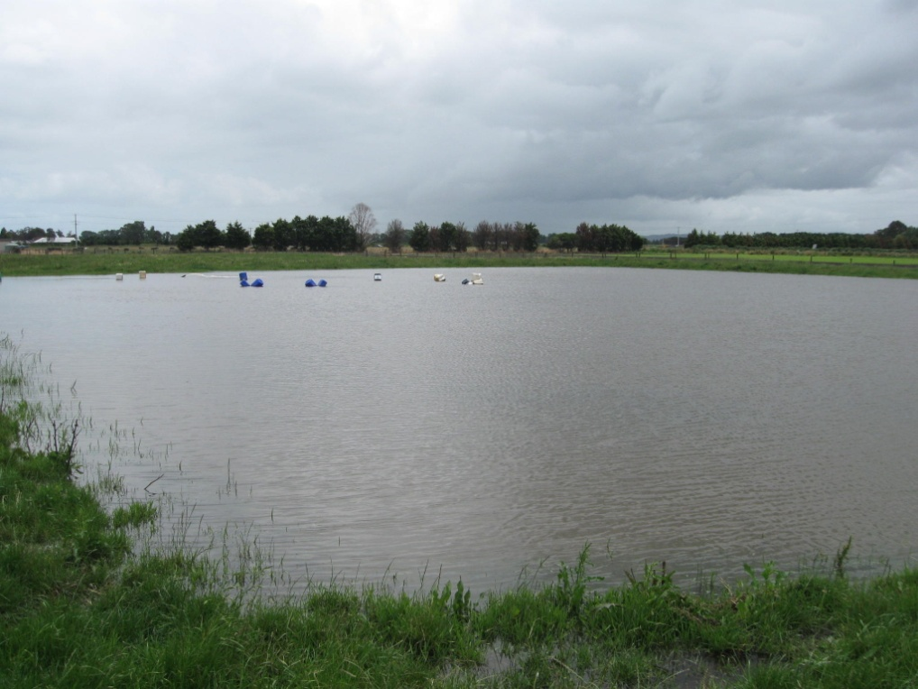

Plate Ballato Reference Dam 1. 38 Growling Grass Frog recorded during survey in December 2011 and January 2012. (Photo taken in December 2011)

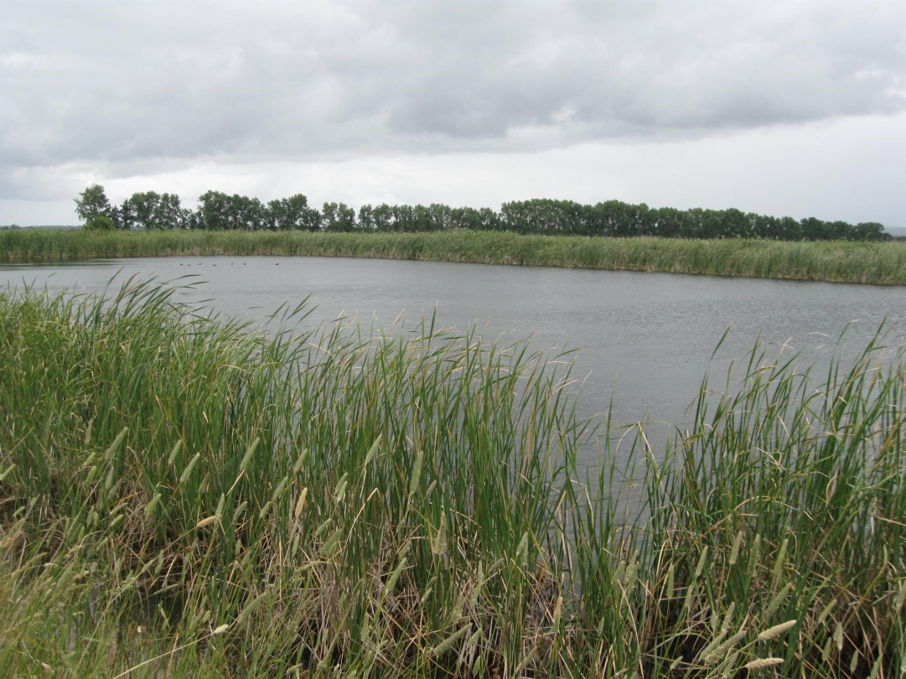

Plate Ballarto Reference Dam 2. Four Growling Grass Frogs recorded in December 2011 (Photo taken in December 2011)

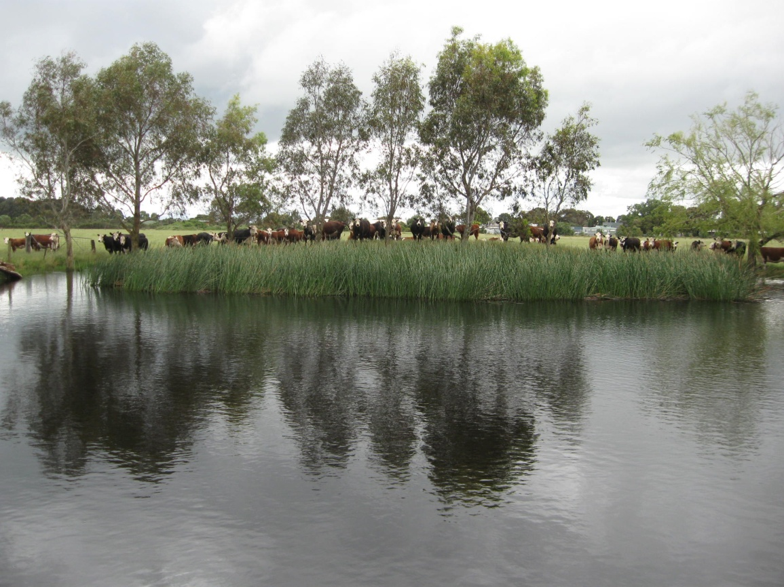

Plate Rossiter Dam 1 (Photo taken December 2011)

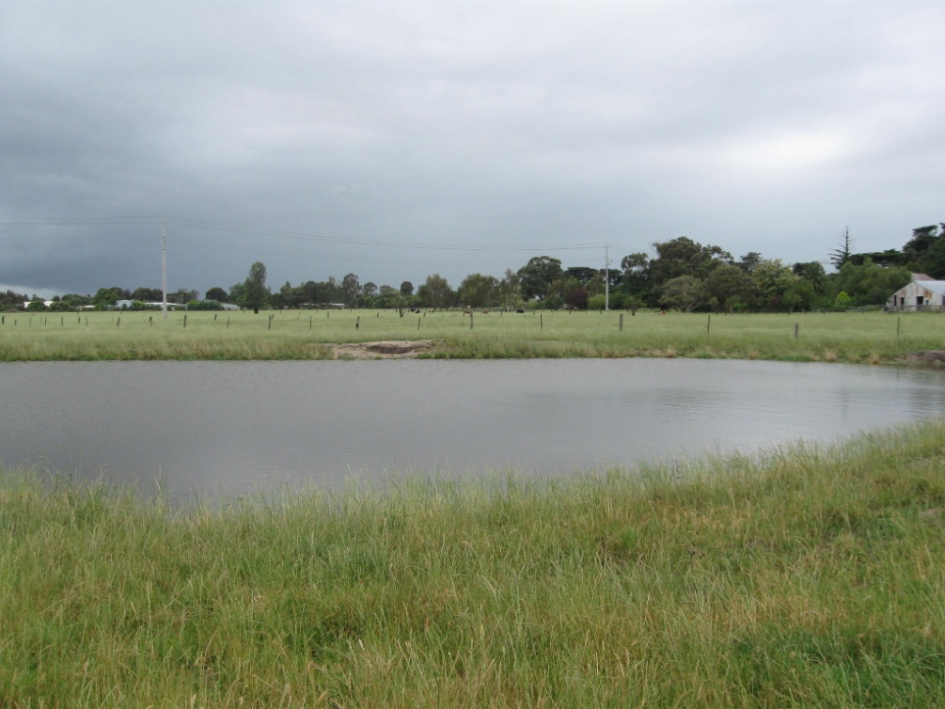

Plate Rossiter Dam 2 (Photo taken December 2011)

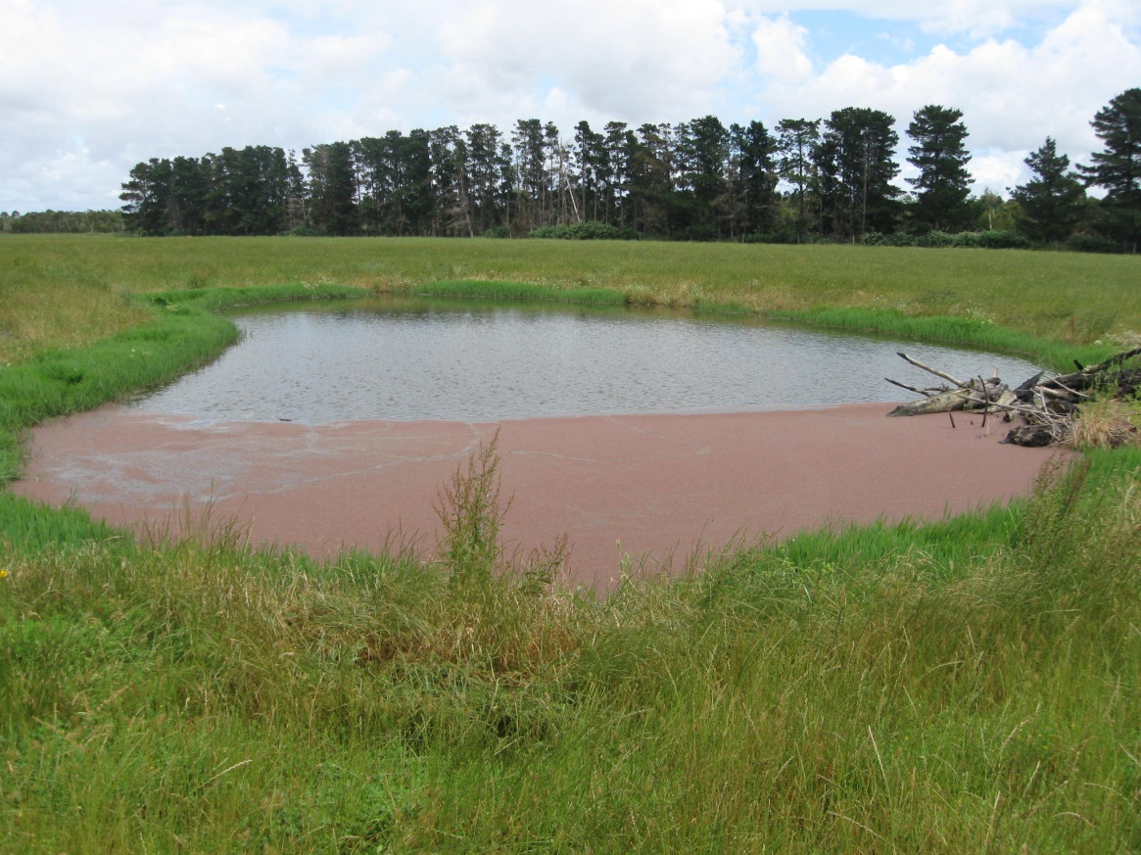

Plate Rossiter Dam 3 (Photo December 2011).

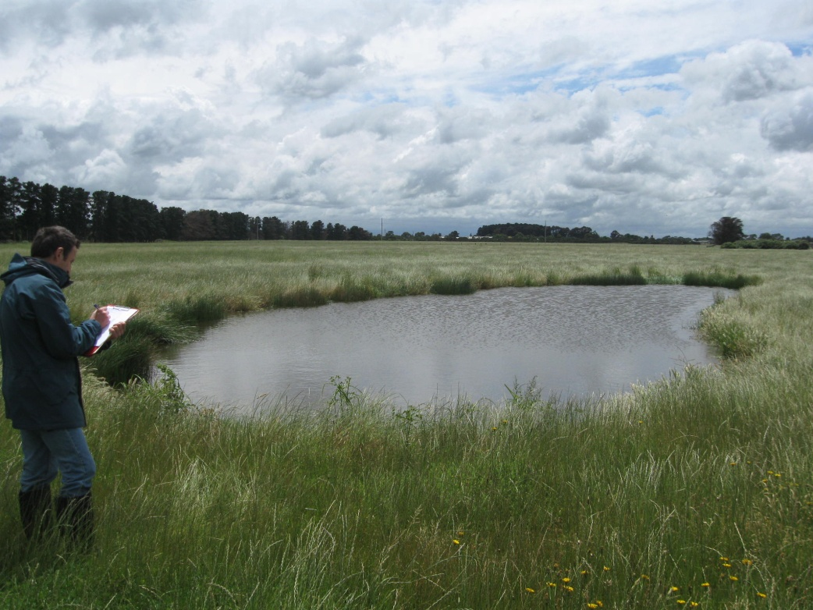

Plate Rossiter Dam 4 (Photo December 2011)

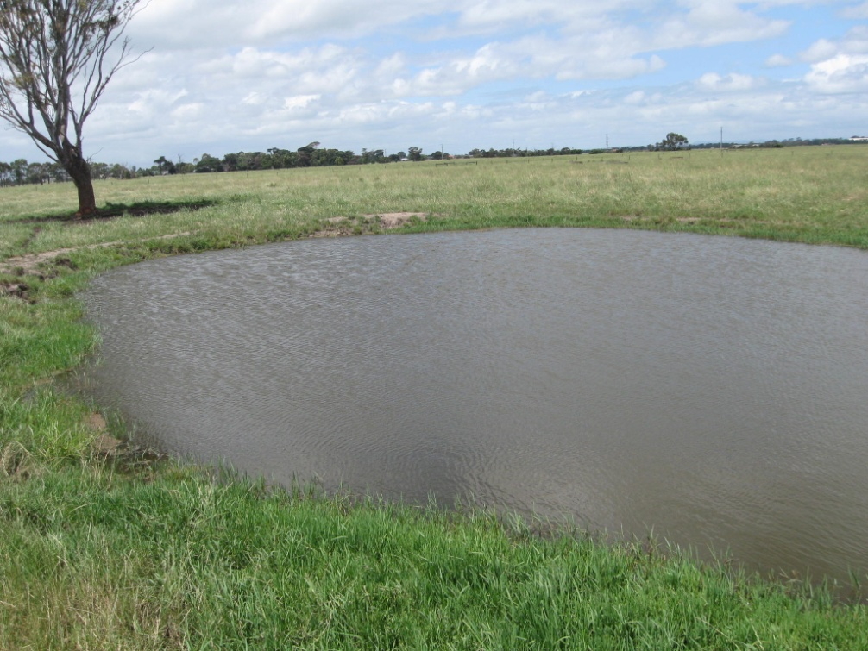

Plate Rossiter Dam 5. Three Growling Grass Frogs recoded in December 2011 (Photo December 2011)

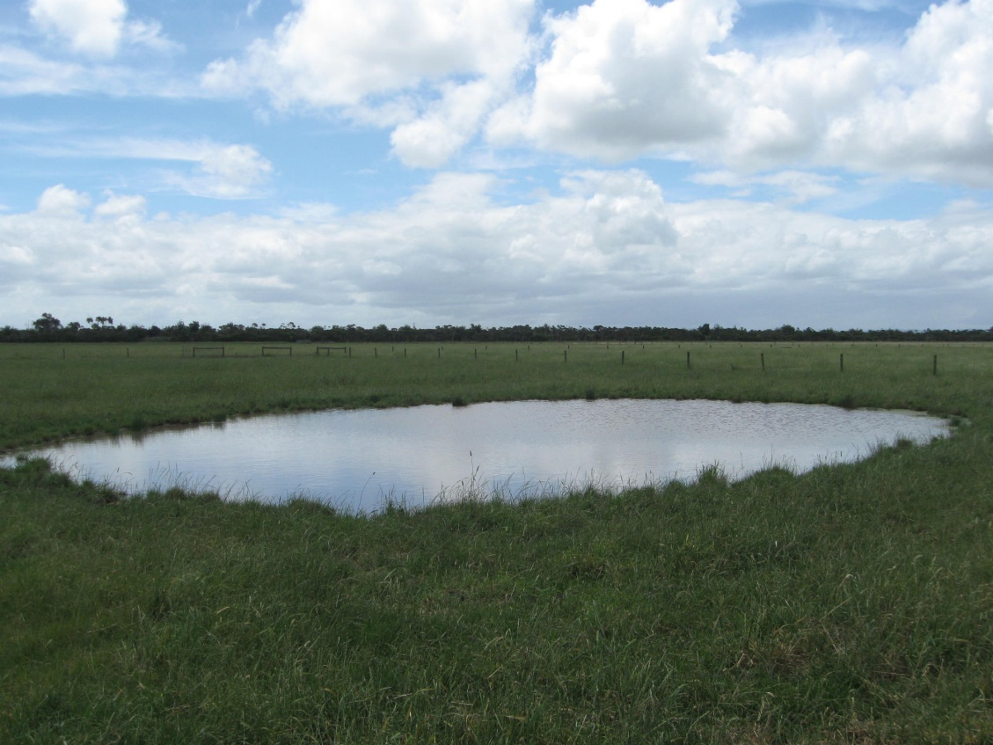

Plate Rossiter Dam 6 (Photo December 2011)

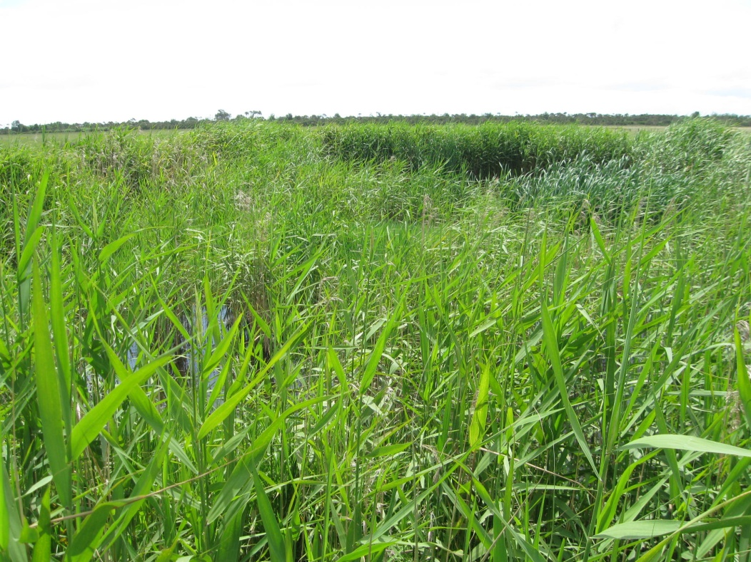

Plate Rossiter Dam 7 (Photo December 2011)

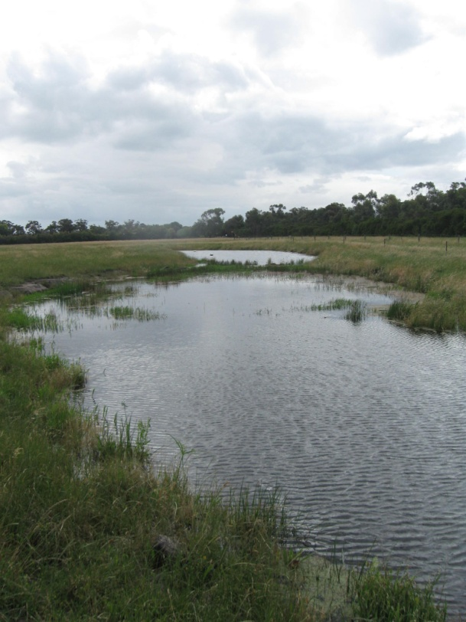

Plate Rail Dam 1. 12 Growling Grass Frogs recorded in December 2011 and 4 in January 2012 (Photo December 2011)

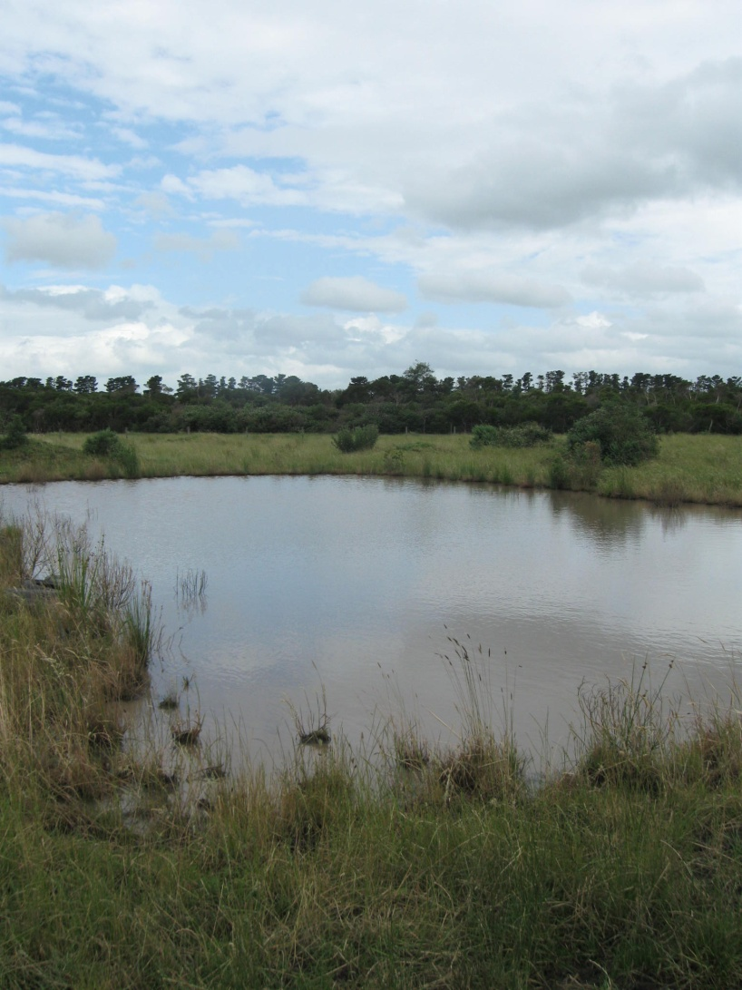

Plate Rail Dam 2 (Photo December 2012)