**KOO WEE RUP BYPASS PROJECT**

**Compliance Assessment Report July 2017-June 2018**

EPBC Reference 2010/5784

Date: 24 September 2018  
Version: 1.0

Prepared for

**Department of the Environment**

Approvals Monitoring South Section

CANBERRA ACT

Table of Contents

TERMS, ABREVIATIONS AND DEFINITION 3

1. EXECUTIVE SUMMARY 4

2. INTRODUCTION 4

2.1. Background 4

2.2. Purpose of This Document 5

2.3. Environment Protection and Biodiversity Act 1999 Requirements 5

2.3.1. EPBC Approval 5

2.3.2. Performance and Compliance Reporting 6

2.3.3. Non Compliance Reporting 6

3. PROJECT COMPLIANCE 6

3.1. Compliance with EPBC Conditions of Approval 6

3.2. Compliance with the Fauna Management Plan 6

3.3. Compliance with the Offset Management Plan 7

4. PERFORMANCE AND COMPLIANCE OF EPBC 2010/5784 7

5. ACKNOWLEDGEMENT 18

APPENDIX A – PROJECT MAP 19

APPENDIX B – 2017-2018 RESULTS OF THE FAUNA MANAGEMENT PLAN 21

SUMMARY 22

APPENDIX C – OFFSET MANAGEMENT PLAN PERFORMANCE INDICATORS RESULTS 25

APPENDIX D – FAUNA AND WETLAND HABITAT PHOTOS 32

**Figures**

Graph A1: Results of Southern Brown Bandicoots recorded on Infrared Scouting/trail Cameras

**Tables**

Table 1.0: List of Terms and Abbreviation

Table 2.0: EPBC Act Approval Notice 2010/5784 compliance results.

Table C1 - Habitat Restoration and Revegetation Performance Evaluation

Table C2 - Wetland and Drain Establishment Performance Evaluation

Table C3 - Predator Control Performance Evaluation

Table C4 - Fauna-proof Fences and other Infrastructure Performance Evaluation

# TERMS, ABREVIATIONS AND DEFINITION

The terms, abbreviations and definitions that have been used in this documents are listed in the below table.

Table 1.0: List of Terms and Abbreviation

|  |  |
| --- | --- |
| Terms / Abbreviation | Definition |
| DoE | Department of Environment |
| DSEWPaC | Department of Sustainability, Environment, Water, Population and Communities |
| DELWP (formally DSE) | Department of Environment, Land, Water and Planning (formally Department of Sustainability and Environment) |
| EPBC Act | Environmental Protection and Biodiversity Conservation Act 1999 |
| EPA | Environmental Protection Authority |
| FMP | Koo Wee Rup Bypass Fauna Management Plan |
| GGF | Growling Grass Frog |
| ha | Hectare |
| Compliant | The requirements of the condition has been carried out |
| Not Applicable /Not Required | The requirements of conditions were not been triggered during the reporting period or were no longer applicable to the reporting period. |
| Non-compliant | Implementation of the condition has not been carried out in accordance with condition. |
| OMP | Koo Wee Rup Bypass EPBC Act 1999 Offset Management Plan |
| SBB | Southern Brown Bandicoot |

1. EXECUTIVE SUMMARY

The approval to the EPBC Act referral 2010/5784 was issued to VicRoads on 10 October 2013 for construction of the Koo Wee Rup Bypass. The Bypass is located approximately 1.5 km from the outskirts of the Koo Wee Rup Township between Manks Road and South Gippsland Highway.

Under Condition 11 of the approved EPBC Act referral 2010/5784, an annual compliance assessment report is required to be published on the VicRoads website within three months of June 30 each year following the commencement of construction activities, addressing compliance with each of the conditions of this approval, including implementation of any management plans/programs as specified in the conditions.

Under condition 7(b) of the approved EPBC Act referral 2010/5784, the annual compliance report is required to also include results of the preconstruction surveys, capture and release operations and ongoing monitoring in accordance with the reporting protocols of section 8 of the FMP. These reports can also be found on the VicRoads website for the Koo Wee Rup Bypass.

Under Condition 8(c) of the approved EPBC Act referral 2010/5784, the annual compliance report is required to also include the outcomes of the Offset Management Plan against the performance indicators (for habitat restoration and revegetation, wetland and drain establishment, predator control, fauna-proof fences and other infrastructure) as per section 3 of the Offset Management Plan.

This compliance report addresses the current status of the Koo Wee Rup Bypass Project against the condition of approval for the EPBC Referral Act 2010/5784 for the environmental activities carried out from between 1 July 2017 to 30 June 2018. This is the final compliance report to be prepared under the EPBC Act approval 2010/5784 for the Koo Wee Rup Bypass Project.

1. INTRODUCTION

The Koo Wee Rup Bypass is the first stage of a future upgrade of the Healesville – Koo Wee Rup Road to freeway standard between the Pakenham Bypass and the South Gippsland Highway. The bypass is located to the west of the Koo Wee Rup township and is situated 65 kilometres south-east of Melbourne, within the Shire of Cardinia, passing through land currently used for farming. The bypass is approximately 3.4 kilometres long on an alignment which leaves Healesville-Koo Wee Rup Road south of Manks Road to a roundabout on the South Gippsland Highway at Rossiter Road, including bridging over the Bunyip River and associated drains. The plan of the project area can be found in Appendix A of this report.

* 1. Background

The bypass provides a 3.4 km link from Healesville – Koo Wee Rup Road (south of Manks Road) to a roundabout on the South Gippsland Highway at Rossiter Road, including bridging over the Bunyip River and associated drains. The bypass purpose is to re-route large commercial vehicles and trucks from travelling through the Koo Wee Rup township to the bypass which will in return reduce noise pollution and improve safety to the community of Koo Wee Rup.

* 1. Purpose of This Document

The purpose of this document is to assess the compliance of the Koo Wee Rup Bypass project to the EPBC Conditions of approval EPBC2010/5784.

The EPBC conditions incorporate the Koo Wee Rup Bypass’ Fauna Management Plan and Offset Management Plan for mitigation measures to the three threatened fauna species which are known to occur within the project area. These threatened fauna species are the Growling Grass Frog (*Litoria raniformis*), Southern Brown Bandicoot (*Isoodon obesulus obesulus*) and Australian Grayling (*Prototroctes maraena*), which are all listed under the Commonwealth *Environment Protection and Biodiversity Conservation Act 1999* (EPBC) and Victorian *Flora and Fauna Guarantee Act 1988.*

* 1. Environment Protection and Biodiversity Act 1999 Requirements

The objective of the Environment Protection and Biodiversity Conservation Act 1999 (EPBC Act) is to manage and protect flora and fauna of national and international significance including ecological communities and heritage places of national environmental significance.

* + 1. EPBC Approval

Approval of the Commonwealth Minister for the Environment is required under the EPBC Act if an ‘action’ will have or is likely to have a significant impact on a matter of national environmental significance. Due to potential impacts on threatened species and the proximity of a Ramsar wetland, the project was referred to the then Department of Sustainability, Environment, Water, Population and Communities (DSEWPaC) on 20 December 2010.

A decision issued on 14 January 2011 determined that the proposal was a controlled action and required assessment and approval under the EPBC Act before it could proceed. The relevant controlling provisions were:

* Listed threatened species and communities (sections 18 and 18A) being:
  + Southern Brown Bandicoot (Isoodon obesulus obesulus),
  + Growling Grass Frog (Litoria raniformis)
  + Australian Grayling (Prototroctes maraena); and
* Wetlands of international importance (sections 16 and 17B) (the Ramsar Convention) being Western Port Bay.

A request was submitted on 18 August 2011 to vary the proposed action to apply to the Koo Wee Rup Bypass only. A decision was issued on 20 September 2011 accepting this variation to the EPBC referral. VicRoads subsequently further developed the design for the Koo Wee Rup Bypass and submitted another request on 11 May 2012 to vary the proposed action, which was formally accepted on 28 May 2012.

Final approval was issued to VicRoads on the 10 October 2013 with the Proposed Action: Construction of a bypass of the Koo Wee Rup Township between Manks Road and South Gippsland Highway, Victoria. A copy of the EPBC Approval Notice can be found on the DoE website.

<http://www.environment.gov.au/cgi-bin/epbc/epbc_ap.pl?name=referral_detail&proposal_id=5784>

* + 1. Performance and Compliance Reporting

Under Condition 11 of the approved EPBC Act referral 2010/5784, an annual compliance assessment report is required to be published on VicRoads website within three months of June 30 each year following the commencement of construction activities, addressing compliance with each of the conditions of this approval, including implementation of any management plans/programs as specified in the conditions.

Under Condition 8(c) of the approved EPBC Act referral 2010/5784, the Annual Report under condition 11 is required to also include the outcomes of the Offset Management Plan against the performance indicators (for habitat restoration and revegetation, wetland and drain establishment, predator control, fauna-proof fences and other infrastructure) as per section 3 of the Offset Management Plan. A copy of the EPBC approval can be found on the DoE website.

<http://www.environment.gov.au/cgi-bin/epbc/epbc_ap.pl?name=referral_detail&proposal_id=5784>

* + 1. Non Compliance Reporting

There are no non compliance occurrences to report during this reporting period.

1. PROJECT COMPLIANCE
   1. Compliance with EPBC Conditions of Approval

VicRoads has complied with all conditions referenced in the EPBC Act approval 2010/5784 for the annual reporting period. There are a number of conditions that are not required to be implemented at this stage of the project. Section 4 of this report provides a summary of the performance and compliance with each of the 16 conditions of approval.

* 1. Compliance with the Fauna Management Plan

Under condition 7(b) of the approved EPBC Act referral 2010/5784, the annual compliance report is required to also include results of the preconstruction surveys, capture and release operations and ongoing monitoring in accordance with the reporting protocols of section 8 of the FMP. These reports can also be found on the VicRoads website for the Koo Wee Rup Bypass. Further information on the FMP results can be found in Appendix B.

* 1. Compliance with the Offset Management Plan

The Offset Management Plan (OMP) is required as part of the approvals for the construction of the Koo Wee Rup Bypass under the Environment Protection and Biodiversity Conservation Act 1999 (EPBC Act). The OMP is required to offset habitat losses and compensate for population fragmentation impacts to the Southern Brown Bandicoot and Growling Grass Frog that cannot be avoided during the construction of the Bypass.

Under Condition 8(c) of the approved EPBC Act referral 2010/5784, the annual compliance report is required to also include the outcomes of the Offset Management Plan against the performance indicators (for habitat restoration and revegetation, wetland and drain establishment, predator control, fauna-proof fences and other infrastructure) as per section 3 of the Offset Management Plan.

The OMP addresses and describes:

* Impacts to the listed species associated with the construction of the Bypass;
* Commitments for offsetting the impacts to the Southern Brown Bandicoot and Growling Grass Frog;
* Commitments pertaining to current and future management to ensure ongoing restoration and improvement of offset sites;
* Commitments regarding the protection of the offset sites in perpetuity;
* Monitoring and reporting procedures on the progress of the offset sites; and
* How the proposed offsets align with the EPBC Act Environmental Offsets Policy.

Further information on the above OMP elements can be found in Appendix C.

1. PERFORMANCE AND COMPLIANCE OF EPBC 2010/5784

The table provided below details the actions and evidence of the Koo Wee Rup Bypass Project and compliance with the EPBC Act approval notice 2010/5784.

Table 2.0: EPBC Act Approval Notice 2010/5784 compliance results.

| **Item** | **Conditions of the Approval** | **Actions** | **Completed / Ongoing** | **Comments / Evidence** |
| --- | --- | --- | --- | --- |
| 1 | The action must not occur outside of the project area. | Work limits have been specified in the VicRoads Contract which confines work to within the defined project area. | **Completed** | Construction of the Koo Wee Rup Bypass was completed in May 2015 and all works were contained within the project area.  Aerial photographs taken can verify works did not extend outside the project work area. |
| 2 | To minimise impacts on the Western Port Ramsar Wetland and Australian Grayling, the person taking the action must ensure that the following measures are undertaken:   1. there must be no extraction of water from the Bunyip River; 2. construction activities within the Bunyip River must not occur outside the Bunyip River work area; and 3. sediment, erosion and pollution control protocols must be implemented in accordance with: 4. Construction Techniques for Sediment Pollution Control (EPA Publication No. 275, 1991); and 5. Environmental Guidelines for Major Construction Sites (EPA Publication No. 480, February 1996). | 1. No water extraction from the Bunyip River is permitted in the VicRoads Contract. 2. No construction activity outside the Bunyip River Work Area is a specific requirement of the VicRoads Contract Specification. 3. Audit and surveillance to be undertaken at regular basis to ensure best practice erosion and sediment control has been implemented to minimise the impacts to the Bunyip River Drains. | **Completed** | 1. Water for construction works was extracted from on site sources, sediment ponds or from McDonalds Drain with a water extraction licence obtained from the relevant water supplier. No water was extracted from the Bunyip River. 2. Amendments from the Bunyip River work area were approved by the Minister in March and June 2014. The latest variation to the Bunyip River work area was approved on 18 June 2014 and can be found on the DoE website at the following address:-   <http://www.environment.gov.au/epbc/notices/assessments/2010/5784/2010-5784-variation-to-conditions.pdf>  All works were contained within the revised Bunyip River work area.   1. Auditing and surveillance reports have verified that best practice erosion and sediment control were implemented. Note: Construction of the bridge was completed in February 2015. |
| 3 | The person taking the action must ensure that construction activities do not impact on more than 2.53 hectares of Southern Brown Bandicoot habitat. | Ensure the construction activities do not impact on more than 2.53 hectares of Southern Brown Bandicoot habitat. | **Completed** | At the end of construction (May 2015), the total clearing of vegetation for construction activities impacted 1.17 hectares of Southern Brown Bandicoot habitat. The final amount of vegetation clearing is 54% below the 2.53 hectares permitted by the conditions.  A detailed set of plans has been prepared which documents the total amount of the clearing of Southern Brown Bandicoot habitat. |
| 4 | The person taking the action must ensure that construction activities do not impact on more than 2.17 hectares of Growling Grass Frog terrestrial habitat. | Ensure the construction activities do not impact on more than 2.17 hectares of Growling Grass Frog terrestrial habitat. | **Completed** | At the end of construction (May 2015), the total clearing of vegetation for construction activities impacted 0.71 hectares of Growling Grass Frog terrestrial habitat. The final amount of vegetation clearing is 67% below the 2.17 hectares permitted by the conditions.  A detailed set of plans has been prepared which documents the total amount of the clearing of Growling Grass Frog terrestrial habitat. |
| 5 | To minimise noise disturbance to the Southern Brown Bandicoot during the breeding period, pile driving associated with bridge construction activities along the Bunyip River must not be undertaken from **1 July to 30 November** in any year. | VicRoads to avoid pile driving activity associated with bridge construction activities along the Bunyip River from 1 July to 30 November in any year. | **Completed** | VicRoads sought a variation to this condition in a letter dated 5 June 2014 seeking to complete the piling in July if necessary which would enable the bridge and subsequent habitat reinstatement works to be completed earlier. Approval to the variation was granted in a letter dated 18 June 2014 which varied the period when pile driving activities must not be undertaken within the Bunyip River work area from **11 July to 30 November** in any year. The approved variation can be found on the DoE website at the following address:-  <http://www.environment.gov.au/epbc/notices/assessments/2010/5784/2010-5784-variation-to-conditions.pdf>  Notwithstanding the granting of the above variation, the last of the pile driving activities within the Bunyip River work area were completed on 28 June 2014 which still achieved compliance with the original condition. |
| 6 | To minimise noise disturbance to the Southern Brown Bandicoot, construction activities at night time (between sunset and sunrise), must not occur within 100m of Southern Brown Bandicoot habitat. | Avoid construction activities within 100m of the 3 key Southern Brown Bandicoot habitat areas listed in the FMP, when undertaking night time works**.** | **Completed** | The Contractor incorporated into the Construction Environmental Management Plan control measures to delineate the construction work area 100 metres away from the 3 key Southern Brown Bandicoot habitat areas listed in the FMP, when undertaking night time works**.**  At the end of construction (May 2015), no construction works had been undertaken between sunset and sunrise within 100 metres of the 3 key habitat areas. |
| 7 | To minimise impacts on the Australian Grayling, Southern Brown Bandicoot and Growling Grass Frog from construction activities, the person taking the action must implement the Fauna Management Plan; and:   1. ensure the implementation of the Fauna Management Plan, including the fauna monitoring program and predator control program, begins prior to commencement of construction activities and continues over a period of at least 5 years; and ensure the Annual Report under condition 11, documents the results of the Fauna Management Plan (including results of preconstruction surveys, capture and release operations, and ongoing monitoring), in accordance with the reporting protocols at section 8 of the Fauna Management Plan. Survey results must be accompanied with a shapefile of the survey results. | 1. VicRoads undertook the Fauna Monitoring and Predator Control Programs as per Fauna Management Plan requirements. 2. This report addresses the conditions. | **Completed** | 1. The following preconstruction and construction programs have been undertaken as per the FMP:  * Southern Brown Bandicoots and Pre-Construction Predator Baseline Surveys - Ecology Australia ( 17 April – 21 May 2013). * Growling Grass Frog and Swamp Skink Baseline Survey – Ecology Australia (December 2011 to February 2012). * Predator control program - Abzeco (May 2013 – May 2014). * Construction phase Fauna monitoring program - Mal’s Environment and Ecological Services (commenced January 2014) * Koo Wee Rup Bypass Predator Control Program July-August 2014 * Koo Wee Rup Bypass Predator Control Program September-October 2014 * Koo Wee Rup Bypass Predator Control Program December-January 2014-15 * Koo Wee Rup Bypass Predator Control Program March 2015 * Koo Wee Rup Bypass Predator Control Program May 2015 * Koo Wee Rup Bypass Construction Phase GGF Monitoring Program - Spring-Summer 2014-2015 * Koo Wee Rup Bypass Construction Phase SBB Monitoring Program - Spring 2014 * Koo Wee Rup Bypass Construction Phase SBB Monitoring Program - Autumn 2015 * Koo Wee Rup Bypass Post-construction Monitoring, Southern * Brown Bandicoot - Autumn 2016 * Koo Wee Rup Bypass Post-construction Monitoring, Southern Brown Bandicoot - Spring 2016 * Koo Wee Rup Bypass Growling Grass Frog Post-construction Monitoring - 2015/2016 season * Koo Wee Rup Bypass Growling Grass Frog post-construction monitoring - 2016/2017 season * Koo Wee Rup Bypass Predator Control Program – Summer 2017 * Koo Wee Rup Bypass Predator Control Program – Autumn 2017 * Koo Wee Rup Bypass Predator Control Program – Winter 2017 * Koo Wee Rup Bypass Predator Control Program- Winter Spring 2017 * Koo Wee Rup Bypass Predator Control Program- Spring 2017 * Koo Wee Rup Bypass Predator Control Program – Summer 2018 * Koo Wee Rup Bypass Predator Control Program – Autumn 2018 * Koo Wee Rup Southern Brown Bandicoot Monitoring- Autumn 2017 * Koo Wee Rup Southern Brown Bandicoot Monitoring- Summer 2017  1. A summary of VicRoads’ compliance with the implementation of the Fauna Management Plan is included as Appendix B of this report.   The reports and results of the FMP programs listed under item 7a above are available on the VicRoads website for the Koo Wee Rup Bypass. |
| 8 | To compensate for the loss of 2.53 hectares of Southern Brown Bandicoot habitat, the person taking the action must:   1. enter into an Agreement under section 173 of the Planning and Environment Act 1987 to secure the Koo Wee Rup Bypass Offset, within 24 months of the date of this approval, and: 2. provide the department with a signed copy of the Agreement and evidence of lodgement with the Titles Office, within 2 weeks of lodgement; 3. provide the department with the offset attributes, shapefile and map clearly defining the location and boundaries of the Koo Wee Rup Bypass Offset, within 2 weeks of lodgement; and 4. ensure that the Agreement is registered on the title on which the Koo Wee Rup Bypass Offset is located, and provide the department with evidence of registration, within 2 weeks of registration. 5. ensure the Offset Management Plan is implemented. Implementation of the Offset Management Plan, including the fauna monitoring program and predator control program, must begin prior to commencement of construction activities and continue to be implemented over a period of at least 5 years; and 6. ensure the Annual Report under condition 11, documents the outcomes of the Offset Management Plan against the performance indicators (for habitat restoration and revegetation, wetland and drain establishment, predator control, fauna-proof fences and other infrastructure) as per section 3 of the Offset Management Plan. | 1. VicRoads entered into the section 173 agreement with Cardinia Shire Council under the *Planning and Environment Act 1987* as per condition*.* 2. VicRoads implemented the OMP including the Fauna Monitoring and Predator Control Programs for 5 years. 3. VicRoads documented the outcomes of the Offset Management Plan in the Annual Report. | **Completed** | 1. All of the bandicoot habitat revegetation required by the Offset Management Plan has been established on land that was acquired by VicRoads for the Koo Wee Rup Bypass project. VicRoads requested Department of Environment to extend the timeframe for entering into a section 173 agreement for the land parcels and the timeframe was extended till 10 June 2018. VicRoads entered into the section 173 agreement with Cardinia Shire Council and notified Department of Environment on 4 June 2018. 2. VicRoads has been implementing the Offset Management Plan as required. The fauna monitoring and predator control programs have been implemented as discussed in item 7 above. 3. The outcomes for the performance indicators of the OMP are summarised in Appendix C of this report in the following tables:-  * Table C1: Habitat Restoration and Revegetation * Table C2: Wetland and Drain Establishment * Table C3: Predator Control * Table C4: Fauna-proof Fences and other Infrastructure |
| 9 | Within 30 calendar days after the commencement of construction activities, the person taking the action must advise the department in writing of the actual date of commencement of construction activities. | VicRoads to advise the department of actual date of commencement of construction activities | **Completed** | Written notification was sent to the department on 19 November 2013, advising that construction activities commenced on site on 18 November 2013. |
| 10 | The person taking the action must maintain accurate records substantiating all activities associated with or relevant to the conditions of approval, including measures taken to implement management plans/programs and make them available upon request to the department. Such records may be subject to audit by the department or an independent auditor in accordance with section 458 of the EPBC Act, or used to verify compliance with the conditions of approval. Summaries of audits will be posted on the department’s website. The results of audits may also be publicised through the general media. | Records of the implementation of management plans/programs are being maintained, and are available for auditing purposes. | **Completed** | Management plans and programs can be found on the VicRoads website for the Koo Wee Rup Bypass project.  <https://www.vicroads.vic.gov.au/planning-and-projects/regional-road-projects/koo-wee-rup-bypass-koo-wee-rup> |
| 11 | Within three months of June 30 each year following the commencement of construction activities, the person taking the action must publish a report on their website addressing compliance with each of the conditions of this approval, including implementation of any management plans/programs as specified in the conditions. Documentary evidence providing proof of the date of publication must be provided to the department at the same time as the compliance report is published. Non-compliance with any of the conditions of the approval must also be reported to the department within 2 business days of becoming aware of the non-compliance. | The annual compliance report shall be published on the VicRoads web site by 30 September each year for 5 years. | **Completed** | This report and associated supporting documents can be found on the VicRoads website for the Koo Wee Rup Bypass project.  <https://www.vicroads.vic.gov.au/planning-and-projects/regional-road-projects/koo-wee-rup-bypass-koo-wee-rup>  Evidence of the date of publication has been provided to the Department at the same time this report was published. |
| 12 | Upon the direction of the Minister, the person taking the action must ensure that an independent audit of compliance with the conditions of approval is conducted and a report submitted to the Minister. The independent auditor must be approved by the Minister prior to the commencement of the audit. Audit criteria must be agreed to by the Minister and the audit report must address the criteria to the satisfaction of the Minister. | Upon the direction of the Minister, VicRoads shall submit the supportive evidence and a report for an independent audit of compliance for this condition. | **Completed** | No actions to date as no directions have been received from the Minister for an independent audit of compliance. |
| 13 | If the person taking the action wishes to carry out any activity otherwise than in accordance with the management plans/programs as specified in the conditions, the person taking the action must submit to the department for the Minister’s written approval a revised version of that management plan/program. The varied activity shall not commence until the Minister has approved the varied management plan/program in writing. The Minister will not approve a varied management plan/program unless the revised management plan/program would result in an equivalent or improved environmental outcome over time. If the Minister approves the revised management plan/program, that management plan/program must be implemented in place of the management plan/program originally approved. | VicRoads to seek approval to any proposed changes to conditions or management plans and programs. | **Completed** | VicRoads has sought and has been granted approval to 3 amendments to the EPBC conditions of approval for the Koo Wee Rup Bypass.  Two amendments for slight changes to the Bunyip River Works Area have been discussed under condition 2(b) above.  An amendment to allow piling within the Bunyip River Works Area to extend slightly into July has also been discussed under condition 5 above. |
| 14 | If the Minister believes that it is necessary or convenient for the better protection of Wetlands of international importance (sections 16 & 17B) or Listed threatened species and communities (sections 18 & 18A) to do so, the Minister may request that the person taking the action make specified revisions to the management plans/programs specified in the conditions and submit the revised management plans/programs for the Minister’s written approval. The person taking the action must comply with any such request. The revised approved management plans/programs must be implemented. Unless the Minister has approved the revised management plans/programs then the person taking the action must continue to implement the management plans/programs originally approved, as specified in the conditions. | VicRoads to comply with any request made by the Minister. | **Completed** | No actions to date as no requests have been received from the Minister. |
| 15 | If, at any time after 5 years from the date of this approval, the person taking the action has not substantially commenced the action, then the person taking the action must not substantially commence the action without the written agreement of the Minister. | VicRoads to ensure construction commences within 5 years of the approval. | **Completed** | This action is now closed as construction activities commenced on 18 November 2013. |
| 16 | Unless otherwise agreed to in writing by the Minister, the person taking the action must publish all management plans/programs referred to in these conditions of approval on their website within 1 month of this approval. Any variations to management plans/programs must be published on the website within 1 month of the variation being approved by the Minister | VicRoads to ensure that management plans/programs referred to in the conditions of approval are available on the VicRoads website within one month of the approval. | **Completed** | Earlier versions of the FMP and Draft OMP had been on the VicRoads website for the planning of the upgrading of the Healesville-Koo Wee Rup Road since public information sessions about the project were undertaken in July 2012. The final versions of these plans were uploaded to the VicRoads Koo Wee Rup Bypass Project website in November 2013. |

1. ACKNOWLEDGEMENT

Biosphere Group: Dr David Nicholls, Sara Maclagan

DELWP: Dr John Hick, Dr Bram Mason, Dr Lochlan Marshal

Ecology Australia: Dr Andrew McMahon, Dr Darren Quin, Dr Lisa Crawfoot

Lend Lease Engineering: Ryan Walkenhaust, Chris Podger, Erick Tansil, Lyndal Isakhan

Mal’s Ecological & Environmental Services: Malcolm Legg

Melbourne Water: Sara Johnson, Keiran Crocker, Peter Neal

Port Phillip Catchment Management Authority: Adam Shaelkoff

Royal Botanical Gardens: Dr Terry Coates

VicRoads: Robert Pearson, Dustin Lehr and Shariful Rony

APPENDIX A – PROJECT MAP

**This picture illustrates the Koo Wee Rup Bypass Plan from Manks Road to South Gippsland Highway. This project plan was developed for the EPBC approval which maps the project area around the bypass road alignment.

Ledgend.
Dark blue line = project area boundary.
Yellow line = Koo Wee Rup Bypass alignment.
Light Blue hash line = Grading area for flood mitigation.
Light Blue dashed line = McGregors drain realignment.
White hashed line = Ancillary works areas (eg. Access, strorage, etc).
**

APPENDIX B – 2017-2018 RESULTS OF THE FAUNA MANAGEMENT PLAN

SUMMARY

VicRoads’ Koo Wee Rup Bypass Fauna Management Plan (FMP) provides extensive details and requirements for the construction phase of the bypass. The commitments outlined in the FMP commence from the preconstruction phase through to the post construction phase of the project. This section summarises the outcomes from the FMP’s key activities undertaken by VicRoads to date to demonstrate compliance with this report.

List of key activities:

* Fauna Monitoring;
* Predator Control;
* Habitat Restoration and Revegetation;
* Capture and Release; and
* Water Quality Baseline Survey.

The following reports listed below, are programs that align with the commitments required under the FMP which can be found on the VicRoads website for the Koo Wee Rup Bypass.

List of program reports:

**Pre-construction Phase Reports**

* Koo Wee Rup Bypass Growling Grass Frog and Swamp Skink Surveys

**Construction Phase Reports**

* Koo Wee Rup Bypass SBB and Pre Predator control monitoring
* Koo Wee Rup Bypass Construction Phase GGF Summer 2014 Monitoring Program
* Koo Wee Rup Bypass Construction Phase Fauna Monitoring SBB Autumn 2014 monitoring program
* Koo Wee Rup Bypass Project Pest Predator Control Program - June 2013
* Koo Wee Rup Bypass Project Pest Predator Control Program - August 2013
* Koo Wee Rup Bypass Project Pest Predator Control Program - January-March 2014
* Koo Wee Rup Bypass Project Pest Predator Control Program - June 2014
* Koo Wee Rup Bypass Predator Control Program July-August 2014
* Koo Wee Rup Bypass Predator Control Program September-October 2014
* Koo Wee Rup Bypass Predator Control Program December-January 2014-15
* Koo Wee Rup Bypass Predator Control Program March 2015
* Koo Wee Rup Bypass Predator Control Program May 2015
* Koo Wee Rup Bypass Construction Phase GGF Monitoring Program - Spring-Summer 2014-2015
* Koo Wee Rup Bypass Construction Phase SBB Monitoring Program - Spring 2014
* Koo Wee Rup Bypass Construction Phase SBB Monitoring Program - Autumn 2015

**Post-construction Phase Reports**

* Koo Wee Rup Bypass Predator Control Program June-August 2016
* Koo Wee Rup Bypass Construction Phase GGF Monitoring Program – Autumn 2016
* Koo Wee Rup Bypass Construction Phase SBB Monitoring Program – Winter 2016
* Koo Wee Rup Bypass Growling Grass Frog post-construction monitoring 2016/17 season
* Koo Wee Rup Bypass post-construction monitoring, Southern Brown Bandicoot, Spring 2016
* Koo Wee Rup Bypass Predator Control Program Winter 2017
* Koo Wee Rup Bypass Predator Control Program Winter Spring 2017 (August 2017- September 2017).
* Koo Wee Rup Bypass Predator Control Program Spring 2017 (October 2017-December 2017).
* Koo Wee Rup Bypass Predator Control Program Summer 2018 (January 2018-February 2018).
* Koo Wee Rup Bypass Predator Control Program Autumn 2018 (March 2018-April 2018).
* KWR Bypass Southern Brown Bandicoot report- Autumn 2017
* KWR Bypass Southern Brown Bandicoot report- Spring-Summer 2017

**Construction Phase Activities**

As of mid May 2015 the project construction works reached practical completion with:

* Earthworks 100% Complete
* Pavement 100% Complete
* Drainage 100% Complete
* Fauna Infrastructures 100% Complete
* Bridge structure 100% Complete

*Fauna Monitoring*

As part of the Koo Wee Rup Bypass Project, VicRoads’ South Eastern Projects commissioned two fauna monitoring programs, one for the Growling Grass Frog and another for the Southern Brown Bandicoot. In addition to this the project commissioned a predator control program, which specifically targeted the Red Fox, Feral Cat and European Rabbit. These surveys were tendered out and administered during the pre-construction, construction and post construction stages.

For further information regarding works undertaken during the pre-construction and construction phases refer to previous editions on the VicRoads website for the Koo Wee Rup Bypass project.

A number of fauna monitoring surveys were recently completed by Ecology Australia, where they investigated the post-construction impacts of the Bypass on the Growling Grass Frog and Southern Brown Bandicoot.

Twenty six dams, constructed wetlands and drains were surveyed between December 2016 and February 2017. From the five sites that held water at the time of survey, 24 Growling Grass Frogs were recorded. Although this is a reduction in numbers as compared to 2014/15 (152 frogs), 2013/14 (61 frogs) and 2011/12 (57 frogs), the likely cause is that two highly reliable sites were not surveyed due to restricted access.

A number of other species were recorded, including Whistling Tree Frog, Spotted Marsh Frog, Striped Marsh Frog and Pobblebonk Frog or Southern Bullfrog, which indicates conditions in the area are still favourable and able to support multiple frog populations.

The majority of frogs were recorded at site which previously had none recorded. This indicates the dynamic nature of Growling Grass Frogs across the landscape coupled with increased pressure from urban development, which can negatively impact on populations.

During the post-construction survey conducted between November 2017 and January 2018, Ecology Australia confirmed the continued presence of Southern Brown Bandicoot across the study area and continued to colonize the revegetation sites.

During the latest monitoring surveys, Southern Brown Bandicoots were filmed on cameras at 18 of the 33 sites (55%). This site was within the revegetation areas established for the project. Further details about these surveys and the locations of the survey monitoring sites can be found in the reports available on the VicRoads website for the Koo Wee Rup Bypass project.

The Post-construction phase of the Predator Control Program was undertaken by Mal’s Ecological and Environment Services. A summary of the results is provided in Appendix C with further details contained in the reports available on the VicRoads website for the Koo Wee Rup Bypass project.

*Habitat Restoration and Revegetation*

Revegetation of the Southern Brown Bandicoot habitat is now 100% complete. Further details are available on the VicRoads website for the Koo Wee Rup Bypass project.

*Wetlands and Drainage Establishment*

The five frog ponds and wetlands were constructed in late 2013 and are now 100% complete. The construction of the McGregor’s Drain realignment and wetland habitat area commenced in early 2014 and is also now 100% complete. Further details are available on the VicRoads website for the Koo Wee Rup Bypass project.

*Capture and Release Protocol*

The Koo Wee Rup Bypass project has fulfilled its obligations regarding this item. Further details are available on the VicRoads website for the Koo Wee Rup Bypass project.

*Water Quality Survey*

The Koo Wee Rup Bypass project has fulfilled its obligations regarding this item. Further details are available on the VicRoads website for the Koo Wee Rup Bypass project.

**Post Construction Phase Activities**

The construction work of Koo Wee Rup Bypass started in August 2013 and reached practical completion in May 2015. The Predator Control as part of the Koo Wee Rup Bypass Fauna Management Plan started in April 2013 and was supposed to continue for five years according to the Section 7a of the EPBC approval. As of the end of June 2015 the project Construction works reached practical completion and Post-Construction maintenance activities commenced. VicRoads completed the Fauna Monitoring and Predator control programs in April 2018 and notified Department of Environment.

APPENDIX C – OFFSET MANAGEMENT PLAN PERFORMANCE INDICATORS RESULTS

**Table C1 - Habitat Restoration and Revegetation** **Performance Evaluation**

| **Item** | **Performance Indicator** | **Evidence** | **Action** |
| --- | --- | --- | --- |
| 1 | Plantings will be completed by Spring 2014 (supplementary plantings will be supplied beyond Spring 2014, if required). | Planting for stages 1, 2 and 3 of the fauna habitat referred to in the FMP and OMP as the “triangle land”, and the “western corridor” were established by 2 July 2014. Refer to Appendix E for photos of the fauna habitat area. | **Completed** |
| 2 | Plantings must be consistent with the species and densities given in the Revegetation and Habitat Restoration Plan (Australian Ecosystems 2012). | Plantings have been established with the species and densities consistent with the Revegetation and Habitat Restoration Plan. Minor modifications were made to the plan, where shrubs were substituted for aquatic plant in low lying land areas that retained water. Refer to Appendix E for photos of the fauna habitat area.  The western habitat along the northern-mid section’s density and growth has had a slow uptake and initially resulted in insufficient density. Further planting were undertaken during the post construction phase of the project to ensure sufficient density and survival rate is maintained. | **Completed** |
| 3 | All high threat weeds (as per DELWP, formally DSE 2007) within revegetation areas should be effectively controlled or eliminated by the end of 2014. | Weeds spray and removal from the newly established fauna habitat areas were undertaken every 2 months during the construction phase. | **Completed** |
| 4 | Other weeds should not exceed 10% of cover by end of 2014. | As above. | **Completed** |
| 5 | Plantings should aim to achieve a 95% survival rate after three years. | The vegetated habitat area was maintained every 2 months during construction and are being maintained every 6 months post construction. The survival rate to date has been successful with most areas showing very good density and growth. | **Completed** |
| 6 | If used, tree guards should be removed as soon as possible following establishment of plants. | Tree guards were not required and plant establishment and growth has been successful with adequate density and growth. | **N/A** |

**Table C2 - Wetland and Drain Establishment** **Performance Evaluation**

| **Item** | **Performance Indicator** | **Evidence** | **Action** |
| --- | --- | --- | --- |
| **1** | Plantings will be completed by Spring 2014 (supplementary plantings will be supplied beyond Spring 2014, if required). | Planting of the fauna habitat referred to in the FMP and OMP as the “re-aligned McGregors Drain” and construction and planting of the 5 frog ponds were established by June 2014.  Refer to Appendix E for photos of the wetland and drain habitat area. | **Completed** |
| **2** | Plantings must be consistent with the species and densities given in the Revegetation and Habitat Restoration Plan (Australian Ecosystems 2012). | Plantings have been established with the species and densities consistent with the Revegetation and Habitat Restoration Plan. Minor modifications were made to the plan, where shrubs were substituted for aquatic plant in low lying land areas that retained water. Refer to Appendix E for photos of the fauna habitat area.  The western habitat along the northern-mid section’s density and growth has had a slow uptake with initial insufficient density. Further planting were undertaken during the post construction phase of the project to ensure sufficient density and survival rate is maintained. | **Completed** |
| **3** | Plantings should aim to achieve a 95% survival rate after three years. | The vegetated habitat area was maintained every 2 months during construction and are being maintained every 6 months post construction. The survival rate to date has been successful with most areas showing very good density and growth. | **Completed** |
| **4** | All high threat weeds (as per DELWP, formally DSE 2008) within created wetlands should be effectively controlled or eliminated by end of 2014. | Weeds spray and removal from the newly established fauna habitat areas were undertaken every 2 months during the construction phase. The first post-construction herbicide control treatment was conducted in mid September 2016. | **Completed** |
| **5** | Other weeds should not exceed 10% of cover by the end of 2014. | As above | **Completed** |
| **6** | If used, tree guards and temporary guards (netting) should be removed as soon as possible following establishment of plants. | Tree guards were not required and plant establishment and growth has been successful with adequate density and growth. | **N/A** |

**Table C3 - Predator Control Performance Evaluation**

| **Item** | **Performance Indicator** | **Evidence** | **Action** |
| --- | --- | --- | --- |
| **1** | Detectable decline in the abundance (activity indices) of feral predators in the project area, as ascertained by camera monitoring and bait uptake (e.g. see Mal’s Ecological & Environmental Services 2018). | Since April 2013 there have been 23 predator control pulse programs, specifically targeting Red Fox, Feral Cat and European Rabbits. The most recent results indicated a decrease in Red Fox free feed take ups, with Red Foxes detected at nine sites. This suggests a low number of foxes residing in the adjacent lands. Feral Cats were recorded at five locations during summer 2017 within the drain complex and roadside vegetation, which suggests there are low numbers present within the project area. European Rabbits were detected at 18 site and results indicate a decline in distribution across the survey area. No European Hares were recorded in the latest monitoring season. | **Completed** |
| **2** | High initial rate of fox bait uptake (i.e. >60%), followed by subsequent decline in rate of bait uptake (see Mal’s Ecological & Environmental Services 2018). | Free feed takes between the 21st and 22nd pulses decreased by 50% and 1080 bait takes were the same. Free feed takes between the 22nd and 23rd pulses were the same and 1080 bait takes increased by 40%.All free feed takes during the final (23rd) fox control pulses totals to 199 and 1080 fox bait takes totals to 179. The results along with road kill data therefore indicates that up to 142 foxes have been killed during the 23 fox control pulses. This also indicates that a small fox population density resides in the greater area and on-going control pressure on the fox population is keeping it down to a minimum.  The low fox population is also allowing Southern Brown Bandicoot population densities to increase which is supported by increased sightings and digging activities of bandicoots by MEES staff over the last three years. | **Completed** |
| **3** | Any active fox dens located in the project area are fumigated promptly following detection. | No active dens were identified. | **Completed** |
| **4** | A decrease in the number of dens that require fumigation annually. | As above. | **Completed** |
| **5** | An increase in the detection of Southern Brown Bandicoots as gauged through activity indices and camera monitoring. | During the Summer 2018 monitoring program Southern Brown Bandicoots were recorded through either film or sand pad at 18 of the 33 monitoring sites (55% of sites) compared to 33% recorded in the last report. Although Bandicoots are persisting within the project area there is a decline in distribution across the survey area.  Further details of the Southern Brown Bandicoot monitoring can be found on the VicRoads website for the Koo Wee Rup Bypass. | **Completed** |
| **6** | All monitoring and predator control activities are documented. | Documentation of the monitoring and predator control activities has been documented and is available on the VicRoads website for the Koo Wee Rup Bypass. | **Completed** |

**Table C4 - Fauna-proof Fences and other Infrastructure** **Performance Evaluation**

| **Item** | **Performance Indicator** | **Evidence** | **Action** |
| --- | --- | --- | --- |
| **1** | All monitoring activities of the use of fauna underpasses by Southern Brown Bandicoots and Growling Grass Frogs are documented. | Three fauna underpasses were constructed for the project to provide for movement under the road for the Southern Brown Bandicoots. Two culverts were constructed for the realigned section of McGregor’s Drain with another culvert also installed under the bypass adjacent to the disused rail line. Cameras were installed at either ends of these culverts between March and May to see if the bandicoots would utilise the culverts, however no bandicoots were recorded using the culverts during this monitoring period. These works have since been completed however there has been no Southern Brown Bandicoots activity recorded to date. | **Completed** |
| **2** | Minimal evidence of road mortality of Southern Brown Bandicoots and Growling Grass Frogs. | No evidence of road mortality of Southern Brown Bandicoot or Growling Grass Frog was recorded during the 2017-2018 survey. | **Completed** |

APPENDIX D – FAUNA AND WETLAND HABITAT PHOTOS

The photos below show the comparisons between revegetation site 1 during the autumn 2016 and Winter 2017 monitoring programs. Photos D. Lehr 2017.

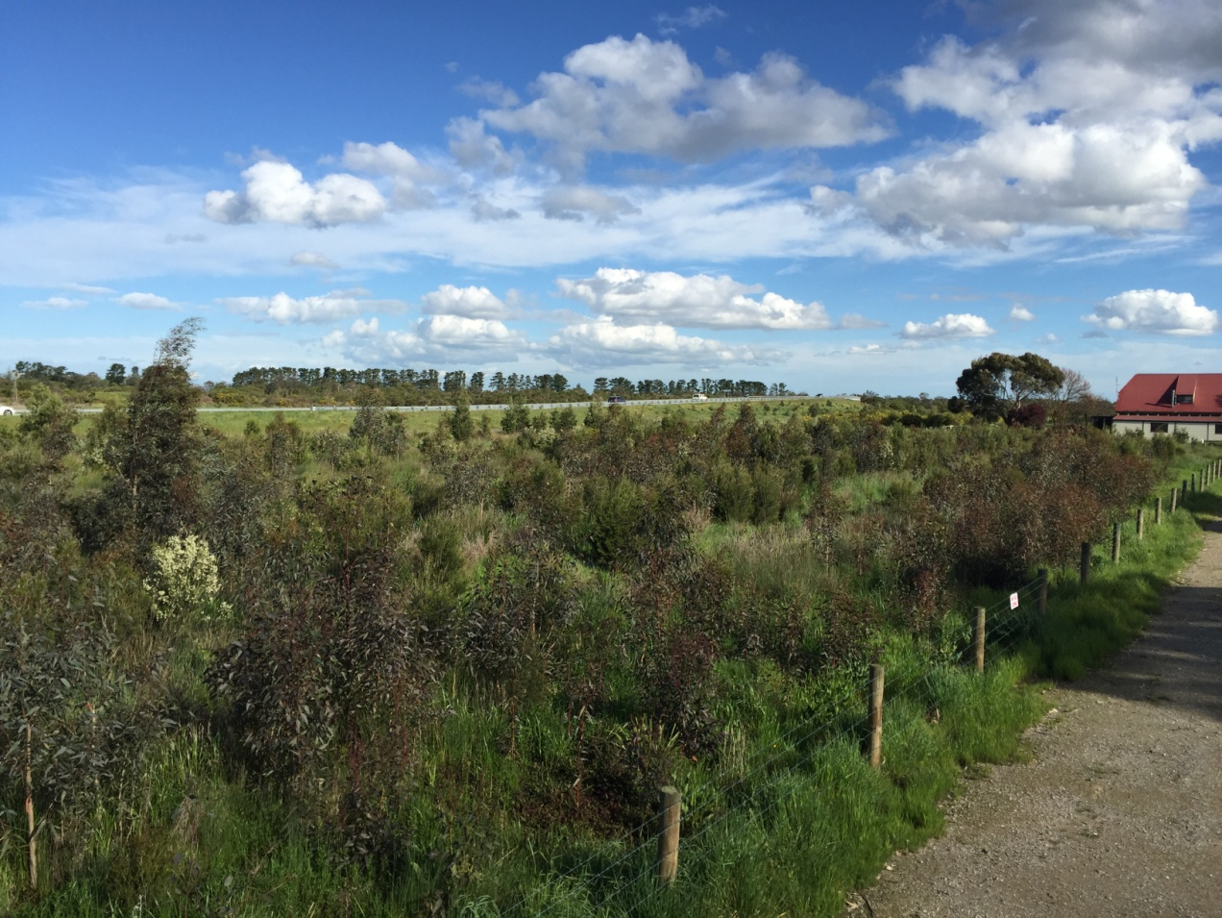

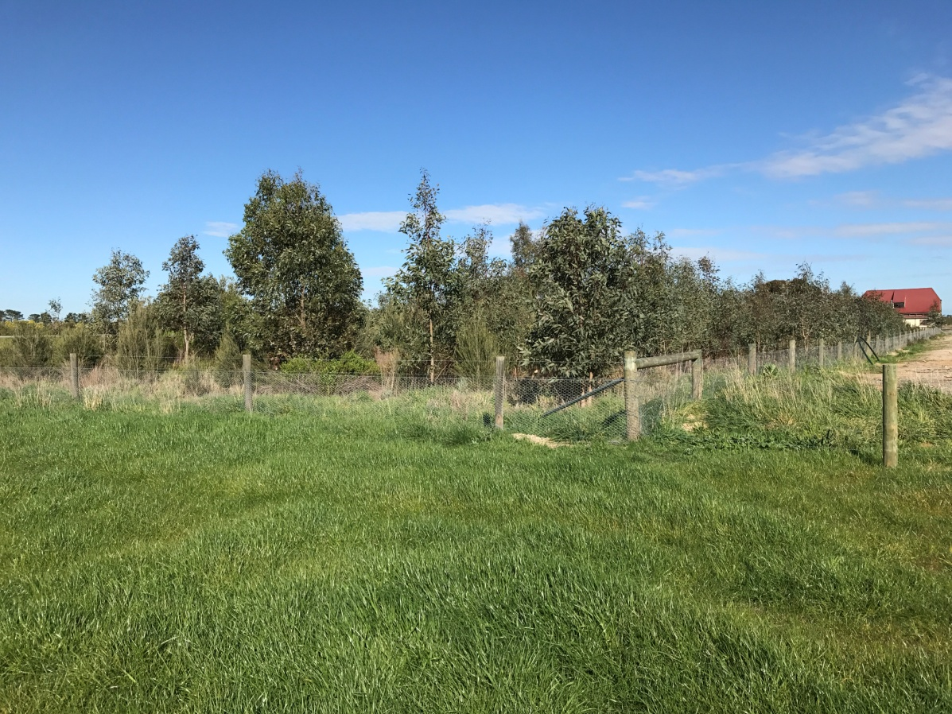

The photos below compare the revegetated habitat corridor of the realignment of McGregor’s Drain with mulch, swamp scrubs and artificial habitat on the north-west side of the bypass alignment, between Manks Road Healesville Koo Wee Rup Road.

Photo taken 2016

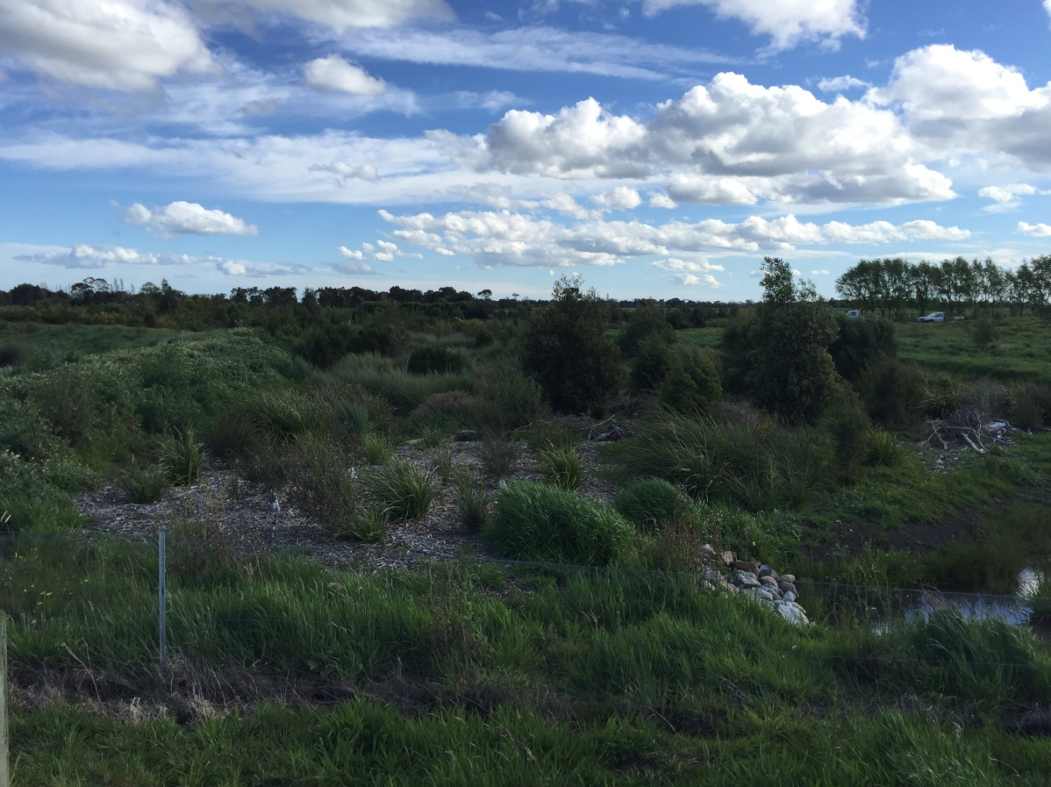

Photo taken 2017

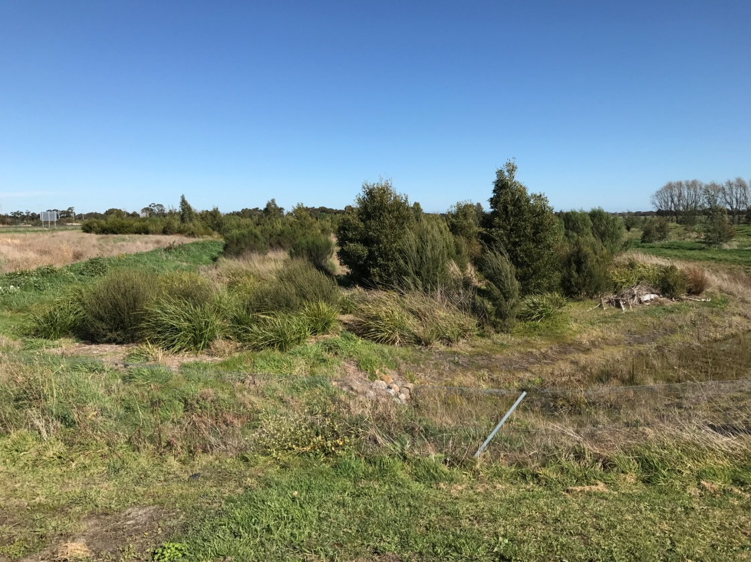

This photo shows the established bandicoot habitat and shelters within McGregor’s Drain revegetation site. Photo D. Lehr 2017.