KOO WEE RUP BYPASS PROJECT

Compliance Assessment Report July 2014-June 2015
EPBC Reference 2010/5784

Date: 25 September 2015
Version: 1.0

Prepared for
Department of the Environment
Approvals Monitoring South Section
CANBERRA ACT
Document information
Criteria | Details
Document title: | Compliance Assessment Report EPBC Reference 2010/5784 July 2014 -June 2015
Document owner: | VICROADS
Document author: | Nadia Arkoudis
Version: | 1.0
Issue date: | 25 September 2015


© Document copyright of VicRoads
This document is copyright. This document is published publically for the purpose of compliance to the EPBC Act Permit requirement and is for general information only.

Table of Contents
TERMS, ABREVIATIONS AND DEFINITION 4
1 Executive Summary 5
2 INTRODUCTION 6
2.1 Background 6
2.2 Purpose of This Document 6
2.3 Environmental Protection and Biodiversity Act 1999 Requirements 6
2.3.1 EPBC Approval 7
2.3.2 Performance and Compliance Reporting 7
2.3.3 Non Compliance Reporting 8
3 Project Compliance 9
3.1 Compliance with EPBC Conditions of Approval 9
3.2 Compliance with the Fauna Management Plan 9
3.3 Compliance with the Offset Management Plan 9
4 PERFORMANCE AND COMPLIANCE OF EPBC 2010/5784 11
5 Acknowledment 17
APPENDIX A – PROJECT MAP 19
APPENDIX B – 2014-2015 Results of the Fauna Management Plan 23
APPENDIX C – Offset Management Plan PERFORMANCE INDICATORS Results 33
APPENDIX D – FAUNA REGISTER 40
APPENDIX E – Fauna and Wetland Habitat Photos 49

TERMS, ABREVIATIONS AND DEFINITION

The terms, abbreviations and definitions that have been used in this documents are listed in the below table.

Table 1.0: List of Terms and Abbreviation
Terms / Abbreviation | Definition
DoE | Department of Environment
DSEWPaC | Department of Sustainability, Environment, Water, Population and Communities
DEPI | Department of Environment and Primary Industries
EPBC Act | Environmental Protection and Biodiversity Conservation Act 1999
EPA | Environmental Protection Authority
FMP | Koo Wee Rup Bypass Fauna Management Plan
GGF | Growling Grass Frog
ha | Hectare
Compliant | The requirements of the condition has been carried out
Not Applicable /Not Required | The requirements of conditions were not been triggered during the reporting period or were no longer applicable to the reporting period.
Non-compliant | Implementation of the condition has not been carried out in accordance with condition.
OMP | Koo Wee Rup Bypass EPBC Act 1999 Offset Management Plan
SBB | Southern Brown Bandicoot
VicRoads website for the Koo Wee Rup Bypass project. | https://www.vicroads.vic.gov.au/planning-and-projects/regional-road-projects/koo-wee-rup-bypass-koo-wee-rup

Executive Summary
The approval to the EPBC Act referral 2010/5784 was issued to VicRoads on 10 October 2013 for construction of the Koo Wee Rup Bypass. The Bypass is located approximately 1.5 km from the outskirts of the Koo Wee Rup Township between Manks Road and South Gippsland Highway.
Under Condition 11 of the approved EPBC Act referral 2010/5784, an annual compliance assessment report is required to be published on the VicRoads website within three months of June 30 each year following the commencement of construction activities, addressing compliance with each of the conditions of this approval, including implementation of any management plans/programs as specified in the conditions.
Under condition 7(b) of the approved EPBC Act referral 2010/5784, the annual compliance report is required to also include results of the preconstruction surveys, capture and release operations and ongoing monitoring in accordance with the reporting protocols of section 8 of the FMP. These reports can also be found on the VicRoads website for the Koo Wee Rup Bypass.
Under Condition 8(c) of the approved EPBC Act referral 2010/5784, the annual compliance report is required to also include the outcomes of the Offset Management Plan against the performance indicators (for habitat restoration and revegetation, wetland and drain establishment, predator control, fauna-proof fences and other infrastructure) as per section 3 of the Offset Management Plan.
This compliance report addresses the current status of the Koo Wee Rup Bypass Project against the condition of approval for the EPBC Referral Act 2010/5784 for the environmental activities carried out from between 1 July 2014 to 30 June 2015. This is the second compliance report to be prepared under the EPBC Act approval 2010/5784 for the Koo Wee Rup Bypass Project.

INTRODUCTION
The Koo Wee Rup Bypass is the first stage of a future upgrade of the Healesville – Koo Wee Rup Road to freeway standard between the Pakenham Bypass and the South Gippsland Highway. The bypass is located to the west of the Koo Wee Rup township and is situated 65 kilometres south-east of Melbourne, within the Shire of Cardinia, passing through land currently used for farming. The bypass is approximately 3.4 kilometres long on an alignment which leaves Healesville-Koo Wee Rup Road south of Manks Road to a roundabout on the South Gippsland Highway at Rossiter Road, including bridging over the Bunyip River and associated drains. The plan of the project area can be found in Appendix A of this report.

Background
The bypass provides a 3.4 km link from Healesville – Koo Wee Rup Road (south of Manks Road) to a roundabout on the South Gippsland Highway at Rossiter Road, including bridging over the Bunyip River and associated drains. The bypass purpose is to re-route large commercial vehicles and trucks from travelling through the Koo Wee Rup township to the bypass which will in return reduce noise pollution and improve safety to the community of Koo Wee Rup.

Purpose of This Document
The purpose of this document is to assess the compliance of the Koo Wee Rup Bypass project to the EPBC Conditions of approval EPBC2010/5784.
The EPBC conditions incorporate the Koo Wee Rup Bypass’ Fauna Management Plan and Offset Management Plan for mitigation measures to the three threatened fauna species which are known to occur within the project area. These threatened fauna species are the Growling Grass Frog (Litoria raniformis), Southern Brown Bandicoot (Isoodon obesulus obesulus) and Australian Grayling (Prototroctes maraena), which are all listed under the Commonwealth Environment Protection and Biodiversity Conservation Act 1999 (EPBC) and Victorian Flora and Fauna Guarantee Act 1988.

Environmental Protection and Biodiversity Act 1999 Requirements
The objective of the Environment Protection and Biodiversity Conservation Act 1999 (EPBC Act) is to manage and protect flora and fauna of national and international significance including ecological communities and heritage places of national environmental significance.

EPBC Approval

Approval of the Commonwealth Minister for the Environment is required under the EPBC Act if an ‘action’ will have or is likely to have a significant impact on a matter of national environmental significance. Due to potential impacts on threatened species and the proximity of a Ramsar wetland, the project was referred to the then Department of Sustainability, Environment, Water, Population and Communities (DSEWPaC) on 20 December 2010.
A decision issued on 14 January 2011 determined that the proposal was a controlled action and required assessment and approval under the EPBC Act before it could proceed. The relevant controlling provisions were:

- Listed threatened species and communities (sections 18 and 18A) being:
  - Southern Brown Bandicoot (Isoodon obesulus obesulus),
  - Growling Grass Frog (Litoria raniformis)
  - Australian Grayling (Prototroctes maraena); and
- Wetlands of international importance (sections 16 and 17B) (the Ramsar Convention) being Western Port Bay.

A request was submitted on 18 August 2011 to vary the proposed action to apply to the Koo Wee Rup Bypass only. A decision was issued on 20 September 2011 accepting this variation to the EPBC referral. VicRoads subsequently further developed the design for the Koo Wee Rup Bypass and submitted another request on 11 May 2012 to vary the proposed action, which was formally accepted on 28 May 2012.

Final approval was issued to VicRoads on the 10 October 2013 with the Proposed Action: Construction of a bypass of the Koo Wee Rup Township between Manks Road and South Gippsland Highway, Victoria. A copy of the EPBC Approval Notice can be found on the DoE website.
http://www.environment.gov.au/cgi-bin/epbc/epbc_ap.pl?name=referral_detail&proposal_id=5784

Performance and Compliance Reporting
Under Condition 11 of the approved EPBC Act referral 2010/5784, an annual compliance assessment report is required to be published on VicRoads website within three months of June 30 each year following the commencement of construction activities, addressing compliance with each of the conditions of this approval, including implementation of any management plans/programs as specified in the conditions.
Under Condition 8(c) of the approved EPBC Act referral 2010/5784, the Annual Report under condition 11 is required to also include the outcomes of the Offset Management Plan against the performance indicators (for habitat restoration and revegetation, wetland and drain establishment, predator control, fauna-proof fences and other infrastructure) as per section 3 of the Offset Management Plan. A copy of the EPBC approval can be found on the DoE website.
http://www.environment.gov.au/cgi-bin/epbc/epbc_ap.pl?name=referral_detail&proposal_id=5784

Non Compliance Reporting
There are no non compliance occurrences to report during this reporting period.

Project Compliance

Compliance with EPBC Conditions of Approval
VicRoads has complied with all conditions referenced in the EPBC Act approval 2010/5784 for the annual reporting period. There are 5 conditions that are not required to be implemented at this stage of the project. Section 4 of this report provides a summary of the performance and compliance with each of the 16 conditions of approval.

Compliance with the Fauna Management Plan
Under condition 7(b) of the approved EPBC Act referral 2010/5784, the annual compliance report is required to also include results of the preconstruction surveys, capture and release operations and ongoing monitoring in accordance with the reporting protocols of section 8 of the FMP. These reports can also be found on the VicRoads website for the Koo Wee Rup Bypass. Further information on the FMP results can be found in Appendix B.

Compliance with the Offset Management Plan
The Offset Management Plan (OMP) is required as part of the approvals for the construction of the Koo Wee Rup Bypass under the Environment Protection and Biodiversity Conservation Act 1999 (EPBC Act). The OMP is required to offset habitat losses and compensate for population fragmentation impacts to the Southern Brown Bandicoot and Growling Grass Frog that cannot be avoided during the construction of the Bypass.
Under Condition 8(c) of the approved EPBC Act referral 2010/5784, the annual compliance report is required to also include the outcomes of the Offset Management Plan against the performance indicators (for habitat restoration and revegetation, wetland and drain establishment, predator control, fauna-proof fences and other infrastructure) as per section 3 of the Offset Management Plan.
The OMP addresses and describes:
- Impacts to the listed species associated with the construction of the Bypass;
- Commitments for offsetting the impacts to the Southern Brown Bandicoot and Growling Grass Frog;
- Commitments pertaining to current and future management to ensure ongoing restoration and improvement of offset sites;
- Commitments regarding the protection of the offset sites in perpetuity;
- Monitoring and reporting procedures on the progress of the offset sites; and
- How the proposed offsets align with the EPBC Act Environmental Offsets Policy.
Further information on the above OMP elements can be found in Appendix C.

PERFORMANCE AND COMPLIANCE OF EPBC 2010/5784
The table provided below details the actions and evidence of the Koo Wee Rup Bypass Project and compliance with the EPBC Act approval notice 2010/5784.

Table 2.0: EPBC Act Approval Notice 2010/5784 compliance results.
Item | Conditions of the Approval | Actions | Comments / Evidence
1 | The action must not occur outside of the project area | Work limits have been specified in the VicRoads Contract which confines work to within the defined project area. | Construction of the Koo Wee Rup Bypass was completed in May 2015 and all works were contained within the project area.  Aerial photographs taken can verify works did not extend outside the project work area.
2 | To minimise impacts on the Western Port Ramsar Wetland and Australian Grayling, the person taking the action must ensure that the following measures are undertaken:  - there must be no extraction of water from the Bunyip River;  - construction activities within the Bunyip River must not occur outside the Bunyip River work area; and  - sediment, erosion and pollution control protocols must be implemented in accordance with:  - Construction Techniques for Sediment Pollution Control (EPA Publication No. 275, 1991); and  - Environmental Guidelines for Major Construction Sites (EPA Publication No. 480, February 1996). | - No water extraction from the Bunyip River is permitted in the VicRoads Contract.  - No construction activity outside the Bunyip River Work Area is a specific requirement of the VicRoads Contract Specification.  - Audit and surveillance to be undertaken at regular basis to ensure best practice erosion and sediment control has been implemented to minimise the impacts to the Bunyip River Drains. | - Water for construction works was extracted from on site sources, sediment ponds or from McDonalds Drain with a water extraction licence obtained from the relevant water supplier. No water was extracted from the Bunyip River.  - Amendments from the Bunyip River work area were approved by the Minister in March and June 2014. The latest variation to the Bunyip River work area was approved on 18 June 2014 and can be found on the DoE website at the following address:-  http://www.environment.gov.au/epbc/notices/assessments/2010/5784/2010-5784-variation-to-conditions.pdf  All works were contained within the revised Bunyip River work area.  - Auditing and surveillance reports have verified that best practice erosion and sediment control were implemented. Note: Construction of the bridge was completed in February 2015.
3 | The person taking the action must ensure that construction activities do not impact on more than 2.53 hectares of Southern Brown Bandicoot habitat. | Ensure the construction activities do not impact on more than 2.53 hectares of Southern Brown Bandicoot habitat. | At the end of construction (May 2015), the total clearing of vegetation for construction activities impacted 1.17 hectares of Southern Brown Bandicoot habitat. The final amount of vegetation clearing is 54% below the 2.53 hectares permitted by the conditions.  A detailed set of plans has been prepared which documents the total amount of the clearing of Southern Brown Bandicoot habitat.
4 | The person taking the action must ensure that construction activities do not impact on more than 2.17 hectares of Growling Grass Frog terrestrial habitat. | Ensure the construction activities do not impact on more than 2.17 hectares of Growling Grass Frog terrestrial habitat. | At the end of construction (May 2015), the total clearing of vegetation for construction activities impacted 0.71 hectares of Growling Grass Frog terrestrial habitat. The final amount of vegetation clearing is 67% below the 2.17 hectares permitted by the conditions.  A detailed set of plans is being prepared which will document the total amount of the clearing of Growling Grass Frog terrestrial habitat.
5 | To minimise noise disturbance to the Southern Brown Bandicoot during the breeding period, pile driving associated with bridge construction activities along the Bunyip River must not be undertaken from 1 July to 30 November in any year. | VicRoads to avoid pile driving activity associated with bridge construction activities along the Bunyip River from 1 July to 30 November in any year. | VicRoads sought a variation to this condition in a letter dated 5 June 2014 seeking to complete the piling in July if necessary which would enable the bridge and subsequent habitat reinstatement works to be completed earlier. Approval to the variation was granted in a letter dated 18 June 2014 which varied the period when pile driving activities must not be undertaken within the Bunyip River work area from 11 July to 30 November in any year. The approved variation can be found on the DoE website at the following address:-  http://www.environment.gov.au/epbc/notices/assessments/2010/5784/2010-5784-variation-to-conditions.pdf  Notwithstanding the granting of the above variation, the last of the pile driving activities within the Bunyip River work area were completed on 28 June 2014 which still achieved compliance with the original condition.
6 | To minimise noise disturbance to the Southern Brown Bandicoot, construction activities at night time (between sunset and sunrise), must not occur within 100m of Southern Brown Bandicoot habitat. | Avoid construction activities within 100m of the 3 key Southern Brown Bandicoot habitat areas listed in the FMP, when undertaking night time works. | The Contractor incorporated into the Construction Environmental Management Plan control measures to delineate the construction work area 100 metres away from the 3 key Southern Brown Bandicoot habitat areas listed in the FMP, when undertaking night time works.  At the end of construction (May 2015), no construction works had been undertaken between sunset and sunrise within 100 metres of the 3 key habitat areas.
7 | To minimise impacts on the Australian Grayling, Southern Brown Bandicoot and Growling Grass Frog from construction activities, the person taking the action must implement the Fauna Management Plan; and:  - ensure the implementation of the Fauna Management Plan, including the fauna monitoring program and predator control program, begins prior to commencement of construction activities and continues over a period of at least 5 years; and  - ensure the Annual Report under condition 11, documents the results of the Fauna Management Plan (including results of preconstruction surveys, capture and release operations, and ongoing monitoring), in accordance with the reporting protocols at section 8 of the Fauna Management Plan. Survey results must be accompanied with a shapefile of the survey results. | - VicRoads to undertake the Fauna Monitoring and Predator Control Programs as per Fauna Management Plan requirements.  - This report addresses the conditions | - The following preconstruction and construction programs have been undertaken as per the FMP:  - Southern Brown Bandicoots and Pre-Construction Predator Baseline Surveys - Ecology Australia ( 17 April – 21 May 2013).  - Growling Grass Frog and Swamp Skink Baseline Survey – Ecology Australia (December 2011 to February 2012).  - Predator control program - Abzeco (May 2013 – May 2014).  - Construction phase Fauna monitoring program - Mal’s Environment and Ecological Services (commenced January 2014)  - Koo Wee Rup Bypass Predator Control Program July-August 2014  - Koo Wee Rup Bypass Predator Control Program September-October 2014  - Koo Wee Rup Bypass Predator Control Program December-January 2014-15  - Koo Wee Rup Bypass Predator Control Program March 2015  - Koo Wee Rup Bypass Predator Control Program May 2015  - Koo Wee Rup Bypass Construction Phase GGF Monitoring Program - Spring-Summer 2014-2015  - Koo Wee Rup Bypass Construction Phase SBB Monitoring Program - Spring 2014  - Koo Wee Rup Bypass Construction Phase SBB Monitoring Program - Autumn 2015  - A summary of VicRoads’ compliance with the implementation of the Fauna Management Plan is included as Appendix B of this report.  The reports and results of the FMP programs listed under item 7a above are available on the VicRoads website for the Koo Wee Rup Bypass.
8 | To compensate for the loss of 2.53 hectares of Southern Brown Bandicoot habitat, the person taking the action must:  - enter into an Agreement under section 173 of the Planning and Environment Act 1987 to secure the Koo Wee Rup Bypass Offset, within 24 months of the date of this approval, and:  - provide the department with a signed copy of the Agreement and evidence of lodgement with the Titles Office, within 2 weeks of lodgement;  - provide the department with the offset attributes, shapefile and map clearly defining the location and boundaries of the Koo Wee Rup Bypass Offset, within 2 weeks of lodgement; and  - ensure that the Agreement is registered on the title on which the Koo Wee Rup Bypass Offset is located, and provide the department with evidence of registration, within 2 weeks of registration.  - ensure the Offset Management Plan is implemented. Implementation of the Offset Management Plan, including the fauna monitoring program and predator control program, must begin prior to commencement of construction activities and continue to be implemented over a period of at least 5 years; and  - ensure the Annual Report under condition 11, documents the outcomes of the Offset Management Plan against the performance indicators (for habitat restoration and revegetation, wetland and drain establishment, predator control, fauna-proof fences and other infrastructure) as per section 3 of the Offset Management Plan. | - VicRoads to enter into a section 173 agreement under the Planning and Environment Act 1987 as per condition.  - VicRoads to implement the OMP including the Fauna Monitoring and Predator Control Programs  - VicRoads to document the outcomes of the Offset Management Plan in the Annual Report. | - All of the bandicoot habitat revegetation required by the Offset Management Plan has been established on land that was acquired by VicRoads for the Koo Wee Rup Bypass project (i.e. there is no external private land that was used for this revegetation that would currently require a section 173 agreement to be created). Before a section 173 agreement is created on the properties that have been acquired, some of this acquired land first needs to be subdivided and this process will still take some time.  VicRoads will seek to extend the timeframe for entering into a section 173 agreement for the land parcels which will be subdivided.  - VicRoads has been implementing the Offset Management Plan as required. The fauna monitoring and predator control programs have been implemented as discussed in item 7 above.  - The outcomes for the performance indicators of the OMP are summarised in Appendix C of this report in the following tables:-  - Table C1: Habitat Restoration and Revegetation  - Table C2: Wetland and Drain Establishment  - Table C3: Predator Control  - Table C4: Fauna-proof Fences and other Infrastructure
9 | Within 30 calendar days after the commencement of construction activities, the person taking the action must advise the department in writing of the actual date of commencement of construction activities. | VicRoads to advise the department of actual date of commencement of construction activities | Written notification was sent to the department on 19 November 2013, advising that construction activities commenced on site on 18 November 2013.
10 | The person taking the action must maintain accurate records substantiating all activities associated with or relevant to the conditions of approval, including measures taken to implement management plans/programs and make them available upon request to the department. Such records may be subject to audit by the department or an independent auditor in accordance with section 458 of the EPBC Act, or used to verify compliance with the conditions of approval. Summaries of audits will be posted on the department’s website. The results of audits may also be publicised through the general media. | Records of the implementation of management plans/programs are being maintained, and are available for auditing purposes. | Management plans and programs can be found on the VicRoads website for the Koo Wee Rup Bypass project.  https://www.vicroads.vic.gov.au/planning-and-projects/regional-road-projects/koo-wee-rup-bypass-koo-wee-rup
11 | Within three months of June 30 each year following the commencement of construction activities, the person taking the action must publish a report on their website addressing compliance with each of the conditions of this approval, including implementation of any management plans/programs as specified in the conditions. Documentary evidence providing proof of the date of publication must be provided to the department at the same time as the compliance report is published. Non-compliance with any of the conditions of the approval must also be reported to the department within 2 business days of becoming aware of the non-compliance. | The annual compliance report shall be published on the VicRoads web site by 30 September each year. | This reports and associated supporting documents can be found on the VicRoads website for the Koo Wee Rup Bypass project.  https://www.vicroads.vic.gov.au/planning-and-projects/regional-road-projects/koo-wee-rup-bypass-koo-wee-rup  Evidence of the date of publication has been provided to the Department at the same time this report was published.
12 | Upon the direction of the Minister, the person taking the action must ensure that an independent audit of compliance with the conditions of approval is conducted and a report submitted to the Minister. The independent auditor must be approved by the Minister prior to the commencement of the audit. Audit criteria must be agreed to by the Minister and the audit report must address the criteria to the satisfaction of the Minister. | Upon the direction of the Minister, VicRoads shall submit the supportive evidence and a report for an independent audit of compliance for this condition. | No actions to date as no directions have been received from the Minister for an independent audit of compliance.
13 | If the person taking the action wishes to carry out any activity otherwise than in accordance with the management plans/programs as specified in the conditions, the person taking the action must submit to the department for the Minister’s written approval a revised version of that management plan/program. The varied activity shall not commence until the Minister has approved the varied management plan/program in writing. The Minister will not approve a varied management plan/program unless the revised management plan/program would result in an equivalent or improved environmental outcome over time. If the Minister approves the revised management plan/program, that management plan/program must be implemented in place of the management plan/program originally approved. | VicRoads to seek approval to any proposed changes to conditions or management plans and programs. | VicRoads has sought and has been granted approval to 3 amendments to the EPBC conditions of approval for the Koo Wee Rup Bypass.  Two amendments for slight changes to the Bunyip River Works Area have been discussed under condition 2(b) above.  An amendment to allow piling within the Bunyip River Works Area to extend slightly into July has also been discussed under condition 5 above.
14 | If the Minister believes that it is necessary or convenient for the better protection of Wetlands of international importance (sections 16 & 17B) or Listed threatened species and communities (sections 18 & 18A) to do so, the Minister may request that the person taking the action make specified revisions to the management plans/programs specified in the conditions and submit the revised management plans/programs for the Minister’s written approval. The person taking the action must comply with any such request. The revised approved management plans/programs must be implemented. Unless the Minister has approved the revised management plans/programs then the person taking the action must continue to implement the management plans/programs originally approved, as specified in the conditions. | VicRoads to comply with any request made by the Minister. | No actions to date as no requests have been received from the Minister.
15 | If, at any time after 5 years from the date of this approval, the person taking the action has not substantially commenced the action, then the person taking the action must not substantially commence the action without the written agreement of the Minister. | VicRoads to ensure construction commences within 5 years of the approval. | This action is now closed as construction activities commenced on 18 November 2013.
16 | Unless otherwise agreed to in writing by the Minister, the person taking the action must publish all management plans/programs referred to in these conditions of approval on their website within 1 month of this approval. Any variations to management plans/programs must be published on the website within 1 month of the variation being approved by the Minister | VicRoads to ensure that management plans/programs referred to in the conditions of approval are available on the VicRoads website within one month of the approval. | Earlier versions of the FMP and Draft OMP had been on the VicRoads website for the planning of the upgrading of the Healesville-Koo Wee Rup Road since public information sessions about the project were undertaken in July 2012. The final versions of these plans were uploaded to the VicRoads Koo Wee Rup Bypass Project website in November 2013.

Acknowledment

Biosphere Group: Dr David Nicholls, Sara Maclagan

DEPI: Dr John Hick, Dr Bram Mason, Dr Lochlan Marshal

Ecology Australia: Dr Andrew McMahon, Dr Darren Quin, Dr Lisa Crawfoot

Lend Lease Engineering: Ryan Walkenhaust, Chris Podger, Erick Tansil, Lyndal Isakhan

Melbourne Water: Sara Johnson, Keiran Crocker, Peter Neal

Port Phillip Catchment Management Authority: Adam Shaelkoff

Royal Botanical Gardens: Dr Terry Coates

VicRoads: Frank Kauhausen, Lee Kohls, Robert Pearson

This Page has been Left Blank

APPENDIX A – PROJECT MAP

This Page has been Left Blank

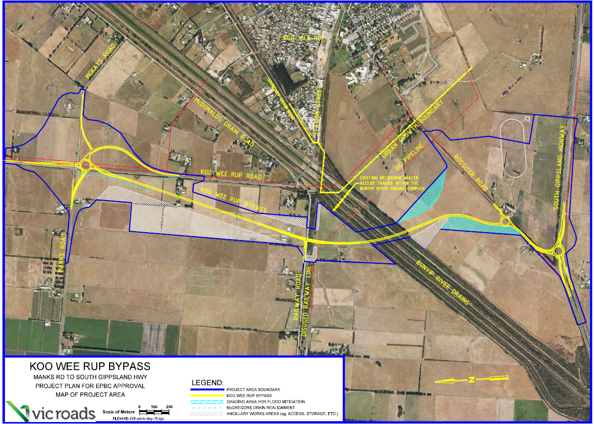

This Page has been Left Blank

APPENDIX B – 2014-2015 Results of the Fauna Management Plan

This Page has been Left Blank
Summary
VicRoads’ Koo Wee Rup Bypass Fauna Management Plan (FMP) provides extensive details and requirements for the construction phase of the bypass. The commitments outlined in the FMP commence from the preconstruction phase through to the post construction phase of the project. This section summarises the outcomes from the FMP’s key activities undertaken by VicRoads to date to demonstrate compliance with this report.
List of key activities:
- Fauna Monitoring;
- Predator Control;
- Habitat Restoration and Revegetation;
- Capture and Release; and
- Water Quality Baseline Survey.

The following reports listed below, are programs that align with the commitments required under the FMP which can be found on the VicRoads website for the Koo Wee Rup Bypass.
List of program reports:
- Koo Wee Rup Bypass Growling Grass Frog and Swamp Skink Surveys
- Koo Wee Rup Bypass SBB and Pre Predator control monitoring
- Koo Wee Rup Bypass Construction Phase GGF Summer 2014 Monitoring Program
- Koo Wee Rup Bypass Construction Phase Fauna Monitoring SBB Autumn 2014 monitoring program
- Koo Wee Rup Bypass Project Pest Predator Control Program - June 2013
- Koo Wee Rup Bypass Project Pest Predator Control Program - August 2013
- Koo Wee Rup Bypass Project Pest Predator Control Program - January-March 2014
- Koo Wee Rup Bypass Project Pest Predator Control Program - June 2014
- Koo Wee Rup Bypass Predator Control Program July-August 2014
- Koo Wee Rup Bypass Predator Control Program September-October 2014
- Koo Wee Rup Bypass Predator Control Program December-January 2014-15
- Koo Wee Rup Bypass Predator Control Program March 2015
- Koo Wee Rup Bypass Predator Control Program May 2015
- Koo Wee Rup Bypass Construction Phase GGF Monitoring Program - Spring-Summer 2014-2015
- Koo Wee Rup Bypass Construction Phase SBB Monitoring Program - Spring 2014
- Koo Wee Rup Bypass Construction Phase SBB Monitoring Program - Autumn 2015

Construction Phase Activities
As of mid May 2015 the project construction works reached practical completion with:
- Earthworks 100% Complete
- Pavement 100% Complete
- Drainage 100% Complete
- Fauna Infrastructures 100% Complete
- Bridge structure 100% Complete

Fauna Monitoring
The fauna monitoring project was undertaken by Mal’s Ecological and Environment Services and commenced in January 2014 with the first phase of monitoring for the Growling Grass Frog. The second phase of the Growling Grass Frog surveys between Spring 2014 and Summer 2015 indicated that the Growling Grass Frog population densities increased at five sites, decreased at three sites and stayed stable at one site. The arrival of new populations of Growling Grass Frogs at such sites indicates that the species is able to move across the landscape and colonize new sites that retain adequate habitat and few threats. During this survey Growling Grass Frogs were absent from dam sites including some of the newly created wetlands that retained good habitat but retained the Common Froglet in high population densities. Further information can be obtained from the Growling Grass Frog monitoring report which can be found on the VicRoads website for the Koo Wee Rup Bypass project.
During the construction of the project between autumn 2014 and autumn 2015 surveys identified that the Southern Brown Bandicoot were widespread across the study area and had colonized all of the revegetation sites by spring 2014.
During the spring 2014 monitoring surveys, Southern Brown Bandicoots were filmed on cameras at 20 of the 32 sites (59.4 %) and further bandicoot evidence was collected at 26 of the 28 sand pad sites (93%). These sites include sites within the revegetation areas established for the project as well as other sites around Manks Road, McKays Road, Koo Wee Rup Road as well as within the original vegetation corridors. The number of bandicoot photographs taken at each site during the spring 2014 surveys are shown in Graph A1 below. Further details about these surveys and the locations of the survey monitoring sites can be found in the reports available on the VicRoads Koo Wee Rup Bypass website.

Graph A1: Results of Southern Brown Bandicoots recorded on Digital Scouting/trail Cameras
Map 3: Locations of Southern Brown Bandicoot diggings, filmed at camera sites, sightings and road kills during the 2014-15 monitoring program

Fauna species filmed on camera during the 2 monitoring periods

During the autumn 2015 monitoring program Southern Brown Bandicoots were filmed at all of the eight monitoring sites (100% of sites), with a 67% increase in bandicoots filmed at the monitoring sites between the autumn 2014 monitoring program and this monitoring program. The records suggest about a 40% increase of Bandicoot presence between spring 2014 and autumn 2015 monitoring programs.

The total number of bandicoot photographs taken at all sites during the three monitoring surveys to date are compared in Graph A2 below.

Graph A2: Number of Southern Brown Bandicoots filmed on cameras per monitoring period.

Further information can be obtained from the Southern Brown Bandicoots monitoring reports which can be found on the VicRoads website for the Koo Wee Rup Bypass project.

Predator Control
The Construction phase of the Predator Control Program was undertaken by Abzeco, followed by Mal’s Ecological and Environment Services during the construction of the project. A summary of the results is provided in Appendix C with further details contained in the reports available on the VicRoads website for the Koo Wee Rup Bypass project.

Habitat Restoration and Revegetation
Revegetation of the Southern Brown Bandicoot habitat is now 100% complete. The new fauna habitat corridor along the northern end of the bypass was completed in the final quarter of 2014. Additional habitat was placed on the north-east side of the project near McKays Road early 2015 to complete the required 7.1ha of revegetated habitat area in accordance to the EPBC permit conditions. Approximately 95,000 plants have been planted for the projects wetlands and habitat restoration and revegetation.

During construction the total vegetation removal was carefully planned to ensure that the allowable area of native vegetation habitat removed was not exceeded. The table below compares the allowable habitat loss to the final areas of actual habitat lost.
Table A1 Summary of Fauna Habitat Loss
Vegetation Type | Allowable Habitat Loss | Actual Habitat Loss | % of Allowable Land Cleared. | % of Habitat Retained
Growling Grass Frog Habitat | 2.17 Ha | 0.71 Ha | 33% | 66%
Southern Brown Bandicoot Habitat | 2.53 Ha | 1.17 Ha | 46% | 54%

Wetlands and Drainage Establishment
The five frog ponds and wetlands were constructed in late 2013 and are now 100% complete. The construction of the McGregor’s Drain realignment and wetland habitat area commenced in early 2014 and is also now 100% complete.

Capture and Release Protocol
The VicRoads Contractor has established a register to record any threatened fauna observed on site. Details of the observation for the 2014-15 reporting period are provided in Appendix D. A capture and release protocol was prepared by the contractor and approved by DEPI. Only one bandicoot had previously been captured and released in conformance with the protocol in March 2014 but no further capture and release of bandicoots was required during the 2014-15 reporting period. Although many more bandicoots sightings were recorded on site during 2014-15 the bandicoots usually quickly departed such that capturing and releasing of the animals was not required.

Water Quality Survey
Water quality monitoring undertaken during the construction phase in the Bunyip River was undertaken during winter 2014 and summer of 2015. Typical results during these wetter months indicate that turbidity upstream of the Koo Wee Rup Bypass Worksite was between 40 - 70 NTU. Downstream results indicate that construction works are having negligible impact to turbidity as all readings are within 7 NTU's or 6% of upstream results. As per pre construction monitoring results the spike in Turbidity of 206 and 178 NTU is a result of a significant rain event of 35mm within the preceding 24 hours. The downstream results on this occasion were within 3.5% further details are provided in the below Table B2 and Graph B2.

Graph B1 Water quality monitoring in the Bunyip River during the construction phase

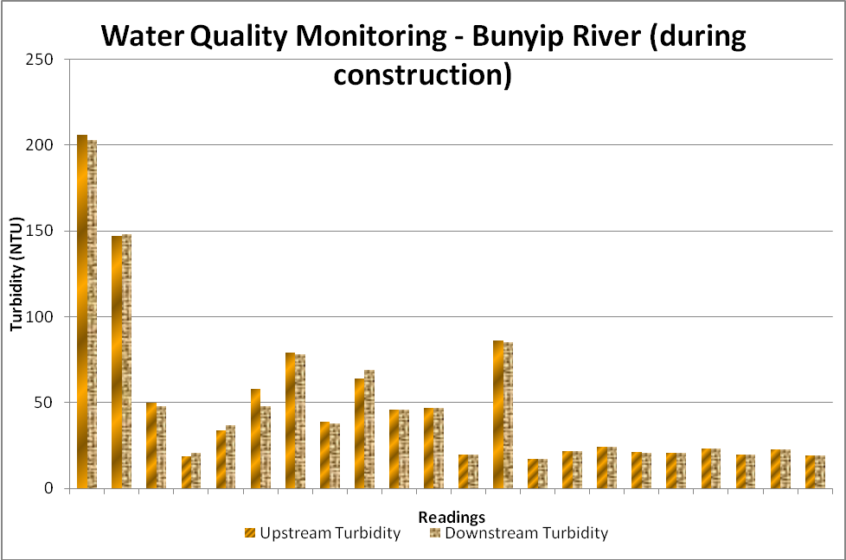

Table B2 Water quality monitoring in the Bunyip River during the construction phase
Date | Upstream Turbidity | Downstream Turbidity
2/07/2014 | 206 | 203
7/07/2014 | 147 | 148
18/07/2014 | 50 | 48
18/08/2014 | 19 | 21
25/08/2014 | 34 | 37
3/09/2014 | 58 | 48
10/09/2014 | 79 | 78
4/10/2014 | 39 | 38
7/10/2014 | 64 | 69
27/10/2014 | 46 | 46
1/11/2014 | 47 | 47
24/11/14 | 20 | 20
17/11/14 | 86 | 85
8/12/14 | 17.2 | 17.1
5/01/15 | 21.6 | 21.6
8/01/15 | 24.1 | 24.3
9/01/15 | 21.2 | 20.9
13/01/15 | 20.9 | 20.9
21/01/15 | 23.3 | 23.3
9/02/15 | 19.7 | 19.6
16/02/2015 | 22.9 | 22.9
19/02/15 | 19.5 | 19.5

Post Construction Phase Activities
As of the end of June 2015 the project Construction works reached practical completion and Post-Construction maintenance activities have commenced and will continue until mid May 2017. VicRoads will continue to implement the Fauna Monitoring and Predator control programs until late 2017, up to the life of the Fauna Management Plan and Offset Management Plan.

This Page has been Left Blank

APPENDIX C – Offset Management Plan PERFORMANCE INDICATORS Results

This Page has been Left Blank
Table C1 - Habitat Restoration and Revegetation Performance Evaluation

Item | Performance Indicator | Evidence
1 | Plantings will be completed by Spring 2014 (supplementary plantings will be supplied beyond Spring 2014, if required). | Planting for stages 1, 2 and 3 of the fauna habitat referred to in the FMP and OMP as the “triangle land”, and the “western corridor” were established by 2 July 2014. Refer to Appendix E for photos of the fauna habitat area.
2 | Plantings must be consistent with the species and densities given in the Revegetation and Habitat Restoration Plan (Australian Ecosystems 2012). | Plantings have been established with the species and densities consistent with the Revegetation and Habitat Restoration Plan. Minor modifications were made to the plan, where shrubs were substituted for aquatic plant in low lying land areas that retained water. Refer to Appendix E for photos of the fauna habitat area.  The western habitat along the northern-mid section’s density and growth has had a slow uptake and has resulted with insufficient density. Further planting will be undertaken during the post construction phase of the project to ensure sufficient density and survival rate is maintained.
3 | All high threat weeds (as per DSE 2007) within revegetation areas should be effectively controlled or eliminated by the end of 2014. | Weeds spray and removal from the newly established fauna habitat areas were undertaken every 2 months during the construction phase.
4 | Other weeds should not exceed 10% of cover by end of 2014. | As above.
5 | Plantings should aim to achieve a 95% survival rate after three years. | The vegetated habitat area was maintained every 2 months during construction and will be maintained every 6 months post construction. The survival rate to date has been successful with most areas showing very good density and growth.
6 | If used, tree guards should be removed as soon as possible following establishment of plants. | Tree guards were not required and plant establishment and growth has been successful with adequate density and growth.

Table C2 - Wetland and Drain Establishment Performance Evaluation

Item | Performance Indicator | Evidence
1 | Plantings will be completed by Spring 2014 (supplementary plantings will be supplied beyond Spring 2014, if required). | Planting of the fauna habitat referred to in the FMP and OMP as the “re-aligned McGregors Drain” and construction and planting of the 5 frog ponds were established by June 2014.  Refer to Appendix E for photos of the wetland and drain habitat area.
2 | Plantings must be consistent with the species and densities given in the Revegetation and Habitat Restoration Plan (Australian Ecosystems 2012). | Plantings have been established with the species and densities consistent with the Revegetation and Habitat Restoration Plan. Minor modifications were made to the plan, where shrubs were substituted for aquatic plant in low lying land areas that retained water. Refer to Appendix E for photos of the fauna habitat area.  The western habitat along the northern-mid section’s density and growth has had a slow uptake and providing insufficient density. Further planting will be undertaken during the post construction phase of the project to ensure sufficient density and survival rate is maintained.
3 | Plantings should aim to achieve a 95% survival rate after three years. | The vegetated habitat area was maintained every 2 months during construction and will be maintained every 6 months post construction. The survival rate to date has been successful with most areas showing very good density and growth.
4 | All high threat weeds (as per DSE 2008) within created wetlands should be effectively controlled or eliminated by end of 2014. | Weeds spray and removal from the newly established fauna habitat areas were undertaken every 2 months during the construction phase.
5 | Other weeds should not exceed 10% of cover by the end of 2014. | As above
6 | If used, tree guards and temporary guards (netting) should be removed as soon as possible following establishment of plants. | Tree guards were not required and plant establishment and growth has been successful with adequate density and growth.

Table C3 - Predator Control Performance Evaluation

Item | Performance Indicator | Evidence
1 | Detectable decline in the abundance (activity indices) of feral predators in the project area, as ascertained by camera monitoring and bait uptake (e.g. see Ecology Australia 2013e). | An initial predator control program was implemented from 6 months prior to the commencement of construction activities to early 2014 but reported only low levels of bait updates. During this period several other fox baiting programs within the area of Koo Wee Rup were deployed which may have reduced fox population during that period.  During the construction phase there was a greater fox bait uptake which may have been contributed to the minimal fox baiting programs being delivered in the surrounding the project area during 2014 and 2015.
2 | High initial rate of fox bait uptake (i.e. >60%), followed by subsequent decline in rate of bait uptake (see Ecology Australia 2013d). | Greater than 60% of fox bait uptake was identified during 2014 to 2015.  All free feed takes during the nine fox control pulses totals to 70 and 85 of the poison baiting fox bait uptakes.  The results indicate that there have been 52 foxes killed during the predator control program and therefore contributed with other fox control programs to a low fox population within the Koo Wee Rup area.  The low fox population is also allowing Southern Brown Bandicoot population densities to increase which is supported by increased sightings and digging activities of bandicoots by Lend Lease & MEES staff over the last 18 months.
3 | Any active fox dens located in the project area are fumigated promptly following detection. | Fox den fumigation commenced October and November 2014. Active searching for fox dens was undertaken along Railway Road, Bunyip River Drain Complex and other locations within the bypass footprint. Two non-active fox dens were found west of the construction of the new bridge along the Bunyip River Drain Complex. Both were destroyed and mapped using a GPS unit.
4 | A decrease in the number of dens that require fumigation annually. | As above, information to be provided in the next reporting period.
5 | An increase in the detection of Southern Brown Bandicoots as gauged through activity indices and camera monitoring. | During the autumn 2015 monitoring program Southern Brown Bandicoots were filmed at all of the eight monitoring sites (100% of sites), with a 67% increase in bandicoots filmed at the monitoring sites between the autumn 2014 monitoring program and this monitoring program. Records suggest that there has been about a 40% increase in bandicoot detection between the spring 2014 and autumn 2015 monitoring programs.  Further details of the Southern Brown Bandicoot monitoring can be found on the VicRoads website for the Koo Wee Rup Bypass. Refer to Appendix D for the fauna obsevation register.
6 | All monitoring and predator control activities are documented. | Documentation of the monitoring and predator control activities has been documented and is available on the VicRoads website for the Koo Wee Rup Bypass.

Table C4 - Fauna-proof Fences and other Infrastructure Performance Evaluation

Item | Performance Indicator | Evidence
1 | All monitoring activities of the use of fauna underpasses by Southern Brown Bandicoots and Growling Grass Frogs are documented. | Three fauna underpasses were constructed for the project to provide for movement under the road for the Southern Brown Bandicoots. Two culverts were constructed for the realigned section of McGregor’s Drain with another culvert also installed under the bypass adjacent to the disused rail line. Cameras were installed at either ends of these culverts between March and May to see if the bandicoots would utilise the culverts, however no bandicoots were recorded using the culverts during this monitoring period. The works were still being completed at the time of the autumn 2015 monitoring so it could be expected that it may still take some time before the bandicoots would use these culverts and monitoring will continue in future surveys.
2 | Minimal evidence of road mortality of Southern Brown Bandicoots and Growling Grass Frogs. | The road mortality of one Southern Brown Bandicoot was reported to the project in the 2014-2015 reporting period. In August 2014 a deceased bandicoot was found on Railway Road about 200m east of the project work site. Further details are contained in the Fauna Register of Appendix D.  No evidence of road mortality of Growling Grass Frogs was recorded for the 2014-15 reporting period.

This Page has been Left Blank

APPENDIX D – FAUNA REGISTER

This Page has been Left Blank

Lend Lease Engineering Table Register of Fauna observations at KWR Bypass July 2014 – December 2014

Species | Date | Location | Co-ordinates | Accuracy (m) | Description | In work area | Time of observation | Action | Observer | Reported by | Map Reference
SBB | 14/07/2014 | Railway Rd near site entrance |  | within 50m on map | One SBB spotted crossing Railway Road near site entrance before moving into surrounding vegetation | N | am |  | ? | Ryan Walkenhorst (email 14/7/14) | 6
SBB | 14/07/2014 | McKays Rd site access point |  | within 10m on map | One SBB spotted at McKays Road, crossing site access point before moving into surrounding vegetation | Y | am |  | Sub-Contractor | Ryan Walkenhorst (email 14/7/14) | 7
SBB | 17/07/2014 | Near the corner of Mackays and Healesville-Koo Wee Rup Roads |  | within 10m on map | One SBB (not within work area but) seen to cross Healesville-Koo Wee Rup Road from one swale drain to another. | N | ? |  | site worker | Ryan Walkenhorst (email 17/7/14) | 8
SBB | 22/07/2014 | Railway Road |  | within 10m on map | One SBB seen crossing Railway Road adjacent our Gate 32 site entry. It crossed from one vegetation strip to the other outside of the work site area. | N | am (before Ryan's email at 8.18am) |  | Ryan Walkenhorst | Ryan Walkenhorst (email 22/7/14) | 9
SBB | 22/07/2014 | Railway Road |  | within 10m on map | One SBB near Gate 32 on Railway road this afternoon at about 3pm. Very likely to be the same one I (Ryan W) witnessed this morning, again it just crossed over Railway Road from one vegetation strip to another | N | ~3pm |  | Sub-Contractor | Ryan Walkenhorst (email 22/7/14) | 10
SBB | 22/07/2014 | MacKays Rd |  | within 10m on map | SBB sighting at the northern end of the job at Mackays Road. The bandicoot was observed crossing Healesville-Koo Wee Rup Road near our site entrance. | N | ? (before Ryan's email at 3.45pm) |  | sub-contractors | Ryan Walkenhorst (email 22/7/14) | 11
SBB | 24/07/2014 | Road side drain beside Healesville-Koo Wee Rup Road near Mackays Road |  | within 10m on map | One SBB observed in the roadside drain along Healesville-Koo Wee Rup Road near Mackays Road. We believe this to be the same one that has been observed in that area over the past couple of weeks | N | pm |  | sub-contractors | Ryan Walkenhorst (email 25/7/14) | 12
SBB | 24/07/2014 | Road side drain vegetation north of Railway Road |  | within 10m on map | One SBB observed in the road side drain vegetation north of Railway Road by one of our survey team members as he was marking out points. Again, as above, we believe this to be the same one that has been observed in this area over the past couple of weeks | Y | pm |  | survey team member | Ryan Walkenhorst (email 25/7/14) | 13
SBB | 1/08/2014 | site access point north of Mackays Road |  | within 10m on map | One SBB observed crossing the site access point north of Mackays Road at the corner of Mackays Road and Koo Wee Rup-Healesville Road, from one swale drain area to another. | Y |  |  | VicRoads representative | Ryan Walkenhorst (email 1/8/14) | 14
SBB | 1/08/2014 | middle of Railway Road approximately 200m east of the KWR Bypass alignment | S 38 11.807  E 145 28.443 | 0 | approximately 11:30am today a deceased animal which looked like a bandicoot was identified by a sub-contractor in the middle of Railway Road approximately 200m east of the KWR Bypass alignment. The sub-contractor reported this to myself (Ryan W) and upon closer visual observation it was confirmed the animal was a SBB and had been killed by a vehicle. The bandicoot was hit approximately 200m east of the alignment, not on-site, on Railway Road which is a public road. | N | ~11.30am | The deceased SBB was collected by Malcolm Legg and transported to the Southern Brown Bandicoot Technical Reference Group at the Royal Botanic Gardens, Cranbourne. The GPS co-ordinates of the deceased SBB have been uploaded into our (Lend Lease) Listed Species Road Kill Register. | sub-contractor (& Ryan Walkenhorst who identified it) | Ryan Walkenhorst (email 1/8/14) | 15
SBB | 4/08/2014 | Railway Road |  | within 10m on map | One SBB observed crossing Railway Road adjacent gate 32. | N | ~5.15pm |  | Lend Lease engineer | Ryan Walkenhorst (email 5/8/14) | 16
SBB | 6/08/2014 | access track to the bridge abutment at 460 Railway Road |  | within 10m on map | One SBB observed utilising planted habitat corridor. The bandicoot was seen crossing our access track to the bridge abutment at 460 Railway Road from one side of planted habitat corridor to the other. | Y | am (before Ryan's email at 10.16am) |  | Lend Lease foreman | Ryan Walkenhorst (email 6/8/14) | 17
SBB | 7/08/2014 | Mackays Road adjacent to site entrance |  | within 10m on map | Mackays Road adjacent to our site entrance, the bandicoot was observed in the road side drain | Y | pm |  | Lend Lease employee | Ryan Walkenhorst (email 8/8/14) | 18
SBB | 8/08/2014 | next to Gate 30 site entrance on Railway Road |  | within 10m on map | A bandicoot was observed in the grass next to Gate 30 site entrance on Railway Road | N | am |  | ? | Ryan Walkenhorst (email 8/8/14) | 19
SBB | 12/08/2014 | Railway Road adjacent to our site entries “31” and “32” |  | within 50m on map | One bandicoot sighting along Railway Road adjacent to our site entries “31” and “32” | N | late pm |  | ? | Ryan Walkenhorst (email 13/8/14) | 20
SBB | 13/08/2014 | Railway Road adjacent to our site entries “31” and “32” |  | within 50m on map | 2 bandicoot sightings along Railway Road adjacent to our site entries “31” and “32” | N | am |  | ? | Ryan Walkenhorst (email 13/8/14) | 21
SBB | 18/08/2014 | swale drain along Mackays Road, to the swales along Koo Wee Rup Healesville Road. |  | within 10m on map | A bandicoot was observed multiple times throughout the day by our traffic management rep from 9am to 4pm moving from the swale drain along Mackays Road, to the swales along Koo Wee Rup Healesville Road. | Y and N | between 9am - 4pm |  | traffic management rep | Ryan Walkenhorst (email 19/8/14) | 22
SBB | 22/08/2014 | Access track to the bridge abutment within the habitat planting corridoor (stage 1 and 2) |  | within 10m on map | The bandicoot was seen foraging within the habitat corridor immediately next to the access track to the bridge abutment at 460 Railway Road. | Y | ? |  | Sub-contractor | Ryan Walkenhorst - directly into spread sheet | 23
SBB | 28/08/2014 | Pasture area behind the farm house located at 460 Railway Road adjacent to the habitat planting stages 1, 2 and 3. |  | within 10m on map | Two Lend Lease employees observed a number of bandicoots and rabbits foraging around in the pasutre area from around 5:15pm to 6:15 pm. The area the bandicoots were observed falls within the site boundary. | Y | between 5:15pm and 6:15pm |  | Two Lend Lease employees | Ryan Walkenhorst (email 29/08/14) | 24
SBB | 1/09/2014 | Crossing Railway Road from the north side to south side adjacent gate 32. |  | within 10m on map | The civil superinendent observed a SBB crossing Railway Road from one vegetated swale drain to another adjacent the Projects gate 32 access point. |  | am - between 7am and 8am |  | Site Superintendent | Ryan Walkenhorst (emial 01/09/14) | 25
SBB | 10/09/2014 | Culvert north of McKays Road under Koo Wee Rup Healesville Road |  | within 10m on map | Two Lend Lease employees observed a bandicoot crossing under Koo Wee Rup Healesville Road using the existing drainage culvert. |  | 4:30pm |  | Two Lend Lease employees | Ryan Walkenhorst (emial 12/09/14) | 26
SBB | 11/09/2014 | Crossing Railway Road from the north side to south side adjacent gate 32. |  | within 10m on map | Lend Lease superintendent observed a bandicoot cross Railway road in front of him immediately adjacent Gate 32. |  | 5pm |  | Site Superintendent | Ryan Walkenhorst (emial 12/09/14) | 27
SBB | 12/09/2014 | Foraging along the south side of Railway Road, approx 300m east of Gate 32. |  | within 10m on map | Two Lend Lease employees observed a bandicoot foraging in the long grass on the south side of Railway Road just before the bridge that crosses McGregors Drain. |  | 12:30pm |  | Two Lend Lease employees | Ryan Walkenhorst (emial 12/09/14) | 28
SBB | 16/09/2014 | Crossing Railway Road from the north side to south side adjacent gate 30. |  | within 10m on map | Two LL employees observed a bandicoot immediately adjacent gate 30 as they exited the site onto Railway Rd. |  | 10.39am |  | Two Lend Lease employees | Ryan Walkenhorst (emial 17/09/14) | 29
SBB | 17/09/2014 | Stage 2 habitat planting at 460 Railway Road site |  | within 10m on map | Two LL employees and a VicRoads employee observed a bandicoot foraging within the Stage 2 habitat corridor planting adjacent the old farm house at 460 Railway Road site area. |  | 8:30am |  | Two Lend Lease employees + 1 VR employee | Ryan Walkenhorst (emial 17/09/14) | 30
Stripped Marsh Frog | 27/10/2014 | Immediately south of Railway Road at the western end of the fauna culvert |  | within 10m on map | Lend Lease Foreman observed the deceased animal in grass adjacent to the fauna culvert work occurring south of Railway Road. The Foreman reported the animal to an Engineer (Ollie Gibbs) and to the Environmental Manager (Chris Podger). No visible signs of injury or damage to the animal observed. | Y | 4:00 PM |  | One Lend Lease employee | Chris Podger (email (28/10/14) | 31
SBB | 3/11/2014 | Crossing Railway Road from the north side to south side adjacent gate 31. |  | within 10m on map | Lend Lease employee observed the animal when arriving to work. The animal was observed running in a north to south direction across Railway Road from one swale to the other. No other wildlife was seen in the area. | N | 8:10 AM |  | One Lend Lease employee | Chris Podger (email (03/11/14) | 32
SSB | 6/11/2014 | Crossing McKays Road near site Gate 20 |  | within 10m on map | Lend Lease employee observed the animal moving from the southern drain to the northern drain | Y | 1:30 PM |  | One Lend Lease employee | Chris Podger (email (02/12/14) | 33
SSB | 13/11/2014 | Manks road bridge |  | within 10m on map | Lend Lease employee observed the animal within long grass on the south side of Manks Road bridge (western side of Koo Wee Rup - Healesville Road). The animal saw the employee and ran under the bridge. | Y | 4:00 PM |  | One Lend Lease employee | Chris Podger (email (02/12/14) | 34
SSB | 26/11/2014 | Near the front veranda of the house behind the site office |  | within 10m on map | Two lend Lease employees saw the animal on the front veranda of the house. The animal stayed still for 30 - 40 seconds and then ran away to the south into the newly established habitat corridor. | N | 8:00 AM |  | Two Lend Lease employees | Chris Podger (email (02/12/14) | 35
SSB | 11/12/2014 | Out back of the house behind the shed that contains the flocculent |  | within 10m on map | Environmental Manager saw animal behing the house when inspection flocculent. Animal ran off to the south east into long grass. | N | 10:16 AM |  | One Lend Lease employee |  | 36

APPENDIX E – Fauna and Wetland Habitat Photos

This Page has been Left Blank

The photos below show the comparisons between revegetation site 1 during the autumn 2014 and autumn 2015 monitoring programs. Photos M. Legg 2015.

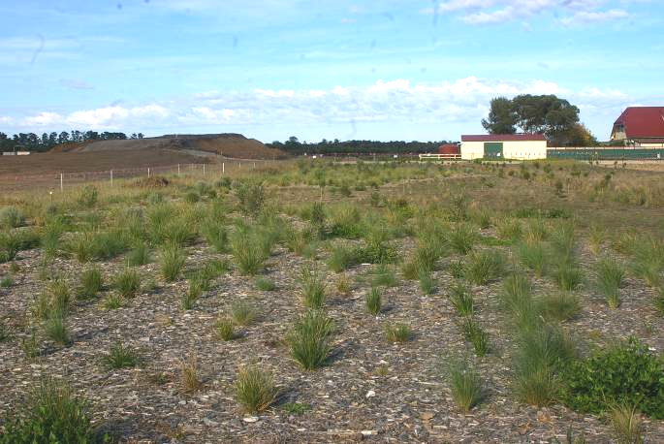

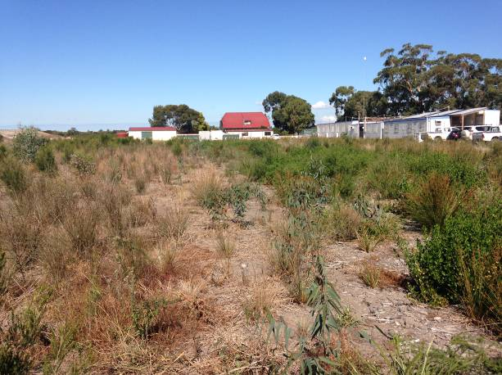
The photos below compare the revegetated habitat corridor of the realignment of McGregor’s Drain with mulch, swamp scrubs and artificial habitat on the north-west side of the bypass alignment, between Manks Road Healesville Koo Wee Rup Road.

Photo taken 2014
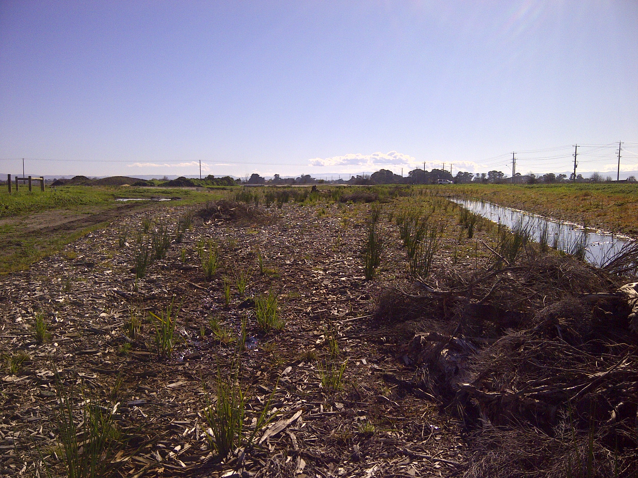

Photo taken 2015
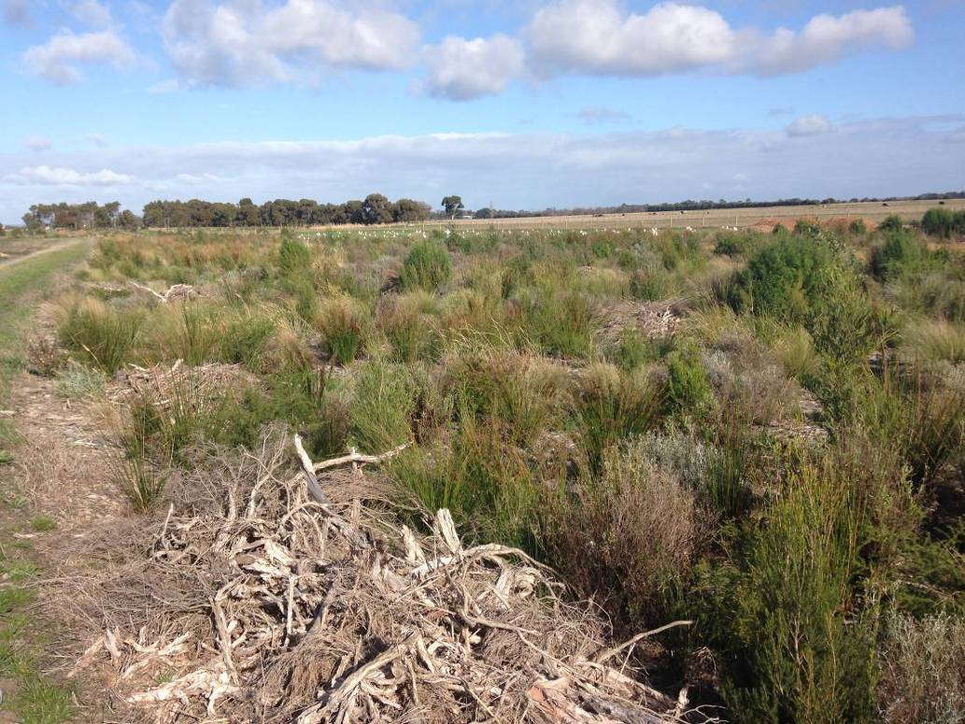
This photo shows the established bandicoot habitat and shelters within McGregor’s Drain revegetation site. Photo M. Legg 2015.

