Victoria’s Bushfire Monitoring, Evaluation and Reporting Framework 2024-2034

We acknowledge and respect Victorian Traditional Owners as the original custodians of Victoria’s land and waters, their unique ability to care for Country and deep spiritual connection to it.

We honour Elders past and present whose knowledge and wisdom have ensured the continuation of culture and traditional practices.

DEECA is committed to genuinely partnering with Victorian Traditional Owners and Victoria’s Aboriginal community to progress their aspirations.

© The State of Victoria Department of Energy, Environment and Climate Action May 2024.

# Creative Commons

This work is licensed under a Creative Commons Attribution 4.0 International licence, visit the Creative Commons website (http://creativecommons.org/licenses/by/4.0/).

You are free to re-use the work under that licence, on the condition that you credit the State of Victoria as author. The licence does not apply to any images, photographs or branding, including the Victorian Coat of Arms, and the Victorian Government and Department logos.

**Printed by smo**

**ISBN** 978-1-76136-529-4 **(pdf/online/MS word)**

# Disclaimer

This publication may be of assistance to you but the State of Victoria and its employees do not guarantee that the publication is without flaw of any kind or is wholly appropriate for your particular purposes and therefore disclaims all liability for any error, loss or other consequence which may arise from you relying on any information in this publication.

# Accessibility

To receive this document in an alternative format, phone the Customer Service Centre on 136 186, email customer.service@delwp.vic.gov.au, or contact National Relay Service on 133 677. Available at DEECA website (www.deeca.vic.gov.au).

# Contents

Definitions 3

Executive summary 6

1. Introduction 8

1.1. Audience 9

1.2. Context 10

2. Scope 13

2.1. Objectives of the Framework 13

2.2. Framework principles 16

2.3. Conceptual model 17

3. Outcomes and intermediate outcomes 19

4. The Framework 22

4.1. Framework overview 22

4.2. Key evaluation questions 23

4.3. Outcome indicators and measures 27

4.4. Reporting 29

4.5. Continuous improvement 29

5. Implementation 30

# Definitions

| **Term** | **What is this?** |
| --- | --- |
| **The Strategy** | Victoria’s Bushfire Management Strategy.  A 10-year, whole-of-sector strategy to guide bushfire management in Victoria in the context of a changing climate, growing population, changing demographics and Aboriginal self-determination and Treaty. |
| **The Framework** | Victoria’s Bushfire Monitoring, Evaluation and Reporting Framework.  A 10-year framework to guide the monitoring evaluation and reporting and improvement of the Strategy. |
| **VBMER Plan** | Victoria’s Bushfire Monitoring, Evaluation and Reporting Plan.  A sector plan to inform implementation of the Framework that provides specific details of how monitoring, evaluation and reporting will be undertaken. |
| **The bushfire management sector (sector)** | The bushfire management sector comprises any entity with a role or function for bushfire management as defined under the State Emergency Management Plan (SEMP).[1] The bushfire management sector includes:   * Country Fire Authority (CFA), including Forest Industry Brigades * Department of Government Services (which includes Local Government Victoria) * Department of Transport and Planning (DoT) * Emergency Management Victoria (EMV) * Emergency Recovery Victoria (ERV) * Fire Rescue Victoria (FRV) * Forest Fire Management Victoria (FFMVic) (comprising the Department of Energy, Environment and Climate Action (DEECA), Melbourne Water, VicForests and Parks Victoria) * Local governments * Regulators (including the Conservation Regulator) * Water authorities.   The bushfire management sector collaborates with various organisations to achieve shared outcomes. This includes Traditional Owners industries and communities. Partnerships with Traditional Owners will evolve over time as Victoria continues to support self-determination and Treaty. |
| **MER** | Monitoring, evaluation and reporting. |
| **Monitoring** | Monitoring is the planned, regular, and continuous collection and analysis of data and other information to track progress of a strategy, program or project. Data and other information gathered by monitoring will contribute to evaluation. |
| **Evaluation** | Evaluation is the planned and periodic collection and assessment of data, which allows a judgement to be made about the appropriateness, effectiveness, efficiency, impact and lessons stemming from a strategy, program or project. Evaluation relies on monitoring data but is supplemented by additional data and information collected at a point in time, for example through interviewing and surveying of stakeholders. |
| **Reporting** | Reporting is the written presentation of monitoring and/or evaluation data findings. This often occurs annually during the life of a strategy, program or project, or at given time points, for example, mid-point evaluation reporting or end of program evaluation reporting.  Annual monitoring reporting involves bringing together all monitoring data collected over a 12-month period. It provides an indication of progress being made and can highlight challenges and opportunities.  Evaluation reporting is more comprehensive and aims to answer the evaluation questions and propose recommendations for improvement at key stages during delivery of a strategy, program or project. |
| **Improvement** | Improvement is the process of taking monitoring and evaluation findings and conclusions and making decisions and changes as needed in response to these. This is intended to improve the strategy, program or project and ensure it is making continued progress towards its intended outcomes. |
| **Strategy domains** | Domains provide a logical structure for grouping-related outcomes, and a line of sight from each outcome to the overall vision. These have been defined in the Strategy and agreed to by the sector. |
| **Strategy outcomes** | Strategy outcomes are high-level, long-term outcomes that are defined in the Strategy and agreed to by the sector. They represent what we as a state are working towards and what success looks like. |
| **Intermediate outcomes** | Intermediate outcomes articulate the change we need to see to achieve the Strategy outcomes. These outcomes have been designed to connect the high-level outcomes and the strategic directions in the Strategy, allowing a deeper understanding of factors that contribute to the strategy outcomes. |
| **Outcome indicators** | Outcome indicators specify what needs to change to achieve a desired outcome and set the direction of change. For example, increase in community knowledge of bushfire management. |
| **Outcome measures** | Outcome measures provide more granular, specific detail about what will change and how we will know if we are making progress. Measures articulate the specific way we know or count the change we want to see. For example, for the above indicator: Percentage of community program participants who stated the program increased their bushfire management knowledge. |
| **Strategic directions** | Strategic directions articulate what we will focus on and ‘do’ to achieve the outcomes articulated in the Strategy, and therefore also the intermediate outcomes. They provide direction and focus for our work and have been agreed to by the sector. |
| **Knowledge** | Knowledge includes facts, information, data and skills acquired through experience, education or research. It can include both the theoretical and practical. For the purposes of the Framework we specifically include the following sources of knowledge:   * Research * Modelling * MER * Local and community knowledge * Expert knowledge * Traditional Owner and cultural knowledge. |

# Executive summary

Victoria’s Bushfire Management Strategy (the Strategy) defines a vision and shared outcomes to guide bushfire management in Victoria for the next 10 years and how all Victorians will work together to progress these outcomes. Victoria’s Bushfire Monitoring, Evaluation and Reporting Framework (the Framework) contained within this document provides high-level guidance for monitoring, evaluation and reporting (MER) on the delivery of the Strategy.

The key objectives of the Framework are to:

* demonstrate the sector’s progress towards the 7 outcomes of the Strategy
* demonstrate sector performance to communities and government
* contribute to the sector’s evidence base for bushfire management
* support decision-making and continuous improvement, including for future investment in the sector.

The Framework provides the foundation for the development of a more detailed MER plan - Victoria’s Bushfire MER Plan (VBMER Plan) – that identifies how monitoring, evaluation and reporting will be led by the sector in partnership with the community. This will include governance arrangements, roles and responsibilities and specific MER actions. The VBMER Plan will be regularly reviewed to adapt to changing circumstances and new knowledge and information.

To achieve the above objectives, the Framework outlines:

* the intended audience and scope of the Framework and the role of the sector in its implementation
* the principles that underpin MER design and delivery
* a conceptual model for MER of the Strategy that links MER to lessons and improvement, and Strategy review and implementation
* intermediate outcomes and proposed preliminary measures that articulate the change we need to see to achieve the higher-level Strategy outcomes
* the 5 focus areas for evaluation: appropriateness, effectiveness, efficiency, outcomes, and lessons and opportunities
* key evaluation questions that will guide the MER activities
* evaluation and reporting timelines and objectives
* mechanisms for MER to inform continuous improvement
* a phased approach to implementation of the Framework to enable the sector to build its capacity and capability to deliver MER over time.

**Figure 1** provides an overview of the key elements of the Framework and how it informs continuous improvement of the Strategy and its implementation. It outlines how the Strategy and Framework provide the outcomes and intermediate outcomes that are the immediate focus of MER in Phase 1 of implementation. These outcomes inform annual tracking of Strategy progress.

In Phase 2, the scope of MER will expand to include 5 evaluation focus areas: appropriateness, effectiveness, efficiency, outcomes and lessons and opportunities. In this phase, MER activities will expand to provide annual reports and periodic evaluations that provide information and evidence to inform decision-making and improvement processes. This is a critical element for informing continuous improvement of the Strategy and its implementation.

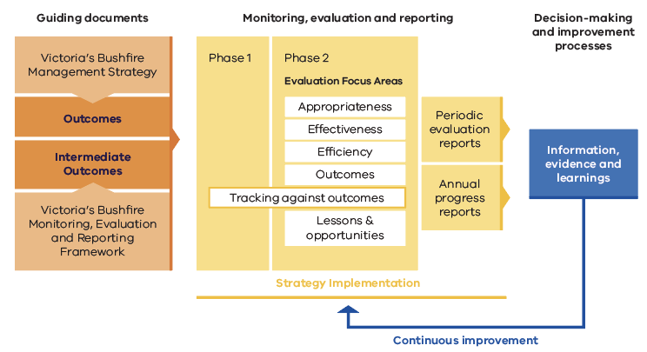

Figure 1. Overview of the key elements of the Framework and how it informs continuous improvement of the Strategy.

# 1. Introduction

MER frameworks and plans define the scope of monitoring and evaluation so that we know what information to collect and when. They establish guidance and processes to help us to understand what is and isn’t working about the strategies, programs and projects we implement, and ensure that what is learnt is used to continually adapt and improve as needed.

This Framework provides a high-level approach to monitor, evaluate and report (MER) on the delivery of the Strategy. The Framework is designed to provide consistent MER guidance over the life of the Strategy (2024-2034) and, as shown in **Figure 2**, will be supported by a more detailed MER plan - Victoria’s Bushfire MER Plan (VBMER Plan). The VBMER Plan will provide specific activity detail for delivering the VBMERF and will be regularly reviewed to ensure it remains relevant and fit for purpose. A VBMERF schedule has been developed as a first step towards the VBMER Plan. It outlines the initial elements and will form the basis for further development.

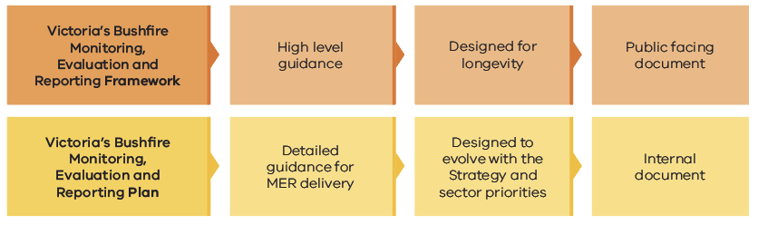

Figure 2. High-level overview of the scope of the Framework and supporting VBMER Plan.

## 1.1. Audience

**Table 1** identifies the various audiences for the Framework including:

* **primary audience**: these are sector partners who will utilise the Framework to guide their work
* **secondary audience**: these are stakeholders or organisations that will benefit from or value understanding the Framework (for example, for the purposes of transparency) but will be less directly involved in delivering MER activities.

**Table 1.** Audiences for the Victorian Bushfire Monitoring, Evaluation and Reporting Framework.

| **Primary audience** | **Intended use** | **Value for audience** |
| --- | --- | --- |
| Government | Accountability | * allows audience to review what government departments and agencies have committed to deliver relating to MER * provides high-level overview of the governance structure for how the Framework will be implemented * facilitates planning and coordination for bushfire management at all levels of government to inform investment. |
| Office of Bushfire Risk Management (OBRM) | Guidance  Accountability | * provides high-level guidance on what will be evaluated (when and how) to support coordination of monitoring and evaluation by the sector * informs delivery of MER, including needs, timing and resource management. |
| Sector partners | Guidance  Accountability | * provides high-level guidance on what will be evaluated (when and how) * reviews and understands the sector’s MER commitments and contribution expectations * informs project and program design, development and evaluation. |
| Victorian communities | General information  Transparency | * provides high level insights and information on what the sector is working towards and how this will be evaluated * holds the government accountable for delivering bushfire management outcomes. |
| **Secondary audience** | **Intended use** | **Value for audience** |
| Stakeholders | General information  Guidance  Transparency | * facilitates an understanding of the effectiveness of bushfire management across the state * provides high level guidance of how to apply MER to bushfire management programs for external groups and organisations. |

## 1.2. Context

The Strategy defines a vision and shared outcomes to guide bushfire management in Victoria for the next 10 years and how all Victorians will work together to progress these outcomes.

It brings the extensive work the sector is already doing together with the work it plans to do over the next 10 years to ensure there is a **shared vision** for what a safer and more resilient Victoria looks like and defines the outcomes we will work toward to realise that shared vision.

**Our shared vision:** Victorians work together to manage bushfire risk for safer communities and healthy ecosystems in a changing climate.

Underpinning the Strategy’s vision are 7 domains with desired outcomes (**Table 2**) that will guide bushfire management in Victoria over the next 10 years. These bushfire-specific outcomes are nested within the Victorian Government’s broader Emergency Management Sector Outcomes Framework[2] and support whole-of-government emergency management outcomes.

**Table 2.** Vision, domains and outcomes of the Strategy.

| **Vision: Victorians work together to manage bushfire risk for safer communities and healthy ecosystems in a changing climate** | | | | | | |
| --- | --- | --- | --- | --- | --- | --- |
| **Domain** | | | | | | |
| **People and community safety** | **Critical infrastructure and economic resilience** | **Aboriginal self-determination in cultural fire and bushfire management** | **Ecosystem resilience and nature conservation** | **Informed decision-making, evidence-based approaches and tools** | **Working together, accountability and shared responsibility** | **Enhanced capability and capacity** |
| **Outcomes** | | | | | | |
| Communities are more resilient to the impacts of bushfires and bushfire management activities | Business, industry and infrastructure are more resilient to the impacts of bushfires and bushfire management activities | The sector supports and enables self-determination of Traditional Owners and Aboriginal Victorians in land and bushfire management | Fire regimes support healthy and resilient ecosystems and nature conservation in a changing climate | Victoria uses the best available science, innovation and knowledge to support evidence-based decisions | The sector, land managers, communities and industry work together effectively and share responsibility for managing bushfire risk across public and private land | Victoria is supported and equipped with the skills, equipment, capability and systems to safely and effectively manage bushfire |

# 2. Scope

**Sector commitment**

In delivering and implementing the Framework the sector commits to:

* work together to implement the Framework and the associated VBMER Plan
* allocate resources to deliver agreed Framework and VBMER Plan responsibilities, noting that this will be commensurate with each organisation’s level of responsibility for bushfire management
* foster transparency by contributing available data and information and providing input in line with the Framework and VBMER Plan
* learn from evaluation findings, including engaging with recommendations, and working to agree to and implement improvements across individual organisations and the whole sector.

## 2.1. Objectives of the Framework

MER objectives articulate why we are doing MER and how the information gathered will be used. This is particularly important in settings where MER is informed by data collected from a wide range of sources and contexts. There are 4 key objectives for the Framework:

* to demonstrate the sector’s progress towards the 7 outcomes of the Strategy
* to demonstrate sector performance to communities and government
* to contribute to the sector’s evidence base for bushfire management
* to support decision making and continuous improvement, including for future investment in the sector.

**Table 3** outlines how these objectives will be achieved by the sector and why these are important.

**Table 3.** Objectives of the Framework.

| **Objectives** | **How will the sector achieve these objectives?** | **Why is this important?** |
| --- | --- | --- |
| **To demonstrate the sector’s progress towards the 7 outcomes of the Strategy** | * collect and analyse data and information in line with the identified indicators and measures to assess progress towards intermediate and Strategy outcomes (through monitoring and evaluation) * report on and sharing progress towards outcomes in line with the Framework. | * this will enable the sector to determine if it is making progress in the desired areas or not, and based on this, clarify where more effort might need to be directed * to enable the sector to understand whether the Strategy has been effective or not and to determine what is working and isn’t working * the sector needs to be accountable to the community about the outcome of investment in bushfire risk management. |
| **To demonstrate sector progress and performance to communities and government** | * collect, analyse and report on data and information in line with the identified evaluation questions, indicators and measures so that progress towards intermediate and strategy outcomes can be assessed * develop appropriate reporting and communication products for different audiences and make them available to the intended audiences i.e. the public, government and the sector * celebrate achievements within the sector and learn from our experiences. | * the sector needs to be accountable to communities and government, and ensure community understands what the sector is doing and the progress being made * to increase transparency of sector progress, investment and efficient use of funding * the sector can see and understand the impact of the work it does and the progress being made * to recognise the efforts of all involved and celebrate successes. |
| **To contribute to the sector’s evidence base for bushfire management** | * collect, analyse and report on data and information in line with the Framework * develop appropriate reporting and communication products for different audiences, and make them available to the intended audiences i.e. the public and the sector * work collaboratively and share learnings and findings across the sector * support the active use of evidence and findings through developing continuous improvement pathways * build the sector’s evaluation capacity to collect and utilise useful and quality data. | * sector activity and investment decisions can be based on current evidence * data and information are available and accessible for use by the sector and others. |
| **To support decision-making, continuous improvement and learning, including for future investment in the sector** | * develop and implement the Framework with cross-sector input and engagement * make evaluation findings available to the sector at all levels * act on recommendations and learnings to continually adapt and improve in line with current priorities * build the sector’s evaluation capacity and use evaluation findings to support decision-making and continuous improvement. | * the sector can change and adapt as needed to achieve intended outcomes and impacts, particularly considering changing contexts and a changing climate. This includes informing any revisions of the Strategy in future * the sector is supported to continue to base decisions on evidence and science, including evaluative evidence. |

## 2.2. Framework principles

The sector has established a set of principles that underpins its approach to MER and articulates what is important to it in how it will deliver MER.

**Framework principles**

Principles establish the foundations of our approach to MER and articulate what is important to the sector in how we will deliver MER. The principles that guide the Framework and underpin the sector’s approach to implementing MER are:

* **Shared responsibility for implementing the Framework**  
  This means that each sector partner will contribute in line with its level of responsibility for bushfire management. While contributions may look different for different departments and agencies, the sector collaborates to ensure progress towards our agreed outcomes and to measure and report on our progress.
* **Flexibility and adaptability in our MER approach**This framework offers the sector guidance for a MER approach and establishes the boundaries for MER. As the sector grows and continues to work and learn together, the MER approach will adapt accordingly in line with best practice. In the first instance it focuses on data and information already available and builds on this steadily over time. Strategy and Framework delivery evolve together.
* **Sharing and using existing data across the sector wherever possible, building data as needed and learning as a sector**While some new data is likely needed to respond to key evaluation questions, the Framework will make use of existing data and information where appropriate and possible. Similarly, where appropriate and possible, any new data collected and collated will be useful for multiple purposes and interrogated at multiple scales. To support this, the Framework will refer to other existing sector monitoring and evaluation, making direct links where possible. This is intended to reduce the burden on the sector and make the most of existing data and resources. Data collated as a part of the Framework will be made available for other uses and needs that the sector may have, independent of the Framework. This will be described in the VBMER Plan.
* **Consideration and recognition of contextual factors that influence the delivery of the** Framework and findings  
  The sector will assess any changing context and/or contextual factors that influence the ability to progress delivery of the Strategy and achieve the outcomes identified. It will analyse and interpret data to document and tell the story in a way that recognises this, together with any unexpected outcomes and external processes which influence outcomes. For example, this may include changes in legislation, policy or government priorities.
* Respect for Traditional Owner and Aboriginal self-determination and working together in a **culturally-safe way**  
  The sector will work with Traditional Owners and Aboriginal communities and groups in a culturally-safe way, which respects self-determination. In doing so, the sector acknowledges that:
* understanding local context and history is essential for working with Traditional Owners and Aboriginal communities and groups
* not all Traditional Owners have the capacity or desire to contribute to fire and land management initiatives, nor to monitoring and evaluation activities
* there is a rich diversity of Traditional Owners and Aboriginal communities and groups across the state, and the sector respects that each community will work in its own way, in its own time.

Further the sector recognises that for some outcomes this may also mean that data collection and data storage approaches, analysis and evidence are different to reflect cultural-safe evaluation practice and use.

## 2.3. Conceptual model

The Framework provides the approach to MER and how this will inform the improvement and implementation of the Strategy. This approach is outlined in **Figure 3**. Further detail of the approach is described in later sections of this document and further defined in the supporting VBMER Plan.

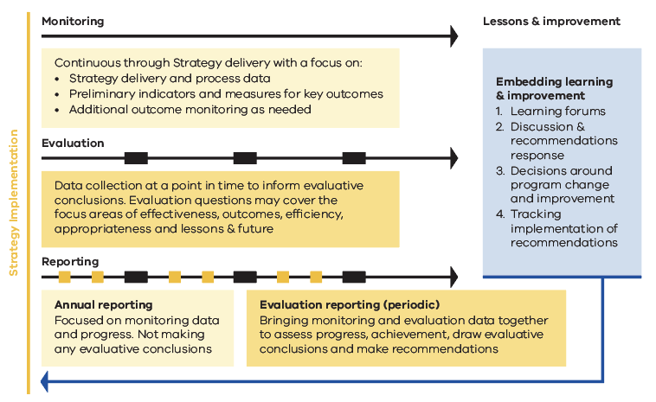

Figure 3. Conceptual model for monitoring, evaluation, reporting and improvement.

The Framework will connect to and draw on existing sector MER activities, but importantly, it will not replace existing sector MER or provide specific sub-program MER (cross-sector or otherwise) – this remains a critical responsibility for designated departments and agencies managing specific bushfire management-related programs and projects.

The Framework is focussed on how the work of the sector comes together as a whole to contribute to, influence and drive the achievement of the outcomes identified in the Strategy. **Figure 4** outlines how the programs and projects delivered by the sector may contribute data and information which – when combined and complemented by data collected specifically for the Framework – enables reporting at the Strategy level. The current programs and projects that contribute to the Strategy outcomes are at varying levels of maturity, with some, but not all programs, having clear MER approaches specified. It is envisaged that this will be an area of focus over the life of the Strategy.

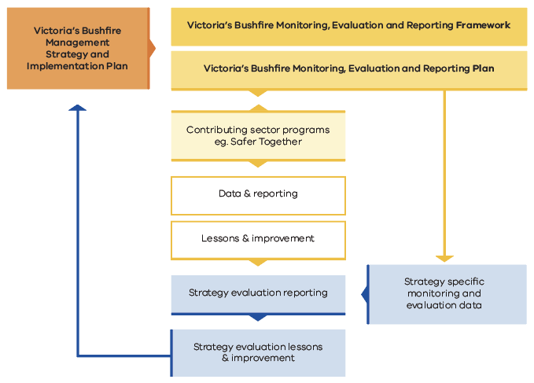

Figure 4. Map of the connection between the Framework and the VBMER Plan, and sector programs that may contribute data to inform progress and achievements in line with the Strategy.

# 3. Outcomes and intermediate outcomes

The Strategy’s 7 high-level outcomes provide useful long-term overarching goals describing what the sector is seeking to achieve. This Framework introduces intermediate outcomes (**Table 4**) to link the high-level Strategy outcomes to measures that can be used to meaningfully track delivery. This is because the Strategy outcomes are long term in nature, so the intermediate outcomes provide a vehicle for assessing progress over time.

Intermediate outcomes help to unpack what the long-term outcomes look like over a shorter reporting period and have been developed to:

* provide a deeper understanding of what contributes to Strategy outcomes
* support development of useful indicators and measures that can be linked back to strategic directions in the Strategy and their contribution to the achievement of strategic outcomes.

It is important to note that the intermediate outcomes developed for the Strategy outcome ‘The sector enables self-determination of Traditional Owners and Aboriginal Victorians in land and bushfire management’ are placeholders only. The intermediate outcomes relating to self-determination will be developed and determined by Victoria’s Traditional Owners.

**Table 4.** Intermediate outcomes aligned to Strategy outcomes.

| **Strategy outcome** | **Intermediate outcome** |
| --- | --- |
| **Communities are more resilient to the impacts of bushfires and bushfire management activities** | 1a) People and communities are empowered to contribute to bushfire management, including mitigation, planning, preparedness, response and recovery in their local area and on their land |
| 1b) The impact of fire on community values is reduceda |
| 1c) People and communities recover in a timely and safe way following bushfire events |
| **Business, industry and infrastructure are more resilient to the impacts of bushfires and bushfire management activities** | 2a) The impact of bushfire and bushfire management on assets and continuity of businesses, industry, critical infrastructure and essential services is reduced |
| 2b) Bushfire management is informed by business and industry knowledge and expertise |
| 2c) Business and industry have the capacity to contribute to bushfire management |
| **The sector supports and enables self-determination of Traditional Owners and Aboriginal Victorians in land and bushfire management** | 3a) The sector works with Traditional Owners and Aboriginal Victorians to enable them to undertake fire management according to their self-determined interests and objectives |
| 3b) The sector has increased cultural competency, pathways and resourcing to work with Traditional Owners and Aboriginal Victorians |
| 3c) The sector provides culturally appropriate support to Traditional Owners and Aboriginal Victorians who are seeking to plan and deliver cultural fire management activities on Country |
| **Fire regimes support healthy and resilient ecosystems and nature conservation in a changing climate** | 4a) Current, up-to-date ecological values inform bushfire management for ecosystem resilience and nature conservation |
| 4b) Bushfire management supports appropriate fire regimes to promote ecosystem resilience |
| 4c) Bushfire management planning and decisions to support ecosystem resilience are based on evidence, knowledge and values |
| **Victoria uses the best available science, innovation and knowledge to support evidence-based decisions** | 5a) Bushfire management planning and decisions are collaborative and based on up-to-date and current evidence, knowledge and valuesa, including that of community and, with consent, Traditional Owners |
| 5b) Bushfire management planning and decisions consider and incorporate future scenarios and predictions, including under climate change |
| 5c) The sector has a shared understanding of the effectiveness of risk-reduction options and directs resources to the most effective actions to reduce bushfire risk |
| **The sector, land managers, communities and industry work together effectively and share responsibility for managing bushfire risk across public and private land** | 6a) The sector and partners collaborate to identify and implement bushfire management that meets their individual and shared responsibilities |
| **Victoria is supported and equipped with the skills, equipment, capability and systems to safely and effectively manage bushfire** | 7a) The sector has the resources it needs, and in the right places to undertake bushfire management |
| 7b) The sector’s workforce and volunteers are healthy, safe and representative of the community they protect |
| 7c) The sector has the capability, tools, systems and processes to work together effectively and uses these to manage bushfire |

1. ‘Values’ includes, but is not limited to, human life, community values, the economy, infrastructure, ecosystems and ecosystem services values.
2. These intermediate outcomes are placeholders only. The final intermediate outcomes relating to self-determination will be developed and determined by Victoria’s Traditional Owners.

# 4. The Framework

## 4.1. Framework overview

The Framework is structured around the 5 MER focus areas of effectiveness, outcomes, efficiency, appropriateness and lessons and opportunities (See **Figure 5**). These MER focus areas will guide sector MER activity, and articulate what knowledge is required to demonstrate Strategy progress and to continuously improve. Each focus area has Key Evaluation Questions (KEQs) to guide MER.

Progress will be reported in 2 ways:

* annual tracking of measures for intermediate outcomes will be reported each year. This will provide a snapshot of the sector’s progress, with a focus on quantitative data.
* evaluation reporting will bring together quantitative and qualitative data, gathered over multiple years, to assess KEQs for each focus area. This allows the sector to identify opportunities for change and improvement. Evaluation reports will include findings from periodic evaluations undertaken during the life of the Strategy and a final evaluation.

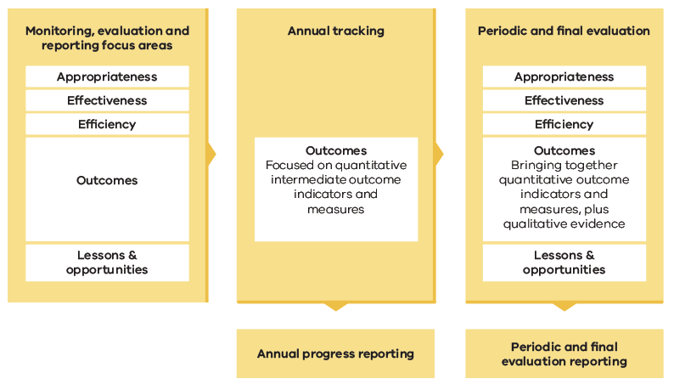

Figure 5. Framework overview and its structure in relation to the five MER focus areas.

## 4.2. Key evaluation questions

The evaluation will be guided by a set of key evaluation questions (KEQs) which has been established in collaboration with sector partners. These questions will establish the primary focus and scope of what is explored through monitoring and evaluation. As shown in **Table 5** below, these KEQs are structured under the 5 MER focus areas.

Not all KEQs will be relevant to all evaluation timepoints. This is indicated in the right columns of **Table 5**. The 3 evaluation time points are:

* **annual tracking:** provides an opportunity for yearly tracking of intermediate outcomes demonstrating progress towards Strategy outcomes.
* **periodic evaluation:** a detailed evaluation process that covers almost all evaluation questions across the focus areas of effectiveness, outcomes, efficiency, appropriateness and lessons and opportunities. The mid-point evaluation is timed to precede the 2029 Strategy review to inform the process.
* **final evaluation:** covers all questions across all focus areas and will be designed to inform the Strategy review scheduled in 2034.

Annual tracking measures for intermediate outcomes will be a key input for responding to all KEQs. Specific to annual reporting is the KEQ 2a outcome. The timing of use of KEQs is also described in **Table 5**.

**Table 5.** Key evaluation questions that will guide the evaluation processes and the evaluation and reporting time point that each question would be asked.

| **Key Evaluation Question** | **Sub-questions** | **Timing** | | |
| --- | --- | --- | --- | --- |
| **Annual tracking** | **Periodic evaluation** | **Final evaluation** |
| **Effectiveness** | | | | |
| **1. To what extent has the Strategy effectively influenced the sector?** | a. What action has been taken towards achieving Strategy outcomes? |  | Y | Y |
| b. To what extent and in what ways has the Strategy influenced:   * What the sector does (together and independently), and * how the sector works? |  | Y | Y |
| c. What cross-sector governance is in place to guide how the sector works in line with the Strategy? How effective has this been? |  | Y | Y |
| d. To what extent and in what ways is the sector working together towards Strategy outcomes? |  | Y | Y |
| **Outcomes** | | | | |
| **2. To what extent has progress been made towards Strategy outcomes?** | a. What progress has been made towards the Strategy intermediate outcomes? | Y | Y | Y |
| b. What, if any, unanticipated positive or negative outcomes have resulted from implementation of the Strategy? |  | Y | Y |
| c. What contextual or environmental factors have influenced and/or impacted progress towards outcomes? (For example, government changes, funding, climate) |  | Y | Y |
| **Efficiency** | | | | |
| **3. To what extent and in what ways has the Strategy increased sector efficiency?** | a. How and in what ways has the sector invested in the Strategy? To what extent has this been sufficient given the intended outcomes? |  | Y | Y |
| b. What evidence is there of efficient and effective prioritisation of actions and work in line with the Strategy? |  | Y | Y |
| c. To what extent has the Strategy supported efficient decision-making as a sector, both collaboratively and as individual organisations? |  | Y | Y |
| d. What evidence is there of efficiency gains through cross-sector collaboration and integration? |  | Y | Y |
| **Appropriateness** | | | | |
| **4. To what extent does the Strategy provide appropriate and useful direction for the sector?** | a. To what extent is the Strategy an appropriate response in line with government priorities, obligations, recent bushfire events and emerging sector requirements? |  | Y | Y |
| b. To what extent has the Strategy met government, stakeholder and community needs and expectations? |  |  | Y |
| c. How has the sector appropriately engaged with and included community and Traditional Owners in the work it does, including activities delivered under the Strategy? |  | Y | Y |
| **Lessons and opportunities** | | | | |
| **What are the lessons and opportunities to improve the Strategy and how it is used by the sector?** | a. To what extent is the data and information being collected through the VBMERF useful to the sector? |  | Y | Y |
| b. What lesson have been learnt in relation to the effectiveness, outcomes, efficiency and appropriateness of the Strategy? |  | Y | Y |
| c. What evidence is there that we are learning and improving because of research and evaluation, specifically in relation to the Strategy and its implementation? |  | Y | Y |
| d. How could implementation of the Strategy be improved to ensure it is effective, efficient, appropriate and the sector continues to make progress towards intended outcomes? |  | Y | Y |
| e. Has our approach to MER improved evaluation capacity and how could data collection, reporting and evaluation be improved going forward to ensure that it is valuable and used by the sector? |  | Y | Y |

## 4.3. Outcome indicators and measures

The outcome indicator model (**Figure 6**) articulates how indicators and measures are used to track progress towards intermediate outcomes. This will provide essential insights on progress and contribute to evaluation of the outcomes focus areas described in **Table 5**. This model aligns with Victorian Government outcomes architecture where indicators and measures are defined as follows:

* **outcome indicators**: specify what needs to change to achieve a desired outcome (in this case, the intermediate outcomes) and sets the direction of change. For example, increase in community knowledge of bushfire management
* **outcome measures**: provide more granular, specific detail about what will change and how we will know if we are making progress. Measures articulate the specific way we know or count the change we want to see. For example, for the outcome indicator ‘Increase in community knowledge of bushfire management,’ one outcome measure could be ‘percentage of community program participants who stated the program increased their bushfire management knowledge.’

To ensure robust conclusions, the sector will draw on multiple indicators and measures to build a picture of outcome progress and achievement. During the initial stages of Framework implementation, preliminary indicators and measures will be used to assess progress. Further indicators and measures will be developed during the implementation of the Strategy to deepen understanding as resources allow.

Preliminary and potential indicators and measures are defined as follows:

* **preliminary indicators and measures** will help measure progress towards intermediate outcomes and represent core data that can be tracked from establishment of the Strategy. Preliminary indicators and measures show progress towards intermediate outcomes using data that is accessible now (Phase 1)
* **potential indicators and measures** will add to the preliminary indicators and measure over time, to enable increasingly robust measurement of progress towards intermediate outcomes. These represent things that are either more complex to collect and collate in a useful and uniform way, or which the sector does not currently collect. These are the indicators and measures that will take more time and investment to deliver (Phase 2).

Additional qualitative evidence will be drawn upon to undertake outcomes evaluation. This may include evidence or information obtained from surveys, interviews and expert opinion.

A VBMERF Schedule has been developed for the sector that:

* provides a list of preliminary indicators and further potential indicators that was identified during the sectors Strategy development process
* presents the preliminary indicators alongside the measures, benchmarks or targets, and data sources for each
* provides a summary of the initial reporting approach which will be strengthened over time as additional indicators and data sources are identified.

This Schedule forms the first step to a full VBMER Plan and supports effective public and internal government evaluation and reporting processes from the commencement of the Strategy and Framework. It will be updated as potential indicators are developed to address gaps, to revise existing preliminary indicators and measures where required, or as evaluation and reporting processes are improved.

Figure 6. Our ability to demonstrate our achievement and progress towards intermediate outcomes

## 4.4. Reporting

Reporting is the written communication of monitoring and evaluation data, findings, and conclusions. There are 2 types of reporting that will occur through the life of the Strategy, guided by the Framework. These are:

* annual progress reporting (intermediate outcome tracking)
* periodic evaluation reporting (frequency to be determined), including end-of-Strategy final evaluation reporting.

Further detail around the purpose, scope, audience and timing of these reports is presented in **Table 6**, with the initial reporting approach included in the VBMERF Schedule.

## 4.5. Continuous improvement

Though reporting and continuous improvement are 2 distinct things they are inextricably linked to each other. By ensuring that these 2 elements are delivered in an integrated and considered way, the sector can ensure their benefits by effectively adapting and improving in response to gathered information and evidence.

To realise the benefit of MER, continuous improvement needs to be embedded into the way the sector delivers. Participatory processes, where the sector is engaged in the process of identifying and acting upon lessons and recommendations, are key.

For the Framework, this will be achieved in 2 ways:

* **embedding collaborative learning opportunities and forums for the sector**These learning forums will be an opportunity for key personnel across the sector to share monitoring and evaluation findings and to discuss what this means for the sector and its work. Whilst the purpose of these forums is to share information and identify improvement opportunities, each may vary based on emerging challenges, opportunities and priorities of the sector
* **establishing decision-making processes and pathways**   
  This is linked to governance and will map responsibilities for taking monitoring and evaluation information and acting upon recommendations.

Table 6. Overview of MER reporting

| **Report Type** | **Purpose & scope** | **Audience** | **Timing** |
| --- | --- | --- | --- |
| **Annual progress reporting** | To provide regular updates on progress towards intermediate outcomes. The focus will be on monitoring and data, and tracking delivery, and less on evaluation – presenting the current ‘state’ rather than reporting on opportunities to learn and improve | Sector  Public | Annual, first version due Dec 2025 |
| **Periodic evaluation reporting** | To evaluate against the defined evaluation focus areas and key evaluation questions, and make recommendations for adaptation and improvement including reprioritisation, focus and investment | Sector  Public | Periodically throughout implementation of the Strategy and aligned with the Strategy review |
| **Final evaluation reporting** | To explore a fuller suite of evaluation questions across the focus areas of effectiveness, outcomes, efficiency, appropriateness, and lessons and opportunities | Sector  Public | Aligned to inform the Strategy final review (2034) |

# 5. Implementation

This Framework is designed to be implemented from ‘Day 1’ with the expectation that over time, the data and information available to track progress and success at achieving outcomes will improve and grow. Over this time, the Strategy will mature and be reviewed – as will the MER approach and the data that is available. This means a phased approach will be the most effective way to support delivery of the Framework.

* **phase 1** (current state) will enable the sector to track progress towards intermediate outcomes using preliminary indicators and measures
* **phase 2** (within 2 years of Strategy commencement) will enable the sector to evaluate against all 5 MER focus areas, including more robust outcome tracking and evaluation through the addition of supporting indicators, measures and associated targets as well as qualitative evidence.

Phase 2 development includes the development of the supporting VBMER Plan, providing further insight and guidance in relation to the overall program logic and assumptions, governance arrangements, roles and responsibilities across the sector, as well as future sector metric and target setting for key activity areas. The VBMER Plan and delivery of Phase 1 MER activities will be coordinated through the OBRM.

1. Emergency Management Victoria (2021a). Victorian State Emergency Management Plan. Emergency Management Victoria, Melbourne, Victoria.
2. Victorian Government (2022). Sector Outcomes Framework Emergency Management. Victorian Government, Melbourne, Victoria.