Remote Inspections Practice Note
About this Better Regulation Victoria practice note
Practice notes are part of a package of guidance that equips regulators to deliver the Towards Best Practice guide. They are produced by Better Regulation Victoria to support regulators to review and improve specific areas of their operations.
This Practice Note assists regulators considering using (or enhancing the use of) virtual or remote inspections (‘remote inspections’), to assess compliance of businesses or other regulated entities (‘duty holders’).

Scope and application
Remote inspections cover a spectrum of uses of technology to enhance or complement traditional, in-person, verification of duty holder compliance. Remote inspections include:
- virtual attendance, by using video calls to duty holders for interviews, to assess straightforward compliance matters, or to alternate in-person and virtual assessments in an inspection program
- information preparation, where regulators engage with duty holders to lodge self-assessments, information or data in advance, to help streamline and target inspection activities and their scope
- remote support, by using video calls to link on-site inspectors to specialists or peer regulators
- using drones to capture imagery, complementing what feasibly be observed in-person.
Where used appropriately, they can improve efficient use of resources and expertise, enhance officer capabilities, promote compliance, and streamline duty holder interactions.
In general, remote inspections can complement and extend on the role of in-person inspections, provided that regulators understand their limitations and risks. This practice note provides a framework for considering remote inspections.

Criteria for using remote inspections
The following criteria can guide decisions about whether to use remote and virtual technology. These are not fixed – changes in technology, social attitudes and regulator circumstances may affect their relevance in each context. Regulators who want to use remote inspections may also want to seek legal advice about their use, including on:
- any administrative law considerations for remote inspections
- any limitations of their powers that may apply to virtual and remote settings
- whether remote inspections would be consistent with their functions and objectives
- any obligations that apply to the collection and storage of digital data.

Virtual and remote inspections may be more suited to circumstances where:
 | Regulators have confidence in duty holder performance, through established interactions and compliance history | 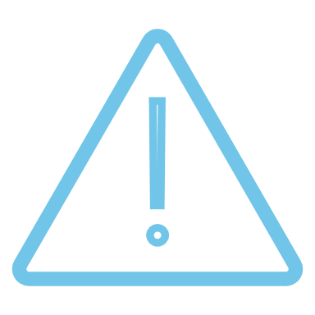 | They can be used for lower-risk assessments, or to increase the effectiveness of routine inspections, and associated non-compliances would not cause significant harm
 | They can help streamline information collection and verification, especially if duty holders are geographically dispersed |  | Compliance assessment is more administrative, or officers do not require detailed insights on on-site activities, or need to rely on intuition, duty holder engagement, or their senses to assess compliance
 | They can provide assurance that is appropriate to their scope and role, to complement the assurance provided by on-site inspection activities |  | Non-compliance cannot be easily and quickly hidden, and any non-compliance detected via remote inspections can be escalated to on-site inspections or other responses
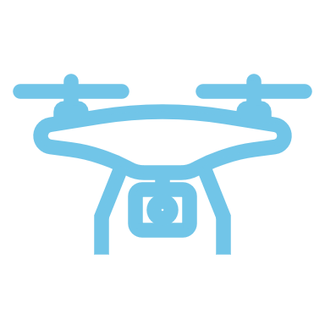 | Appropriate technology is available to support remote inspections and people have the skills and resources to use the technology |  | They can improve the overall inspection program, by complementing, enhancing, or substituting traditional inspections

Framework for considering remote inspections
The following steps guide regulators on whether to adopt remote or virtual inspections, and to identify their potential role within a broader compliance assessment program (e.g. a hybrid of remote and in-person inspections, or virtual enhancement of in-person inspections, across a cohort of duty holders). Note that the culture, circumstances and requirements of the regulator will also impact any decisions.
- Consider your monitoring approaches for different cohorts or activities, and if compliance has the following attributes. If so, remote inspections may have a role.
Risk and Trust | Information Collected | Inspection Details
• Businesses inspected have a good track record of compliance  • Businesses inspected generally do not have an Incentive to be misleading  • There is limited potential for societal harm if businesses are non-compliant | • Critical information isn’t likely to be missed when inspecting remotely  • Purpose is to fill gaps in knowledge or support ability to assess risk/compliance  • A significant proportion of relevant information can be collected and reviewed prior to the inspection | • Non-compliance cannot be easily and quickly hidden, particularly if inspections rely on being un-announced or the ‘element of surprise’  • Your legislative powers are not tied to physical powers of entry  • It is safe for duty holders to use the remote technology
- Consider the technology options available for remote and virtual inspections. Insights on technology and human capability will highlight potential costs and barriers

Tech Capabilities
• Are there technology options that allow you to collect the necessary information from a remote or virtual inspection, and how significant would a technology investment be?
• Do assessing officers and businesses both have the capabilities to perform an inspection using your chosen technology option, and how difficult would a transition be?
- Assess the benefits and costs of moving selected on-site inspections to remote inspections using your chosen technology option
Benefits |   Costs
• Do inspections take less time and/or fewer resources?  • Do inspections provide greater or easier access to regulated parties?  • Does adoption enable more inspections to occur overall, or complement existing efforts?  • Are you able to collect more or better information as a result of the change? | • What are the costs to you for implementing the use of remote and virtual inspections?  • What are the costs to regulated parties?  • Are you able to implement remote/virtual capabilities quickly?
If your assessment suggests that benefits may outweigh costs, move to Step 4.
- Consider the following factors and prepare to make the change
- Any capability gaps (for the regulator and for duty holders) that need to be addressed
- Potential options for technology investment and implementation e.g., pilots
- Experience of other regulators, and potential options for collaborative solutions
- Your policies and legislation and any implications of these for incorporating remote inspections into your compliance monitoring and inspections program
- Digital Victoria technology guidelines (Reuse before Rent before Buy before Build)
- The appropriate mixture of inspection types within your monitoring approach

Developing the use of remote inspections
The following table outlines different approaches to remote inspections and considerations if adopting them, which apply in addition to the general remote inspection criteria.
Use of remote inspections | Description of compliance monitoring activities | Practical considerations
None | Information is largely collected on-site.  Minimal information is provided prior to the inspection. | Can some information be collected remotely prior to the inspection? (e.g., via desktop review, by phone etc).
Basic | Basic information is collected prior to the inspection, but most relevant information is collected via on-site inspection.  Use basic remote audit technologies such as phone audits and pre-audit desktop review. | Can information be collected using existing remote inspection technologies (e.g., mobile phones and online meetings)?  Are officers and businesses comfortable and safe to use the technology?  Do you have the appropriate IT infrastructure such as secure file transfer, file security software, appropriate video technology etc.?
Moderate | A significant proportion of information is collected via desktop review prior to inspection.  Inspections are primarily done using technologies like videoconferencing, but tend to use readily available tools and technologies.  Remote inspections tend to be used to confirm findings from desktop review, rather than detect any new issues. | Do you have appropriate protocols in relation to data security, privacy for information gathered via virtual means etc.?  Do you have appropriate capabilities (e.g., in data analytics?)
Extensive | Information collected remotely is analysed with other information to enable better risk targeting of businesses.  Tailored technologies such as drones or audit-specific tools may be used to collect new information. | Have you set up a monitoring and evaluation framework to assess the effectiveness of on-site vs. remote and virtual inspections?  Are there any opportunities to use technology to collect or analyse information that you could not do previously?  Are there any aspects of your regulatory framework that could be changed with the use of new technology?

