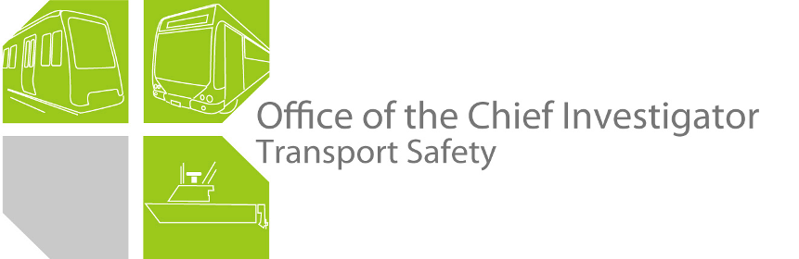

Rail Safety Investigation

Report No 2011/08

Safeworking irregularity and near-miss incident

Australian Rail Track Corporation

Between Seymour and Avenel

25 July 2011

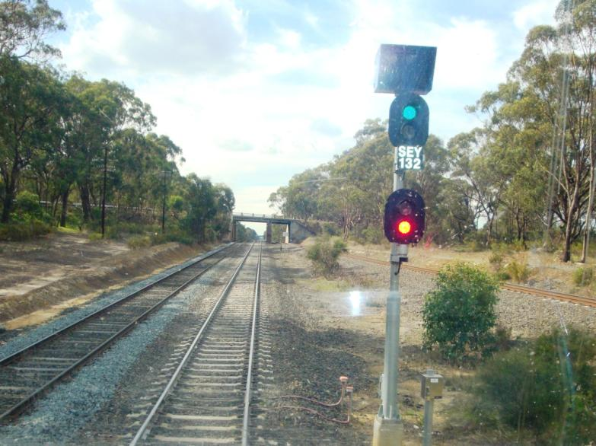

The Chief Investigator 5

Executive Summary 7

1. Circumstances 9

1.1 General 9

1.2 Incident sequence of events 10

2. Factual Information 13

2.1 Background 13

2.2 Network Control operations 14

2.3 The worksite 23

2.4 Personnel 26

2.5 Recorded information 29

3. Analysis 35

3.1 The Incident 35

3.2 Wrong-routing of train 8615 35

3.3 Track Blocking 36

3.4 Protection of track maintenance activity 37

3.5 Communications 38

3.6 Network Control rostering 39

3.7 Error-tolerance of the Phoenix TCS 40

3.8 Clarity of train control diagram 41

4. Conclusions 43

4.1 Findings 43

4.2 Contributing factors 43

5. Safety Actions 45

5.1 Safety Actions taken since the event 45

5.2 Recommended Safety Actions 46

The Chief Investigator

The Chief Investigator, Transport Safety is a statutory position under Part 7 of the *Transport Integration Act 2010*. The objective of the position is to seek to improve transport safety by providing for the independent no-blame investigation of transport safety matters consistent with the vision statement and the transport system objectives.

The primary focus of an investigation is to determine what factors caused the incident, rather than apportion blame for the incident, and to identify issues that may require review, monitoring or further consideration. In conducting investigations, the Chief Investigator will apply the principles of ‘just culture’ and use a methodology based on systemic investigation models.

The Chief Investigator is required to report the results of an investigation to the Minister for Public Transport or the Minister for Ports. However, before submitting the results of an investigation to the Minister, the Chief Investigator must consult in accordance with section 85A of the *Transport (Compliance and Miscellaneous) Act 1983*.

The Chief Investigator is not subject to the direction or control of the Minister in performing or exercising his or her functions or powers, but the Minister may direct the Chief Investigator to investigate a transport safety matter.

Executive Summary

The Australian Rail Track Corporation (ARTC) main line from Melbourne to Seymour is single line. From Seymour north to the Murray River crossing near Albury the corridor consists of two parallel lines  the East and West Lines. Each line is bi-directional, meaning that either can be utilised to run trains in either direction.

Maintenance works had been conducted on the East Line and were in effect on the West Line on 25 July 2011  both works crews protected by exclusive possession of their track. These possessions were protected by the network controller (at the Junee Network Control Centre in NSW) by the application of electronic track Blocking to prevent incursion by rail traffic into the areas of work. Because the works on the East Line were expected to be completed earlier than those on the West Line, the East Line was to be cleared and ready for traffic in time for the passage of the Melbourne-to-Albury V/Line passenger train to run from Seymour to Benalla. The works on the East Line were completed as planned and the applicable track Blocking was removed by the network controller at about 1300.

At about 1335, the network controller, in preparing for the passage of the train, inadvertently set the route from the single line onto the West Line, and cleared the applicable signals.

The train departed Seymour at about 1350, accelerated to track speed and ran for approximately 3.5 kilometres before encountering the track maintenance crew in the process of completing a series of rail welds. The track maintenance crew were able to move to safety, although a vehicle remained on the track, and the train stopped—under emergency braking—about 26 metres from the worksite. There were no injuries to passengers, train crew, or track workers or damage to rolling stock or infrastructure.

The investigation could not determine a specific reason for the network controller’s error but found that there were inadequate system defences to prevent both the controller’s error and the hazardous outcome resulting from it.

Following the incident; the Victorian rail safety regulator (Transport Safety Victoria) imposed restrictive conditions on the use of Track Warrants by the ARTC and issued Safety Alerts to accredited rail operators on the subject of safeworking. The ARTC has taken actions related to the way in which Track Warrants are removed.

This report makes recommendations to the ARTC regarding aspects of their train control system, the use of temporary rail bonds and advice to controllers of parallel lines. A recommendation is also made to the track maintenance contractor, Downer EDI Works[1], related to protection requirements when conducting rail welding.

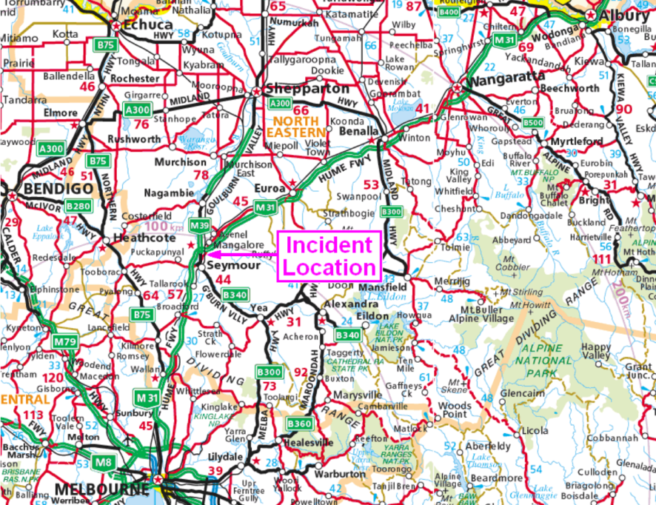

Figure 1 - Incident location map

# Circumstances

## General

On Monday 25 July 2011 at about 1350 V/Line passenger train № 8615 departed Seymour with the route set (and signals cleared) for it to proceed on the West Line towards Albury. After travelling for approximately 3.5 kilometres, the train was running at 74 km/h when it encountered a track maintenance crew with a Hi-Rail[2] vehicle occupying the track. Under emergency braking the passenger train stopped within approximately 250 metres, coming to a stand about 26 metres from the worksite[3]. All track maintenance personnel had moved to safety. There were no injuries among the maintenance staff, train crew, or passengers.

Train 8615 consisted of locomotive N 453 and six cars (comprising car-set SN16 plus power car PCJ492); 284 trailing tonnes and 156.4 metres long. The train’s braking performance, established from data retrieved from its on-board event recorder, was consistent with V/Line’s Standard Emergency Braking specification for locomotive-hauled trains.

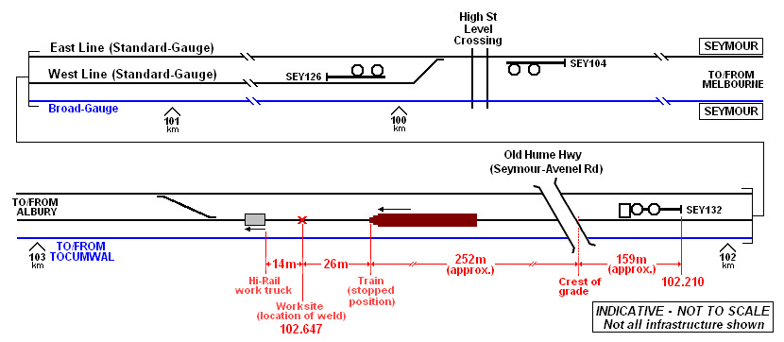

Figure 2 – Indicative diagram of incident site

The maintenance crew was in possession of a current Track Warrant[4] authorising them to occupy the line for maintenance purposes. The work involved the removal of two redundant insulated rail joints by the insertion of OMG sections of rail and the maintenance crew was engaged in preparing the last of four resultant aluminothermic rail welds[5]. At this point in time, this process had left a 25 mm gap in one of the rails. Normally this condition would result in the controlling signal applicable to that track section displaying a Stop indication, however in this instance—as a result of an action taken by the track maintenance crew—the signal was able to be cleared in response to the network controller’s route and signal selection, and it displayed a Proceed indication.

As a consequence of the incident, train 8615 was reversed to Seymour and terminated; the passengers transferring to road coaches.

At the time of the incident the weather at Seymour was fine with a temperature of about 12 degrees Celsius and a north-east breeze of about 7 km/h.

## Incident sequence of events

At 1009 the network controller issued Track Warrant № 7 (to extend until 1500). At 1012:25 he applied a track Block from Down Home Departure signal SEY132 to the 107 kilometre location to protect this Track Warrant.

The immediate actions around this incident then occurred from a point about 2½ hours later and extending over a period of little more than an hour. The timeline below was created by comparing consultant interpretation of data acquired from communications logs, the Phoenix Train Control System, and the locomotive data logger. The sources are not synchronised and the investigation did not reconcile all recorded variances. Thus the timeline is indicative only and does not necessarily represent the instant that an event occurred or an action was taken.

1254 Track maintenance inspector requests permission via radio to conduct a Hi-Rail track patrol on the West Line between Seymour and Benalla from the 109 kilometre location to the 130 kilometre.

1255 Network controller authorises the track patrol from 1255 to 1340 on the West Line. He advises the track inspector of the presence of the welding crew and of their track possession [referring to Track Warrant № 7] and also that he has applied a Block [between the 109 and 130 kilometre locations, for protection of the track inspector].

1300 The Track Warrant for the East Line is Returned (per previous arrangement). Network controller removes track Block from Phoenix TCS.

1335 Network controller sets the route for train 8615 to depart Seymour and enter the West Line.

1338 Track maintenance inspector contacts network controller via radio and advises he is ‘off and clear’ of the West Line.

1339 Network controller removes track Block for Track Warrant № 7 on the West Line.

1348:25 (1350:40 on locomotive data logger) Train 8615 departs Seymour - 14 minutes behind schedule (source: locomotive data logger, location and timescale referenced to GPS)

1351:45 (1354:00 on locomotive data logger) Train brake Emergency application.

The above data indicates that three minutes and 20 seconds has elapsed between the train departing Seymour and arriving at the worksite. The Phoenix TCS replay provided to the investigation shows train 8615 passing signal SEY132 at 13:51:36. If it took 8 seconds to travel the 159 metres from the signal to the crest of the grade beneath the overbridge—the point at which the locomotive crew would have been able to see the worksite ahead of them and make the emergency brake application—then it can be expected that, by the timescale applying to the Phoenix TCS, the emergency brake application would have occurred at around 13:51:44. From this, it is evident that the time displayed by the Phoenix TCS is approximately 2¼ minutes ahead of the GPS time recorded on the locomotive data logger.

1352 Network controller attempts to reinstate Blocking applicable to the Track Warrant on the West Line.

1352 First mobile phone call to network controller followed about four seconds later by an emergency radio call. A two-way conversation ensues.

1352 The above conversation is terminated. A second emergency call is initiated some seven seconds later for a duration of 26 seconds. These two calls were effectively logged by the system as a single ‘session’.

1358: Network controller reinstates the Blocking applicable to the Track Warrant on the West Line.

# Factual Information

## Background

### General

The standard-gauge line between Melbourne and Sydney is part of the Defined Interstate Rail Network (DIRN). Between Melbourne and Seymour, VIC, it is a bi-directional single line and from Seymour to the Murray River bridge near Albury, NSW, it consists of two parallel bi-directional lines.

The West Line—previously broad-gauge—was converted to standard-gauge as part of the South Improvement Alliance[6] Sydney-to-Melbourne upgrade project. This line, commencing just north of Seymour, was reopened for traffic during September 2010 and V/Line passenger services between Seymour and Albury were resumed in June 2011. The broad-gauge Seymour-to-Tocumwal line, operated by V/Line under Train Order safeworking rules, parallels the standard-gauge West Line as far as Mangalore.

This standard-gauge route in Victoria is managed by the ARTC[7] under a long-term lease arrangement. In 2007 the ARTC embarked on a major investment programme to upgrade the track between Melbourne and Sydney that included the replacement of existing timber and steel sleepers with new concrete sleepers.

The maximum allowable line speed between Melbourne and Albury is 130 km/h and the maximum authorised line speed for a locomotive-hauled passenger train is 115 km/h, however a month prior to this incident V/Line had imposed their own speed restriction of 80 km/h. This was due to concern regarding the physical state of the track resulting from mud holes, and the rough ride imposed upon locomotives and passenger cars.

The Australian Transport Safety Bureau commenced a systemic investigation into the interstate rail track managed by the ARTC between Melbourne and Sydney in August 2011[8].

### Train Operations

Rail movements are conducted under the rules contained in ARTC document TA20[9], Section 17 Centralised Traffic Control System, which ensure train separation by signal indications. In order to facilitate maintenance activities the ARTC has a suite of supplementary rules within TA20 to provide protection against rail traffic entering into an active maintenance worksite. The levels of protection are:

* Absolute Occupation. No rail traffic is generally permitted apart from work trains.
* Track Force Protection. This level of protection is provided by hand-signallers (flags) and the use of Audible Track Warning Signals (ATWSs)[10]. It allows for both train movements and maintenance activities to occur on the same section of track.
* *Track Warrant working* (see section 2.2.3). Trains are excluded from the track section or portion of track section to which the Track Warrant applies.

Since the resumption of passenger train services it has been the practice of ARTC Network Control to run them on the left-hand track (in the direction of travel). This provides a practical advantage for the network controller insofar as there may be a requirement to run following trains[11].

Although the Sydney–Melbourne upgrade project included the installation of bi-directional signalling to both standard-gauge tracks between Seymour and Albury, running on the left-hand track provides more signal sections and thus the opportunity for following trains to run more closely-spaced than does bi-directional running (using the right-hand track in the direction of travel). For this reason, trains are routinely operated on the left-hand track in either direction. The tracks are designated the East and West Lines and this nomenclature applies regardless of the direction of travel.

## Network Control operations

### Network controllers[12]

The responsibilities of ARTC network controllers are outlined in their Position Description document.

Figure 3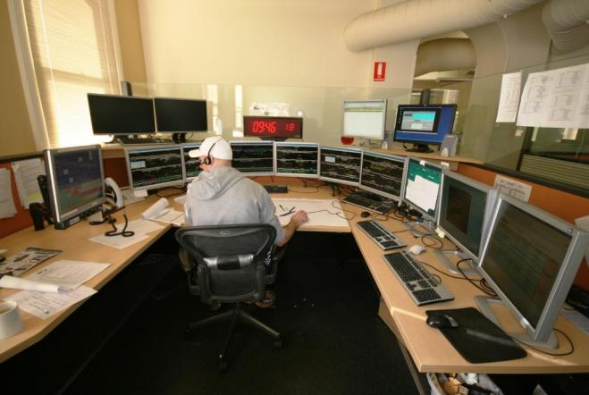 - Junee Network Control workstation, Main South ‘C’ Board

Their primary responsibility is to manage train paths for the safe and efficient transit of rail traffic by planning, setting priorities, and managing train services, and to manage on-track authorities. Network controllers are also required to compile and maintain relevant records—such as train control diagrams—and reports about conditions and movements on the network.

Network controllers in Junee operate from workstations known as ‘control boards’. These are assigned geographically and in some instances, according to rules, jurisdictions and traffic density. The workstations include a semi-circular array of six contiguous computer monitors that display the status of infrastructure including signals, points and track circuits. Communication between network controllers and both train crew and field personnel is via train-to-base radio and mobile telephones as required.

### Train control system

The *Phoenix TD Pro* micro-processor-based desktop Traffic Control System supplied by Union Switch & Signal (now Ansaldo STS) and used by the ARTC at their Junee Network Control Centre is a ‘non-vital’[13] system providing Centralised Traffic Control (CTC)[14] of the ARTC corridor between Melbourne and Sydney. This is a ‘point-and-click’ GUI-based system[15], a feature of which provides for the network controller to apply protective Blocking to various objects on the display map to prevent those objects from being controlled[16]. This includes the ability to reserve a section of track for non-train operational requirements such as maintenance activities. This protection can be applied in association with various forms of safeworking authority.

Blocking commands are operationally in force as soon as the on-screen Blocking form is completed. Information for this form must be entered manually via the keyboard and must contain the name of the person receiving the authorisation for the Block together with the Block limits.

### Track Warrant protection

A Track Warrant is an exclusive track occupancy authority. A paper-based instrument, it is used to protect personnel engaged on unplanned track infrastructure maintenance and repair activities. Track Warrants are issued by the network controller to the site supervisor upon the request of the site supervisor as the authority for works personnel to occupy or be close to a main line. A worksite protected by Track Warrant is not protected by use of ATWSs or handsignals, and joint occupancy with trains is not permitted. When the protection is no longer required by the site supervisor (or by prior arrangement, in order to permit the passage of a train) the Track Warrant is relinquished by ‘Returning’ (fulfilling) it verbally, by radio or phone to the network nontroller.

#### Working rules – TA20, Section 15, Rule 21

Track Warrants may be issued for infrastructure activities;

* that require the track to be broken
* where one or more track vehicles or track machines are used
* where mechanical plant or machinery is to be used within two metres of the line.

Track Warrants are numbered consecutively by the network controller commencing with № 1 at 0001 each day and all works are required to be arranged such that the Track Warrant must be Returned to the network controller at least 20 minutes prior to the scheduled arrival of a train at either end of the affected section of line.

Part (a) provides that where a parallel line is adjacent to the works and those works will or could impinge upon a safe clearance distance from that line, the parallel line must be protected by an additional Track Warrant, hand signallers or the booking out-of-use of that track. In all cases the network controller responsible for the adjacent section of parallel line must be advised of the infrastructure work activities even if safe clearance distances for that parallel line will not be obstructed.

Part (b) of the same Rule prescribes the duties of the track supervisor and train controller [network controller] regarding the issue of a Track Warrant. However, nowhere does the Rule actually state whose responsibility it is to advise the train controller responsible for the parallel line.

Prior to issuing a Track Warrant for infrastructure works the network controller must ensure that:

* there is no rail traffic between the requested Track Warrant limits
* the track force supervisor is provided with all relevant train-running information
* all rail traffic is excluded from the section of line where the Track Warrant is in force.

In CTC territory the fixed signals governing the entrance into the section must be secured at Stop by the network controller’s placement of a Blocking command over the applicable section until the Track Warrant is Returned. The instructions on the Track Warrant must be read back by the track supervisor. The Track Warrant number, operational limits (together with name of the holder) and contact details are recorded on the train control diagram[17] (See Figure 3).

When a site supervisor is Returning a Track Warrant, the network controller is to confirm that the line is clear and verify correct receipt by having the instructions on the Track Warrant repeated back by the site supervisor. Part (b) also stipulates that the network controller is required to then ‘*... suitably endorse the Train Graph* [Train Control Diagram] *to reflect the return of the Track Warrant.*’

### Network controller’s work practices

The following process was used by network controllers for the Issue and Return of Track Warrants. This practice was observed by investigators several days after the incident. The process is not formally documented in ARTC Network Control system procedures. ARTC have advised that the process is ‘...included in the training packages of network controllers’.

*Sequence to Issue a Track Warrant.*

1. A paper pro-forma (in the Track Warrant book) is completed per TA20.
2. The train control diagram is endorsed with details of the Track Warrant (for example; location, time, plus name and phone number of field contact).

*Sequence to apply a Block:*

1. An electronic Block is applied to the computerised train control system using the following on-screen mouse actions;

##### Click the Toolbox ‘BLOCK’ button.

##### Picture of block button

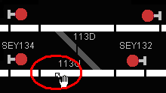

##### Click screen to select limits of track section requiring to be Blocked.

##### Select ‘Simple Block’ option. Complete the on-screen form.

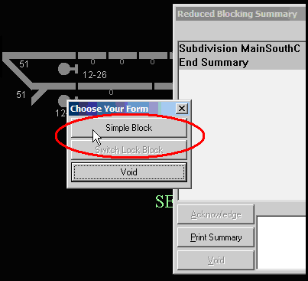

##### Picture of the next screen in the process to issue a track warrantClick ‘Place’ if satisfied with contents of on-screen form

(e) Click ‘Place’ again to Issue the Block.

The activities at step 3 were observed to be completed in rapid succession by the network controller.

*Sequence to Return a Track Warrant:*

1. A paper pro-forma (Track Warrant book) is completed per TA20.
2. The train control diagram is endorsed with details of time-of-Return.

*Sequence to remove the Block:*

1. The electronic Block is removed (if not shared with other issued Track Warrants).

##### Click the Toolbox ‘REMOVE’ button

* 1. Click one of the limits of the Blocked section (Blocking Summary appears)
  2. Selection of relevant Block from drop-down menu (multiple entries will be displayed if multiple blocks have been applied)
  3. Click ‘Edit/View’ button
  4. Click ‘REMOVE’ button (confirm the identity of the operator whose Block is being removed)
  5. Click ‘REMOVE’ again to confirm and delete the Block
  6. Click ‘Close Summary’ button.

The activities at step 3 were also observed to be completed in rapid succession by the network controller.

Thus, the network controller has three references to coordinate when dealing with Track Warrants; a Track Warrant book, the Phoenix computer screen, and the train control diagram.

When Returning Track Warrants the integrity of this vital process hinges upon the vigilance of the network controller in consulting and cross-referencing the paper records with the computer screen display. The train control diagram is maintained manually by the network controller. It is not an electronic document and there is no automatic mechanism by which its functionality is referenced to whatever actions the network controller may take with operating the Phoenix Train Control System.

The Track Warrant form includes a portion upon which the details of its Return are recorded. All Network Control copies of Track Warrants reside sequentially as pages of the book and are only accessible for reference by looking back through the book. Network controllers must record the presence of a Track Warrant on the train control diagram (by depicting its time limits) but they do not endorse the diagram with details of its on-going status; that is to say, by recording the Return of the Track Warrant.

Figure 4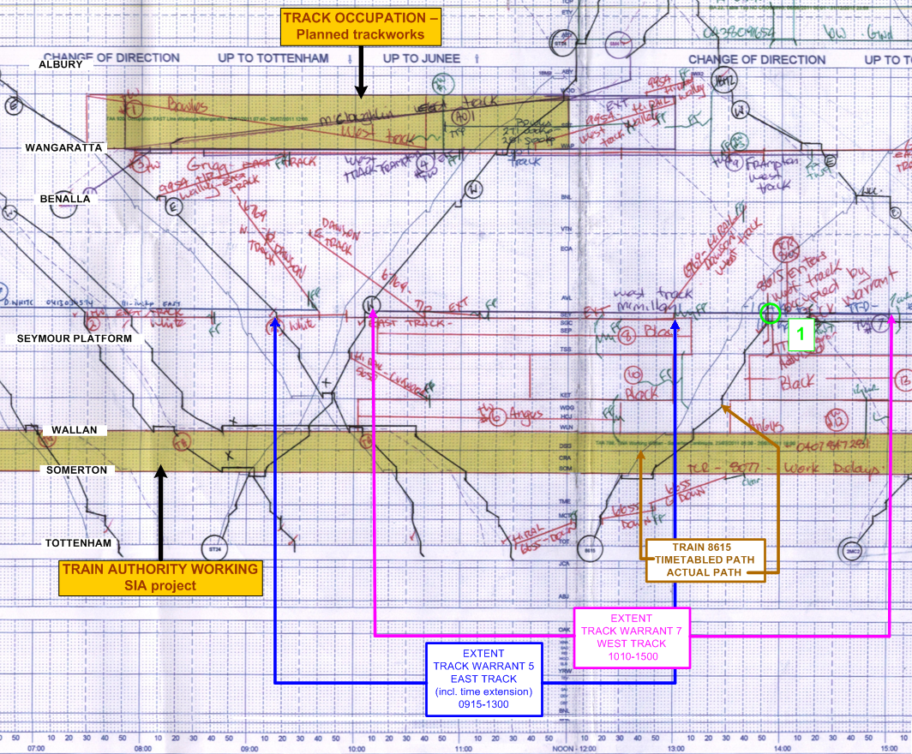 - Copy of a portion of the train control diagram, ARTC Network Control Office, Junee – Monday 25 July 2011 (includes added interpretive remarks). The position labelled as 1 indicates the incident.

*Parallel lines*

The ARTC Code of Practice (document TA20) specifies—with regard to the protection of parallel lines of railway—that where works will or could impinge-upon the parallel line, that the line must be protected by the Issue of an additional Track Warrant for that line or by the implementation of Track Force Protection in accordance with Rules 3 (country) or 4 (suburban) regions as appropriate. For country regions, the occasions where track force protection is required include:

* where any on-track machine carrying work persons and/or material is involved, and
* where any rail being taken out or relaying operations is commencing.

Track Force Protection also provides for the placement of inner and outer flagpersons  the latter not less than 2,000 metres from the worksite and using ATWSs.

In this incident the parallel line was a V/Line broad-gauge main line. Due to the close proximity of the broad-gauge to the West Line (upon which the work was being conducted), the broad-gauge lay within the Danger Zone[18] applicable to the West Line (see Figure 6).

ARTC’s Incident Management Manual (Document TA44), section 4.6 Parallel Rail Lines, requires that in the event of any incident on the above corridor [Tottenham to Junee] immediate action must be taken to warn the network control centre for the location(s), and advice provided regarding all approaching trains. The investigation has found no evidence that this was done.

Both of the instances described above were relevant to this worksite however Centrol (V/Line Train Control – in this case the applicable network control centre), was not advised of the presence of the work crew and the task being undertaken or of the incident having occurred.

### Computerised train control systems in other states

Enquiries were made of the current practice by other agencies with similar computerised control systems. Apart from Queensland, the use of these systems does not vary significantly from that used by the ARTC at Junee.

Both Queensland Rail and QR National provide, maintain and manage access to extensive intra-state rail networks and associated infrastructure. Their control centres manage their networks using a computerised train control program created with proprietary software. To provide the authority for personnel to have exclusive track occupancy, this system utilises a version of the ANRP[19] Track Occupancy Authority (TOA) that is similar to a Victorian Track Warrant but which, under certain circumstances, provides for in-field protection (that is to say, flags and ATWSs).

However, this Queensland program has some software safeguards that prevent the train controller from inadvertently removing a track Block. After the Issue of a TOA has been agreed between the train controller and the protection officer the train controller places electronic Blocking on the track to be occupied. This action presents a randomly-generated set of codes that have to be verbally provided to the protection officer in the field. The protection officer records these and repeats them back. The train controller does not retain a copy of the codes, and once they are accepted the train controller cannot remove the Blocking until the codes have been verbally given back and entered into the system. This manages the risk of the train controller inadvertently removing the Blocking.

The TOA itself is not represented on the QR train controller’s computer monitor; however the particular reason for the TOA having been applied is denoted by colour-coding of the Block.

Should a train controller attempt—subsequent to placing a track Block in protection of a TOA—to then lift that Block while the TOA remains active, an audible alarm will sound to alert the train controller and the resolution procedure requires the intervention of train control supervision.

## The worksite

### Infrastructure

There are three parallel lines in the area of this worksite; the two standard-gauge lines managed by the ARTC and a broad-gauge line managed by V/Line. The ARTC train control system map display in Junee does not reference this adjacent V/line broad-gauge line. The approach by train 8615 to the worksite was over a crest beneath the Seymour-to-Avenel road overbridge (See Figures 5 and 6).

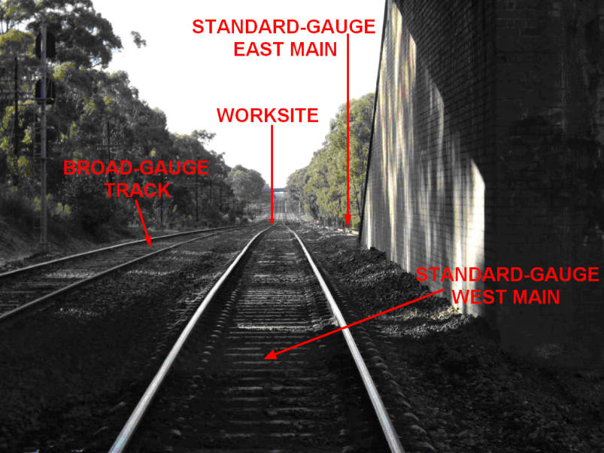

Figure 5 - View along the West Line from the Seymour-Avenel overbridge towards the work site

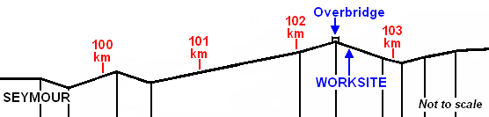

Figure 6 - Track gradient profile – indicative only

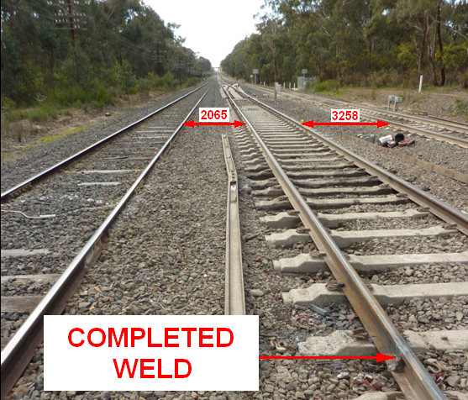

Figure 7 - Track spacing (millimetres) between the broad-gauge and West Line and between East and West Lines. Note also discarded crippled rail sections (both sides of track) removed from location of mud hole.

### Track maintenance activities

On 25 July 2011, track maintenance activities were being undertaken between Seymour and Avenel on both the East and West ARTC lines. These activities were unrelated to each other and involved two companies, one of which was Downer EDI Works. Worksite protection on each line was provided by Track Warrant.

Downer EDI Works was engaged in the elimination of redundant and damaged insulated rail joints (by removing a section of rail to each side of the joints and installing replacement sections that were then welded to produce continuous rail) at the 102.647 kilometre location on the West Line. These joints had deteriorated to the extent that the rail had become vertically ‘crippled’[20], necessitating its removal as well as several metres of rail either side of the joints. The sections of rail removed were about 11 metres long and their replacement required two individual welds on each rail. Track Warrant № 7 had been Issued to protect the works crew. This crew comprised four people including the track supervisor who was also functioning as the protection officer. The work being conducted was a task that had not been completed as scheduled under a previous work order.

At the time of the incident there was one thermic weld to be completed, leaving a gap of about 25 mm in the left-hand rail (Down direction[21]). Due to the relative proximity—about 2.8 kilometre distant—of the High Street level crossing in Seymour, the works crew had applied a temporary rail bond across the rail gap to maintain the integrity of the track circuitry. This action was to prevent what would otherwise have been the continuous operation of the High Street level crossing protection (booms and flashing lights) during the works. This artificial preservation of the track circuit integrity meant that the activities of the welding crew went undetected and unprotected by the signalling system.

At 1300, in preparation for the passage of train 8615, Track Warrant protection for the East Line (Track Warrant № 5) was Returned to the network controller as required.

### Worksite protection

Downer EDI Works are the ARTC’s network track maintenance contractor. Their Job Safety Analysis Worksheet for in-field rail welding specifies that worksite protection will include the use of ATWSs and flags. The worksheet specifies that the site supervisor will obtain the times of expected train movements and ‘permission to occupy track’ (in this case, such information being sourced from the network controller).

The Worksite Protection Plan completed for this site by the protection officer identified designated safe areas for the work crew to seek refuge should it be required. These were the road vehicle access tracks on both sides of the worksite. This plan required maintenance crew members to cross the standard-gauge East Line if moving to the east to clear the site or across the broad-gauge Goulburn Valley (Tocumwal) Line if moving to the west. Both of these were active running lines. The provision for using Track Warrant protection was not incorporated in the Worksite Protection Plan.

The Pre-Work Brief completed for the worksite by the protection officer identified the passage of trains as a high-risk hazard with the use of a Track Warrant being the safety control. As provided-for under TA20 a worksite protected by Track Warrant does not require to be protected by use of ATWSs or handsignals.

### Use of temporary rail bonding

The ARTC informed the investigation that although an Engineering Standard for the use of temporary rail bonds existed for their New South Wales network, there was no such standard in place for the Victorian segment. It would appear that the use of temporary rail bonds by track maintenance personnel in Victoria has become a customary work practice based on one developed (but undocumented) in the 1990s. This method of ensuring the continuity of signalling system circuits during disruptive track works was particularly common when working under Track Force Protection, which retained normal signalling functionality and employed ‘flag protection’ against the movement of trains through the worksite.

## Personnel

### Network controller

The network controller commenced with the ARTC on 10th September 2006 as a Network Controller Level 2, undergoing incremental assessments. He had attained the position of Acting Train Transit Manager (TTM - the Network Control Centre supervisory position) at Junee and was about to receive a permanent promotion to the position of TTM.

Prior to his employment by the ARTC he had been a signaller at Harden, about 90 kilometres north of Junee and from where he now commuted – about an hour’s drive. He had successfully completed the Phoenix Operator Training Course conducted by the system supplier, in January 2007. His last assessment in the ARTC Victorian Safeworking Rules and Procedures was conducted by the ARTC’s safeworking training provider on 7 April 2011.

In interview, the network controller informed the investigation that his shift on this day was no different to many others when managing the entire territory between Junee and Somerton. He stated that the dayshift activities are predominantly related to managing worksite protection, train running information enquiries and network access requests.

Rail traffic, as usual, was light. The network controller did not report having been distracted or being absent for any length of time from the workstation. When speaking with the West Line worksite supervisor early in his shift, the network controller was made aware that welding activities were being conducted, however there was no mention of the use of a temporary rail bonding cable and the effect this would have on signalling and the High Street level crossing protection system at Seymour.

The network controller issued Track Warrant № 5 for the East Line extending from signal SEY112 to signal SEY116 at 0916 through to 0955. Its time was later extended to 1300. It was the controller’s intention to dispatch train 8615 via the East Line. At about 1012, Track Warrant № 7 for the West Line was Issued, extending from signal SEY132 through to the 107 kilometre location from 1010 to 1500. The network controller stated that it is common practice for multiple Track Warrants to be Issued for both the East and West Lines.

At 1254 the network controller received a request from a track inspector to conduct a Hi-Rail inspection between Seymour and Benalla from the 109 kilometre to the 130 kilometre location. At 1255 the controller authorised this activity, advising the track inspector that *“...Blocks are on...”* [from the 109 kilometre to the 130 kilometre location] to extend from 1255 to 1340. A Train Control Incident Report (CTC110725SeymourSafeworkingIrreg.doc, 05/08/11) however, listing all Blocks around the Seymour area placed by the network controller Desk 2 (Main South C) between 0700 and 1600 on the day of the incident does not show that this Block was applied.

The network controller commented that since the re-introduction of V/Line passenger services beyond Seymour on the new dual-line standard-gauge track it has been normal practice to route Albury-bound services via the West Line. On this day, train 8615 was running to a modified schedule due to a track infrastructure project north of Melbourne.

At 1300 Track Warrant № 5 was Returned and its Block lifted. At about 1338 the Block on the West Line was inadvertently removed—with Track Warrant № 7 still in effect—and the route cleared for train 8615 to proceed onto and along the West Line.

In his report of the incident, the network controller stated that, *“At the same time of realising my mistake, the protection officer* [site supervisor working under Track Warrant № 7] *contacted me and informed me that 8615 had entered the Track Warrant limits.”* However, the network controller has since advised the investigation that he did not become aware of his mistake until contacted by the protection officer in the field.

Post-incident drug and alcohol tests were conducted on the network controller with neither being detected. The network controller was relieved of duties on Victorian control boards, provided with remedial training and re-assessed in the Victorian operating rules. He was then permitted to return to work operating non-Victorian control territories.

*Rostering*

The investigation was informed that at the time this incident occurred the Junee Network Control Centre was short of its staffing complement by some three people and that recruitment of five people was currently underway. As a result, the network controller had worked extra shifts to cover vacancies. On the day of the incident, the controller was scheduled to complete his dayshift as Network Controller at 1500 and stated at interview that he was scheduled to resume as Acting Train Transit Manager at 2300 that evening.

Details of the network controller’s roster leading-up to this incident were requested from the ARTC and supplied as follows;

Figure 8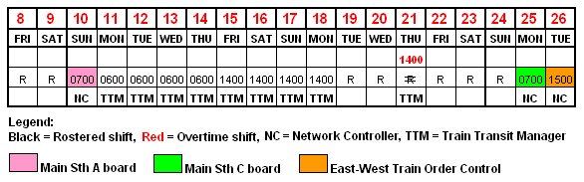 – Network controller's roster

This roster does not reflect that the network controller was scheduled to restart that evening at 2300.

### Train crew report

The two locomotive drivers were supplemented on this day by an instructor driver. The crew reported having departed Seymour and being signalled via a ‘clear for medium-speed’ signal indication onto the West Main Line. The train was accelerated to the temporary track speed of 80 km/h. Home signal SEY132 located at the 102.210 kilometre location was displaying a ‘clear for normal speed’ indication, but only 160 metres beyond the signal the train crested the grade and the locomotive crew sighted the track maintenance crew working on the track ahead.

The driver sounded the horn, made an emergency air brake application, and pressed the train-to-base radio Emergency Call button. This latter action alerted the Junee network controller to an emergency radio call (the system promotes an emergency call to the head of the radio call queue). The train stopped 26 metres short of the work site, where the applicable rail was only temporarily fastened to the sleepers in order to facilitate the welding process.

### Track supervisor

As the supervisor of the track maintenance crew, this person was also the site supervisor on the day as well as having assumed the role of protection officer for arranging and managing safeworking aspects of the project.

The track supervisor had 25 years experience of rail track maintenance and was qualified to perform track force protection duties. He reported that on the day of the incident he developed a Worksite Protection Plan and conducted a Pre-Work Brief prior to the commencement of work. Once in possession of Track Warrant № 7 the maintenance crew went on track and commenced work in the belief that they were protected from any train movements. They were expecting the Albury-bound passenger train to pass their worksite on the East Line at about 1330.

At about 1350 they heard the train’s horn sound in the distance and could clearly hear it approaching, however they were not expecting to see it appear on the West Line when it crested the grade beneath the nearby road overbridge. The site supervisor exhibited a Stop hand signal and moved to intercept the train while the maintenance crew abandoned their work and moved across the adjacent broad-gauge line to a vehicle access track; one of their designated safety areas. The supervisor immediately advised the network controller of the incident by mobile phone.

Although there is a requirement under Section 15 of TA20 that the network control office of a parallel line (in this case V/Line’s *Centrol*) be advised of infrastructure works that might potentially affect that parallel line, this had not been done. The rule does not prescribe whether it is the track supervisor or the network controller who is to provide this advice, and in this instance, the track supervisor was of the view that it was not his responsibility.

## Recorded information

### Phoenix Train Control System presentation screens

The following series of screen shots depict the system map across the incident location, and indicate the manner in which its status is presented to the network controller. A series of flat-screen monitors at the controller’s workstation convey the extent of the area under control. The images shown here depict the display presented on one of these six monitors.

Figures 9 through 17 provide the graphic representation of the network controller’s actions and the sequence of events leading to the event. The series of images provides a comparison between the network controller’s actions and the status displays available to him as he carried out those actions.

‘White’ track is unoccupied, ‘green’ track represents a cleared route set up by the network controller (track sections are arrowed to show direction of travel), and ‘blue’ track represents the extent of Blocking currently applied (in the instances shown here, for Track Warrants). Grey track is ‘unavailable’ where the lay of points prevents access. The notations in yellow have been added. Note: the parallel broad-gauge track is not depicted on these screens.

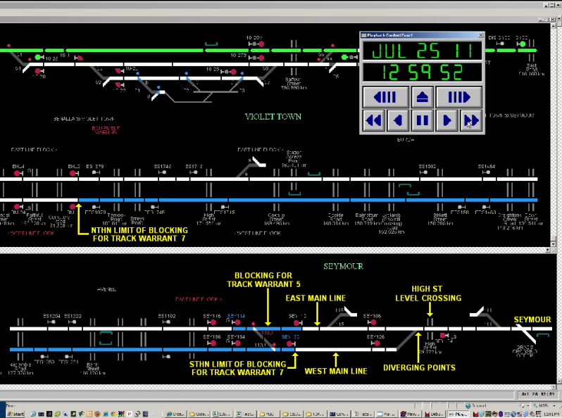

Figure 9 – This image shows the system at about 1300 hrs

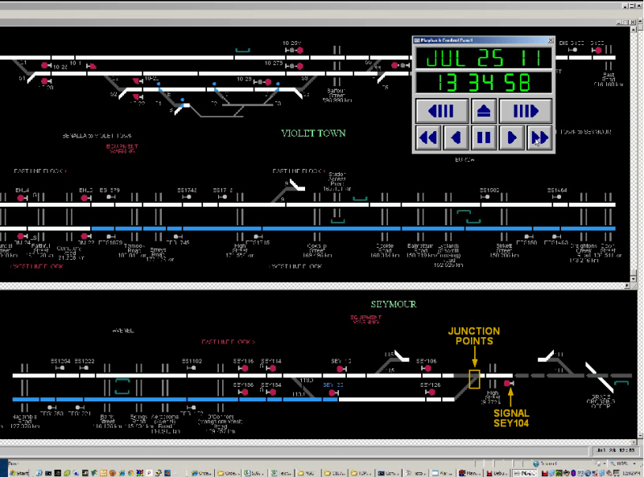Figure 10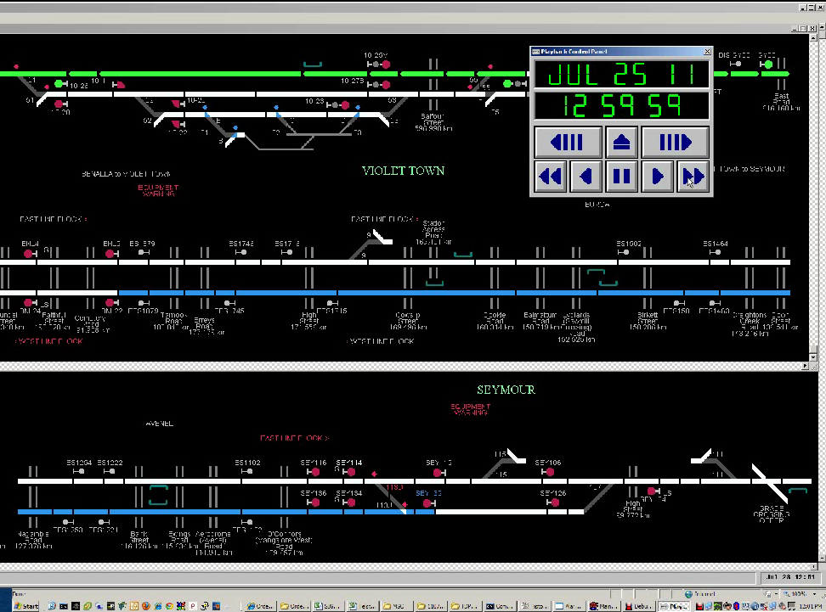 – This image shows that the Blocking applied to the East Line has been lifted (consequent to the Return of Track Warrant № 5) while the Blocking on the West Line remains in force to protect Track Warrant № 7. At this time, the track settings provide the intended route (not cleared) from Seymour directly onto the East Line.

Figure 11 – The network controller has placed a call on the mainline junction points (to set them for the West Line) and to ‘clear’ signal SEY104.

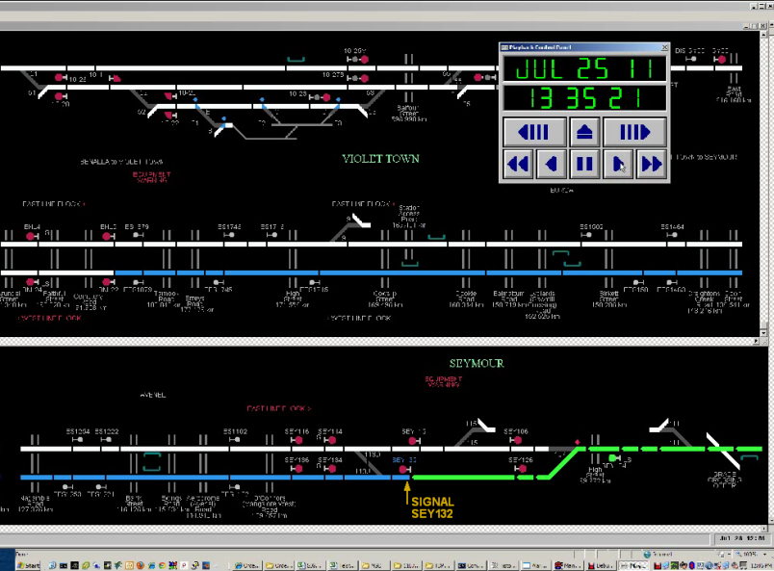

Figure 12 – Signal SEY104 is cleared. The route is set for train 8615 to depart Seymour and enter the West Line which is cleared up to signal SEY132 (the southern limit of Track Warrant № 7). Track Warrant № 7 is still active; note that the computer Blocking protecting it is still in place.

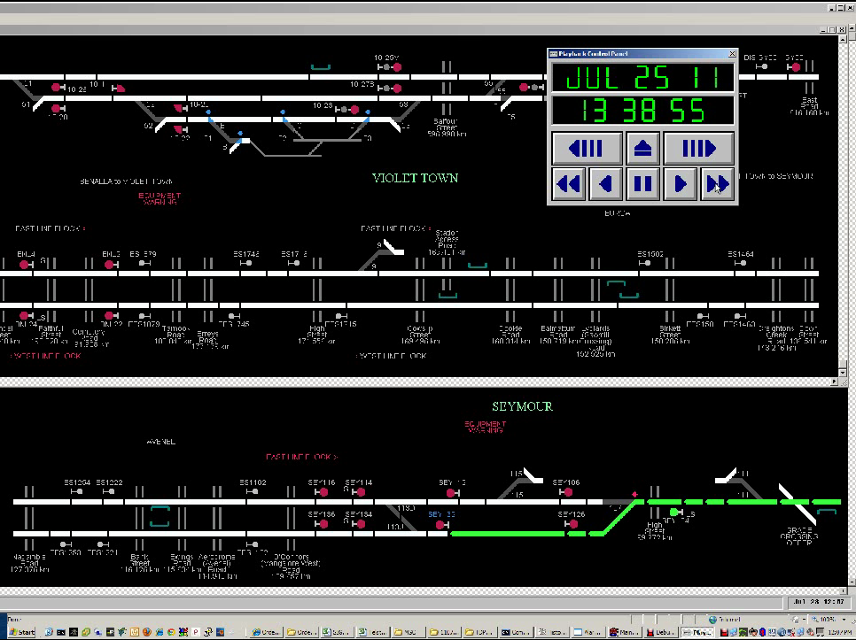

Figure 13 – At this point, although Track Warrant № 7 has not been Returned, the network controller has removed its protective track Blocking. The status of the Track Warrant is not depicted on the screen.

Figure 14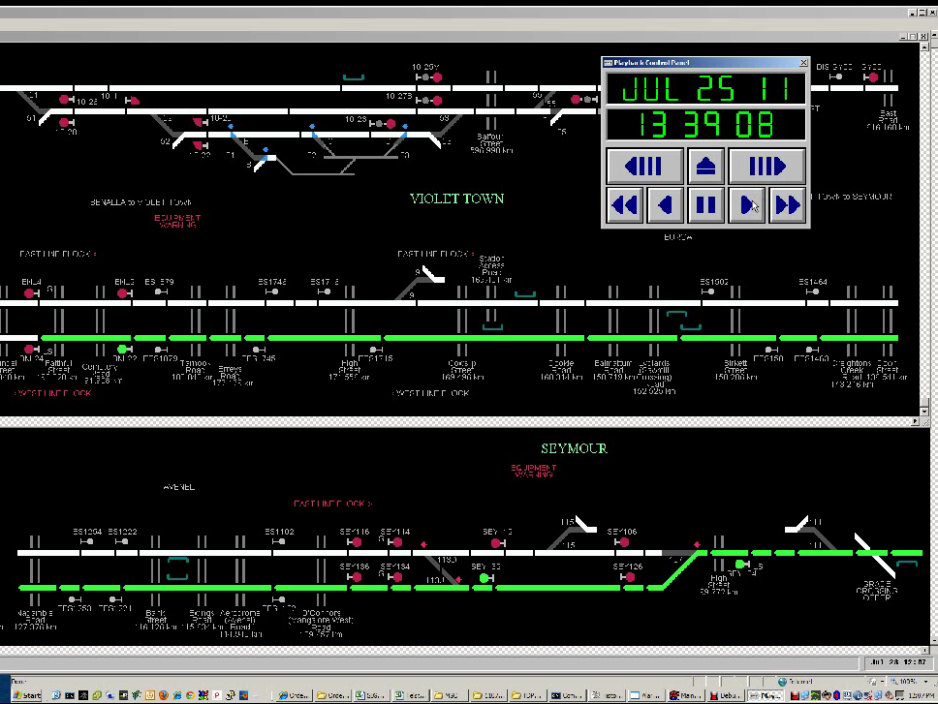 – The West Line through the area covered by Track Warrant № 7 is selected and cleared, as is signal SEY132. Track Warrant № 7 is still in force but the screen presentation does not reflect this.

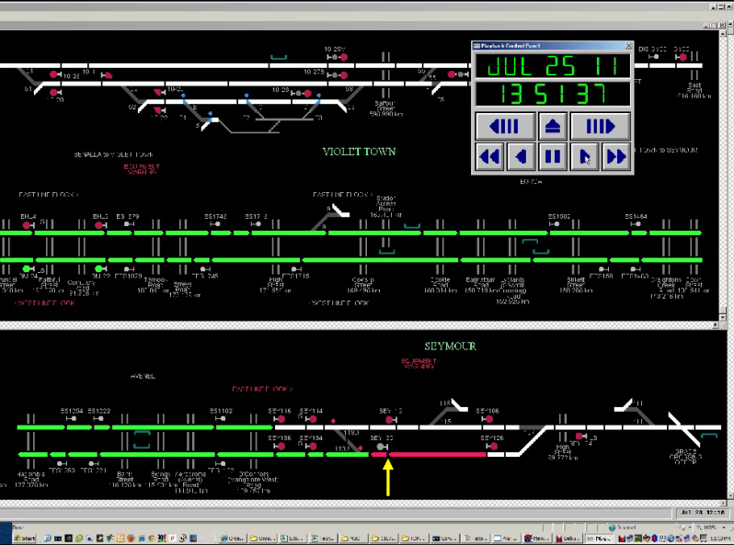

Figure 15 – Train 8615 has cleared through the mainline junction onto the West Line. It is now occupying the section up to and has just passed signal SEY132.

Figure 16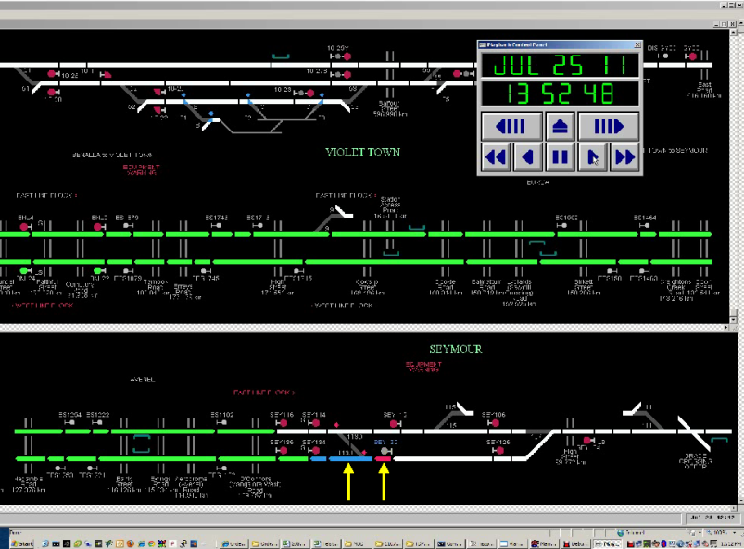 – Train 8615 has passed wholly into the section controlled by signal SEY132 and at this time has encountered the worksite and come to a stand. The network controller is attempting to re-apply the Block applicable to Track Warrant № 7 on the West Line.

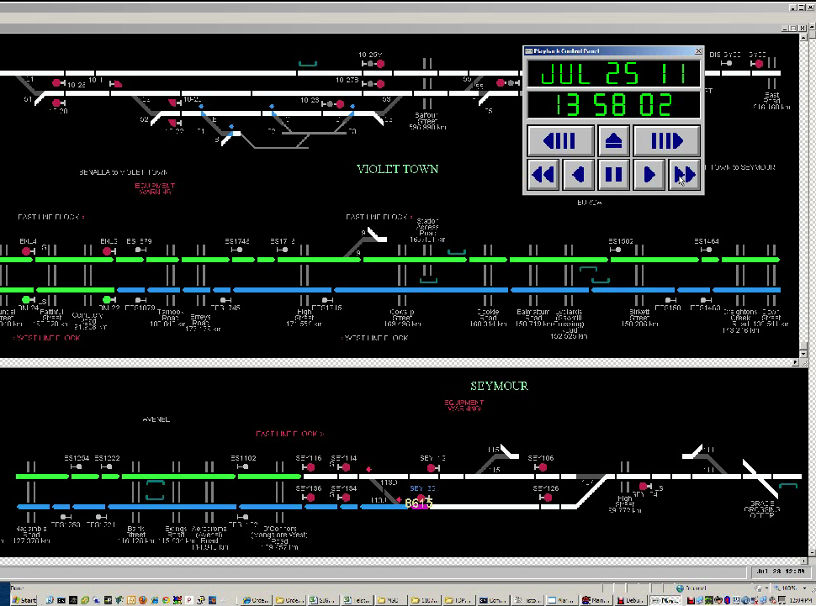

Figure 17 – The network controller has reinstated the Block applicable to Track Warrant № 7.

### Network Control Centre communications

V/Line locomotive crew members initiate radio calls to the Network Control Centre by pushing a Press-To-Talk button which sends the call request to the network controller. This call is queued and the controller will respond to it in due course. An emergency radio call is initiated by pressing a separate ‘Emergency Radio Call’ button. This transmits a call request that overrides the queue and appears on the network controller’s communications screen as a flashing red dialogue box accompanied by an aural alert.

Tabulated data provided by the ARTC of their interpretation of both the log files recorded on their train radio server and at the network controller’s workstation, as well as the Voice Communication System (VCS) was provided to the investigation. The ARTC state that the logs indicate that the emergency calls were received correctly by the system at the Main South Control Board and also that the crew aboard the locomotive of train 8615 were repeatedly pressing the call button. The network controller has stated that he did not receive any emergency calls from train 8615.

At the time the emergency calls were received, the VCS log indicates the network controller was engaged on the phone with the site protection officer and that from this communication would have been aware of the incident and that the train had stopped short of the site. From approximately 1351 until approximately 1352[22] the Network Control Centre is shown as having received four separate emergency calls initiated from the locomotive of train 8615.

In addition, several further calls were made from the locomotive on a mobile phone. The first of these was slightly before the first emergency call.

# Analysis

## The Incident

The Down V/Line passenger train departed Seymour. Due to works in progress on the West Line, the network controller’s intention was to run the train as far as Benalla on the East Line. However, the network controller inadvertently routed the train onto the West Line and then removed the track Block that protected the worksite of a track maintenance crew who were engaged in rail welding under the provisions of a Track Warrant. Travelling at track speed the train encountered the track maintenance crew.

Although the rail welding operation had resulted in a rail discontinuity that would have interrupted the track circuit that controlled the operation of points, signals, and an active road level crossing protection system in that locale, the maintenance crew had effectively ‘jumpered’ the rail gap(s) created as a result of their works, by use of a temporary rail bond. Thus, all systems controlled by that track circuit were able to operate as normal and the train was able to be routed into protected territory.

The locomotive driver reacted quickly and the train stopped under emergency braking just short of the worksite. The maintenance crew, meanwhile, had moved to a designated safe area although the Hi-Rail vehicle remained on the track. Had the train been travelling at the normal posted track speed of 115 km/h, it would undoubtedly have overrun the worksite.

## Wrong-routing of train 8615

The arrangement of signalling on the Seymour-to-Albury dual-track corridor is such that the left-hand track (in the direction of travel) is equipped with more signals, and thus track sections, than is the right-hand track. For this reason, it is normal practice—where fleeting or ‘follow-on’ train movements are required—for traffic to be dispatched via the left-hand track. Junee-based network controllers also control the conventional double-line corridor between Junee and Macarthur in outer south-west Sydney where trains are normally routed on the left-hand track.

When this common practice is added to the aggregate experience of network controllers with dispatching trains over double-line areas it can be expected to result in a tendency to route trains via the left-hand track.

Such a routine is likely to result in a network controller, who might be in some way distracted, switching a train onto the left-hand track when that train might be intended—due either to an existing local operational requirement or to a single out-of-course event—to be sent via the right-hand track. The investigation received confirmation from V/Line that on several occasions—including as late as two days after this incident—Melbourne-bound passenger trains departing Albury had been mistakenly signalled, by Junee network controllers, onto the East (the left-hand line) instead of the West Line as required for trains stopping at the new Wodonga platform, which is only served by the West Line.

When Track Warrant № 5 was Returned at about 1300, the network controller removed the Block from the East Line but took no other actions at that time to set the route for train 8615. It was not until 35 minutes later that he decided to set the route, and then onto the wrong line. There is no apparent reason for the controller’s delay in setting the route via the East Line as there does not appear to have been any other more urgent tasks to undertake. Not having continued to set the route immediately, under the circumstances, presents as an unsatisfactory control technique and a deficiency in task process. It is considered to have contributed to this incident.

Following an ARTC network control process that is mentioned in the training course but does not exist within any documented work procedure, network controllers are expected to endorse the train control diagram with certain details of the Track Warrant; for example; location, time, plus the name and phone number of the field contact  in this case the track supervisor/protection officer. In addition, a vague and undefined instruction in TA20 requires the network controller to ‘suitably’ endorse the diagram such as to ‘reflect’ its Return. On 25 July 2011 the train control diagram was not endorsed in any such manner by the network controller.

## Track Blocking

In the area in which the incident occurred, the network controller was managing two separate maintenance crews operating in adjacent locations on the two parallel main lines, both groups working under the protection of Track Warrants. By prior arrangement, the work on the East Line was to be completed and the applicable Track Warrant Returned by 1300. This was duly accomplished and the network controller removed the track Blocking from the East Line.

The network controller was intending to dispatch train 8615 from Seymour via the East Line to bypass the track works being carried out on the West Line. At 1255 he accepted a request from a track inspector to conduct an inspection by Hi-Rail vehicle between the 109 and 130 kilometre locations. At this time he informed the track inspector that he [the track inspector] could have from 1255 to 1340 to conduct the inspection and that *“...I can’t give you any more...”* The network controller also informed the track inspector that *“Blocks are on”*, presumably a reference to the application of a track Block between these two locations in protection of this activity. A subsequent report, though, prepared by ARTC listing all Blocks placed in the Seymour area during this time does not show such a Block having been applied.

At around 1335 the network controller began to prepare for the passage of train 8615, which had not yet arrived at Seymour. In so-doing he apparently acted by reflex, reversing the mainline points at Seymour to divert train 8615 onto the West Line and clearing the Departure signal. At 1338 the Hi-Rail track inspector called clear of track as arranged, without conveying a specific location to the network controller. The network controller, who had advised the track inspector that he had ‘Blocks on’ (but had not apparently done so) reacted by lifting the Block protecting Track Warrant № 7, thereby exposing the maintenance crew to the risk of unauthorised joint occupancy of the track from that time. It appears that the network controller did not, in fact, apply a Block for the track inspection between the 109 and 130 kilometre locations, and that when the track inspector called clear, the controller mistakenly lifted the only Block existing on the West Line – applied to protect the Track Warrant.

The network controller had stated to the track inspector that he [the controller] could not provide further time for his inspection beyond 1340. From this, the assumption can be made that even at this point the network controller was actively intending that the West Line needed to be clear for the passage of train 8615. This mistake might have been avoided had the Hi-Rail track inspector provided his location at the time of calling clear. Such an action could be expected to have alerted the network controller and prevented the Block placed for the Track Warrant being wrongly lifted. Instead, the controller—having developed the mistaken intention to route the passenger train via the West Line—again reacted reflexively and lifted this Block without being aware of his mistake.

## Protection of track maintenance activity

### Worksite protection

The Pre-Work Brief completed for the worksite by the protection officer identified the passage of trains as a high-risk hazard, with the use of a Track Warrant being the safety control. However, the works would have resulted in a discontinuous track circuit that would have caused the High Street level crossing protection to operate incessantly. The Brief made no mention of the intended use of temporary track bonding in order to maintain the track circuit integrity that would prevent such continuous operation.

Whereas worksite protection undertaken per the medium of Track Force Protection requires the employment of ATWSs and flagpersons, Track Warrant protection does not. The fact that rail traffic had been identified as a high-risk hazard and that the inherent protection offered by a discontinuous track circuit was to be nullified raises the question as to why extra safety controls were not applied by way of compensation.

The Downer EDI Works Job Safety Analysis Worksheet for in-field welding specified the use of both ATWSs and flags. However, the Worksite Protection Plan completed by the protection officer made no reference to the use of either safety feature, despite the identification of the worksite as a high-risk environment.

### Temporary track bonding

Although the ARTC have an Engineering Standard for the use of temporary rail bonds within their New South Wales network, they had no such process for Victoria at the time of this incident. The ARTC acknowledge that the use of temporary rail bonds by track maintenance personnel in Victoria has become a customary work practice. This method of ensuring the continuity of signalling system circuits during disruptive track works was traditionally used when working under the provisions of Track Force Protection. Under these circumstances the maintenance of track circuitry ensured the retention of normal signalling functionality (thus continuing to permit the movement of trains) while the flag protection ensured a valid measure of control of the movement of rail traffic at or through the worksite.

In this incident, the requirement for trains to be able to move up to or through the worksite did not exist; therefore there was no operational requirement for the track maintenance crew to use temporary rail bonding in order to permit this. The apparent reason for the use of bonding was to allow road traffic to use the crossing without the need to provide flagpersons to control road vehicles. Had Track Force Protection been in effect, the following defence against the unexpected incursion by a train into, and its unexpected arrival at the worksite would have been present; a flagperson (with ATWSs in place) would have stopped the train and the track supervisor would have been advised by the flagperson of its presence.

### Existence of parallel lines

The ARTC Code of Practice specifies—with regard to the protection of parallel lines—that where there is a possibility that works in process will or might impinge-upon the parallel line, that the line must be protected either by the Issue of an additional Track Warrant for that line or by the implementation of Track Force Protection. Given the close proximity of the broad-gauge line to the standard-gauge West Line it would have been wise to have allowed for such an event.

In the event of an incident on a corridor having a parallel line (or lines), ARTC’s incident management procedures require that immediate action be taken to warn the train control centre managing that parallel line and in turn, action be taken to advise all approaching trains. The arrangement of tracks at this location—as previously described—would suggest that this action was essential.

These ARTC procedures speak only of parallel lines and do not prescribe specifics around the ownership of those lines. In the case of the Somerton (Melbourne)–Junee corridor, parallel tracks of different networks exist under two sets of circumstances;

* Between the outer Melbourne suburb of Somerton and Seymour, a double-line broad-gauge track shares the corridor with the single standard-gauge track, and
* Between Seymour and Mangalore, dual standard-gauge tracks share the corridor with a single broad-gauge track.

Although in both cases lying immediately parallel to each other, the trackage belonging to each agency is not graphically represented on the network control displays of that other agency. In addition it should be noted that between Seymour and Mangalore the single broad-gauge track lies closer to the adjacent standard-gauge West Line than do the two standard-gauge tracks to each other (see Figure 7).

In terms of spatial awareness, this means that ARTC network controllers on the Main South C Board in Junee see the corridor between Somerton and Seymour represented as simply a single standard-gauge track. The existence of second and third tracks—the parallel Up and Down broad-gauge lines—is thus removed from the network controller’s awareness, as is the single broad-gauge line between Seymour and Mangalore. Under these circumstances, when an incident might occur on the standard-gauge tracks, a network controller in Junee may not immediately think of other parallel trackage within the corridor, even though emergency action might be required to inform the network control centre responsible for this line.

It would seem logical that where any rail corridor contains—within close proximity—the main line track of another agency, that such trackage should be graphically represented on the train control computer display (or on the mimic panel) in the control centres of both agencies. In this case, for each agency the trackage belonging to the foreign network would be graphically presented such as to convey its non-controllable status.

## Communications

The locomotive crew reported having experienced difficulty establishing communications with the network controller following the incident. Examination of the relevant voice logs shows that the communications system performed as designed and that any apparent lack of communication perceived by the locomotive crew stemmed either from their constant pressing of the Emergency Call button or from the fact that the network controller was on the phone and discussing the incident with another party. Having received the call from the Downer EDI Works track supervisor, the network controller was aware of the incident and may have assumed that further emergency calls did not need his immediate attention.

Such an assumption, though, would not be the safest response, since it is entirely possible that more than one emergency incident could occur on one network controller’s territory at any time.

## Network Control rostering

At the time of this incident, the Junee Network Control office was short of its staffing complement by three people. As a result, network controllers were working extra shifts to cover vacancies as depicted in Figure 8. The roster shows the network controller as commencing his shift on the day following the incident at 1500 however a local arrangement was in effect for the day by which the controller was in fact scheduled to recommence at 2300 on the day of the incident; eight hours after finishing; a situation referred-to as a ‘double-back’ shift. This was not reflected on the roster.

The network controller faced an approximate one-hour drive home and a further such commute to return to Junee later that evening. Between these times, he had to eat and attend to any normal domestic requirements; potentially leaving him with minimal time for proper rest. It is possible that the forthcoming obligation of a night-shift closely following a day-shift might preoccupy and potentially distract a network controller during their prior shift.

The network controller reported that in most cases, when he is rostered for a ‘double-back’ shift, he stays in Junee and does not return home between these shifts. The investigation did not ascertain if such accommodation in these cases is provided by the employer.

An ARTC FAID[23] analysis of the network controller’s work cycle for the 29 days leading up to the incident provided a satisfactory fatigue assessment result.

Even with a normal staffing complement, rostering is required to withstand the stress of unexpected demands such as sickness, incident involvement, unforseen training requirements, and other day-to-day personal requirements of employees. With a depleted staff complement, these rostering obligations become more difficult and it may at times be impossible to maintain compliance with FAID limits.

The investigation sought a second interview opportunity to examine these questions and, while the request was initially accepted it was subsequently withdrawn before the interview could take place.

In the context of such considerations, this investigation must speculate upon the degree of stability and ease with which the ARTC was able to ensure coverage of network control office shifts at Junee with a staff deficiency of three. The following three significant issues remain unresolved:

1. How often did local circumstances occur at short notice that required Junee staff rosters to be rearranged to achieve shift coverage with sometimes minimal rest periods for affected employees?
2. Taking account of such alterations, did rosters rearranged under these circumstances maintain the company’s commitment to FAID principles?
3. Was ARTC corporate management aware of the extent of the practice of local rearrangement of rosters?

### Employee’s return to duty

ARTC conducted a post-incident evaluation of the network controller involved in this incident with regard to his knowledge of the Victorian rules and re-instated him to the control of non-Victorian operations. The error made by the controller does not appear to have related to a lack of knowledge of Victorian rules or the rules of any jurisdiction but resulted from poor technique and an oversight when setting the route for train 8615. Being retested on the Victorian rules and then being assigned to a non-Victorian control position would not present as the most beneficial means of determining if the network controller was capable of functioning effectively. A more valid method for the employer to use to satisfy themselves of the level of the network controller’s functional capacity might have been to also subject him to supervisory monitoring over one or more shifts in the position he was controlling at the time of the incident.

## Error-tolerance of the Phoenix TCS

The Phoenix computerised train control system is the medium by which the network controller applies remote control actions to manage rail operations across the applicable region. The train control diagram is the paper instrument upon which all activity across that region is graphed and recorded as it occurs. One activity regularly required of a network controller is the application of safeworking safety assurance measures designed to protect personnel who are authorised to be on or about the track from the danger posed by rail traffic. These measures usually require a form to be filled out both by the network controller and the field supervisor; the controller’s copy remaining book-fast as a record. One such safety assurance mechanism is the Track Warrant, a track occupancy authority conveying an exclusive right to be on or about the track to personnel engaged on unplanned track infrastructure maintenance and repair activities.

Thus, there are three elements to the network controller’s task in managing the safety of an infrastructure crew engaged upon this work:

* The books of numbered forms for the various formal safeworking measures, one of which is the Track Warrant. This is the written record of safeworking mechanisms applied.
* The Phoenix computer display. This is the presentation of system status and report-back of control actions taken.
* The train control diagram. This is the graphic record of on-track activity across the particular region, completed in real-time.

Because the electronic (computer) and paper-based (train control diagram and safeworking measures) elements of this system do not automatically interact, these three sources of information regarding system status require constant attention from the network controller for effective coordination. In this case the process of scrutiny was not sufficiently robust to prevent the occurrence of this incident.

This lack of systems integration between the computerised train control system and the paper-based media is central to this incident. Had a mechanism existed that prevented the network controller from clearing the route for the train to conflict with the still-active Track Warrant, the incident could not have occurred. Because the computerised train control system was not able to alert the network controller to the irregular action he had taken in lifting the track Block and then clearing the route along the West Line, and because it is not network controller’s practice to endorse the train control diagram with details of the status of an existing Track Warrant, this hazardous outcome was possible.

This aspect presents as a systemic deficiency that compares unfavourably with the practice of train control agencies in Queensland. Both Queensland Rail and QR National utilise a computerised train control system created from proprietary software that provides two vital cues to assist in maintaining the train controller’s awareness of the status of any active track occupancy authority;

* The section of track displayed on the screen that is the subject of a Block is given a particular colour depending upon the reason for its Issue (for example, *All trains Block* - used as a reminder device to the network controller, *Coded Block* - Used for Automatic Block Signalling, and *TOA Block*.)
* The use of computer-generated codes that validate train control actions and protect against inappropriate or unsafe subsequent actions is an example of the ‘safety interlock’ element that does not exist in current ARTC practice with the Phoenix system.

The use of computer-generated safety codes to ‘lock’ a workstation and prevent a subsequent train control action from compromising an existing control state is already in use by the ARTC in their Train Order Control safeworking system in other parts of the network. In this case, the system prevents a network controller issuing a subsequent Train Order[24] until the previous one has been Fulfilled. The process of Fulfillment involves the train or locomotive driver returning a computer-generated code previously provided at the time of issuing the Train Order for the network controller’s computer to be able to generate a subsequent Train Order. It would seem useful to consider whether appropriate aspects of this interlocking could not be migrated across to the Phoenix CTC system.

## Clarity of train control diagram

Great care is required in the use and interpretation of the train control diagram in its daily operational use. Due to the amount of ‘on-track’ activity that must often be recorded, such diagrams may inevitably become visually cluttered with a multitude of drawn lines, written notes, and other markings (See Figure 4). This is compounded when the diagram depicts traffic on parallel tracks and notations that must often be made to record adjacent activities. Even to the trained eye of an experienced network controller, this presentation has the potential to cause misinterpretation.

Current technology for computerised train control systems includes at least two significant advances:

* The capacity to utilise an interactive graphics tablet for the train control diagram. This device contains and presents the pre-produced diagram, digitises whatever is drawn upon it and interacts with the train control computer.
* A GUI-based ‘Computer-Aided’ train control diagram presented on a large-format flat-screen and manipulated by mouse-action.

Such systems could be expected to provide the capacity to integrate control actions made through the keyboard or tablet, with such safeworking instruments as track occupancy authorities (in this case, the Track Warrant). This investigation is not aware that any Australian network control agencies are currently planning to upgrade their systems to this level.

# Conclusions

## Findings

1. The lack of integration between Phoenix TCS processes and those pertaining to Issuing and Returning Track Warrants increases the potential for controller-error.
2. The Network Control Centre was short of staff, resulting in local rosters being regularly adjusted without being subject to fatigue analysis.
3. The Phoenix TCS does not depict the existence of the V/Line broad-gauge track.
4. Neither the network controller nor the track supervisor (protection officer) notified the operator of the broad-gauge line (V/Line) that works were being undertaken or of the incident after it occurred.
5. The use by the track maintenance crew of a temporary track bond enabled Home signal SEY132 to display a Proceed indication despite the existence of a gap in one rail.

## Contributing factors

1. The ARTC network control systems allowed a track Block to be lifted with an associated Track Warrant still active.
2. Junee network controllers routinely despatch trains on the left-hand track between Seymour and Albury, according to normal train programming. In this incident, this convention probably caused the network controller to react out of habit.
3. The network controller displayed poor technique in not pre-setting the route for train 8615 after the Return of the Track Warrant for the East Line and then setting the route for train 8615 prior to removing the Block from the West Line.
4. The network controller lost situational awareness between clearing the East Line and then setting a route for the West Line.
5. The network controller did not apply track Blocking to protect a track inspection being conducted on the West Line. Had he done so, he may not have lifted the wrong track Block by mistake.
6. The practice of using temporary track circuit bonding cables when severing the rail enabled the West Line to be used as a feasible route when this should not have been possible.
7. The track maintenance contractor relied upon Track Warrant protection for the worksite instead of following company Job Safety Analysis procedures, reducing the level of defence against inadvertent incursion by a train.

# Safety Actions

## Safety Actions taken since the event

### Transport Safety Victoria

On 5 August 2011, Transport Safety Victoria (TSV) Issued a Safety Alert addressed to accredited rail operators requesting they ensure compliance with their statutory safety duties and review the level of safeworking protection utilised when conducting rail infrastructure works under a Track Warrant.

On 28 September 2011, TSV imposed a restrictive condition upon the issuing of Track Warrants under TA20 (ARTC Code of Practice). In part, this notice  operating from 17 October 2011 to 28 February 2012, and subsequently extended:

1. Restricted the ARTC from issuing a Track Warrant for any planned[25] rail infrastructure work except where the Track Warrant is Issued:

* for emergency works or solely for movement of Hi-Rail vehicles
* for the movement of track machines
* for ad-hoc inspections programmed to be carried out between trains
* to provide protection for work on an adjacent line (including that of another network owner)

1. Required the ARTC to review the risks and controls associated with the use of Track Warrants; this review to be documented and to include a comprehensive identification of additional potential controls relating to the use of Track Warrants and to demonstrate the elimination or management of risks ‘so far as is reasonably practical’.

On 24 October 2011, TSV Issued a Safety Alert addressed to accredited rail operators advising of a number of recent incidents caused by signalling deficiencies and safeworking irregularities during infrastructure works. The incidents mentioned had potential to impact on the safety of workers and the integrity of interlocking. Accredited rail operators were reminded of their responsibility to comply with legislated safety duties.

### Australian Rail Track Corporation

On 2 August 2011 the ARTC introduced a new procedure applicable to the process of Returning (Fulfilling) Track Warrants. This requires the attendance of and endorsement by the Network Control Centre Train Transit Manager whenever a Track Warrant is Returned and the associated track Blocking removed. This amended procedure, however, failed to prevent the unauthorised removal of a track Block protecting maintenance personnel in possession of a Track Warrant on 24 August 2011.

*Phoenix Train Control System update*

In response to this incident, the system software has been modified to provide an additional prompt before a Block can be removed. In this case, the ‘Type’ (of Block) and ‘Block ID’ (the number entered into the system when the Block is applied) fields are enabled and must be completed correctly in order for the REMOVE button to be enabled. The REMOVE button is then selected twice as normal.

In addition, a System Override feature provides that should the REMOVE button not become enabled after an attempt to enter the correct ‘Type’ and/or ‘Block ID’, the Train Transit Manager—upon verification that the action being attempted by the Network Controller is safe—can log into the Network Controller’s workstation and remove the Block.

*Electronic TOA system*

An information technology project was established in February 2011 to examine the potential for introducing an Electronic (on-screen) Track Occupancy Authority system that would integrate with the electronic Blocking functionality of the Phoenix Train Control System.

The project intends to provide an interactive tool for network controllers and worksite protection officers to manage TOAs (including Track Warrants) in a more streamlined way (Note: In 2011 the ARTC Network Control Centre North issued 2,600 TOAs). The intent is to replace paper-based TOA forms with an electronic equivalent that can be distributed directly to protection officers in the field for viewing via a portable electronic device. A further design intent is that the system be expandable to include other form-based safeworking instruments.

A full user-interface with the Phoenix TCS workstation, however, is not considered by the ARTC to be a fit-for-purpose possibility at this point. Such integration—that would provide Blocking protection information—is considered possible in the future. In the meantime a touchscreen tablet device is proposed for use by network controllers and protection officers for input and receipt of the TOA. This would supplant the various pro-forma books; for example the Track Warrant book.

ARTC consultants are currently trialling a Phoenix modification that would require the network controller to enter a TOA reference number onto the workstation Blocking form. This code number would require being re-entered in order to remove the Block.

This initiative is on-going.

## Recommended Safety Actions

Issue 1

The process employed by Australian Rail Track Corporation network controllers managing Victorian territory to administer active Track Warrants requires the cross-referencing by a controller of three elements (a Track Warrant book, the train control diagram and the Phoenix computerised Train Control System) that do not integrate with each other. This deficiency permits the train control process to tolerate the commission of errors by network controllers that can compromise safety.

RSA 2012001

That the Australian Rail Track Corporation reviews their current process for associating the use of the train control diagram and the Phoenix Train Control System with the administration of Track Warrants with a view to strengthening it.

Issue 2

The ARTC is currently engaged upon a project to examine the feasibility of integrating an electronic Track Occupancy Authority (for example, a Track Warrant) with the Blocking functionality of the Phoenix Train Control System.

RSA 2012002

That the project to examine the feasibility of integrating an electronic TOA with the Blocking functionality of the Phoenix Train Control System be progressed with a view to its introduction at the earliest opportunity.

Issue 3

The use of temporary rail bonds on the Australian Rail Track Corporation network in Victoria is an undocumented custom and practice.

RSA 2012003

That the Australian Rail Track Corporation reviews their management and use of temporary rail bonds within Victoria, and if their use is to continue then the parameters for that use should be formally prescribed.

Issue 4

The works being undertaken on the Australian Rail Track Corporation network had the potential to affect the parallel line and operations upon it. The network manager of the parallel line was not provided with the required notification of the works.

RSA 2012004

That the Australian Rail Track Corporation amend TA20 to stipulate who is responsible for carrying out the action prescribed in Section 15, Part 21(a) and (b) regarding notifying the network manager of parallel lines.

RSA 2012005

That the Australian Rail Track Corporation reinforces with their network controllers and maintenance contractors the requirement to ensure compliance with Section 15, Part 21.

Issue 5

Where the active trackage of different network agencies co-exists within a corridor, the asset of one such agency could be easily affected by adjacent works undertaken upon the asset of the other and for this reason it is vital that each network is always considered by the other. Currently, train control map displays and mimic panels do not show the existence of the other network within the corridor and it is possible that train controllers will not always be critically aware of the other network at times when it may need to be considered.

RSA 2012006

That the Australian Rail Track Corporation reviews the graphical configuration of train control monitor displays and stand-alone mimic panels where a separate network exists within the corridor, to permanently convey this additional information to network controllers.

Issue 6

The planning for the rail maintenance task included the selection of a Track Warrant to provide the required protection for the maintenance crew. An alternative, more robust protection strategy was available and was prescribed in company documentation.

RSA 2012007

That Downer EDI Works (Downer Australia) re-enforces the safeworking protection requirements within their *Job Safety Analysis* worksheet (JSA № VRLJSA005) with all relevant employees and contractors when welding broken rail.

Issue 7

The ARTC rosters for network controllers are compiled at a central location and assessed against the company’s fatigue model. The rosters are then distributed to field locations and may be amended for local requirements without fatigue analysis.

RSA 2012008

That the ARTC review local rostering practices to ensure amendments are validated against the company’s fatigue management system.

Issue 8

A staffing shortage at the Junee Network Control Centre sometimes results in a network controller being rostered to work a ‘double-back’ shift (two shifts in close succession). It is therefore possible, depending upon where a network controller might live, that in driving to-and-from home between such shifts they may not be adequately rested.

RSA 2012009

That when network controllers are rostered with the minimum break between shifts, that the ARTC give due consideration to their location of residence so as to minimise the impact of travel upon the employee’s rest period.

1. Now called Downer Australia.
2. A road vehicle or road-driveable machine that has been modified to also travel on rail lines (hence ***Hi***ghway-***Rail***way).
3. For the purposes of this report the ‘worksite’ is considered to be the precise location at which this weld was being undertaken. This was the 102.647 kilometre location.
4. See Section 2.2.3.
5. A fusion weld, whereby the two rail ends are joined in-situ by using molten metal as filler.
6. A group of engineering companies brought together by and including the ARTC to plan, design and deliver a range of improvements along the Sydney–Melbourne rail corridor.
7. Australian Rail Track Corporation – a Federal government-owned company created in 1997 to provide a single point of contact for all rail operators seeking access to the National interstate rail network. ARTC is responsible for maintaining the infrastructure and the flow of traffic on various inter- and intrastate standard-gauge corridors that are leased from state transport agencies.
8. Request from the Federal Minister for Infrastructure and Transport for the ATSB to examine and report on the measures taken to maintain the safety of rail operations where track quality is below acceptable operational standards.
9. Code of Practice – Victorian Mainline Operations.
10. A volatile device used as a warning signal to train and locomotive drivers. The device is placed upon the rail such that when crushed by the passage of a train or locomotive wheel, it produces an explosive noise. One or more ATWSs may be used to provide the required message. The device is also referred-to as a railway 'detonator'.
11. Sometimes called ‘fleeting’.
12. In other rail jurisdictions, this role is referred to as Train Controller or Traffic Controller.
13. An item of equipment involved in the operation of a signalling system whose failure in any state will not cause a reduction in safety of the signalling system. Non-vital systems are typically used for routing logic and for providing remote controls and indications; they are not relied-upon for safety-critical functions.
14. A form of railway signalling by which a train controller can directly control railway points and signals—and thus rail traffic flows—across a region from a remote (centralised) location.
15. Graphical User Interface. A type of interface that allows users to interact with electronic devices using images rather than [keyboard] text commands. A GUI presents the information and actions available to a user via graphical icons and visual indicators. The actions are usually performed through direct manipulation of the graphical elements. The Phoenix software runs on the MS Windows NT platform.
16. Electronic Blocking of a device or section of track ensures that an inadvertent control command cannot be made that would operate or activate that device or circuit in the field when such operation is specifically not desired.
17. A large graphical diagram (χ axis = time, γ axis = distance) used by a train controller, depicting planned and actual operational information over a particular region. These diagrams cover a 24-hour period and are legal documents recording all rail activity over that region.
18. The area within a rail corridor where people or equipment is at risk of being struck by rail traffic. Horizontally, it is the space within three metres of the nearest rail.
19. Australian Network Rules & Procedures.
20. This occurs when the condition of the track support structure (sleepers and ballast) or rail fasteners (clips, spikes, screws, anchors etc) can no longer hold the rail in-line and its linear integrity is compromised. A rail may be crippled (out-of-alignment) either horizontally or vertically, on curved or tangent track. The condition of a crippled rail on a running line will rapidly degrade as it is battered by the continuous action of passing rail wheels.
21. Viewed travelling away from Melbourne.
22. The Server and Workstation time clocks are not referenced to a certified time source and were not synchronised; there is a time difference of approximately 39-seconds. Note also that the logging of train radio events is considered by the system to be low-priority. As such, these events are only recorded to the log file once other higher-priority functions have been recorded. Thus, times recorded for train radio events may not reflect the precise time an event is considered to have occurred.
23. Derived from the company name *Fatigue Audit InterDyne*. This is a stand-alone bio-mathematical software product that derives a risk assessment of the degree of work fatigue for employees, based on their hours-of-work over a recent roster period, or from an anticipated roster. The model is based upon scientific research from the University of South Australia.
24. A paper-based or electronically-delivered authority for a train or locomotive driver to proceed into the section.
25. Work that can be identified 48 or more hours in advance of commencement.