

|  |
| --- |
| Co-design and disability inclusion webinar |
| Bios for presenters |
|  |

# Webinar presenters

## Dr George Taleporos (he/him)



Dr George Taleporos is the chairperson of the Victorian Disability Advisory Council and a member of the Independent Advisory Council for the NDIS. He has over 20 years of experience in the disability field, focussed predominantly on advocacy, human rights policy and practice, service development and management. He has a PhD in the field of psychology, a Graduate Diploma in educational psychology and Honors in sociology. Dr George is the man behind the Summer Foundation’s [Reasonable & Necessary podcast](https://www.summerfoundation.org.au/resources/reasonable-and-necessary-podcast-series-2/) <https://www.summerfoundation.org.au/resources/reasonable-and-necessary-podcast-series-2/>.

## Amanda Lawrie-Jones (she/her)



Amanda is a skilled Access & Inclusion Consultant with decades of organisational capability experience. Amanda has successfully created impact and meaningful change working in both government and non-government sectors. Her commitment to the disability community is demonstrated by participating on several Boards and Committees, including as the current President of Scleroderma Victoria and Scleroderma Australia and Chair of the Board of Arts Access Victoria.

Amanda was also a Finalist in the 2018 National Awards for Disability Leadership in the category of Change Making and nominated for Individual Best Achievement Human Rights at the Aspire Awards in 2020. Amanda is also a member of the Victoriana Disability Advisory Council.

## Jen Hargrave (she/her)

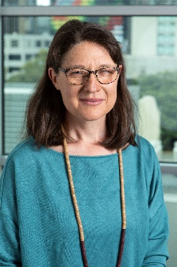

Jen Hargrave is a Policy Officer at Women with Disabilities Victoria (WDV), a Disabled Persons Organisation which runs programs in community building, workforce development and systemic advocacy. She represents WDV in consultations and facilitates WDV members' involvement in consultations.

Jen is also a community based member of the University of a Melbourne research team studying the prevention of violence against people with disabilities. Her other research projects have been with UNSW, the University of Sydney and the DFFH Ethel Temby Scholarship. In these roles, Jen has co-facilitated interviews, co-design groups and consultations with people with disabilities.

## Ruby Susan Mountford (they/them)

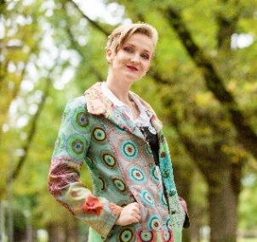

Ruby Susan Mountford is an award winning LGBTIQA+ Disability advocate living on Wurundjeri land, working in community health. Ruby draws from both their professional and lived experience to identify systemic barriers as well as develop and implement strategies for meaningful inclusion and community engagement.

## Melanie Rayment (she/her)

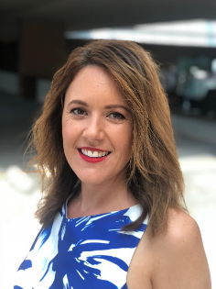

Melanie is the Director of Social Innovation Consulting at The Australian Centre for Social Innovation. Working across a range of social policy areas, Melanie brings together her passion and knowledge for social innovation and (co) design practices to complex social issues to affect change across communities, organisations, policy and services.

She has worked in Sydney, Tokyo and London; including leading service design in children's social care for Barnardo's UK, UTS's Designing Out Crime Research Centre and supporting a range of master's programs in service design, social entrepreneurship and social design.

## Amanda Allen-Toland (she/her)

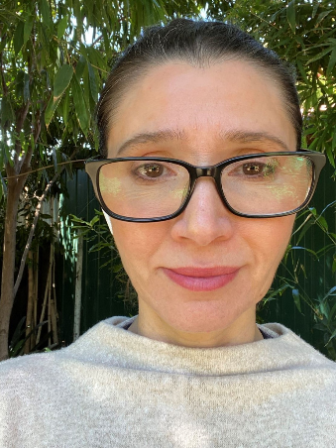

Amanda Allen-Toland is an experienced public sector leader with a track record in delivering complex projects and policy reforms in Aboriginal affairs, population health and international development. As the Director of the Aboriginal Strategy and Oversight Branch, Amanda is working in DFFH to uphold Aboriginal people's right to self-determination so that Aboriginal voice, knowledge and cultural leadership drives policy, legislation and system reform. Currently her focus is on leading the implementation of the Korin Korin Balit Djak System Transformation strategy and building the department’s readiness for the Treaty with Victoria’s First Peoples. Amanda is member of the Gomeroi people of the Gamilaraay nation of NSW and has lived and worked on Wurundjeri land since 2006. Before joining the VPS, Amanda worked for the Commonwealth and non-profit sector in international development in the Asia Pacific region.

|  |
| --- |
| To receive this document in another format, phone 1300 880 043, using the National Relay Service 13 36 77 if required, or [email Office for Disability](mailto:ofd@dffh.vic.gov.au) <ofd@dffh.vic.gov.au>.  Authorised and published by the Victorian Government, 1 Treasury Place, Melbourne.  © State of Victoria, Australia, Department of Families, Fairness and Housing, April 2022.  Except where otherwise indicated, the images in this document show models and illustrative settings only, and do not necessarily depict actual services, facilities or recipients of services. This document may contain images of deceased Aboriginal and Torres Strait Islander peoples.  In this document, ‘Aboriginal’ refers to both Aboriginal and Torres Strait Islander people. ‘Indigenous’ or ‘Koori/Koorie’ is retained when part of the title of a report, program or quotation.  Available at [Inclusive Victoria: state disability plan 2022–2026](https://www.vic.gov.au/state-disability-plan) <https://www.vic.gov.au/state-disability-plan> |